- Execute all the templates shown in the video.

Step 1: Create Project Folder
mkdir terraform-02
cd terraform-02

Step 2: Check Terraform
terraform version
If installed properly, you will see version output.
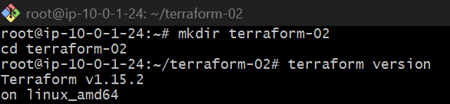

TEMPLATE 1 — Basic Provider Template
Create provider file
nano provider.tf
Paste:
terraform {
required_providers {
local = {
source = "hashicorp/local"
version = "~> 2.5"
}
}
}
provider "local" {}
Save:

Execute Template
terraform init
Expected:
Terraform has been successfully initialized

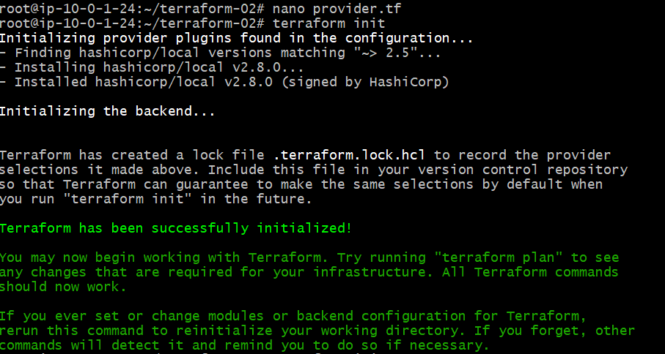

TEMPLATE 2 — Create Local File Resource
Create main.tf
nano main.tf
Paste:
resource "local_file" "demo" {
filename = "demo.txt"
content = "Hello Terraform"
}

Execute
Validate
terraform validate
Plan
terraform plan
Apply
terraform apply -auto-approve

Verify
ls
cat demo.txt
Expected:
Hello Terraform
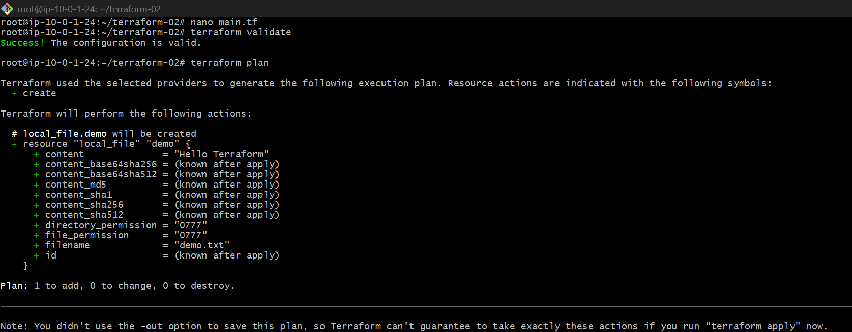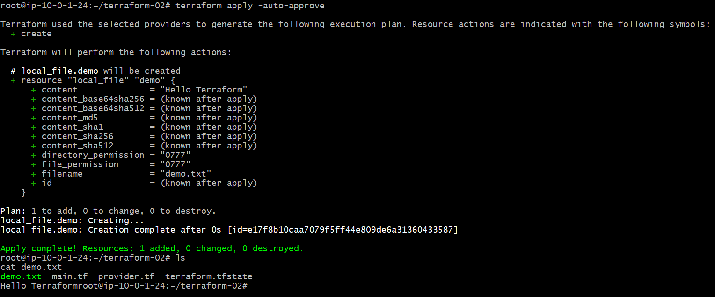
TEMPLATE 3 — Variables Template
Create variables.tf
nano variables.tf
Paste:
variable "filename" {
default = "variable-demo.txt"
}
variable "content" {
default = "This file is created using variables"
}

Modify main.tf
nano main.tf
Replace entire content:
resource "local_file" "demo" {
filename = var.filename
content = var.content
}

Execute
terraform validate
terraform plan
terraform apply -auto-approve

Verify
cat variable-demo.txt

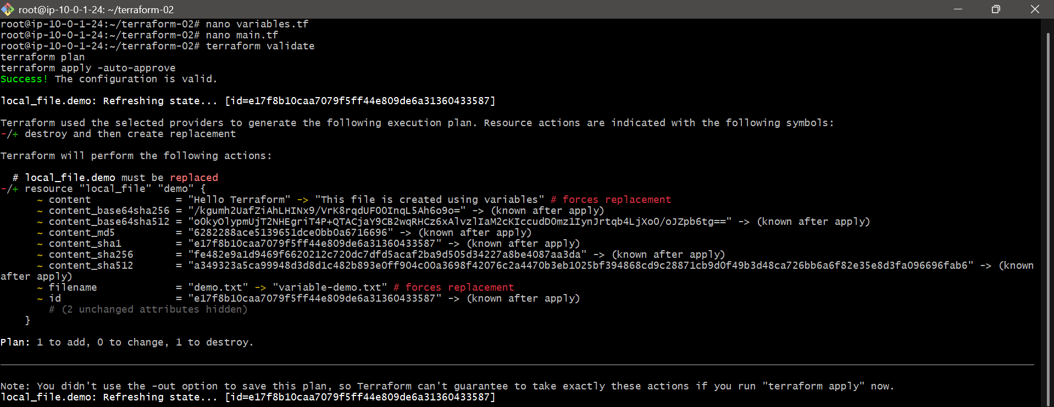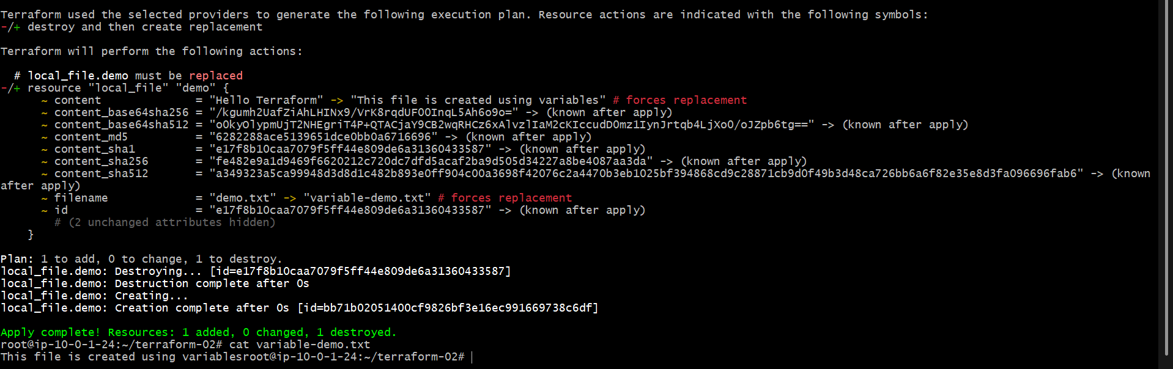

TEMPLATE 4 — Output Template
Create outputs.tf
nano outputs.tf
Paste:
output "file_name" {
value = local_file.demo.filename
}
output "file_content" {
value = local_file.demo.content
}

Execute
terraform apply -auto-approve
Expected output:
file_name = "variable-demo.txt"
file_content = "This file is created using variables"
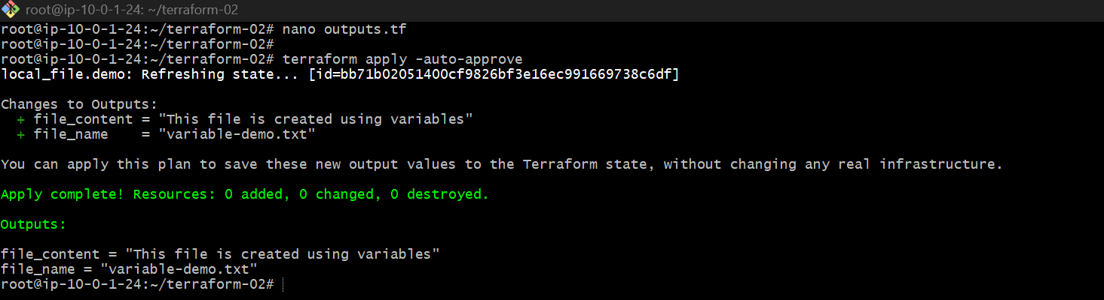

TEMPLATE 5 — Lifecycle Rule Template
Modify main.tf
nano main.tf
Paste:
resource "local_file" "demo" {
filename = var.filename
content = var.content
lifecycle {
create_before_destroy = true
}
}

Execute
terraform plan
terraform apply -auto-approve
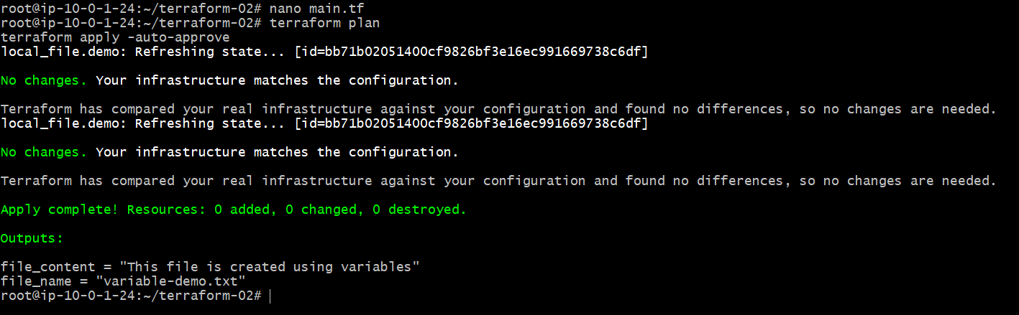

TEMPLATE 6 — Ignore Changes Lifecycle
Modify main.tf
nano main.tf
Paste:
resource "local_file" "demo" {
filename = var.filename
content = var.content
lifecycle {
ignore_changes = [
content
]
}
}

Apply
terraform apply -auto-approve

Change Variable Content
nano variables.tf
Change:
default = "Changed content"

Run Plan
terraform plan
Expected:
Terraform ignores content changes.

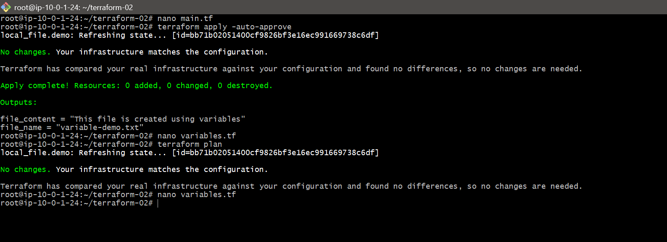

2). Integrate Terraform in Jenkins using the Terraform plugin.
Follow this for Terraform plugin integration in Jenkins.
1. Install Terraform plugin
Jenkins UI:
Manage Jenkins → Plugins → Available plugins
Search: Terraform
Install
Restart Jenkins if asked
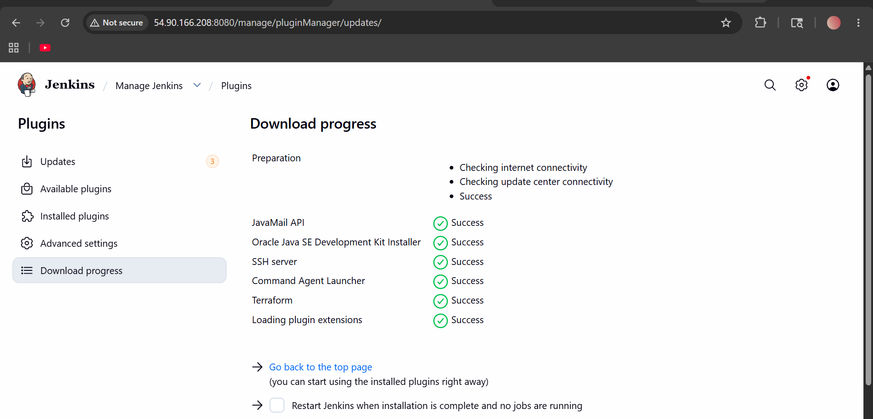
2. Configure Terraform tool
Manage Jenkins → Tools
Find:
Terraform installations
Click:
Add Terraform
Fill:
Name: Terraform
Install automatically: ✅ Enable
Version: latest or any available version
Click:
Save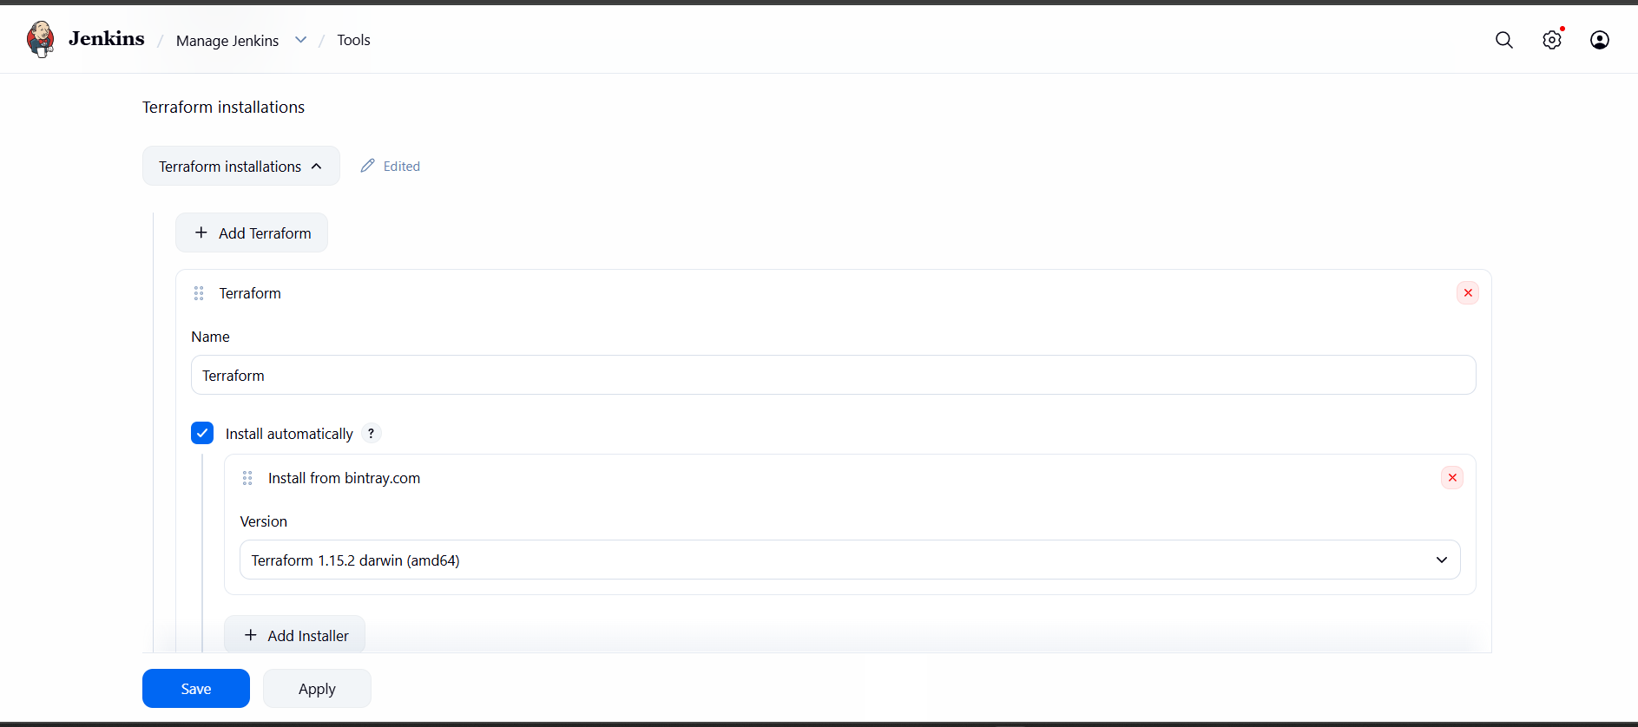
3. Create Pipeline job
New Item → terraform-job → Pipeline → OK
4. Paste this pipeline
pipeline {
agent any
tools {
terraform 'Terraform'
}
stages {
stage('Create Terraform Files') {
steps {
sh '''
cat > main.tf <<EOF
terraform {
required_providers {
local = {
source = "hashicorp/local"
version = "~> 2.5"
}
}
}
provider "local" {}
resource "local_file" "jenkins_demo" {
filename = "jenkins-terraform.txt"
content = "Terraform executed successfully from Jenkins"
}
EOF
'''
}
}
stage('Terraform Init') {
steps {
sh 'terraform init'
}
}
stage('Terraform Plan') {
steps {
sh 'terraform plan'
}
}
stage('Terraform Apply') {
steps {
sh 'terraform apply -auto-approve'
}
}
stage('Verify') {
steps {
sh 'ls -l && cat jenkins-terraform.txt'
}
}
}
}
5. Click Build Now
Expected output:
Apply complete! Resources: 1 added, 0 changed, 0 destroyed.
Terraform executed successfully from Jenkins
That means your Terraform is integrated with Jenkins successfully.
