- Create one Jenkins job using Maven Project for the code below with two stages:
- Stage 1: Git clone
Stage 2: Maven Compilation Code: https://github.com/betawins/java-Working-app.gi

Part 1: Integrate Terraform in Jenkins using Terraform Plugin
Step 1: Install Terraform Plugin
Go to Jenkins:
Manage Jenkins
→ Plugins
→ Available Plugins
Search:
Terraform
Install:
Terraform Plugin
Restart Jenkins if needed.

Step 2: Install Terraform on Jenkins Server
Run on Jenkins server:
terraform version
If not installed:
sudo apt update
sudo apt install -y wget unzip
wget https://releases.hashicorp.com/terraform/1.8.5/terraform_1.8.5_linux_amd64.zip
unzip terraform_1.8.5_linux_amd64.zip
sudo mv terraform /usr/local/bin/
terraform version

Step 3: Add Terraform Tool in Jenkins
Go to:
Manage Jenkins
→ Tools
→ Terraform
Add Terraform:
Name: Terraform
Install automatically: optional
Path: /usr/local/bin/terraform
Save.

Part 2: Create Jenkins Job for Maven Project
Your GitHub code:
https://github.com/betawins/java-Working-app.git
Important: Jenkins Maven Project job does not show stages like Stage 1 and Stage 2.
Stages are mainly used in Pipeline jobs.
So for “two stages”, create a Pipeline job.

Step 1: Create Jenkins Pipeline Job
Go to Jenkins:
New Item
Enter name:
java-working-app-build
Select:
Pipeline
Click:
OK

Step 2: Pipeline Script
Paste this pipeline:
pipeline {
agent any
tools {
maven 'Maven'
}
stages {
stage('Git Clone') {
steps {
git branch: 'main', url: 'https://github.com/betawins/java-Working-app.git'
}
}
stage('Maven Compilation') {
steps {
sh 'mvn clean compile'
}
}
}
}
Click:
Save

Step 3: Build the Job
Click:
Build Now
Then check:
Console Output
You should see:
Stage: Git Clone
Stage: Maven Compilation
BUILD SUCCESS
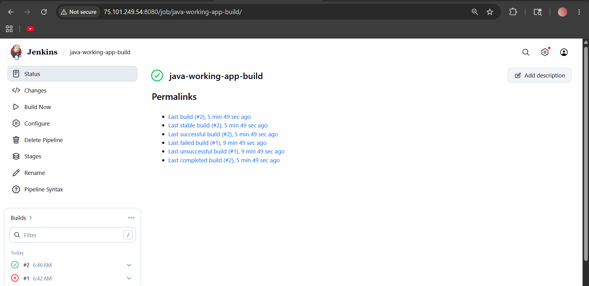

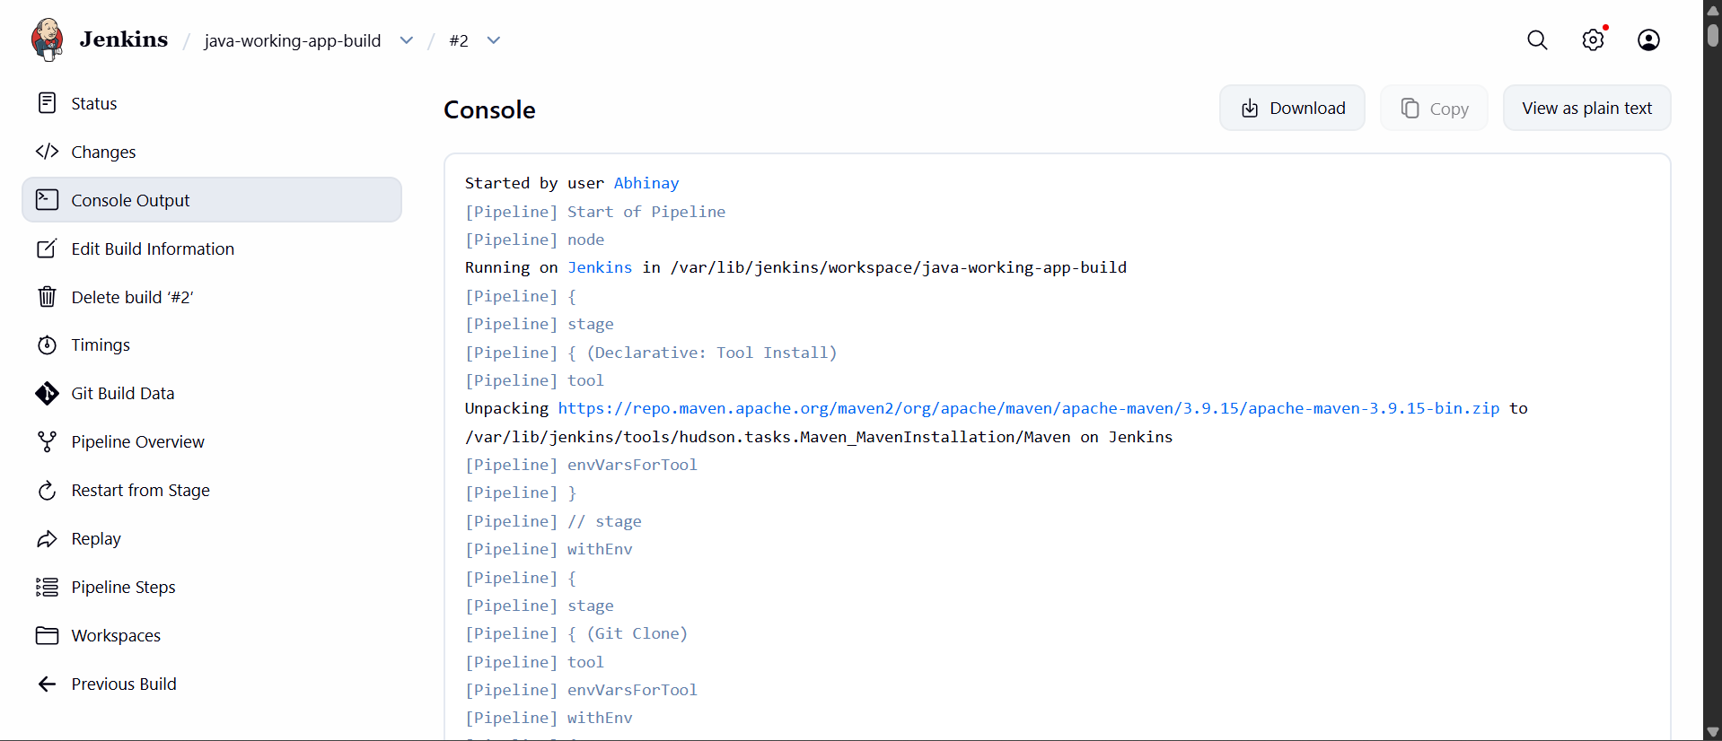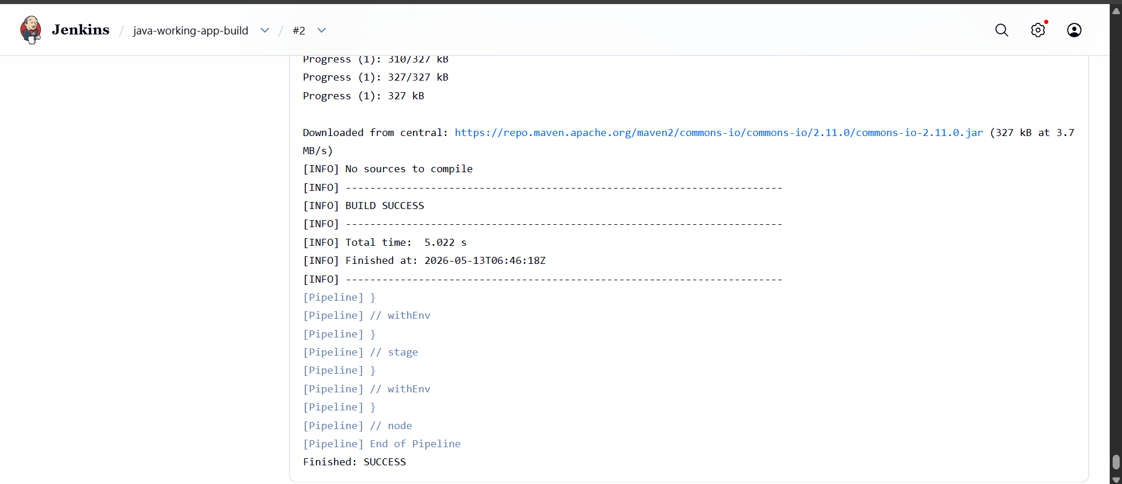

- Use the same code and create a parameterized job in Jenkins with:
- Stage 1: Git clone
Stage 2: Maven Compilation Code: https://github.com/betawins/java-Working-app.git

Step 1: Create New Jenkins Job
Go to Jenkins Dashboard:
New Item
Enter Job Name:
java-working-app-parameterized
Select:
Pipeline
Click:
OK

Step 2: Enable Parameters
Inside job configuration:
✔ Check:
This project is parameterized
Click:
Add Parameter
→ String Parameter
Fill:
Name: BRANCH_NAME
Default Value: main
Description: Enter Git branch name

Step 3: Add Pipeline Script
Scroll to:
Pipeline
→ Definition
→ Pipeline script
Paste this code:
pipeline {
agent any

parameters {
string(
name: 'BRANCH_NAME',
defaultValue: 'main',
description: 'Enter Git branch'
)
}

stages {

stage('Git Clone') {
steps {
git branch: "${params.BRANCH_NAME}",
url: 'https://github.com/betawins/java-Working-app.git'
}
}

stage('Maven Compilation') {
steps {
sh 'mvn clean compile'
}
}
}
}
Step 4: Save Job
Click:
Save

Step 5: Build Job
Click:
Build with Parameters
Enter:
BRANCH_NAME = main
Click:
Build

Expected Output
You should see:
Stage: Git Clone
Then:
mvn clean compile
Finally:
BUILD SUCCESS

What This Job Does
Stage 1: Git Clone
Clones code from:
https://github.com/betawins/java-Working-app.git

Stage 2: Maven Compilation
Runs:
mvn clean compile
This:
- Downloads dependencies
- Compiles Java code
- Verifies project build

Verify Maven Installed
Run on Jenkins server:
mvn -version
If Maven not installed:
sudo apt update
sudo apt install -y maven

Verify Git Installed
Run:
git --version
If not installed:
sudo apt install git -y
