Create a CI/CD pipeline for a Nodejs Application:
https://github.com/betawins/Trading-UI.git

1. Install required tools on Jenkins server
sudo apt update
sudo apt install -y git docker.io
sudo systemctl enable docker
sudo systemctl start docker
sudo usermod -aG docker jenkins
sudo systemctl restart jenkins

2. Create Dockerfile inside repo/project
nano Dockerfile
Paste:
FROM node:18-alpine
WORKDIR /app
COPY package*.json ./
RUN npm install
COPY . .
EXPOSE 3000
CMD ["npm", "start"]
Save:
CTRL + O → ENTER → CTRL + X

3. Jenkins Pipeline Job
Go to:
Jenkins Dashboard → New Item → Pipeline → OK
Pipeline script:
pipeline {
agent any
environment {
APP_NAME = 'trading-ui'
CONTAINER_NAME = 'trading-app'
APP_PORT = '3000'
}
stages {
stage('Git Clone') {
steps {
git branch: 'master',
url: 'https://github.com/betawins/Trading-UI.git'
}
}
stage('Create Dockerfile') {
steps {
sh '''
cat > Dockerfile <<EOF
FROM node:18-alpine
WORKDIR /app
COPY package*.json ./
RUN npm install
COPY . .
EXPOSE 3000
CMD ["npm", "start"]
EOF
'''
}
}
stage('Docker Build') {
steps {
sh '''
docker build -t $APP_NAME:$BUILD_NUMBER .
docker tag $APP_NAME:$BUILD_NUMBER $APP_NAME:latest
'''
}
}
stage('Stop Old Container') {
steps {
sh '''
docker rm -f $CONTAINER_NAME || true
'''
}
}
stage('Deploy New Container') {
steps {
sh '''
docker run -d \
--name $CONTAINER_NAME \
-p $APP_PORT:3000 \
$APP_NAME:latest
'''
}
}
stage('Verify Deployment') {
steps {
sh '''
docker ps
'''
}
}
}
post {
success {
echo 'Node.js Trading UI deployed successfully.'
}
failure {
echo 'Pipeline failed. Check Jenkins console output.'
}
}
}

4. If you get error code 137 again
Run this on Jenkins server:
sudo fallocate -l 4G /swapfile
sudo chmod 600 /swapfile
sudo mkswap /swapfile
sudo swapon /swapfile
free -h
Then build again.

5. Open application
http://<EC2-PUBLIC-IP>:3000
Also allow port 3000 in EC2 Security Group.
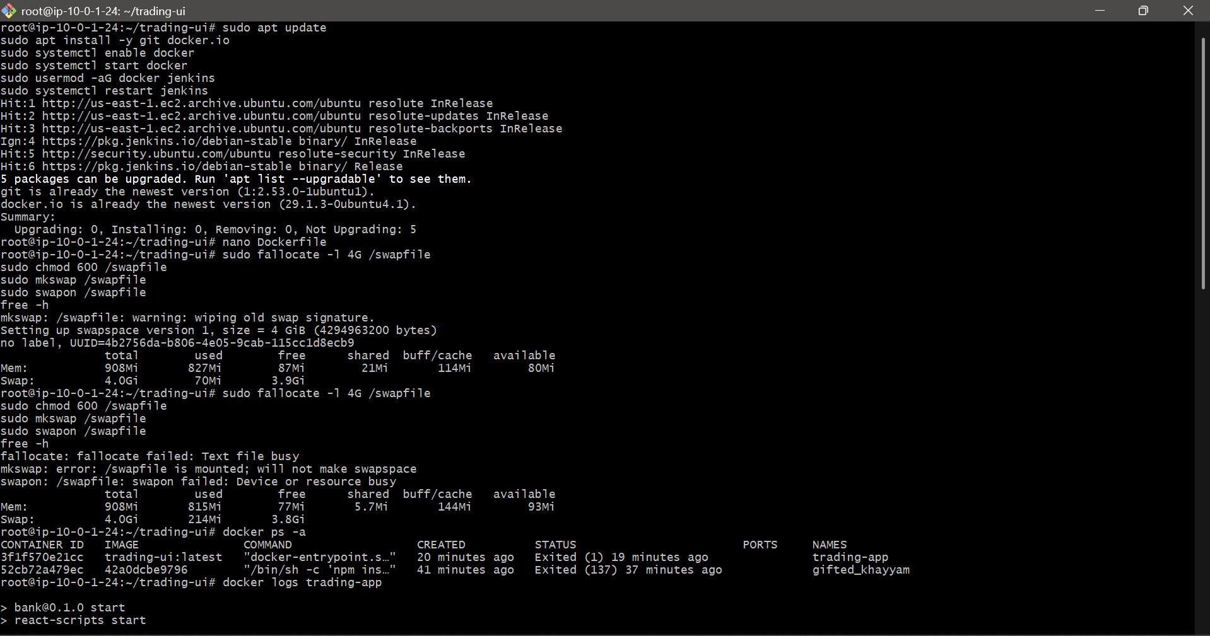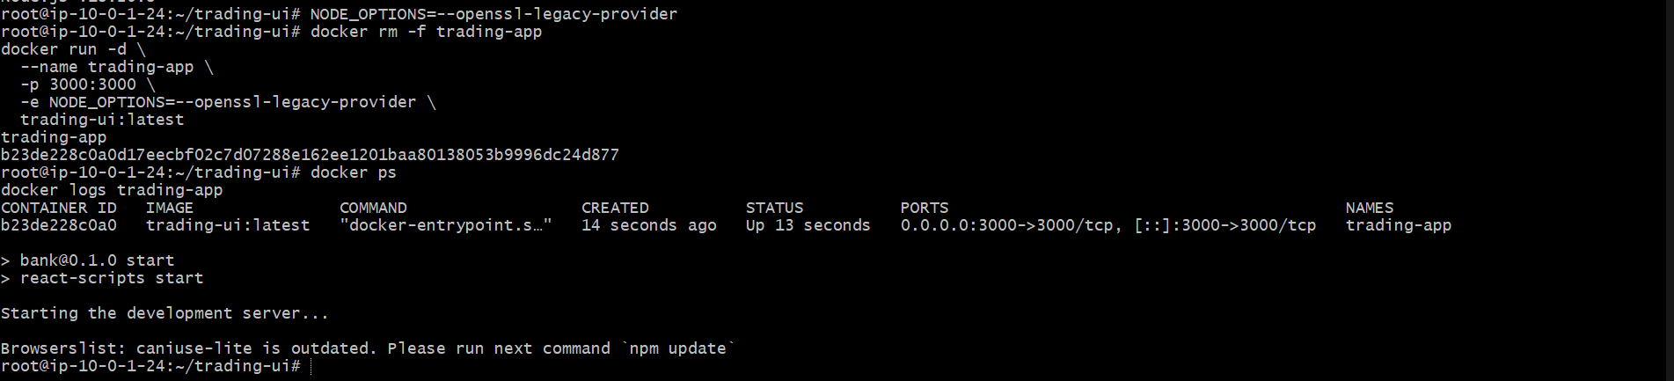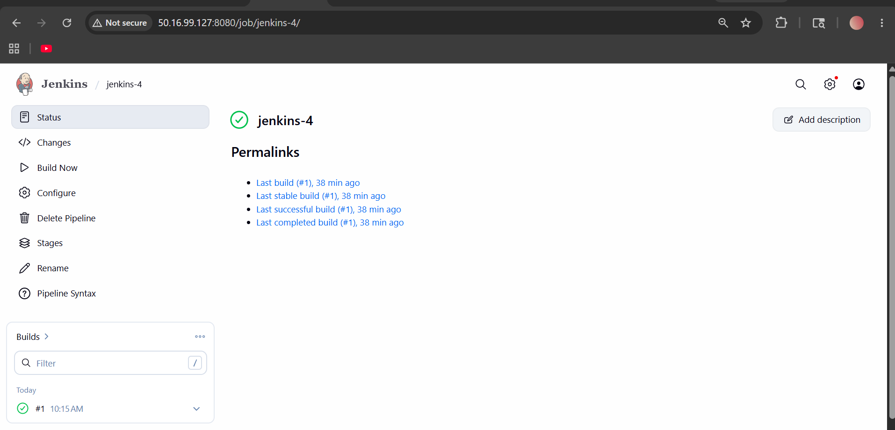
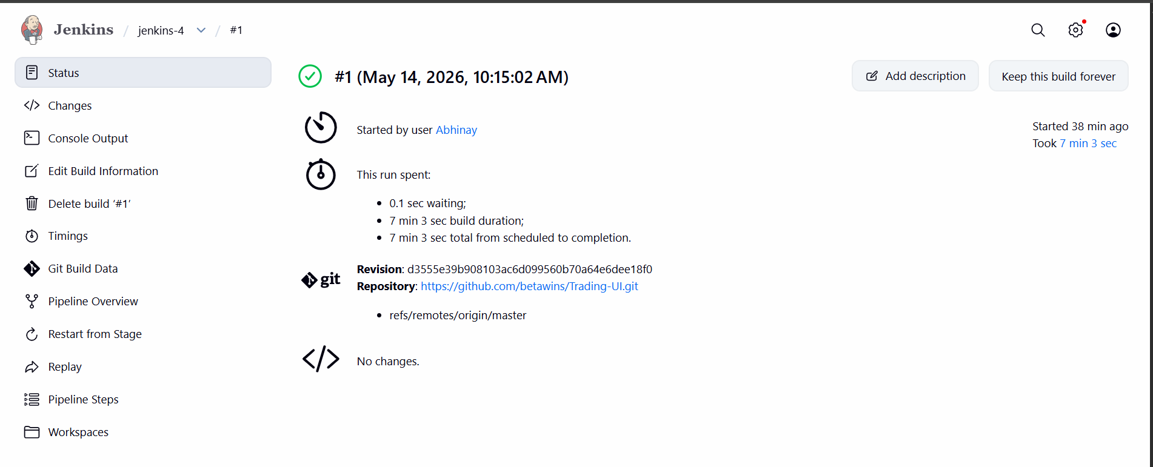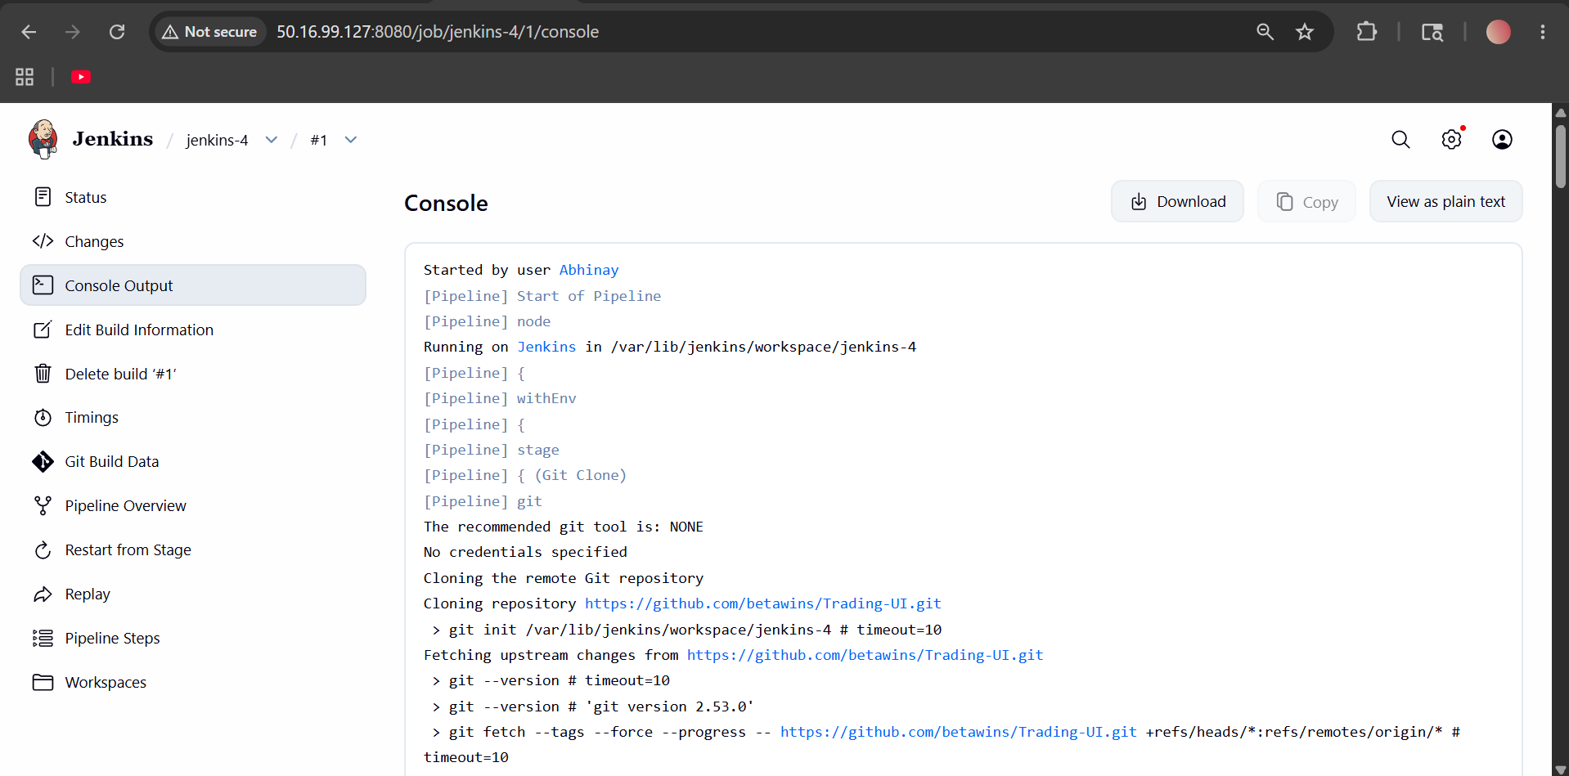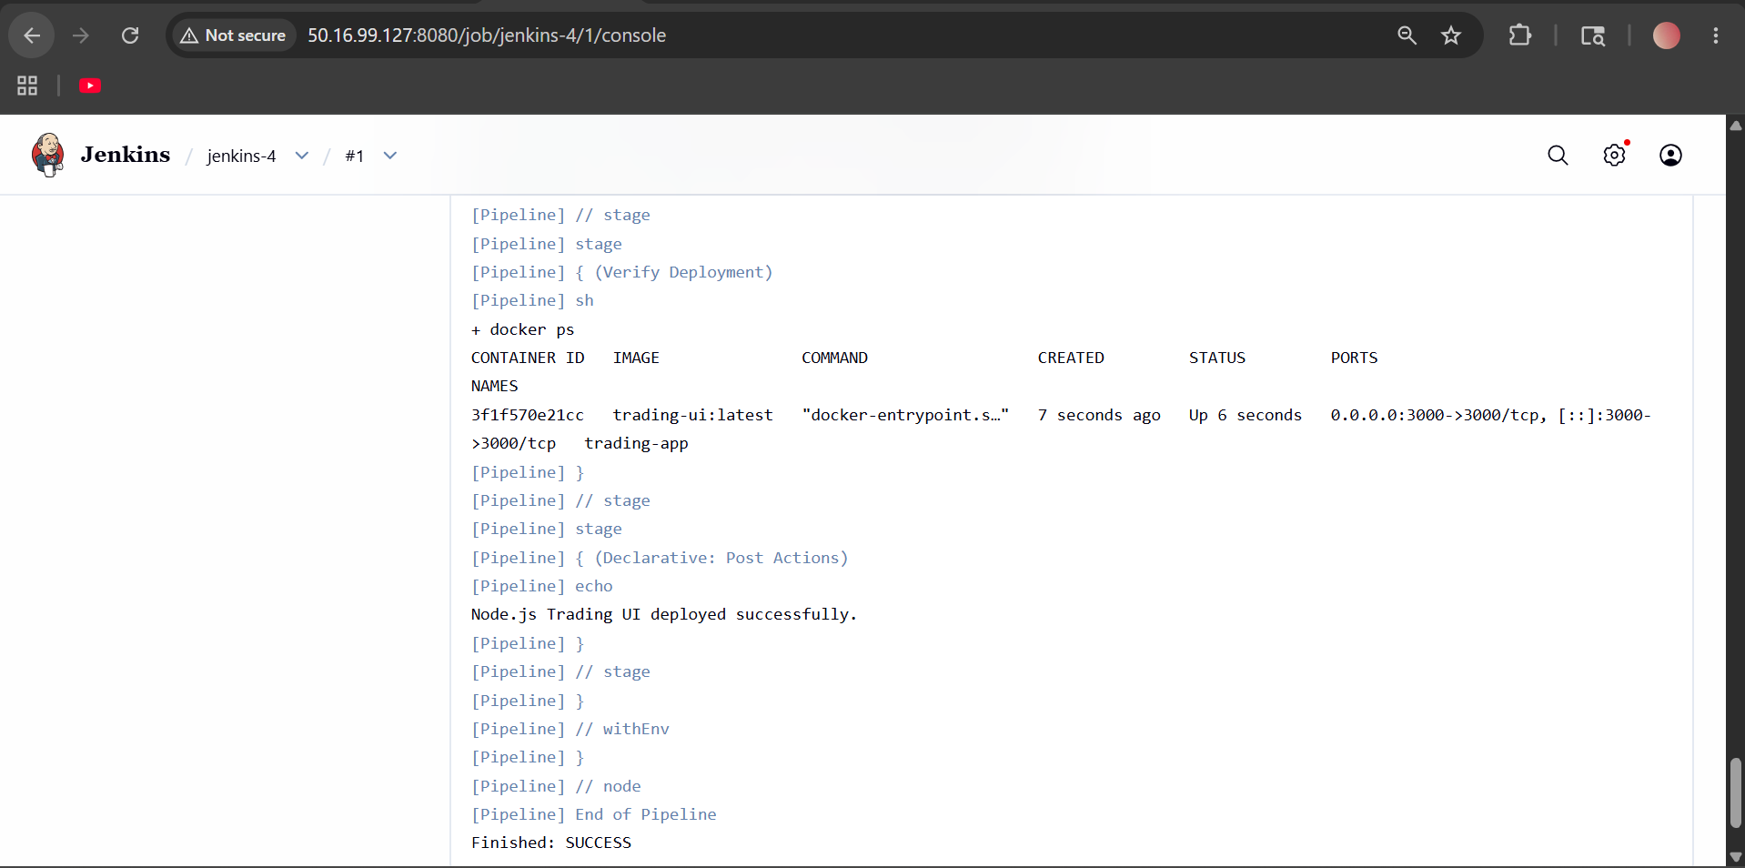

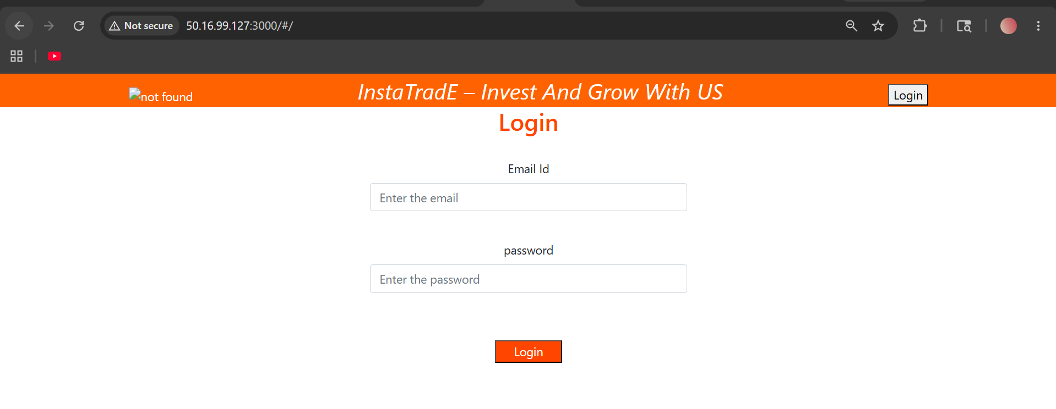

Explain 10 Maven commands.

10 Important Maven Commands
1. Check Maven Version
Command:
mvn -version
Purpose:
- Checks whether Maven is installed
- Displays:
  - Maven version
  - Java version
  - OS details
Example Output:
Apache Maven 3.9.6
Java version: 17

2. Compile Java Code
Command:
mvn compile
Purpose:
- Compiles source code
- Converts .java files into .class files
Compiled files location:
target/classes
Real Use:
- Used before testing or packaging

3. Run Unit Tests
Command:
mvn test
Purpose:
- Executes test cases
- Runs JUnit/TestNG tests
Test files location:
src/test/java
Real Use:
- Verifies application functionality

4. Package Application
Command:
mvn package
Purpose:
- Compiles code
- Runs tests
- Creates:
  - .jar
  - .war
Generated file location:
target/
Example:
target/app.jar

5. Install Package to Local Repository
Command:
mvn install
Purpose:
- Builds application
- Stores artifact in local Maven repository
Local repo location:
~/.m2/repository
Real Use:
- Other local projects can use this dependency

6. Clean Previous Build Files
Command:
mvn clean
Purpose:
- Deletes old target/ folder
Real Use:
- Removes old compiled files
- Prevents build conflicts

7. Clean + Build Application
Command:
mvn clean package
Purpose:
- Deletes old files
- Compiles fresh code
- Creates package
Most commonly used command.

8. Skip Test Cases During Build
Command:
mvn clean install -DskipTests
Purpose:
- Builds application without running tests
Real Use:
- Faster build in CI/CD pipelines

9. Generate Maven Project
Command:
mvn archetype:generate
Purpose:
- Creates new Maven project structure automatically
Creates:
- pom.xml
- src/main/java
- src/test/java
Real Use:
- Starting a new Java project

10. Deploy Artifact to Nexus/Repository
Command:
mvn deploy
Purpose:
- Uploads JAR/WAR to:
  - Nexus
  - Artifactory
  - Remote Maven repository
Real Use:
- CI/CD deployments
- Sharing artifacts with teams

Maven Build Lifecycle Flow
mvn clean
↓
mvn compile
↓
mvn test
↓
mvn package
↓
mvn install
↓
mvn deploy

Important Maven File
pom.xml
Purpose:
- Maven configuration file
Contains:
- Dependencies
- Plugins
- Build configuration
- Project version
Example:
<project>
<groupId>com.demo</groupId>
<artifactId>myapp</artifactId>
<version>1.0</version>
</project>

Real-Time CI/CD Usage
In Jenkins pipeline:
mvn clean package
or
mvn clean install -DskipTests
Used for:
- Java build automation
- Continuous Integration
- Deployment pipelines

