- Create a customized Docker image using a Dockerfile.
1) Create a project folder
mkdir my-docker-app
cd my-docker-app
2) Create a sample application file
Vi index.html
Example: index.html
<h1>Hello from my customized Docker image</h1>
<p>This page is running inside a Docker container.</p>
3) Create a Dockerfile
Create a file named Dockerfile: vi Dockerfile
Paste this:
# Base image
FROM nginx:latest
# Maintainer info
LABEL maintainer="abhinay"
# Remove default nginx page
RUN rm -rf /usr/share/nginx/html/*
# Copy custom file into nginx web folder
COPY index.html /usr/share/nginx/html/
# Expose container port
EXPOSE 80
4) Build the Docker image
docker build -t my-custom-nginx:v1 .
Explanation:
- docker build → builds the image
- -t → gives name and tag
- my-custom-nginx:v1 → image name and version
- . → current folder as build context

5) Check whether image is created
docker images
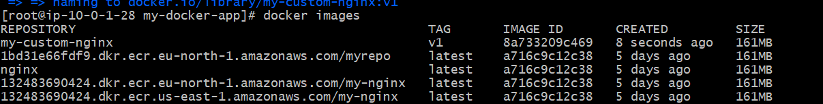
6) Run the container
docker run -d -p 8080:80 --name my-nginx-container my-custom-nginx:v1
Explanation:
- -d → run in background
- -p 8080:80 → map port 8080 on your machine to port 80 inside container
- --name → container name
7) Verify in browser
Open:
http://<server-ip>:8080

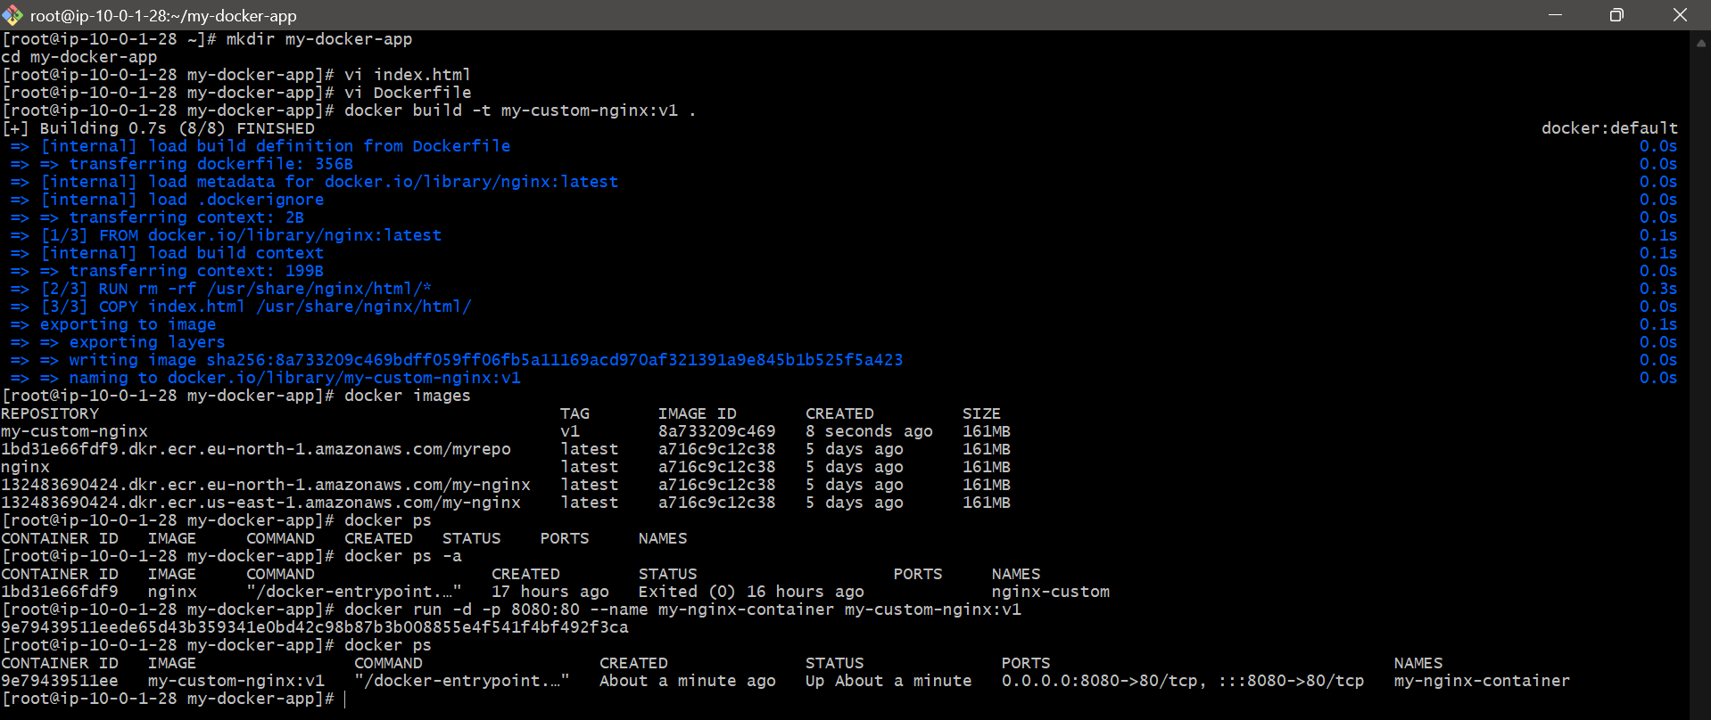

2. Push the image to Docker Hub.
Push Docker Image to Docker Hub
1) Create account on Docker Hub
Go to 👉 https://hub.docker.com
Create an account (if not already).

2) Login to Docker Hub from terminal
docker login
Enter:
- Username
- Password
✅ If success:
Login Succeeded

3) Check your local image
docker images
Example:
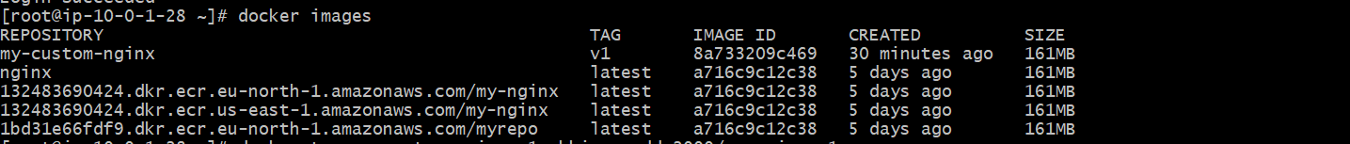

4) Tag the image with Docker Hub username
👉 Format:
docker tag <local-image> <dockerhub-username>/<repo-name>:<tag>
docker tag my-custom-nginx:v1 abhinayreddy2000/my-nginx:v1

5) Push the image to Docker Hub
docker push abhinayreddy2000/my-nginx:v1
You will see layers uploading:
pushing layer...
pushed

6) Verify on Docker Hub
Go to your Docker Hub account → Repositories
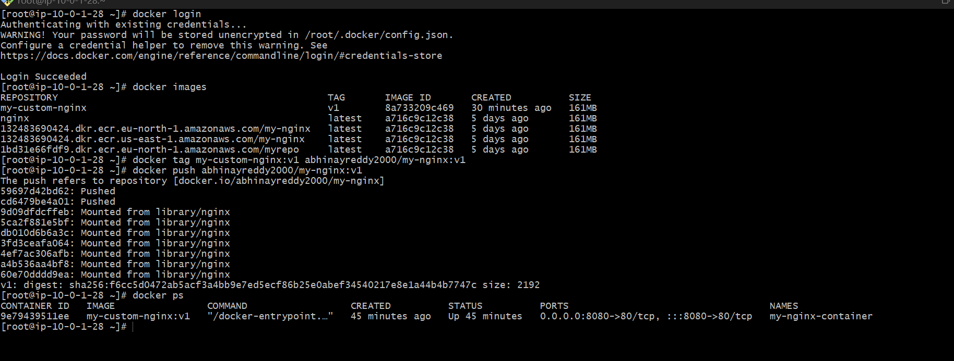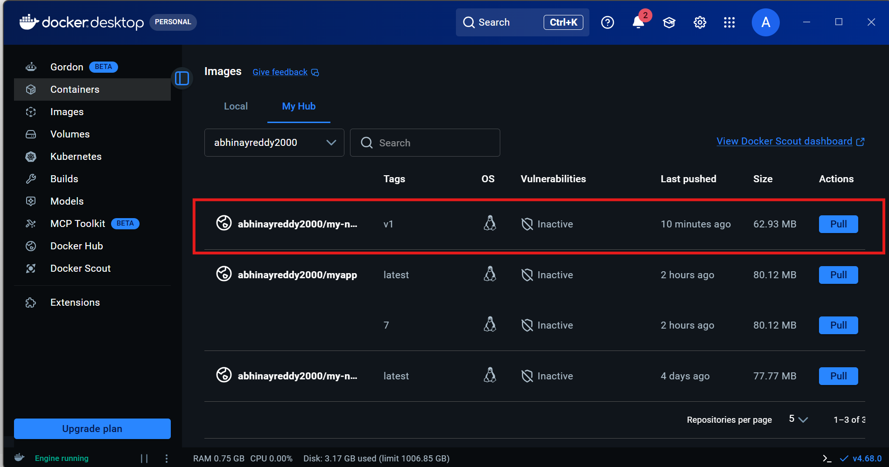

3. Push the same image to Amazon ECR.
Configure the aws
Step 1: Login to ECR (must do)
aws ecr get-login-password --region us-east-1 | \
docker login --username AWS --password-stdin 132483690424.dkr.ecr.us-east-1.amazonaws.com

🔹 Step 2: Tag your image
docker tag my-custom-nginx:v1 132483690424.dkr.ecr.us-east-1.amazonaws.com/my-nginx:v1

🔹 Step 3: Push to ECR
docker push 132483690424.dkr.ecr.us-east-1.amazonaws.com/my-nginx:v1
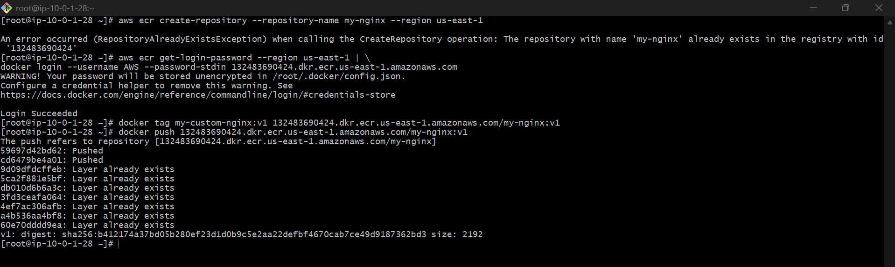
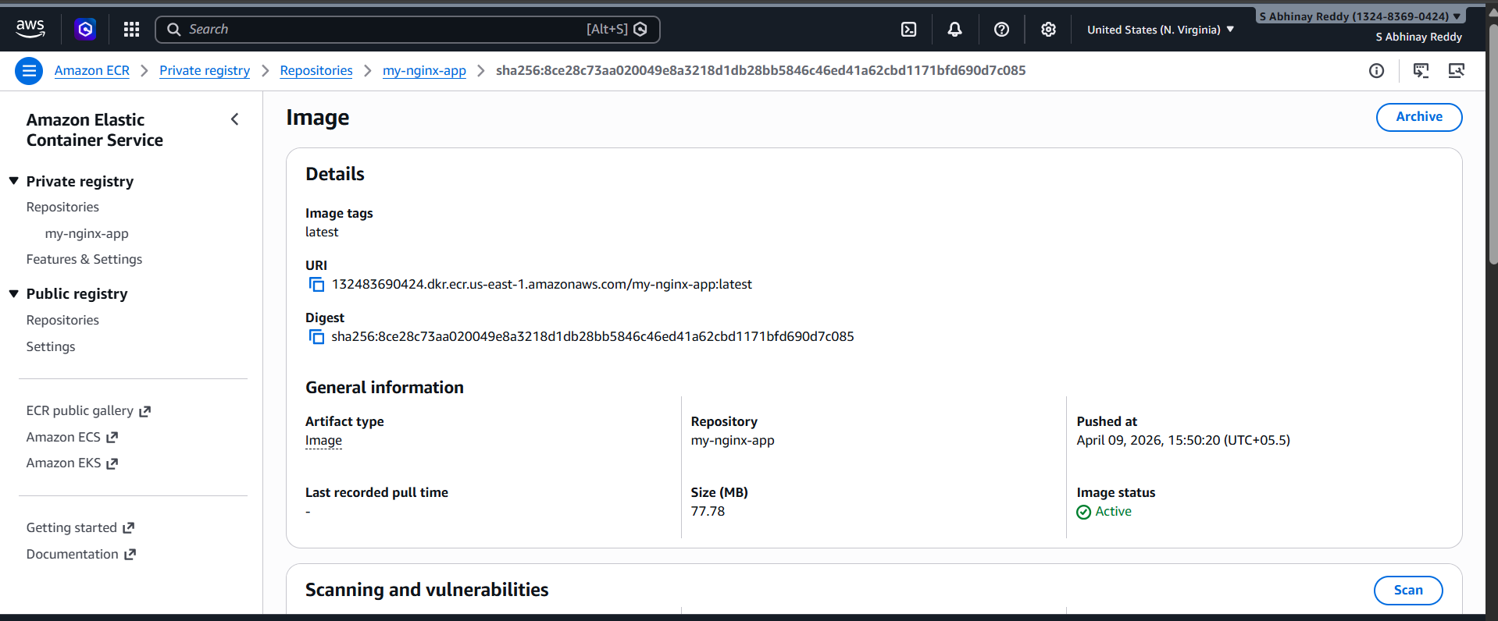

4. Provision one EC2 instance using Terraform and install Jenkins.

1. Create project directory
Run:
mkdir terraform-jenkins
cd terraform-jenkins
2. Create the Terraform file
Create the file:
vi main.tf
terraform {
required_providers {
aws = {
source = "hashicorp/aws"
version = "~> 5.0"
}
}
}

provider "aws" {
region = "us-east-1"
}

# 🔐 Security Group
resource "aws_security_group" "jenkins_sg" {
name = "jenkins-sg"
description = "Allow SSH and Jenkins"
vpc_id = "vpc-0110635c5d5d242ff"

ingress {
description = "SSH"
from_port = 22
to_port = 22
protocol = "tcp"
cidr_blocks = ["0.0.0.0/0"]
}

ingress {
description = "Jenkins"
from_port = 8080
to_port = 8080
protocol = "tcp"
cidr_blocks = ["0.0.0.0/0"]
}

egress {
from_port = 0
to_port = 0
protocol = "-1"
cidr_blocks = ["0.0.0.0/0"]
}
}

# 🖥️ EC2 Instance
resource "aws_instance" "jenkins_server" {
ami = "ami-0ea87431b78a82070"
instance_type = "t3.micro"
subnet_id = "subnet-095883c73e8eabf01"
vpc_security_group_ids = [aws_security_group.jenkins_sg.id]

key_name = "jenkins" # ⚠️ IMPORTANT: use key name, NOT .pem file

associate_public_ip_address = true

user_data = <<-EOF
#!/bin/bash
dnf update -y
dnf install -y java-21-amazon-corretto wget git

wget -O /etc/yum.repos.d/jenkins.repo https://pkg.jenkins.io/redhat-stable/jenkins.repo
rpm --import https://pkg.jenkins.io/redhat-stable/jenkins.io-2023.key

dnf install -y jenkins
systemctl enable jenkins
systemctl start jenkins
EOF

tags = {
Name = "Jenkins-Server"
}
}

# 📤 Outputs
output "public_ip" {
value = aws_instance.jenkins_server.public_ip
}

output "jenkins_url" {
value = "http://${aws_instance.jenkins_server.public_ip}:8080"
}

3. Initialize Terraform
Run:
terraform init
4. Validate the Terraform file
Run:
terraform validate
5. Open Jenkins in browser
Open this in your browser:
http://54.87.197.112:8080
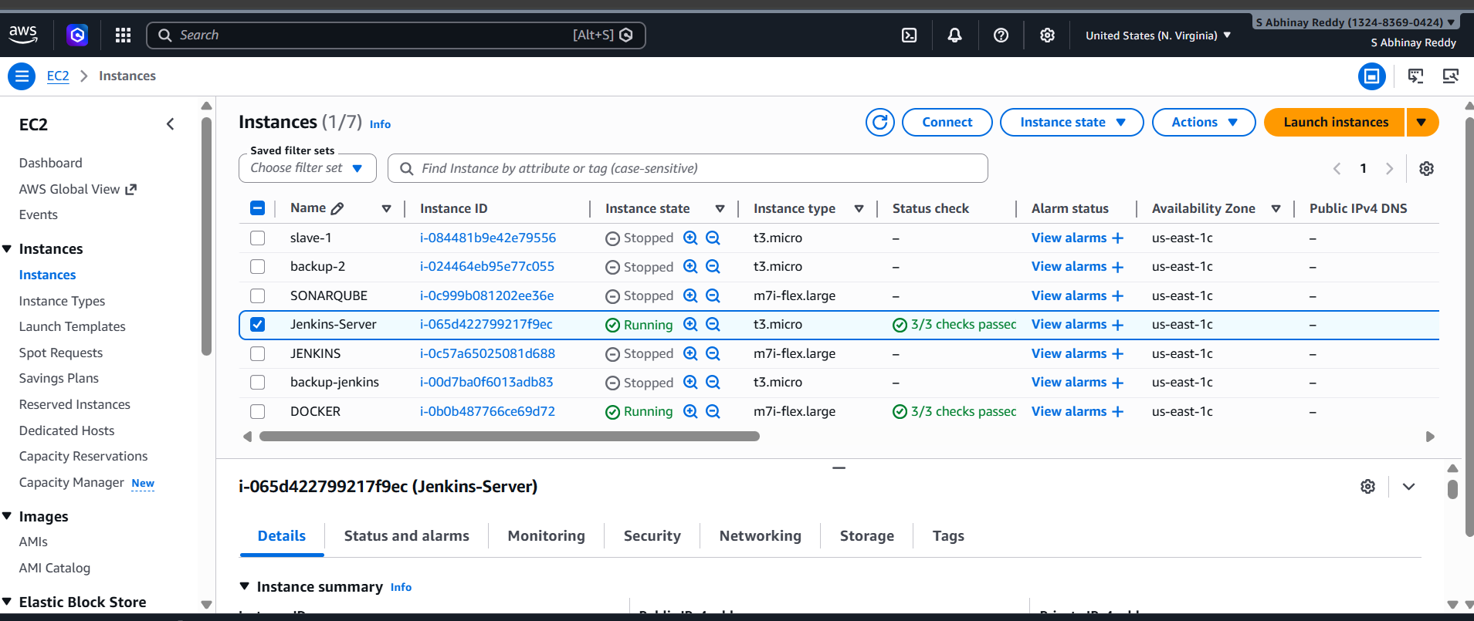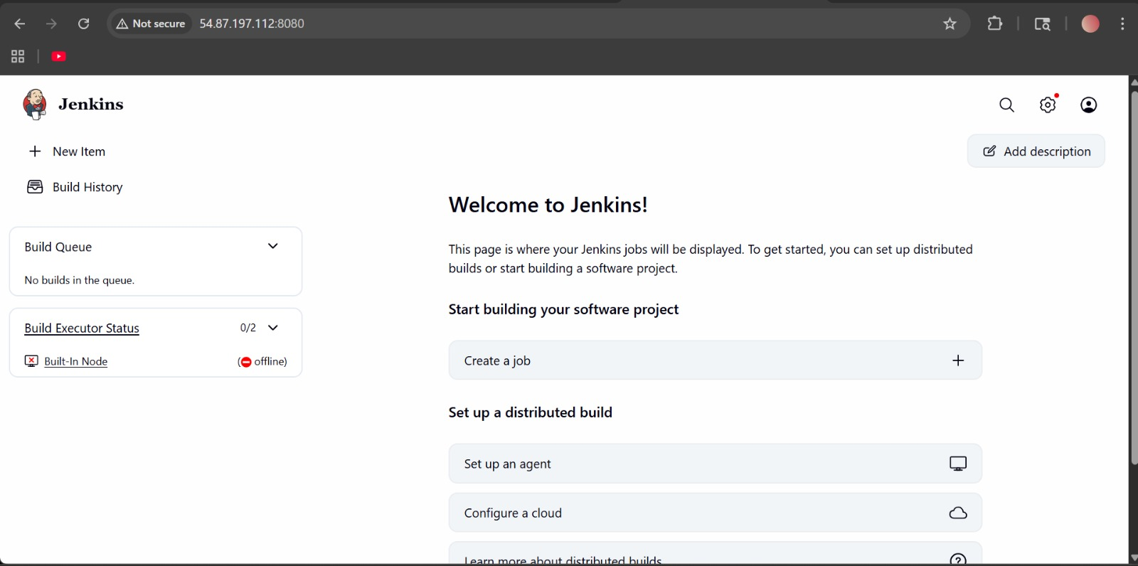

5. Create one Jenkins job to build and push the Docker image to Docker Hub.
Source: https://github.com/betawins/Python-app.git
Prerequisites
Make sure:
✔ Jenkins running (Docker or EC2)
✔ Docker installed inside Jenkins machine
✔ DockerHub account
✔ Git repo (your app)
Step 1: Install Required Tools in Jenkins
Go to Jenkins UI → Manage Jenkins → Plugins
Install:
- Docker Pipeline
- Git Plugin
Step 2: Add DockerHub Credentials
Go to:
Manage Jenkins → Credentials → Global → Add Credentials
Add:
- Username
- Password:
- ID: dockerhub-cred
Step 3: Create Jenkins Job
New Item → Pipeline → Name: docker-pipeline
Step 4: Add Jenkinsfile
Paste this :
pipeline {
agent any

environment {
DOCKERHUB_CREDENTIALS = credentials('dockerhub-cred')
IMAGE_NAME = 'abhinayreddy2000/python-app'
}

stages {
stage('Clone') {
steps {
git branch: 'main', url: 'https://github.com/betawins/Python-app.git'
}
}

stage('Build Docker Image') {
steps {
sh 'docker build -t $IMAGE_NAME:$BUILD_NUMBER .'
sh 'docker tag $IMAGE_NAME:$BUILD_NUMBER $IMAGE_NAME:latest'
}
}

stage('Login to Docker Hub') {
steps {
sh 'echo $DOCKERHUB_CREDENTIALS_PSW | docker login -u $DOCKERHUB_CREDENTIALS_USR --password-stdin'
}
}

stage('Push Docker Image') {
steps {
sh 'docker push $IMAGE_NAME:$BUILD_NUMBER'
sh 'docker push $IMAGE_NAME:latest'
}
}
}

post {
always {
sh 'docker logout || true'
}
success {
echo 'Docker image built and pushed successfully'
}
failure {
echo 'Pipeline failed'
}
}
}
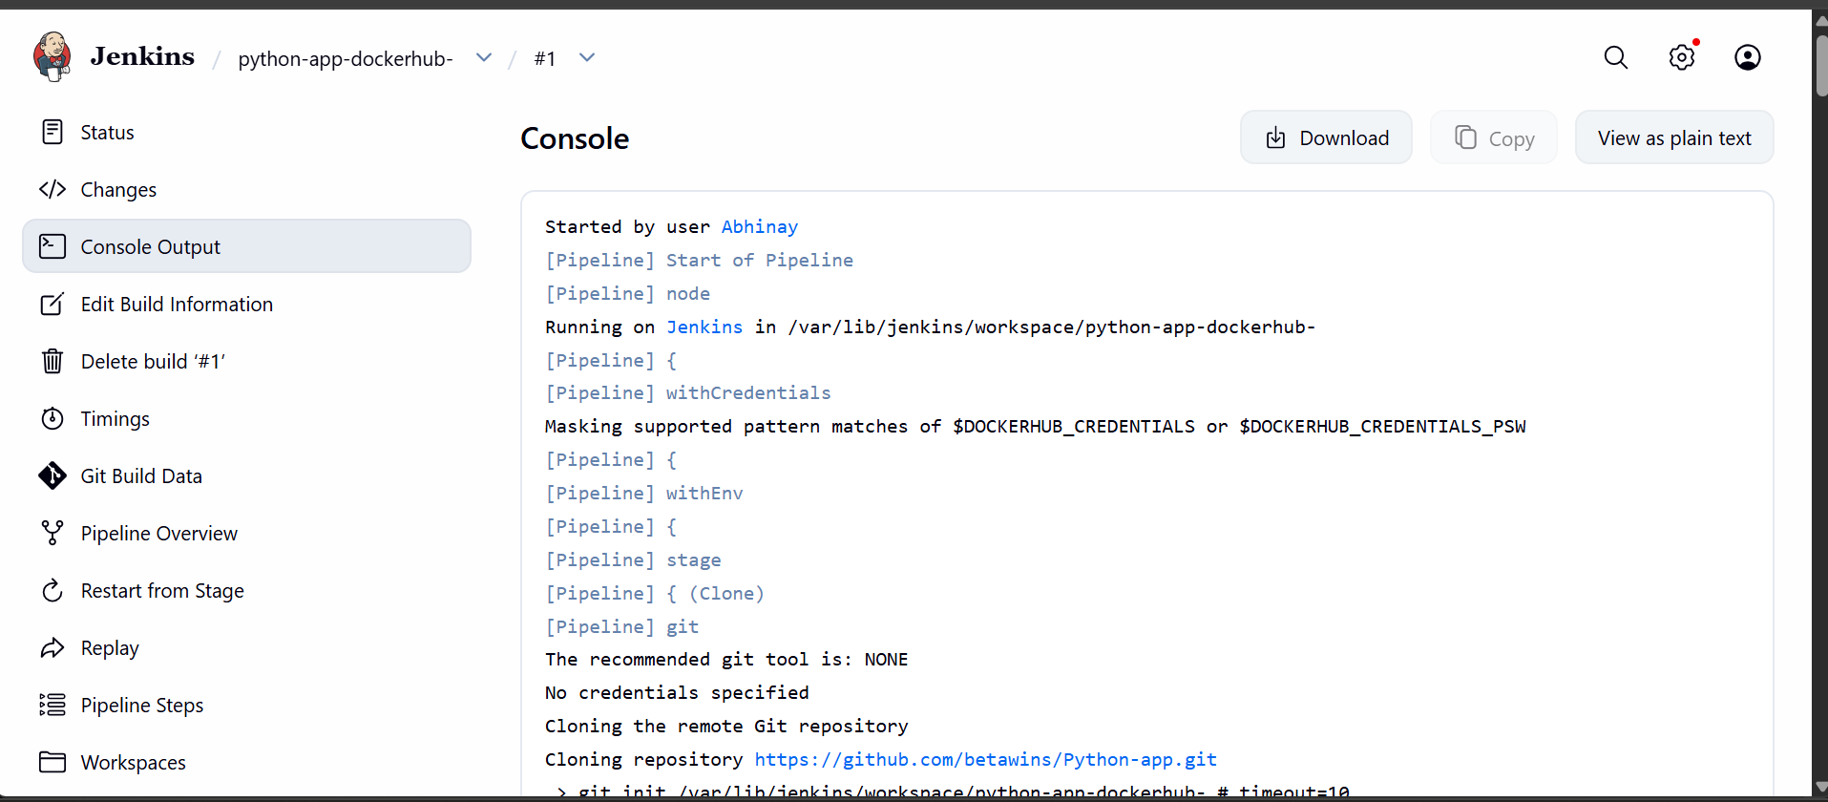

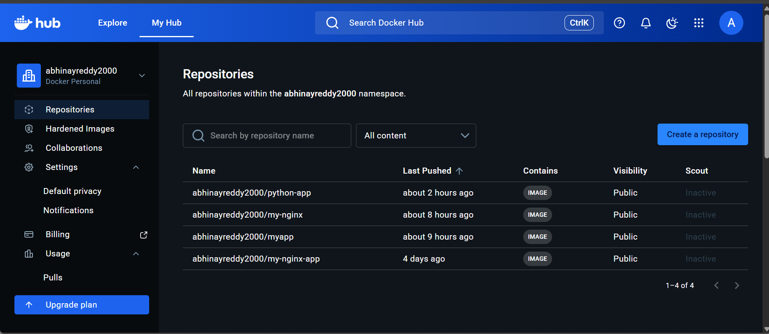

6. From the frontend source code, write a Dockerfile, build a Docker image, run it, and push that image to your Docker registry.
Source Codes: https://github.com/betawins/docker-tasks.git
1. Understand the Frontend App
From typical betawins/docker-tasks repo structure, the frontend is usually:
- HTML / React / Node-based UI
- Runs on a web server (like Nginx or Node)
We’ll assume:
- Static frontend (HTML/JS) OR React build

1.Git Clone
git clone https://github.com/betawins/docker-tasks.git
cd docker-tasks/Frontend_based_source
2. Write Dockerfile (Frontend)
vi Dockerfile
FROM nginx:alpine
COPY . /usr/share/nginx/html
EXPOSE 80
3. Build Docker Image
docker build -t abhinayreddy2000/frontend-app:latest .
4. Run Container
docker run -d -p 8081:80 --name frontend-container abhinayreddy2000/frontend-app:latest
5.Then push to Docker Hub
docker login
docker push abhinayreddy2000/frontend-app:latest

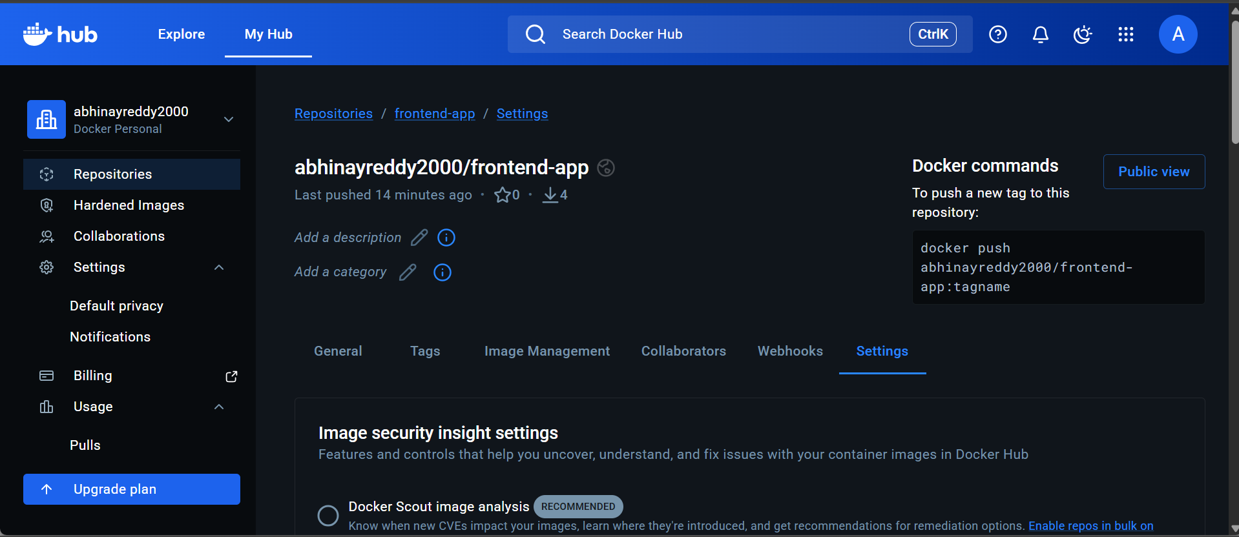
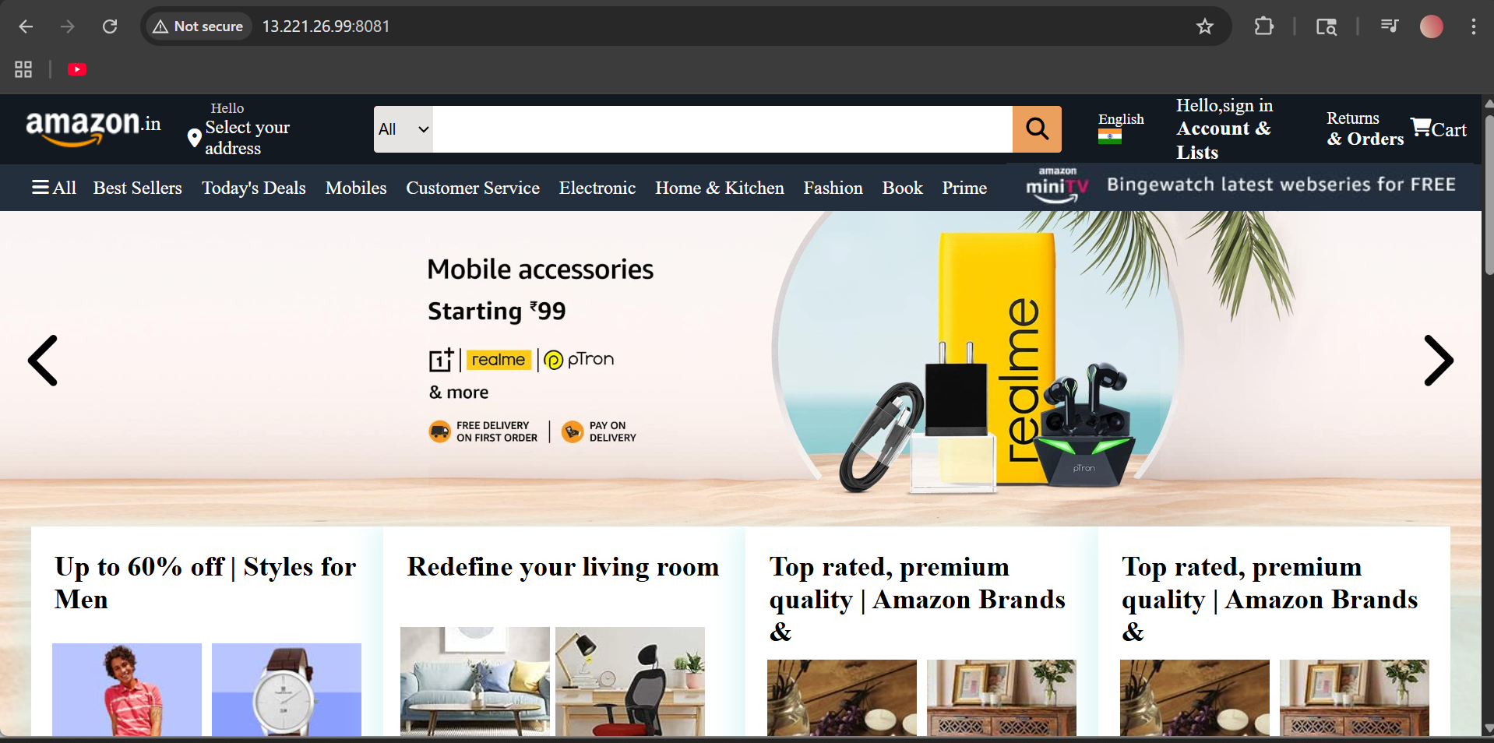

7. From the Java-based source code, write a Dockerfile, build, run, and push the image to the Docker registry.
Source Codes: https://github.com/betawins/docker-tasks.git
Step 1: Go to the Java source folder
From your docker-tasks folder, run:
cd ~/docker-tasks/Java_based_source
Step 2: Create the Dockerfile
Open the Dockerfile:
vi Dockerfile
Press i and paste this:
FROM maven:3.9.6-eclipse-temurin-11 AS build
WORKDIR /app
COPY pom.xml .
COPY src ./src
RUN mvn clean package -DskipTests
FROM eclipse-temurin:11-jre
WORKDIR /app
COPY --from=build /app/target/*.jar app.jar
EXPOSE 8080
ENTRYPOINT ["java", "-jar", "app.jar"]
Save and exit:
- Press Esc
- Type :wq
- Press Enter

Step 3: Build the Docker image
Run this in one line:
docker build -t abhinayreddy2000/java-app:latest .
Explanation:
- docker build = build image
- -t = give image name and tag
- abhinayreddy2000/java-app:latest = your Docker Hub repo name
- . = current folder as build context

Step 4: Verify the image was created
Run:
docker images
Look for:
abhinayreddy2000/java-app latest

Step 5: Run the Java container
This app exposes port 8080 inside the container, so map it to another free port on your server, for example 8082:
docker run -d --name java-container -p 8082:8080 abhinayreddy2000/java-app:latest
Explanation:
- -d = run in background
- --name java-container = container name
- -p 8082:8080 = host port 8082 → container port 8080

Step 6: Check whether container is running
docker ps
You should see java-container.

Step 7: Test the application
Open in browser:
http://<your-ec2-public-ip>:8082
Or test from terminal:
curl http://localhost:8082
If the app has a default Spring Boot page or endpoint, it should respond.

Step 9: Login to Docker Hub
docker login
Enter:
- Docker Hub username
- password or access token

Step 10: Push the image to Docker Hub
docker push abhinayreddy2000/java-app:latest

Step 11: Confirm the pushed image
You can check:
docker images
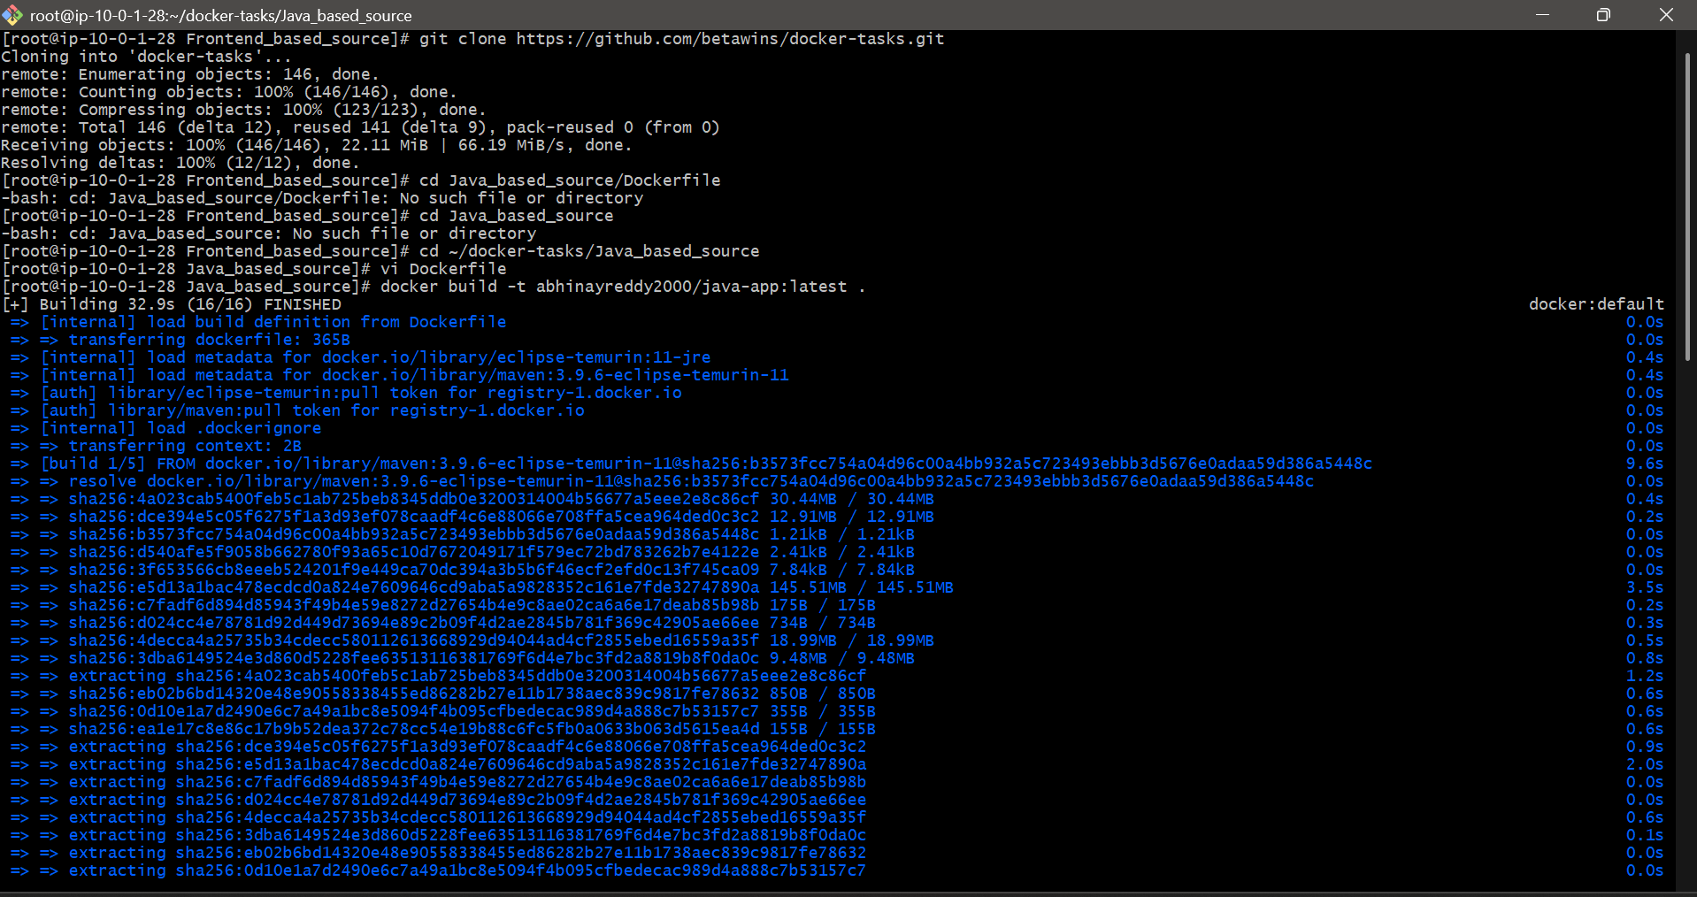
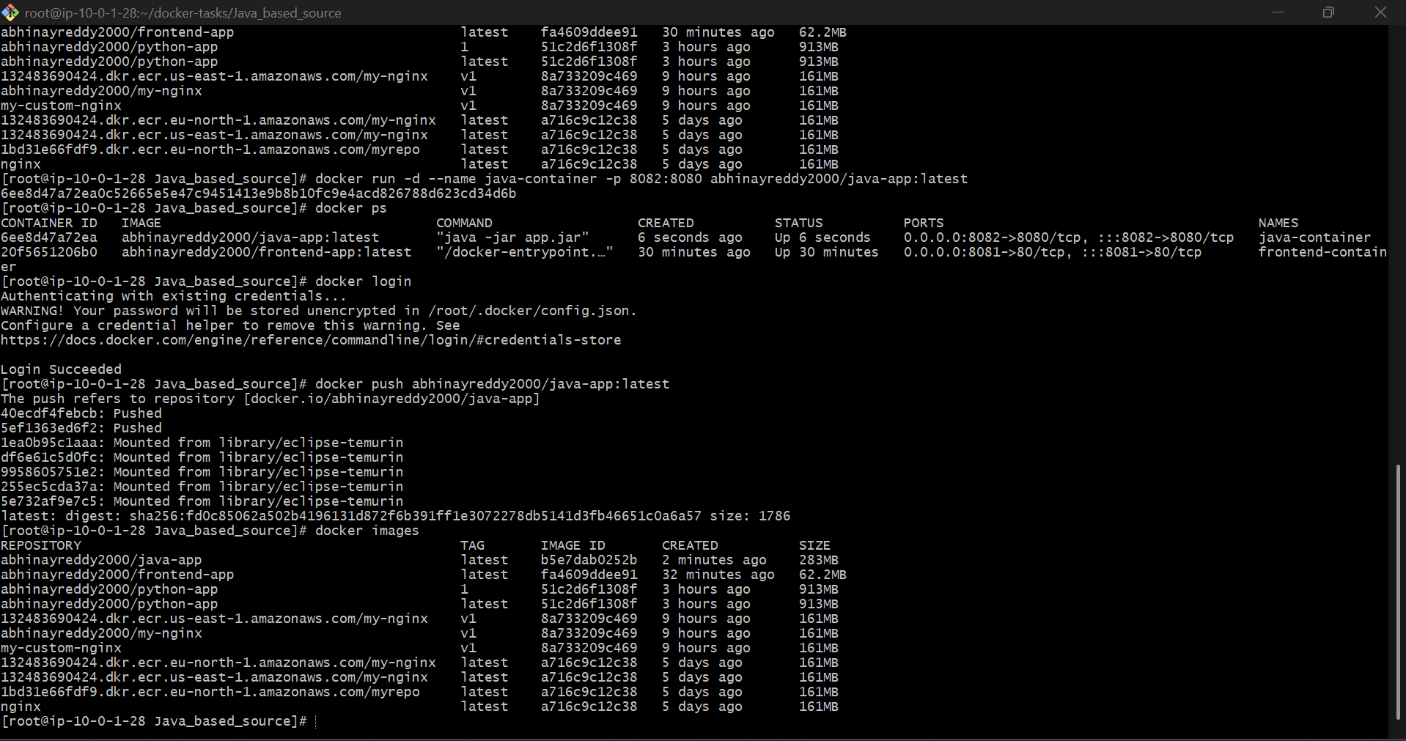
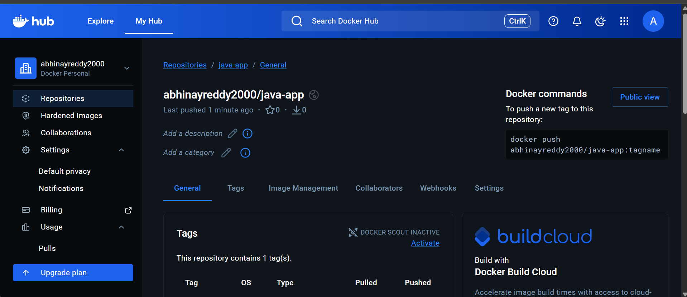
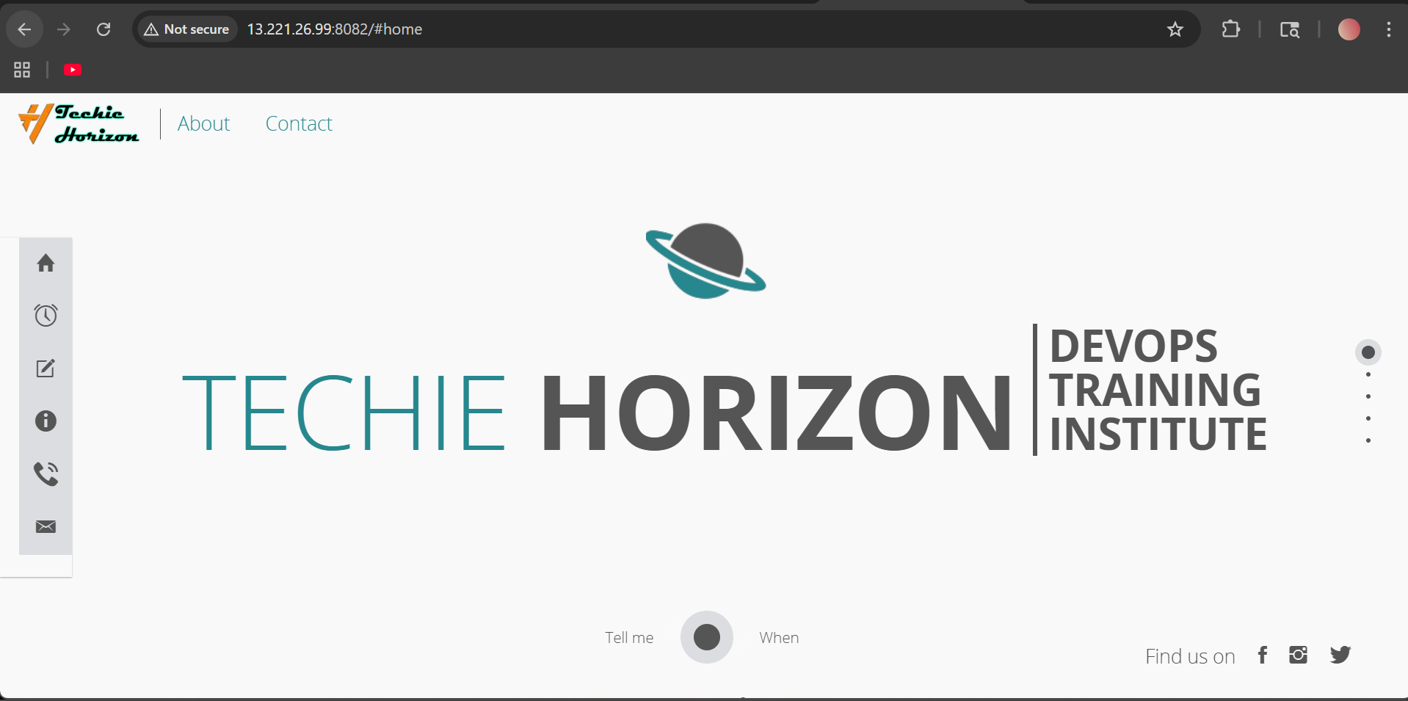
8. From the Node.js-based source code, write a Dockerfile, build with tag v1, run, and push it to the Docker registry.
Source Codes: https://github.com/betawins/docker-tasks.git
Step 1: Go to the Node.js source folder
From the docker-tasks folder, run:
cd ~/docker-tasks/NodeJs_based_source
If you are already inside docker-tasks, run:

Step 2: Create the Dockerfile
Open a Dockerfile:
vi Dockerfile
Press i and paste this:
FROM node:18-alpine AS build
WORKDIR /app
COPY package*.json ./
RUN npm install
COPY . .
RUN npm run build
FROM nginx:alpine
COPY --from=build /app/build /usr/share/nginx/html
EXPOSE 80
Save and exit:

Step 3: Verify the Dockerfile
Run:
cat Dockerfile
Make sure it looks correct.

Step 4: Build the Docker image with tag v1
Run this in one line:
docker build -t abhinayreddy2000/node-app:v1 .
Explanation:
- docker build = build image
- -t = tag the image
- abhinayreddy2000/node-app:v1 = image name and version tag
- . = current folder

Step 5: Check whether image was created
docker images
You should see something like:
abhinayreddy2000/node-app v1

Step 6: Run the container
This image uses Nginx inside the container on port 80, so map it to a free port on your server, for example 8083:
docker run -d --name node-container -p 8083:80 abhinayreddy2000/node-app:v1
Explanation:
- -d = run in background
- --name node-container = container name
- -p 8083:80 = host port 8083 maps to container port 80

Step 7: Check container is running
docker ps
You should see node-container in the list.

Step 8: Test the application
From browser:
http://<your-ec2-public-ip>:8083

Step 9: Login to Docker Hub
docker login
Enter your Docker Hub username and password or access token.

Step 10: Push the image
docker push abhinayreddy2000/node-app:v1

Step 11: Verify pushed image
Check your Docker Hub account and confirm that:
abhinayreddy2000/node-app:v1

step 12: Run the container
docker rm -f node-container
docker run -d --name node-container -p 8083:80 abhinayreddy2000/node-app:v1
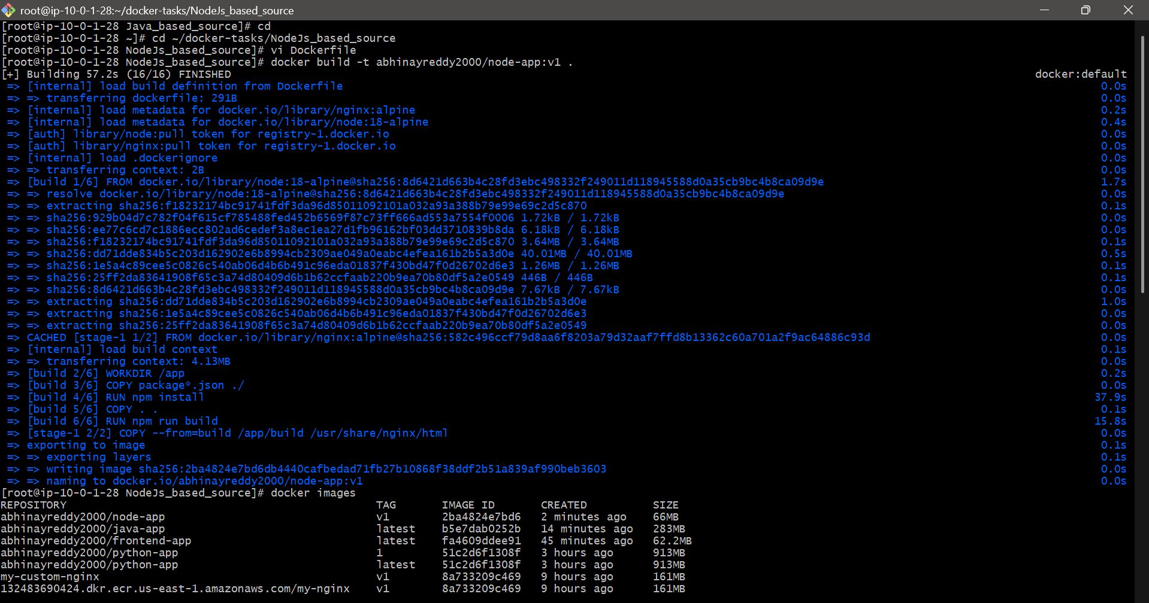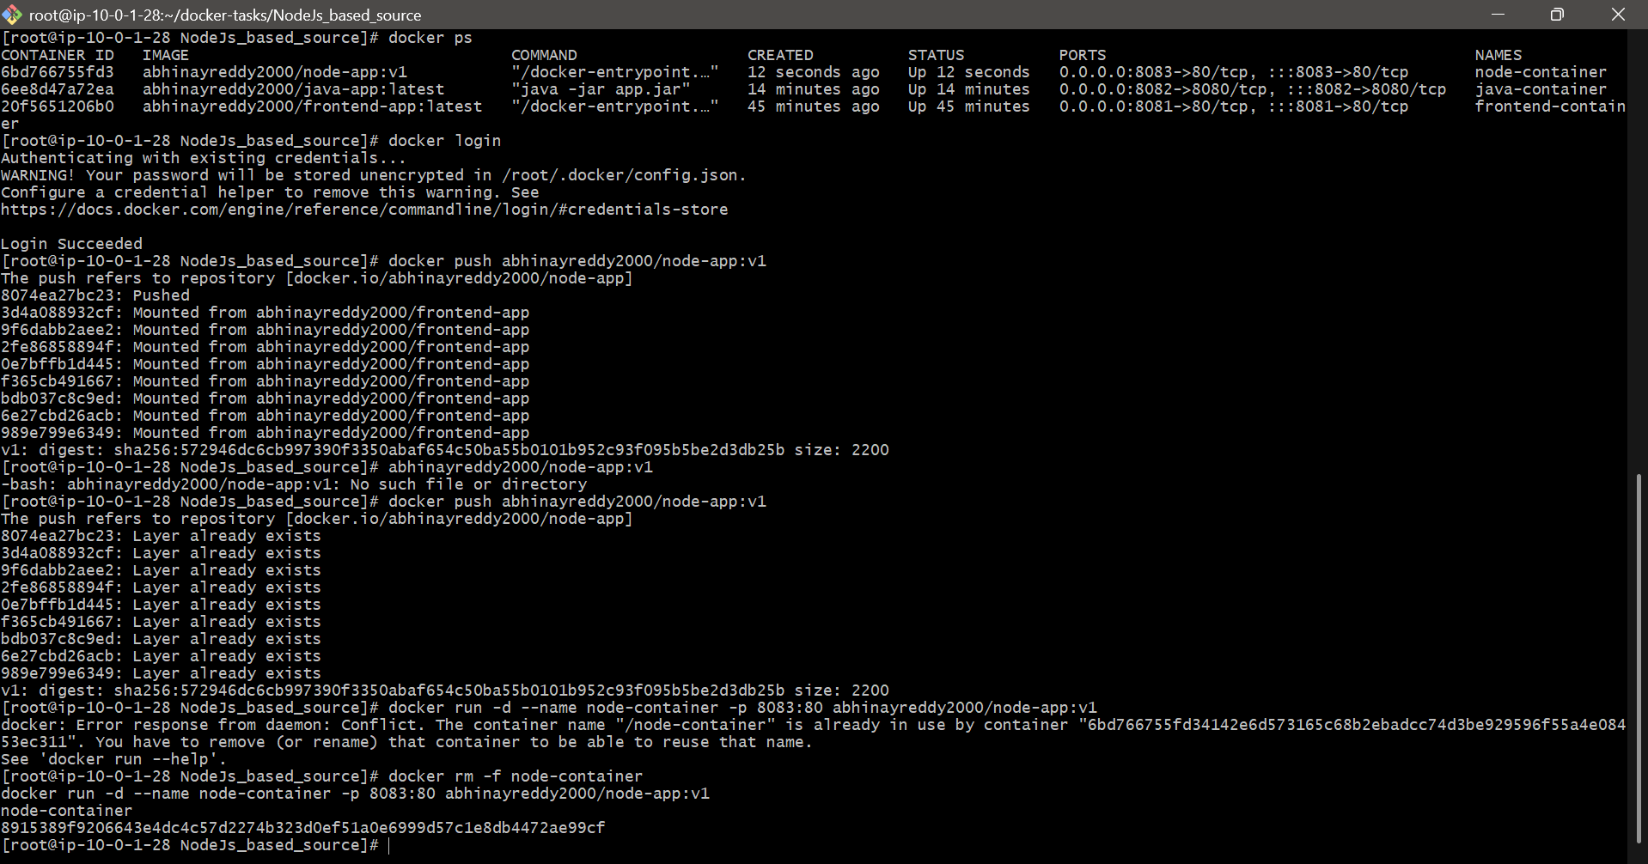
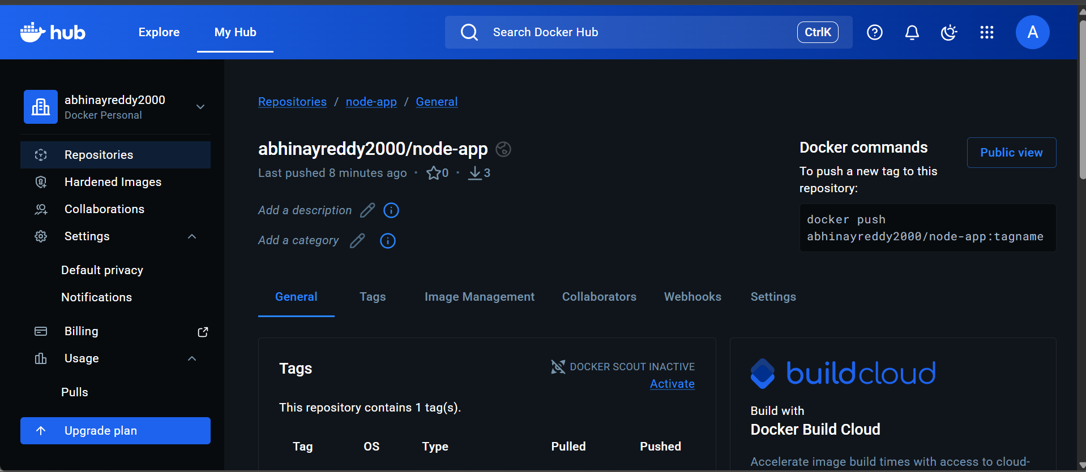



9. Write a docker-compose file to set up WordPress with a MySQL database.
1) Write Dockerfile
Create a file named docker-compose.yml:
vi docker-compose.yml
paste Here:
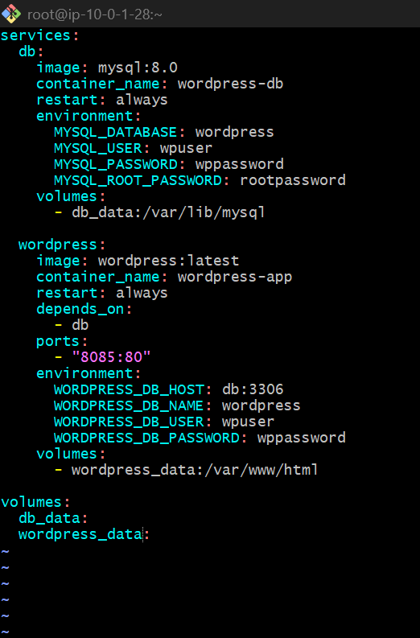
Then run
docker compose down
docker compose up -d
