1) Setup a virtual machine using Ubuntu image.
Step 1: Download Required Software
1. Install VirtualBox
- Go to: VirtualBox Download Page
- Download & install based on your OS (Windows/Linux)
2. Download Ubuntu ISO
- Go to: Ubuntu Download Page
- Download latest Ubuntu Desktop ISO

💻 Step 2: Create a Virtual Machine
Open VirtualBox → Click New
Fill details:
- Name: Ubuntu
- Type: Linux
- Version: Ubuntu (64-bit)

⚙️ Step 3: Allocate Resources
Memory (RAM)
- Minimum: 2 GB
- Recommended: 4 GB+
CPU
- 2 processors (recommended)

💾 Step 4: Create Virtual Hard Disk
- Select: VDI (VirtualBox Disk Image)
- Storage: Dynamically allocated
- Size: 20–30 GB

📀 Step 5: Attach Ubuntu ISO
- Select your VM → Click Settings
- Go to Storage
- Under “Controller IDE” → Click Empty → Choose ISO file
- Attach downloaded Ubuntu ISO

▶️ Step 6: Start the VM
- Click Start
- Ubuntu installer will open

🧑‍💻 Step 7: Install Ubuntu
Follow installer:
- Choose Install Ubuntu
- Select keyboard & language
- Choose Normal Installation
- Select Erase disk and install Ubuntu (safe inside VM)
- Set:
  - Username
  - Password

🚀 Step 8: Finish Setup
- Installation completes → Restart VM
- Remove ISO when prompted
- Ubuntu will boot normally
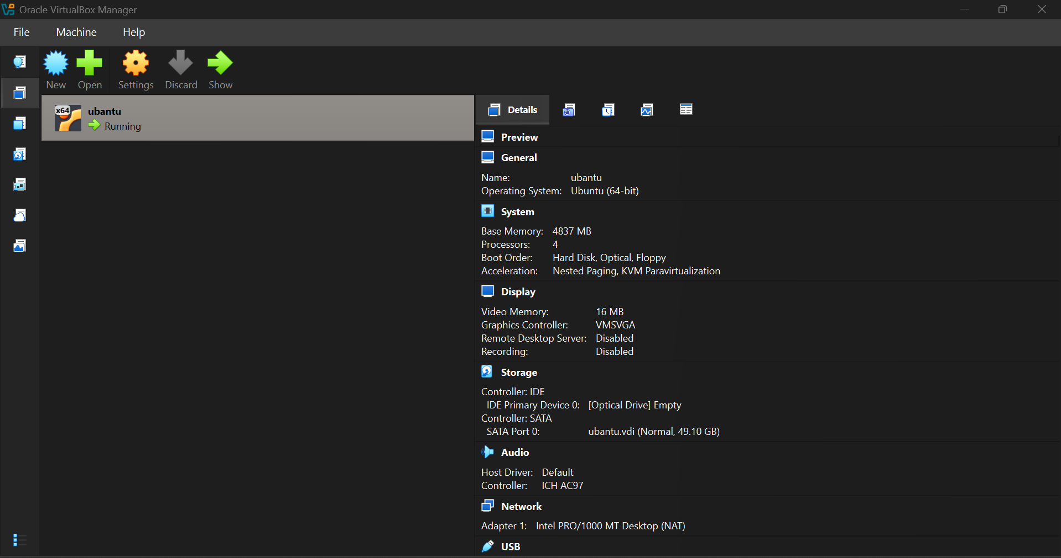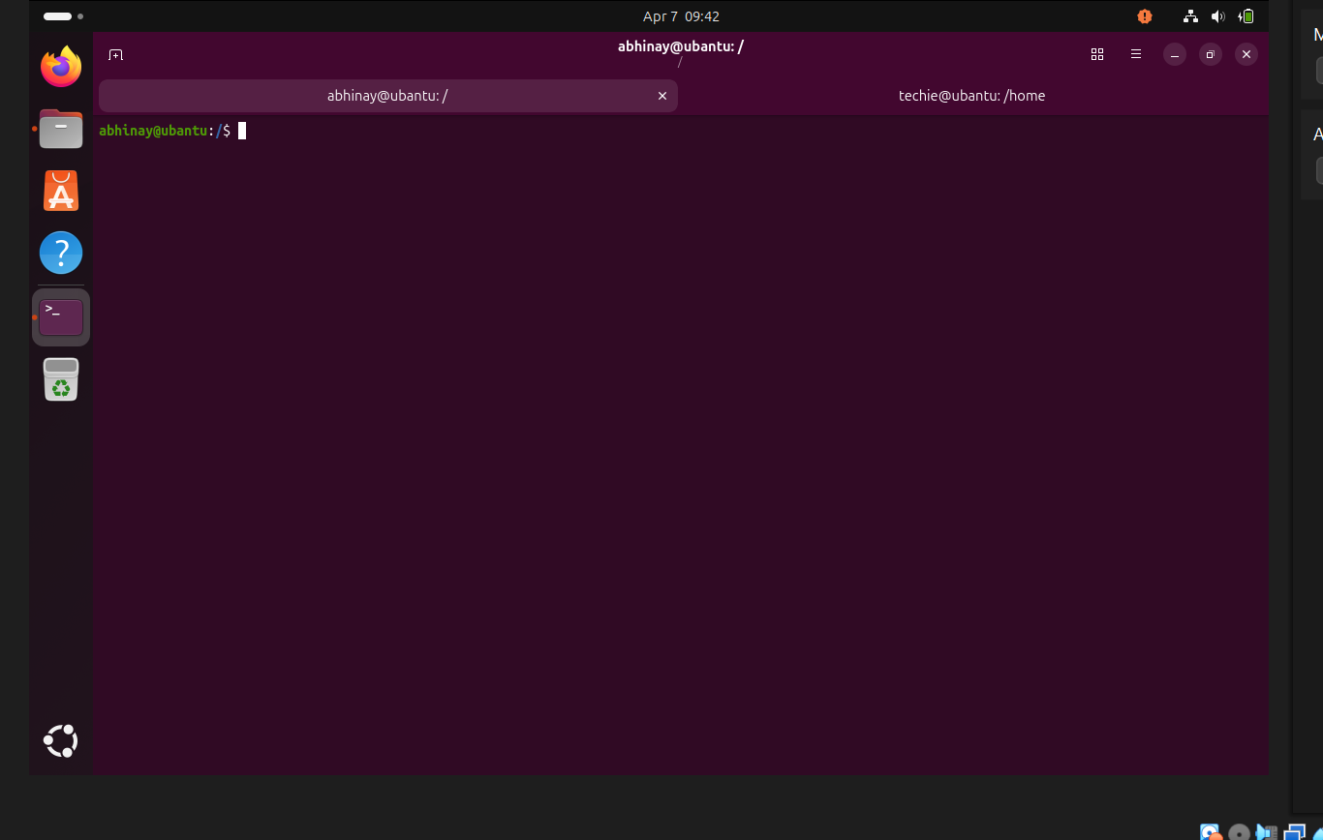

2) Install docker on ec2.
Install Docker on EC2
Step 1: Launch EC2 Instance
- Go to AWS Console
- Launch instance:
  - OS: Amazon Linux 2 (recommended) OR Ubuntu
  - Instance type: t2.micro (free tier)
  - Allow ports:
    - 22 (SSH)
    - 8080 / 80 (optional for apps)

🔐 Step 2: Connect to EC2
Use SSH:
ssh -i "jenkins.pem" ec2-user@34.207.251.66
🐳 Install Docker (Amazon Linux 2)
Step 3: Update system
sudo yum update -y
Step 4: Install Docker
sudo yum install docker -y
Step 5: Start Docker
sudo systemctl start docker
Step 6: Enable Docker (auto-start)
sudo systemctl enable docker
Step 7: Add user to Docker group (avoid sudo)
sudo usermod -aG docker ec2-user
👉 Then logout & login again:
exit
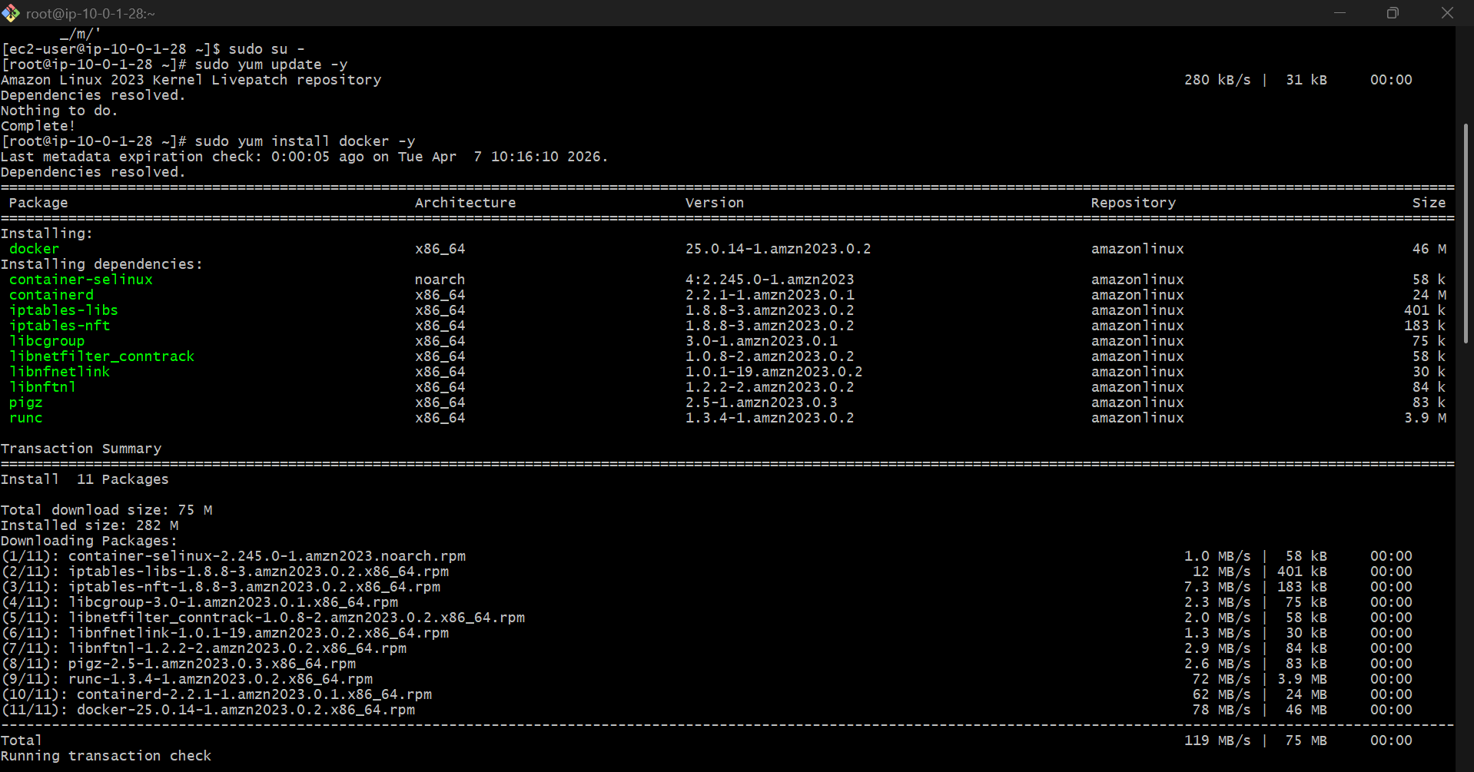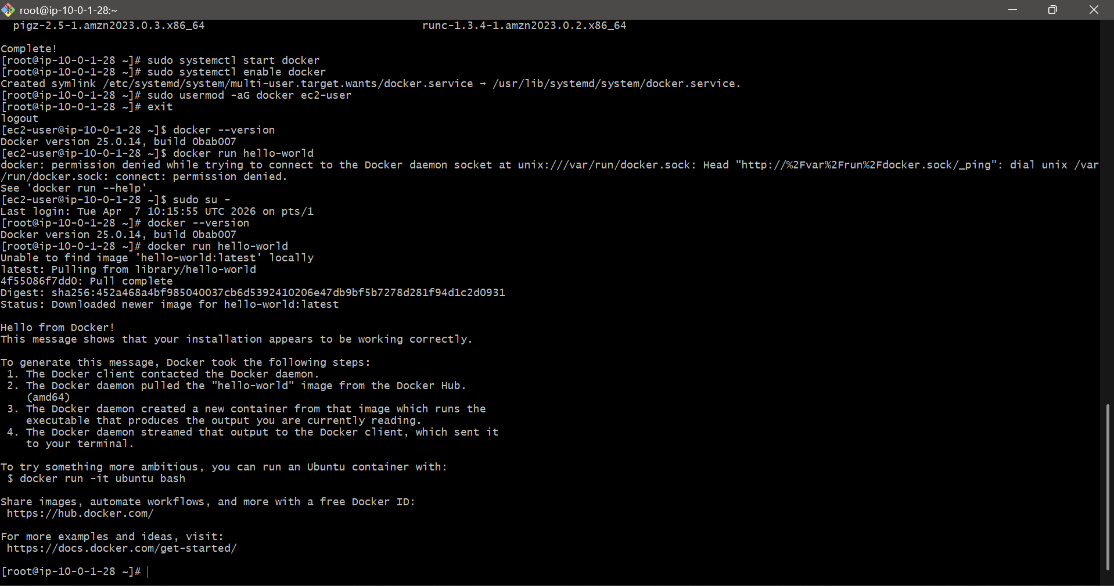

3) Pull 5 docker images.(nginx,apache tomcat,ubuntu,jenkins,sonarqube)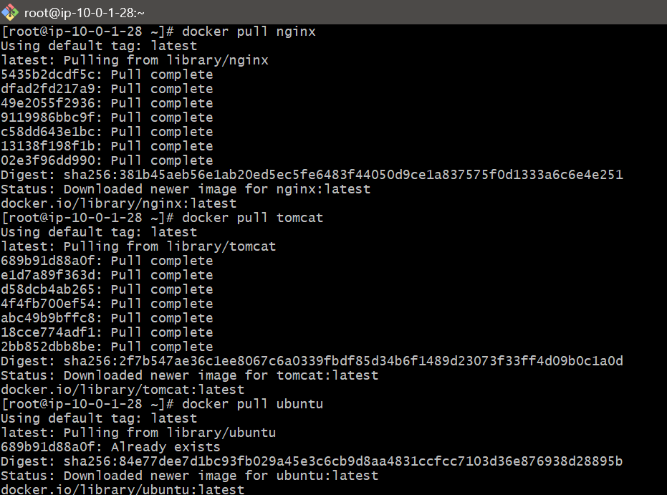 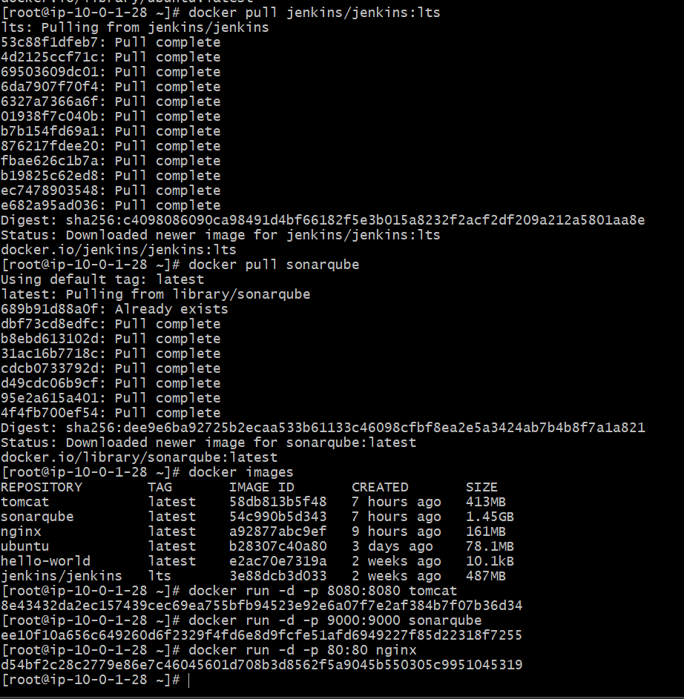

4) Run nginx container and expose on port 81.
Run Nginx Container on Port 81
✅ Command to Run
docker run -d -p 81:80 --name nginx-container nginx

🔍 Explanation
- -d → Run in background
- -p 81:80 →
  - 81 (EC2 port) → 80 (Nginx inside container)
- --name nginx-container → Container name
- nginx → Image

✅ Verify Container
docker ps
👉 You should see nginx running

🌐 Access in Browser
Open:
http:// 34.207.251.66:81
👉 You should see the Nginx welcome page 🎉
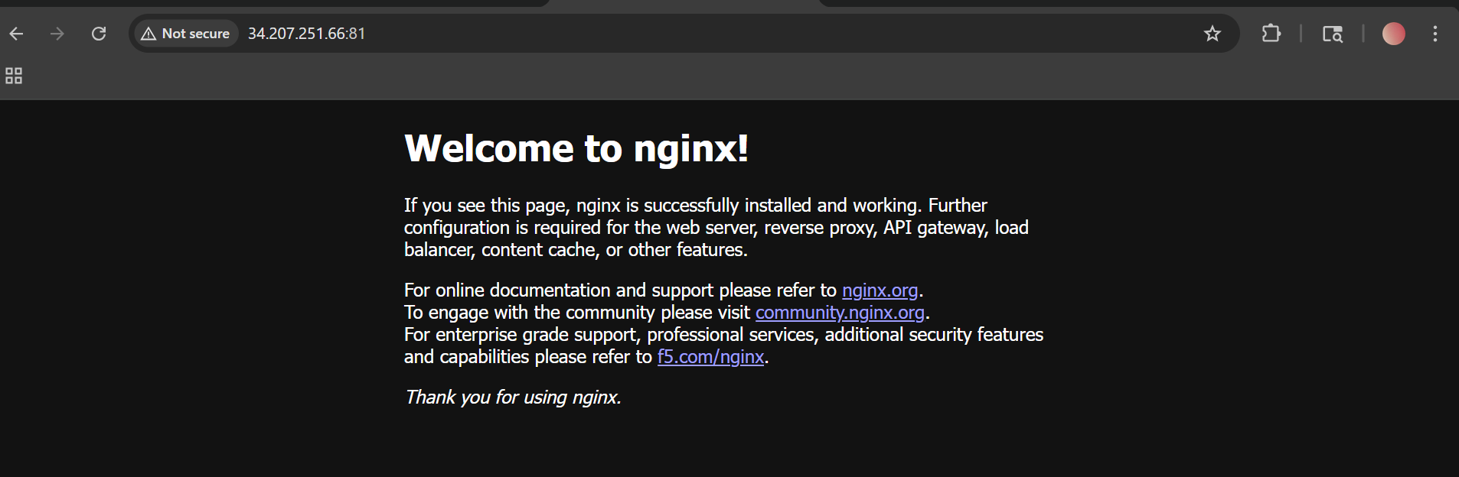

5) Delete the apache tomcat image from local.
Delete Tomcat Image
✅ Step 1: Check images
docker images
👉 Look for:
tomcat

❌ Step 2: Remove the image
docker rmi tomcat

⚠️ If You Get Error (Very Common)
❌ Error:
image is being used by running container
👉 Fix:
Step 1: Stop container
docker ps
docker stop <container-id>
Step 2: Remove container
docker rm <container-id>
Step 3: Remove image again
docker rmi tomcat

💣 Force Delete (Shortcut)
If you want direct removal:
docker rmi -f tomcat

🔍 Verify Deletion
docker images
👉 Tomcat should not appear anymore
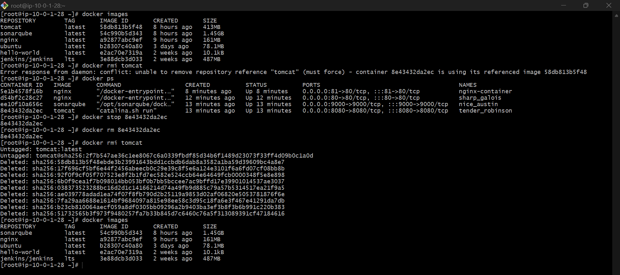
6) Inspect the jenkins image,sonarqube image.
Inspect Jenkins Image
✅ Command
docker inspect jenkins/jenkins:lts

📌 Important Fields You’ll See
- Id → Unique image ID
- RepoTags → Image name & version
- Created → When image was built
- Config:
  - ExposedPorts → Ports used (e.g., 8080)
  - Env → Environment variables
  - Cmd → Default startup command
- Env variables → DB configs etc.
- Entrypoint → How container starts

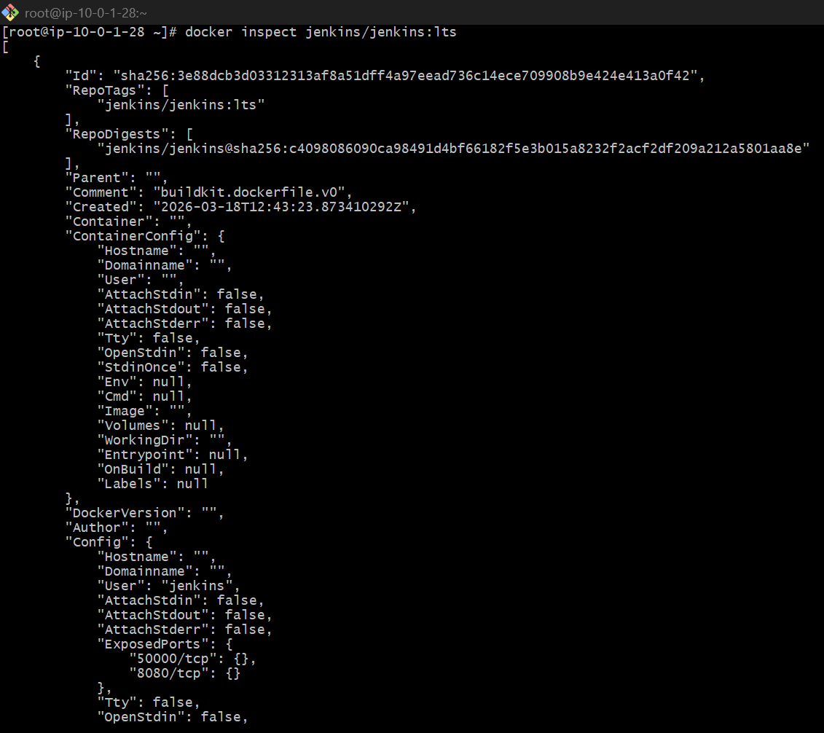
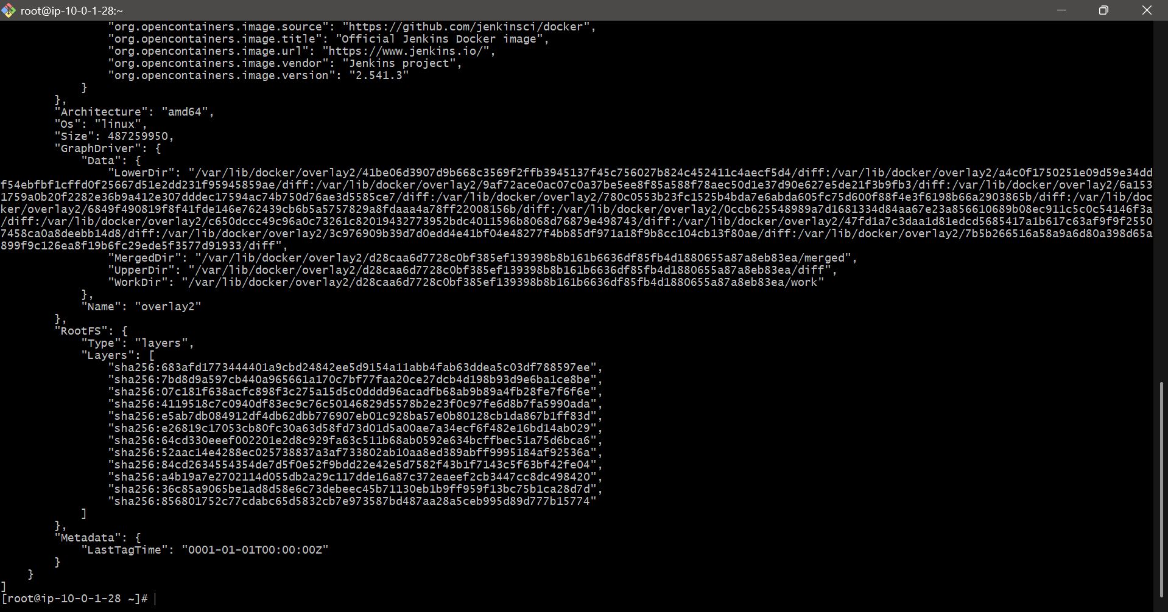

Inspect SonarQube Image
✅ Command
docker inspect sonarqube

📌 Important Fields
- ExposedPorts → Usually 9000
- Volumes → Data storage paths
- Env variables → DB configs etc.
- Entrypoint → How container starts
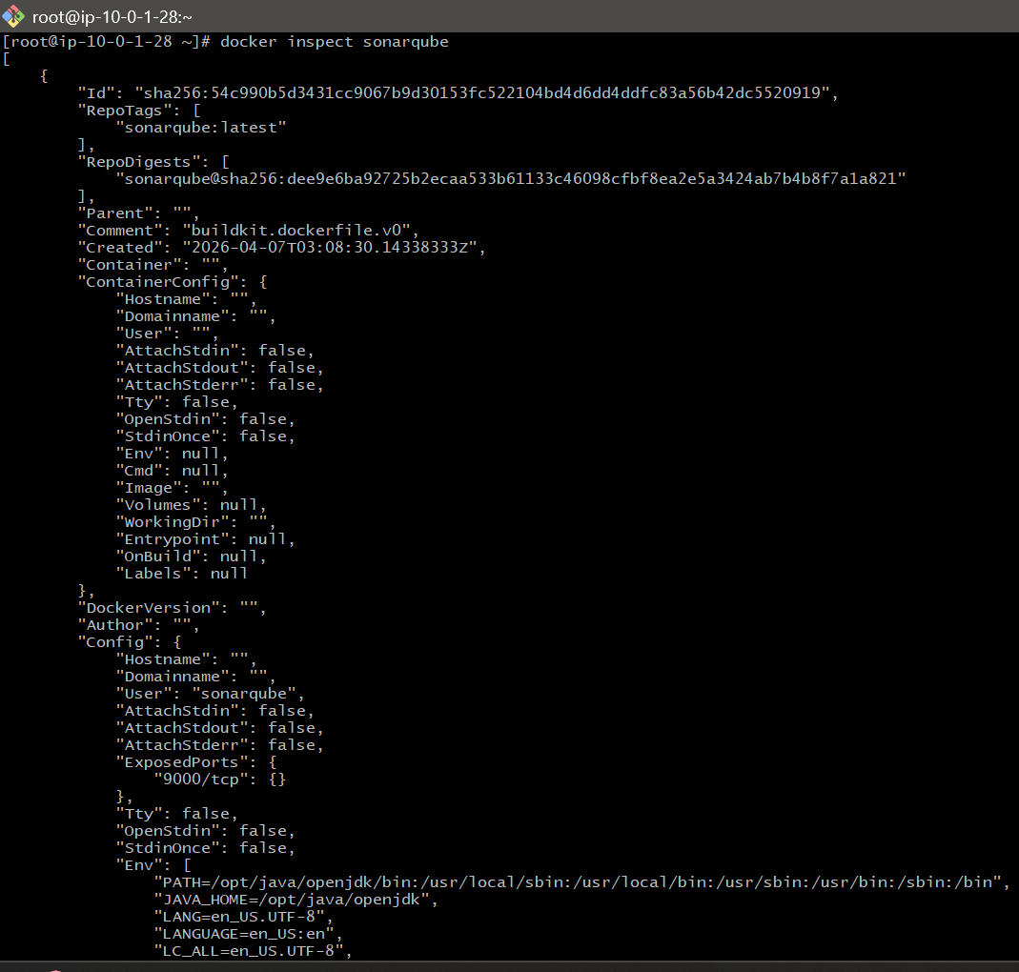

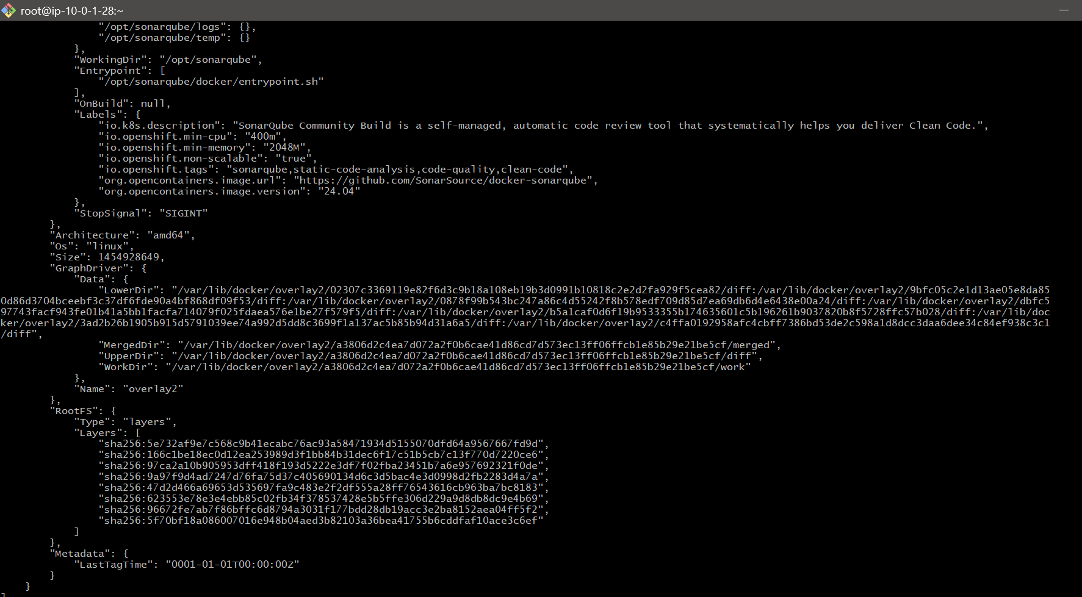

7) Run jenkins contianer and run one sample job.
Step 1: Run Jenkins Container
docker run -d \
--name jenkins-container \
-p 8080:8080 \
-p 50000:50000 \
jenkins/jenkins:lts

🔍 Verify
docker ps

🔑 Step 2: Get Jenkins Initial Password
docker exec jenkins-container cat /var/jenkins_home/secrets/initialAdminPassword
👉 Copy this password

🌐 Step 3: Open Jenkins in Browser
http:// 34.207.251.66:8080
👉 Paste password → Click Continue

⚙️ Step 4: Setup Jenkins
- Click Install Suggested Plugins
- Create:
  - Username
  - Password

Step 5: Create Sample Job
👉 Create Freestyle Job
- Click New Item
- Enter name: sample-job
- Select Freestyle Project
- Click OK

🔧 Add Build Step
Scroll → Build Steps → Execute Shell
Add:
echo "Hello Jenkins!"
date
Click Save

▶️ Step 6: Run Job
- Click Build Now
- Click build → Console Output
👉 You will see:
