- Create a tomcat container on 8080 and deploy sample application in tomcat.
Step 1: Pull Tomcat Image
docker pull tomcat:9

Step 2: Run Tomcat Container on Port 8080
docker run -d -p 8080:8080 --name tomcat-container tomcat:9
👉 What happens here:
- -d → run in background
- -p 8080:8080 → host port → container port
- --name → container name

Step 3: Verify Container Running
docker ps
👉 Open browser:
http:// 98.88.76.238: 8080
You should see Tomcat default page

Step 4: Get Sample WAR File
You can download a sample WAR (example app):
Wget https://tomcat.apache.org/tomcat-7.0-doc/appdev/sample/sample.war

Step 5: Deploy WAR into Tomcat Container
docker cp sample.war tomcat-container:/usr/local/tomcat/webapps/
👉 This copies your app into Tomcat deployment folder

Step 6: Access Your Application
After few seconds, open:
http:// 98.88.76.238:8080/sample
✅ Your application will be running

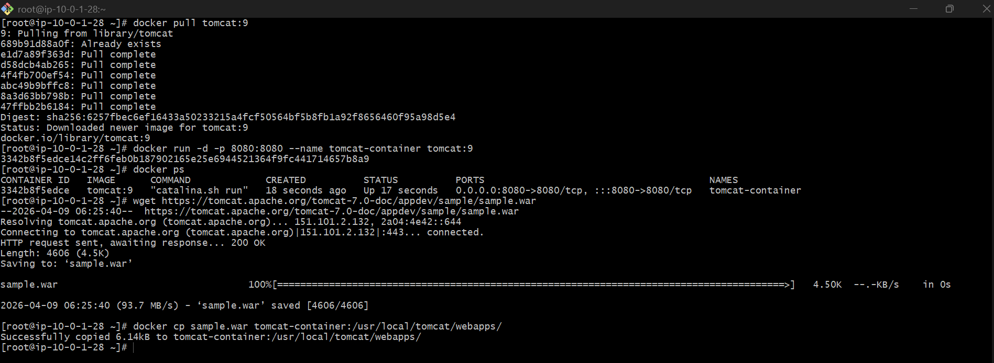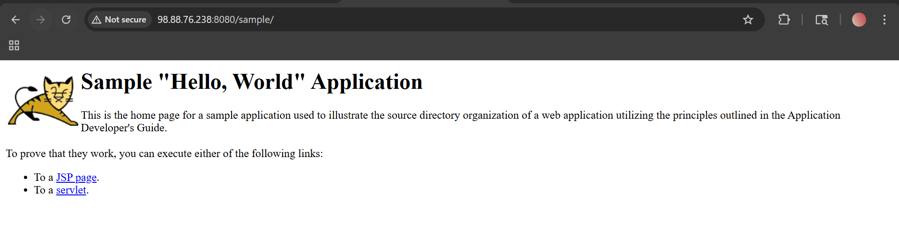

- Create volume and deploy tomcat container on port 8081.

Step 1: Create a Docker Volume
docker volume create tomcat-data
👉 This creates a persistent storage named tomcat-data

Step 2: Run Tomcat Container with Volume on Port 8081
docker run -d -p 8081:8080 \
--name tomcat-volume-container \
-v tomcat-data:/usr/local/tomcat/webapps \
tomcat:9
👉 Explanation:
- -p 8081:8080 → access Tomcat on port 8081
- -v tomcat-data:/usr/local/tomcat/webapps → mount volume to deploy apps
- /usr/local/tomcat/webapps → Tomcat deployment folder

Step 3: Verify Container
docker ps

Step 4: Deploy Sample WAR into Volume
Option 1: Copy WAR into container
docker cp sample.war tomcat-volume-container:/usr/local/tomcat/webapps/

Option 2 (Better): Use volume directly
Find volume location:
docker volume inspect tomcat-data
👉 Go to that path and copy WAR:
cp sample.war <volume-path>/_data/

Step 5: Access Application
Open browser:
http:// 98.88.76.238:8081/sample
✅ Your app will be running on port 8081

🧠 Important Concept (VERY IMPORTANT)
👉 Why use volume?
Without volume:
- If container is deleted → data is lost ❌
With volume:
- Data stays safe even if container is removed ✅
👉 Think like:
- Container = temporary
- Volume = permanent storage
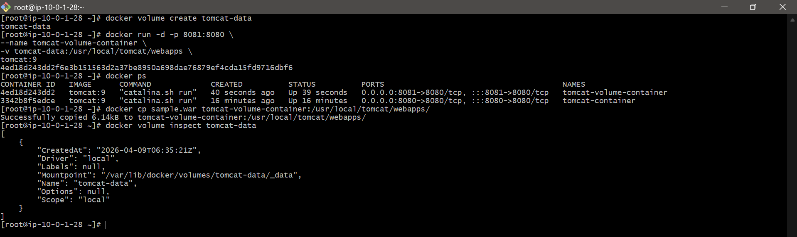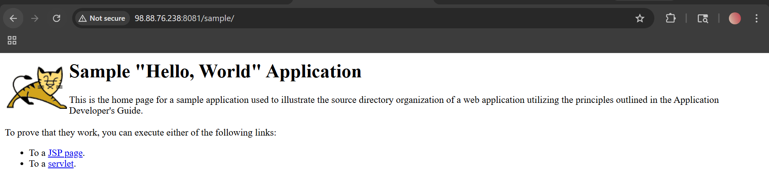

- Limit the nginx container to 500 MB.

Step 1: Pull Nginx Image (if not already)
docker pull nginx

Step 2: Run Nginx Container with Memory Limit
docker run -d -p 80:80 \
--name nginx-limited \
--memory="500m" \
nginx

🧠 Explanation (Important)
👉 --memory="500m"
- Limits container RAM usage to 500 MB
- Prevents container from consuming more system memory
👉 If container exceeds:
- It may be killed (OOM - Out Of Memory)

🚀 Step 3: Verify Memory Limit
docker inspect nginx-limited
or
docker inspect nginx-limited | grep Memory
Look for:
"Memory": 524288000
👉 (500 MB in bytes)
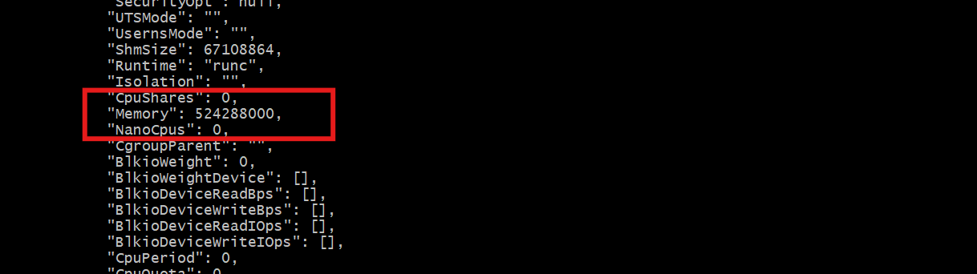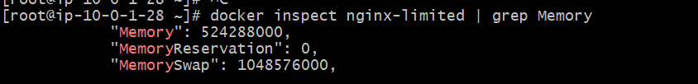

🚀 Step 4: Check Running Container
docker stats
👉 Shows real-time memory usage
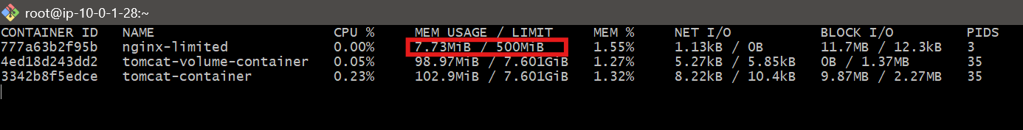

4. Create a sample docker file using below instructions.
- Base module as amazonlinux:latest
- Maintainer you name
- Install nginx
- COPY one index.html file to image
- Expose on port 80

STEP 1: Create a folder
In your EC2 or Linux system:
mkdir my-nginx-project
cd my-nginx-project

STEP 2: Create index.html
nano index.html
Paste this:
<!DOCTYPE html>
<html>
<head>
<title>My Docker App</title>
</head>
<body>
<h1>Hello Abhinay </h1>
<p>Nginx is working!</p>
</body>
</html>
👉 Save:
- Press Ctrl + X
- Press Y
- Press Enter

STEP 3: Create Dockerfile
nano Dockerfile
Paste this:
FROM amazonlinux:latest
LABEL maintainer="Abhinay"
RUN yum update -y && \
yum install -y nginx && \
yum clean all
COPY index.html /usr/share/nginx/html/
EXPOSE 80
CMD ["nginx", "-g", "daemon off;"]
👉 Save same way (Ctrl + X → Y → Enter)

STEP 4: Build Docker Image
docker build -t my-nginx-app .
👉 This creates your custom image

STEP 5: Run Container
docker run -d -p 80:80 --name nginx-app my-nginx-app

STEP 6: Open in Browser
👉 If using EC2:
http:// 98.88.76.238:80
👉 You should see:
Hello Abhinay Reddy
Nginx is working!
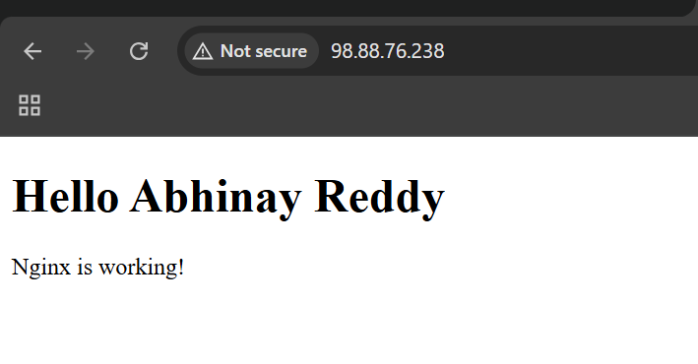

Push Image to Docker Hub.
Step 1: Login to Docker Hub
docker login
👉 Enter:
- Username: abhinayreddy2000
- Password: your-password

Step 2: Check your image
docker images
👉 You should see:
my-nginx-app latest

Step 3: Tag the image
👉 command:
docker tag my-nginx-app abhinayreddy2000/my-nginx-app
Step 4: Push the image
docker push abhinayreddy2000/my-nginx-app
👉 Output should show:
- Pushed
- digest
That means SUCCESS

Step 5: Verify in Docker Hub
Go to 👉 Docker Hub
👉 Login → Repositories → Check:
abhinayreddy2000/my-nginx-app

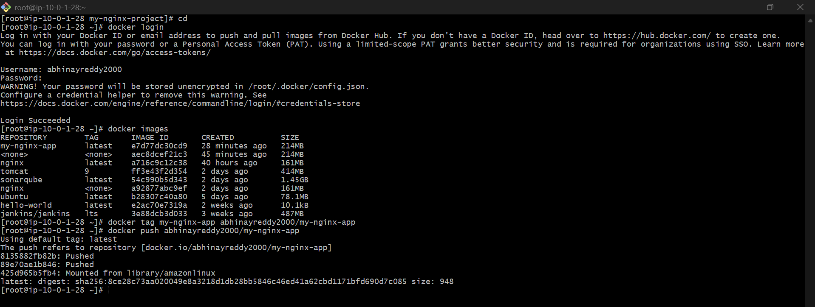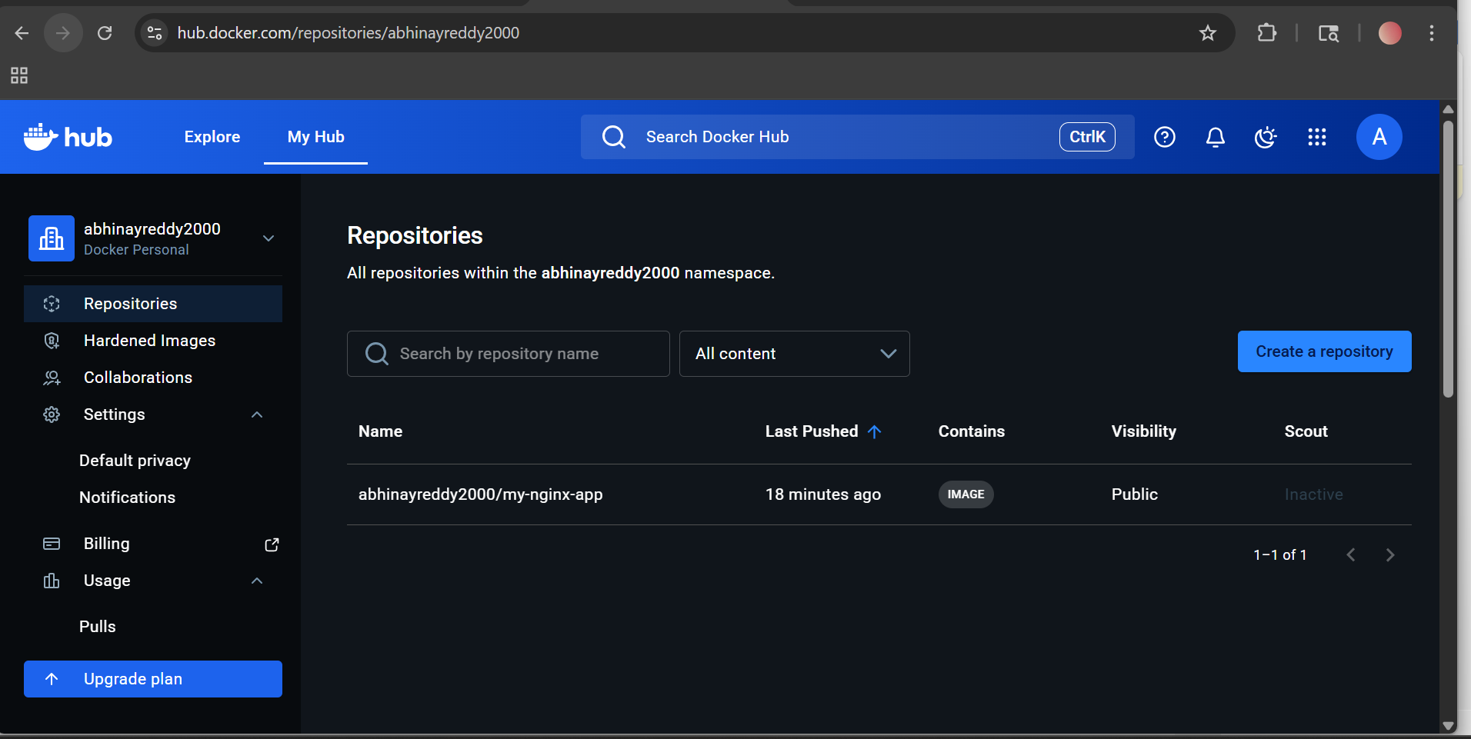

push image to AWS ECR
Step 1: Install AWS CLI (if not installed)
yum install aws-cli -y
Check:
aws --version

Step 2: Configure AWS CLI
aws configure
Enter your details:
AWS Access Key ID: XXXXX
AWS Secret Access Key: XXXXX
Region: us-east-1
Output: json

Step 3: Create ECR Repository
Go to 👉 AWS ECR Console
👉 Click:
- Create repository
- Name: my-nginx-app
- Create

Step 4: Login to AWS ECR
aws ecr get-login-password --region us-east-1 | \
docker login --username AWS --password-stdin 132483690424.dkr.ecr.us-east-1.amazonaws.com

Step 5: Tag your image for ECR
docker tag my-nginx-app 132483690424.dkr.ecr.us-east-1.amazonaws.com/my-nginx-app:latest
Step 6: Push image to ECR
docker push 132483690424.dkr.ecr.us-east-1.amazonaws.com/my-nginx-app:latest

Step 7: Verify
👉 Go to ECR console → your repo → Images tab
👉 You will see your image ✅

