- Create a image from running container.

1. Check running containers
docker ps
👉 This gives you the Container ID or Container Name
2. Check all containers (including stopped ones)
docker ps -a
3. If container exists (stopped)
Start it:
docker start <container_name>
docker start nginx-app
4. Create image from container
docker commit <container_id> <new_image_name>
docker commit nginx-app my-nginx-image:v1
5. Verify
docker images
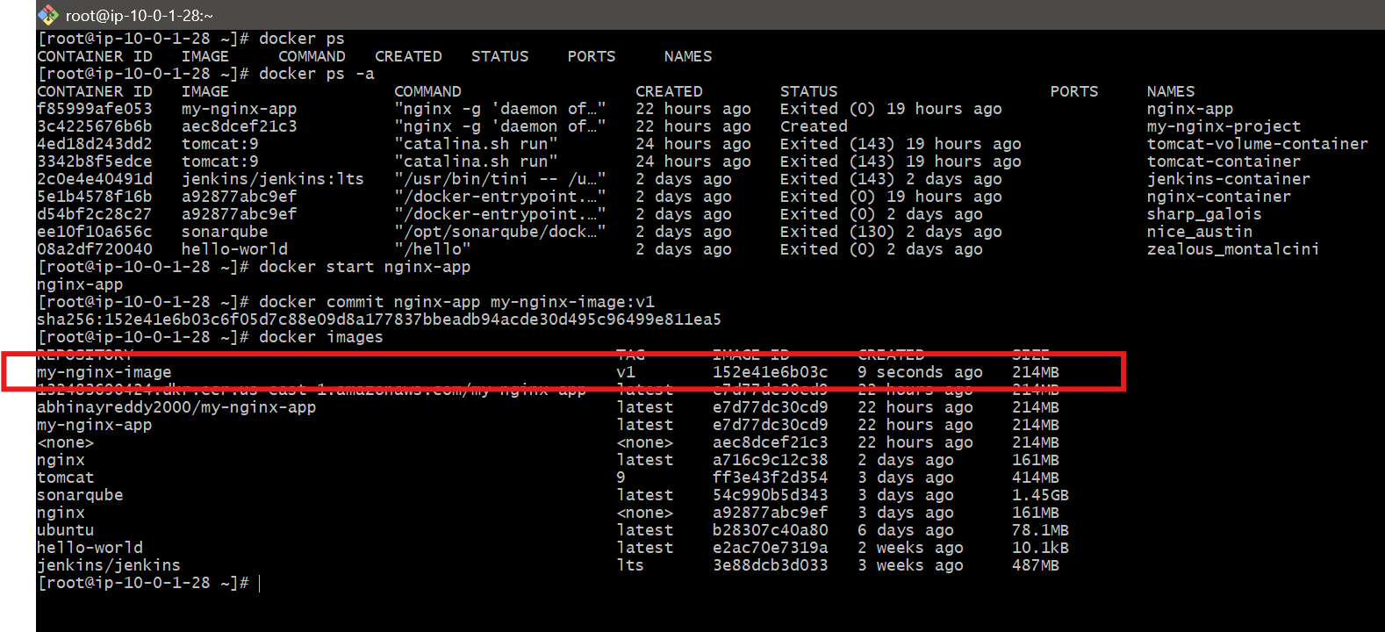

2. Copy image from local machine to docker server and load the image
Step 1: Check Image on Local Machine
docker images
Example:
nginx latest

Step 2: Save Docker Image as TAR File
docker save -o my-image.tar nginx:latest
Explanation
- docker save → exports image
- -o my-image.tar → output file
- nginx:latest → image name

Step 3: Verify TAR File
ls
Output:
my-image.tar

Step 4: Secure Copy File to Server
chmod 400 jenkins.pem
scp -i jenkins.pem my-image.tar ec2-user@54.90.135.47:/home/ec2-user/
Explanation
- scp → copy file securely
- -i jenkins.pem → authentication key
- destination → EC2 server

Step 5: Login to Docker Server
ssh -i jenkins.pem ec2-user@54.90.135.47

Step 6: Load Image into Docker
docker load -i my-image.tar
Explanation
- docker load → imports image
- -i → input file

Step 7: Verify Image on Server
docker images
Output:
nginx latest
Step 8: Run Container on Server
docker run -d -p 80:80 --name nginx-app nginx:latest

🌐 Step 9: Access Application
Open browser:
http://54.90.135.47

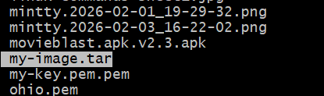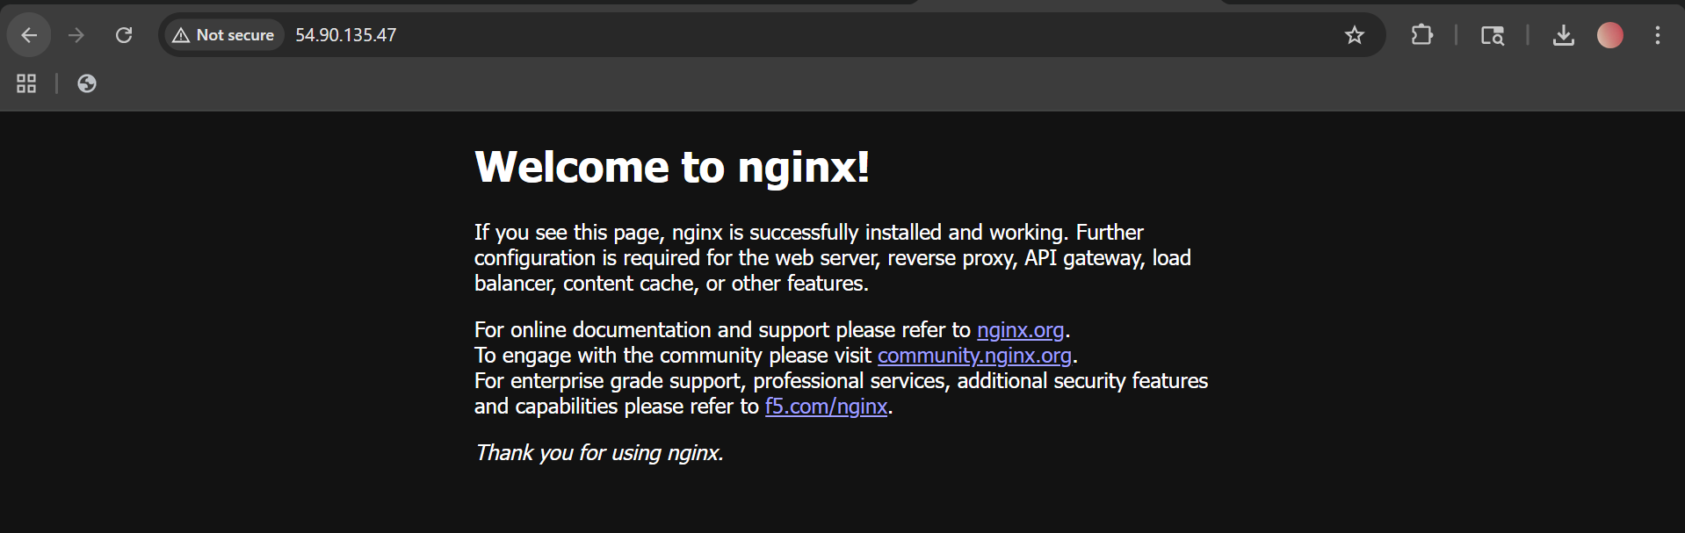
3. Create Docker image using alpine and customize with tomcat.
1) Create a project folder
mkdir alpine-tomcat
cd alpine-tomcat
2) Create a Dockerfile
vi Dockerfile
Paste this:
FROM alpine:3.20
ENV TOMCAT_VERSION=10.1.54
ENV CATALINA_HOME=/opt/tomcat
ENV PATH=$CATALINA_HOME/bin:$PATH
# Install Java and required tools
RUN apk add --no-cache openjdk17-jre curl tar bash
# Create tomcat user and directory
RUN addgroup -S tomcat && adduser -S tomcat -G tomcat
# Download and extract Tomcat
RUN mkdir -p /opt && \
curl -fSL https://downloads.apache.org/tomcat/tomcat-10/v${TOMCAT_VERSION}/bin/apache-tomcat-${TOMCAT_VERSION}.tar.gz -o /tmp/tomcat.tar.gz && \
tar -xzf /tmp/tomcat.tar.gz -C /opt && \
mv /opt/apache-tomcat-${TOMCAT_VERSION} ${CATALINA_HOME} && \
rm /tmp/tomcat.tar.gz && \
chown -R tomcat:tomcat ${CATALINA_HOME}
# Expose Tomcat port
EXPOSE 8080
USER tomcat
WORKDIR /opt/tomcat
CMD ["catalina.sh", "run"]
3) Build the image
docker build -t my-alpine-tomcat-app:v1

4) Check the image
docker images
You should see:
my-alpine-tomcat-app

5) Run the container
docker run -d -p 8080:8080 --name myapp-container my-alpine-tomcat-app:v1
6) Verify it is running
docker ps
Then open:
http://54.90.135.47:8080
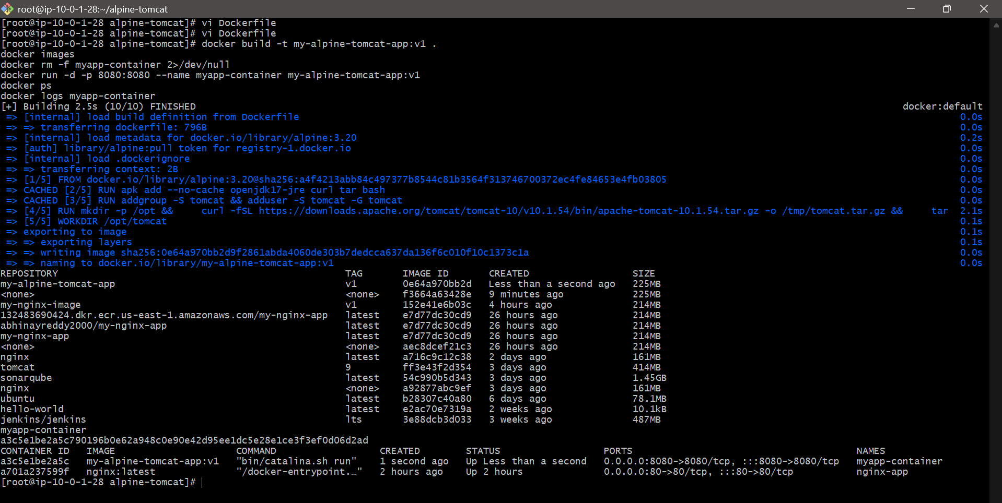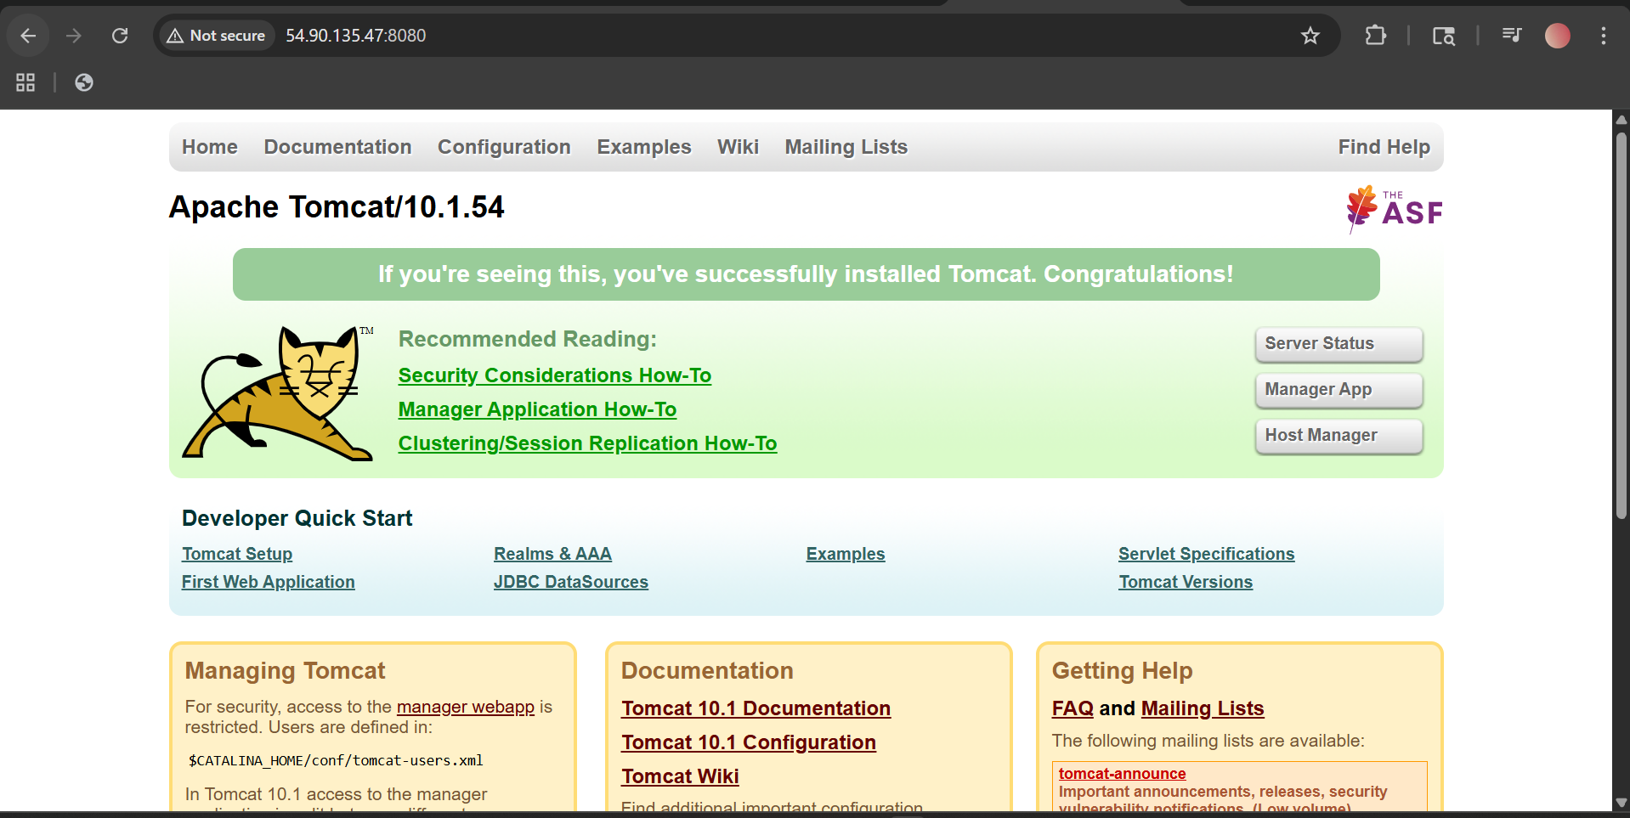

4. Create single stage and multi stage docker file using this
source code: https://github.com/betawins/multi-stage-example.git

- Single-Stage Dockerfile for multi-stage-example
Objective
To create a single-stage Docker image for the Spring Boot project from this repository:
https://github.com/betawins/multi-stage-example.git
In a single-stage Docker build, the same image is used for:
- building the application
- packaging the application
- running the application

Step 1: Clone the source code
First, download the project from GitHub.
git clone https://github.com/betawins/multi-stage-example.git
cd multi-stage-example
Step 2: Check the project files
Verify that the project contains the required files.
ls
You should see files like:
- pom.xml
- src
- mvnw
- mvnw.cmd
Explanation
This confirms that it is a Maven-based Java project.
Step 3: Create the single-stage Dockerfile
Create a Dockerfile named Dockerfile.single.
vi Dockerfile.single
Paste the following content:
FROM maven:3.8.6-openjdk-8
WORKDIR /app
COPY . .
RUN mvn clean package -DskipTests
EXPOSE 8080
CMD ["java", "-jar", "target/multi-stage-example-0.0.1-SNAPSHOT.jar"]
Save and exit:

Step 4: Build the Docker image
Now build the image using the Dockerfile.
docker build --no-cache -f Dockerfile.single -t multi-stage-example:single .
Explanation
- docker build creates the image
- --no-cache forces Docker to rebuild everything
- -f Dockerfile.single tells Docker which file to use
- -t multi-stage-example:single gives the image a name and tag
- . means current directory is the build context

Step 5: Verify the image was created
Check whether the image is available locally.
docker images
Look for:
multi-stage-example single
Explanation
If this image appears, the build was successful.

Step 6: Run the container
Start a container from the image.
docker run -d -p 8080:8080 --name single-container multi-stage-example:single
Explanation
- docker run creates and starts a container
- -d runs it in background mode
- -p 8080:8080 maps server port 8080 to container port 8080
- --name single-container gives the container a name
- multi-stage-example:single is the image name

Step 7: Check running containers
Verify that the container is running.
docker ps
Explanation
This shows all currently running containers.
You should see:
- container name: single-container
- port mapping: 0.0.0.0:8080->8080/tcp

Step 8: Access the application
Open the application in a browser using your server public IP:
http://<EC2-Public-IP>:8080
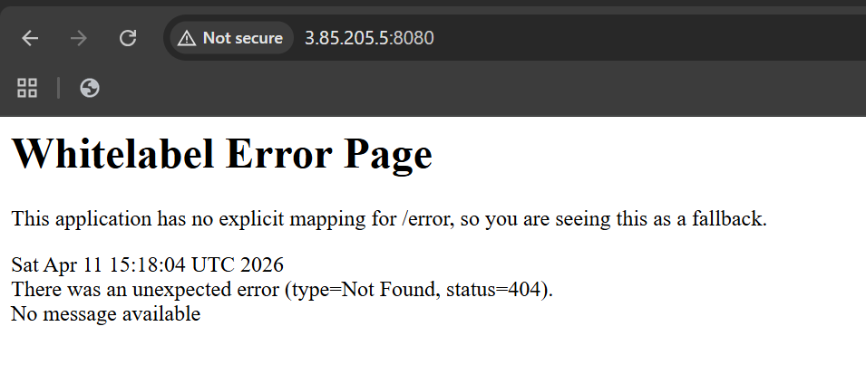

Multi-Stage Dockerfile for multi-stage-example
Objective
To create a multi-stage Docker image for a Spring Boot application where:
- First stage → builds the application (using Maven)
- Second stage → runs the application (using lightweight Java image)

Step 1: Clone the source code
git clone https://github.com/betawins/multi-stage-example.git
cd multi-stage-example
Explanation
Downloads the project and moves into the directory.

Step 2: Verify project structure
ls
You should see:
- pom.xml
- src/
- mvnw

Step 3: Create Multi-stage Dockerfile
vi Dockerfile.multi
Paste this:
# Stage 1: Build
FROM maven:3.8.6-openjdk-8 AS builder
WORKDIR /app
COPY . .
RUN mvn clean package -DskipTests
# Stage 2: Run
FROM eclipse-temurin:8-jre-alpine
WORKDIR /app
COPY --from=builder /app/target/multi-stage-example-0.0.1-SNAPSHOT.jar app.jar
EXPOSE 8080
ENTRYPOINT ["java", "-jar", "app.jar"]

Step 4: Build the Docker image
docker build --no-cache -f Dockerfile.multi -t multi-stage-example:multi .
Explanation
- Builds image using multi-stage Dockerfile
- Tags image as multi-stage-example:multi

Step 5: Verify image
docker images
Look for:
multi-stage-example multi

Step 6: Run the container
docker run -d -p 8081:8080 --name multi-container multi-stage-example:multi
Step 7: Check running container
docker ps
You should see:
multi-container Up ...
0.0.0.0:8080->8080/tcp

Step 8: Access application
Open in browser:
http://<EC2-Public-IP>:8080

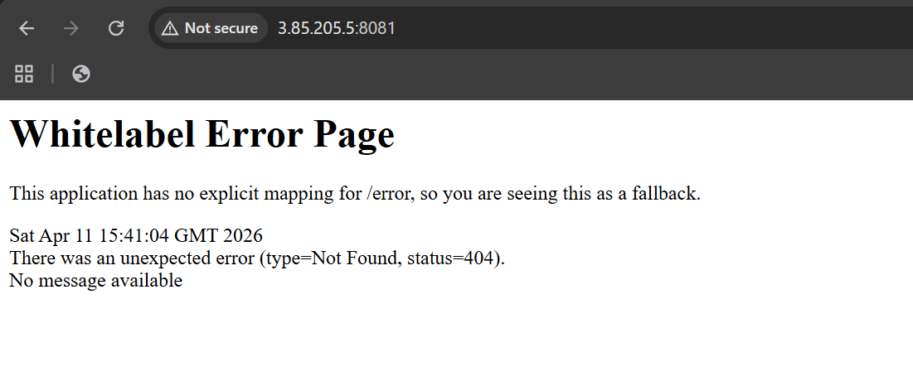

5. Install docker compose and execute sample application.
1. Install Docker Compose
curl -SL https://github.com/docker/compose/releases/latest/download/docker-compose-linux-x86_64 \
-o /usr/local/lib/docker/cli-plugins/docker-compose
Give permission:
chmod +x /usr/local/lib/docker/cli-plugins/docker-compose
👉 Verify installation:
docker compose version 2. Create Sample Application (Nginx)
Step 1: Create project folder
mkdir docker-compose-demo
cd docker-compose-demoStep 2: Create file with name docker-compose.yml
Paste:
version: '3'
services:
web:
image: nginx:latest
container_name: nginx-compose
ports:
- "8085:80"

3. Run the Application
docker compose up -d
👉 Check running containers:
docker ps

5. Access Application
Open browser:
http://<your-ec2-ip>:8085
👉 You will see Nginx welcome page
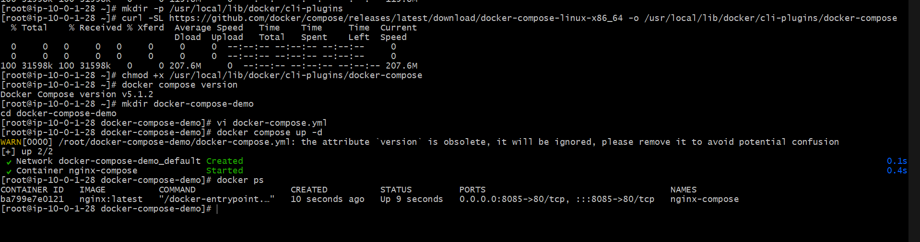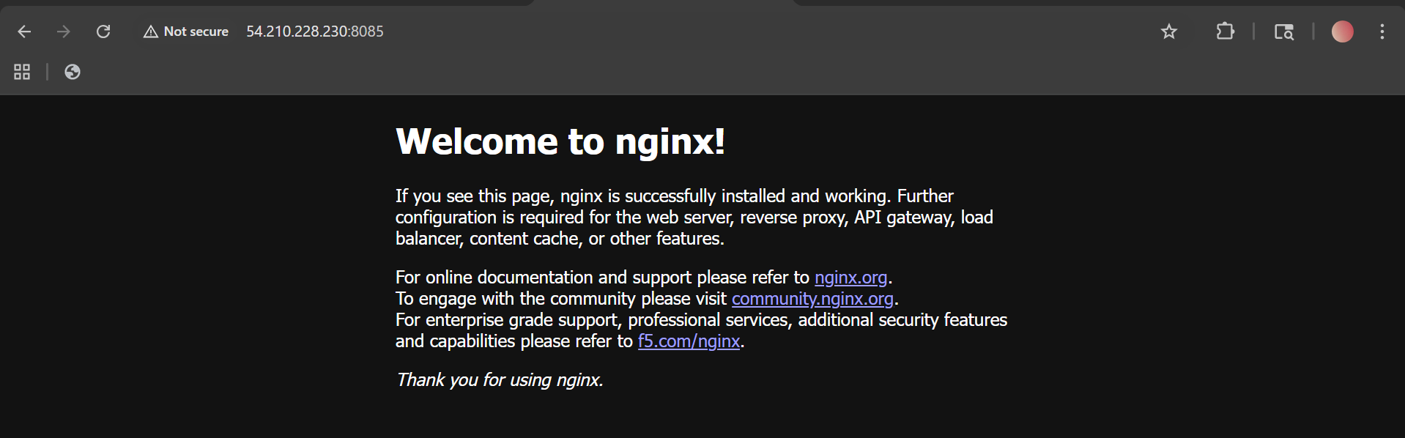

6. Implement solution to scan images when pushed to docker registry.
Step 1: Install Trivy
On Linux / EC2\
sudo yum install -y wget
wget https://raw.githubusercontent.com/aquasecurity/trivy/main/contrib/install.sh
sudo sh install.sh -b /usr/local/bin

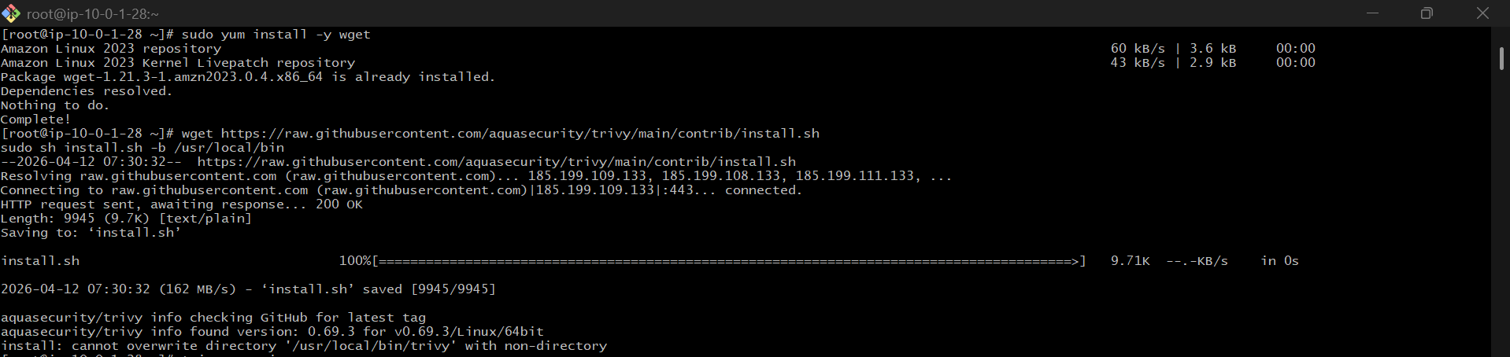

STEP 2: Verify Installation
trivy –version
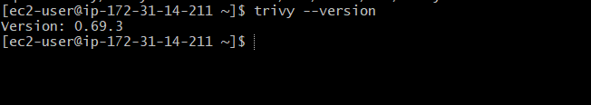
STEP 3: Scan Docker Image
trivy image nginx

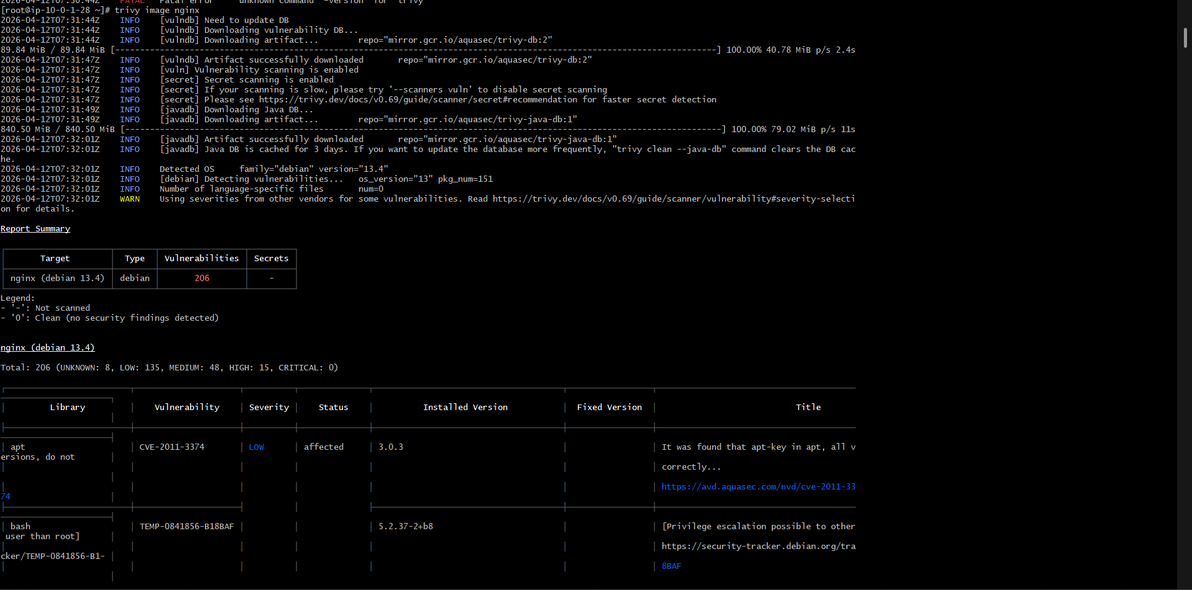

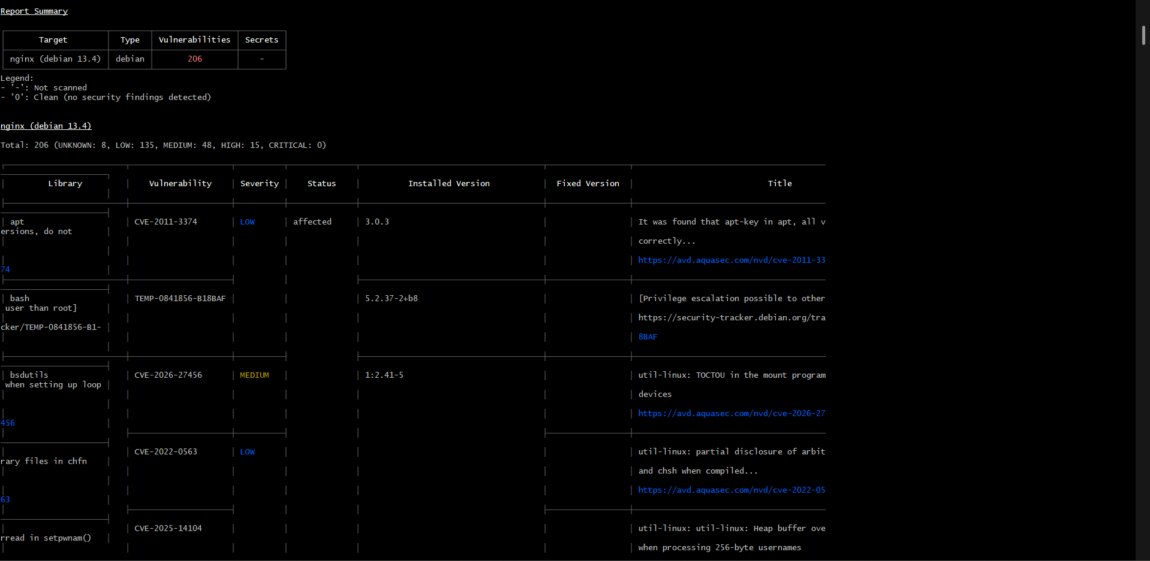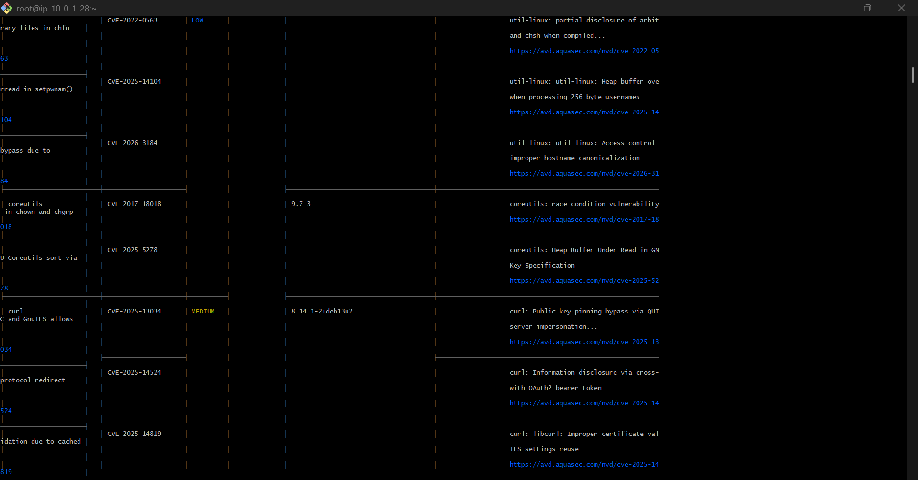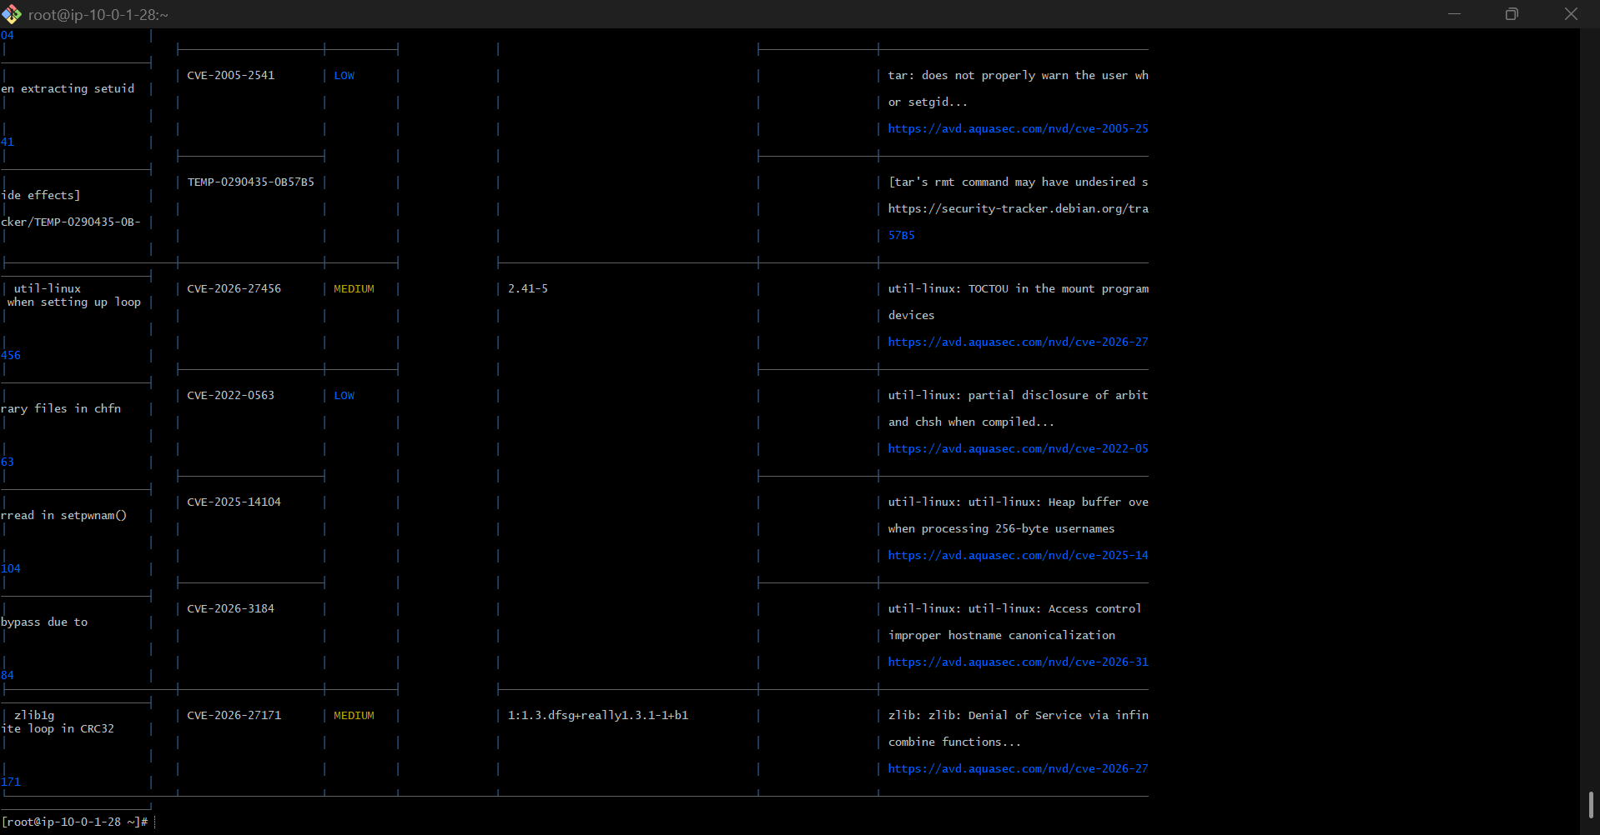
7) Implement solution to scan images when pushed to AWS ECR.

AWS ECR Image Scanning Implementation
Objective
To implement an automated solution that scans Docker images for vulnerabilities when they are pushed to AWS Elastic Container Registry (ECR).

Step 1: Create ECR Repository with Scan on Push
aws ecr create-repository \
--repository-name my-nginx \
--image-scanning-configuration scanOnPush=true \
--region us-east-1

Step 2: Verify Scan on Push is Enabled
aws ecr describe-repositories \
--repository-names my-nginx \
--region us-east-1
Look for:
"imageScanningConfiguration": {
"scanOnPush": true
}

Step 3: Tag Docker Image
docker tag nginx:latest 132483690424.dkr.ecr.us-east-1.amazonaws.com/my-nginx:latest

Step 4: Login to ECR
aws ecr get-login-password --region us-east-1 | docker login \
--username AWS \
--password-stdin 132483690424.dkr.ecr.us-east-1.amazonaws.com

Step 5: Push Image to ECR
docker push 132483690424.dkr.ecr.us-east-1.amazonaws.com/my-nginx:latest
👉 Once pushed, scanning starts automatically.

Step 6: Check Scan Results (CLI)
aws ecr describe-image-scan-findings \
--repository-name my-nginx \
--image-id imageTag=latest \
--region us-east-1

Step 7: Check Scan Results (AWS Console)
- Go to AWS ECR Console
- Select Region: us-east-1
- Open Repository → my-nginx
- Click Image → latest
- Open Scan results / Vulnerabilities
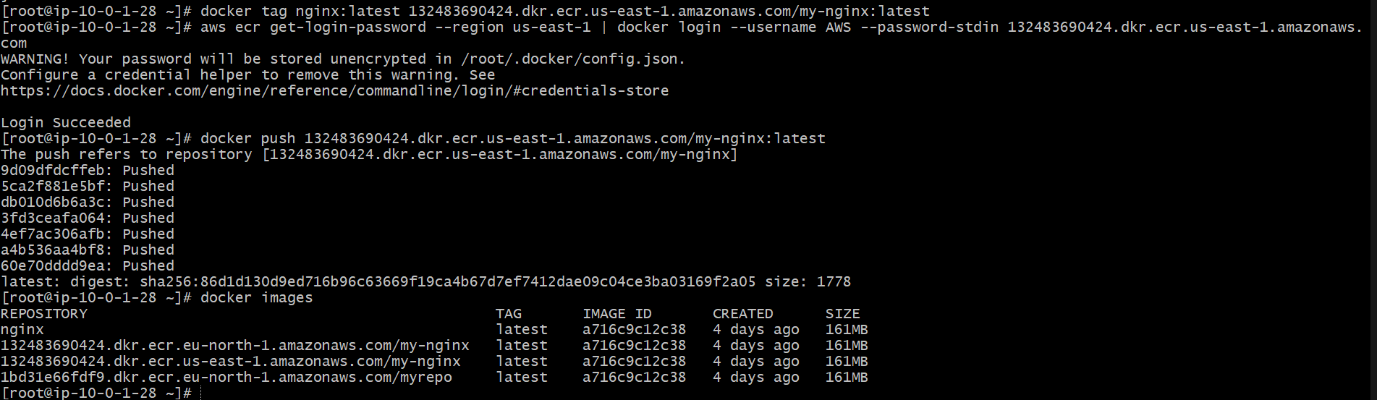

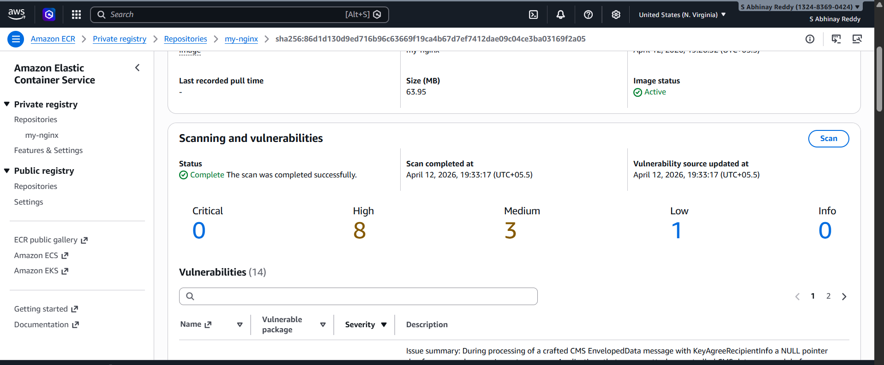

8. Create a Jenkins pipeline to create a docker image and push the image to Docker hub.

Steps to Implement
🔹 Step 1: Install Docker
yum install docker -y
systemctl start docker
systemctl enable docker

🔹 Step 2: Install Jenkins
yum install java-17-openjdk -y
wget -O /etc/yum.repos.d/jenkins.repo https://pkg.jenkins.io/redhat-stable/jenkins.repo
rpm --import https://pkg.jenkins.io/redhat-stable/jenkins.io.key
yum install jenkins -y
systemctl start jenkins

🔹 Step 3: Add Jenkins to Docker Group
usermod -aG docker jenkins
systemctl restart jenkins

🔹 Step 4: Create Docker Hub Credentials in Jenkins
- Go to Manage Jenkins → Credentials
- Add:
  - Username: abhinayreddy2000
  - Password:
- ID: dockerhub-creds

🔹 Step 5: Create Jenkins Pipeline Job
- Go to Jenkins dashboard
- Click New Item
- Select Pipeline
- Name: docker-pipeline

Step 6: Add Pipeline Code
Paste this:
pipeline {
agent any

environment {
IMAGE_NAME = "abhinayreddy2000/myapp"
IMAGE_TAG = "${BUILD_NUMBER}"
}

stages {
stage('Clone Code') {
steps {
git 'https://github.com/betawins/multi-stage-example.git'
}
}

stage('Replace Dockerfile') {
steps {
writeFile file: 'Dockerfile', text: '''
FROM maven:3.8.6-openjdk-8 AS builder

WORKDIR /app
COPY . .

RUN mvn clean package -DskipTests

FROM eclipse-temurin:8-jre-alpine

WORKDIR /app
COPY --from=builder /app/target/*.jar app.jar

EXPOSE 8080
ENTRYPOINT ["java","-jar","app.jar"]
'''
sh 'echo "Updated Dockerfile:"'
sh 'cat Dockerfile'
}
}

stage('Build Docker Image') {
steps {
sh 'docker build -t $IMAGE_NAME:$IMAGE_TAG .'
sh 'docker tag $IMAGE_NAME:$IMAGE_TAG $IMAGE_NAME:latest'
}
}

stage('Login to Docker Hub') {
steps {
withCredentials([usernamePassword(
credentialsId: 'dockerhub-creds',
usernameVariable: 'DOCKER_USER',
passwordVariable: 'DOCKER_PASS'
)]) {
sh 'echo "$DOCKER_PASS" | docker login -u "$DOCKER_USER" --password-stdin'
}
}
}

stage('Push Docker Image') {
steps {
sh 'docker push $IMAGE_NAME:$IMAGE_TAG'
sh 'docker push $IMAGE_NAME:latest'
}
}
}

post {
always {
sh 'docker logout || true'
}
success {
echo 'Docker image built and pushed successfully.'
}
failure {
echo 'Pipeline failed.'
}
}
}

Step 7: Build the Job
- Click Build Now
- Check Console Output

