A New Model for Calculating the Maximum Trust in Online Social Networks using ABC, Firefly & MABC

In this project we are analysing social media Facebook dataset to identify trust of users. Calculating trust help users in identifying genuine and fake account and they can be aware of chatting users based on high trust values. In propose work we are using nature inspired algorithms such as ABC, MABC and Firefly to calculate trust of source and destination user.

User with high followers or incoming edges will be consider as trusted user. Always we trust brand or person which peoples are like most. So by calculating trust values between users we can now which user can be trusted. In propose paper author using Facebook dataset which does not contains TRUST values and it contains ID’s of source (User) and destination (Friends) so by summing friends list we are calculating trust values. User with high followers and friends will get high cost value. The more the cost value the more user can be trusted.

To implement above concept author has generated GRAPH from Facebook dataset where each user can be consider as VERTEX and edges will be mark between user vertex and his friend vertex.

To calculate trust values we will extract FRIENDS LIST from given source and then look for destination USER and if destination not found then we will extract friend list of other friend and this will continue till we get destination in the path. Cost value will get increase as long as the path continues to SCAN in search of destination user. Once destination user found then will calculate average cost value.

To execute above logic we need to make more number of loops to search path of source and destination and to optimize this search we are using ABC, Firefly and MABC algorithms.

**ABC** is also a nature inspired algorithm where employee bee search for food in neighbours and then inform to ONLOOKER bee, this bee will watch waggle dance of employee bees to compute fitness values and if fitness is more then they will move in that more fitness path, if fitness less then it will choose new random path, ABC will suffer heavy computation time due to random path selection.

**Firefly** is a nature inspired algorithm which attract other firefly using their lights, lights intensity will get weaker if distance/fitness value more and can receive strong light intensity if distance is less and based on this distance all firefly will move to optimize path. In trust calculation optimized function will keep moving to next index with greater chances of finding path between source and destination and once path found then optimization will stop. Firefly is superior to ABC as it move towards next position without taking any random path. ABC execution time is more due to random path movement to get optimized solution

**MABC** make worker bee to memorize previous solution and for next search it will get optimized result from memory don’t have result then it will invoke firefly algorithm to get optimized result and then memorize that result for future use.

To implement this project we are using below Facebook dataset

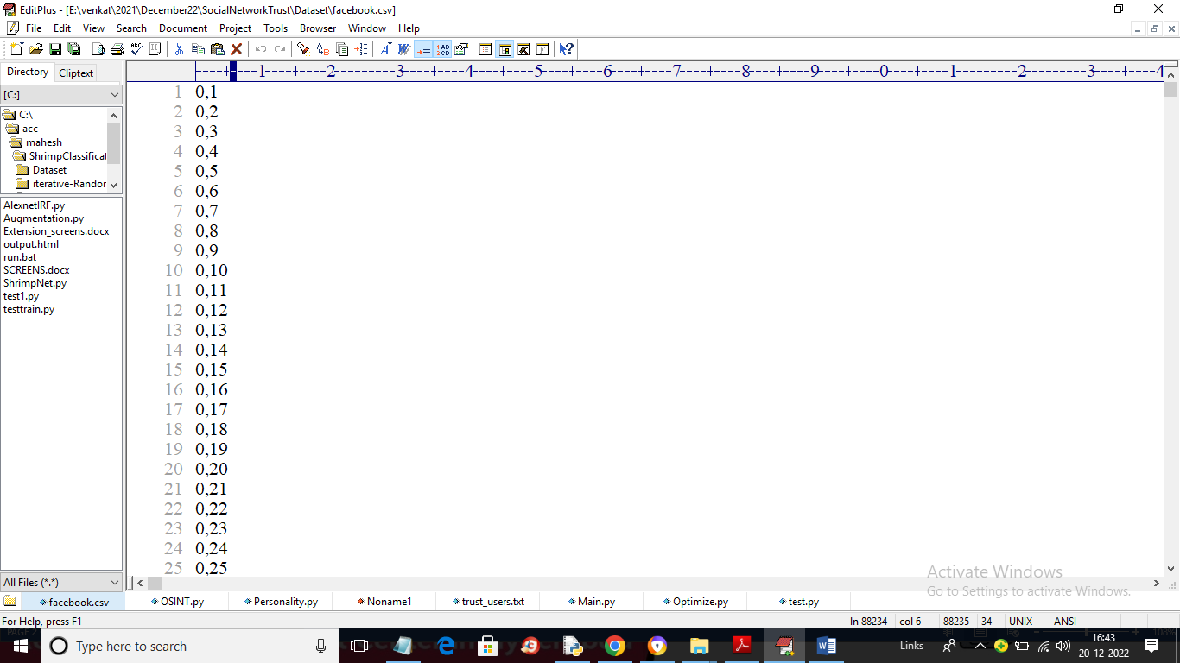

In above dataset before comma is the USER ID and after is the FRIEND ID.

To implement this project we have designed following modules

1. Upload Facebook Dataset: using this module we will upload dataset to application and then application will read all users and generate memory based graph
2. Run ABC Algorithm: this module will take source and destination ID and then execute ABC algorithm to compute cost values and if cost value > 0.010 threshold then user is TRUSTED otherwise untrusted. For each search we will calculate computation time
3. Run Firefly Algorithm: this module will take source and destination ID and then execute Firefly algorithm to compute cost values and if cost value > 0.010 threshold then user is TRUSTED otherwise untrusted
4. Run MABC Algorithm: this module will take source and destination ID and then execute MABC algorithm to compute cost values and if cost value > 0.010 threshold then user is TRUSTED otherwise untrusted
5. Comparison Graph: using this module we will plot computation time graph between all algorithms

In below screen read green and red colour comments to know about ABC

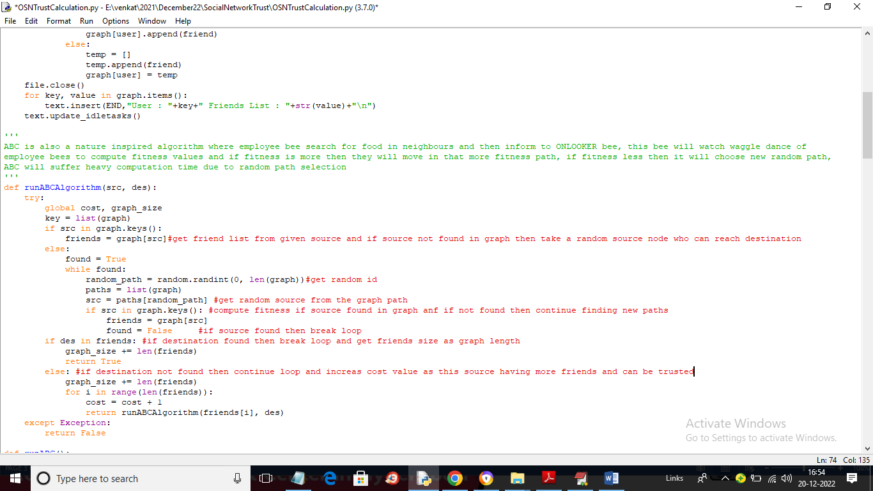

In below screen read about Firefly

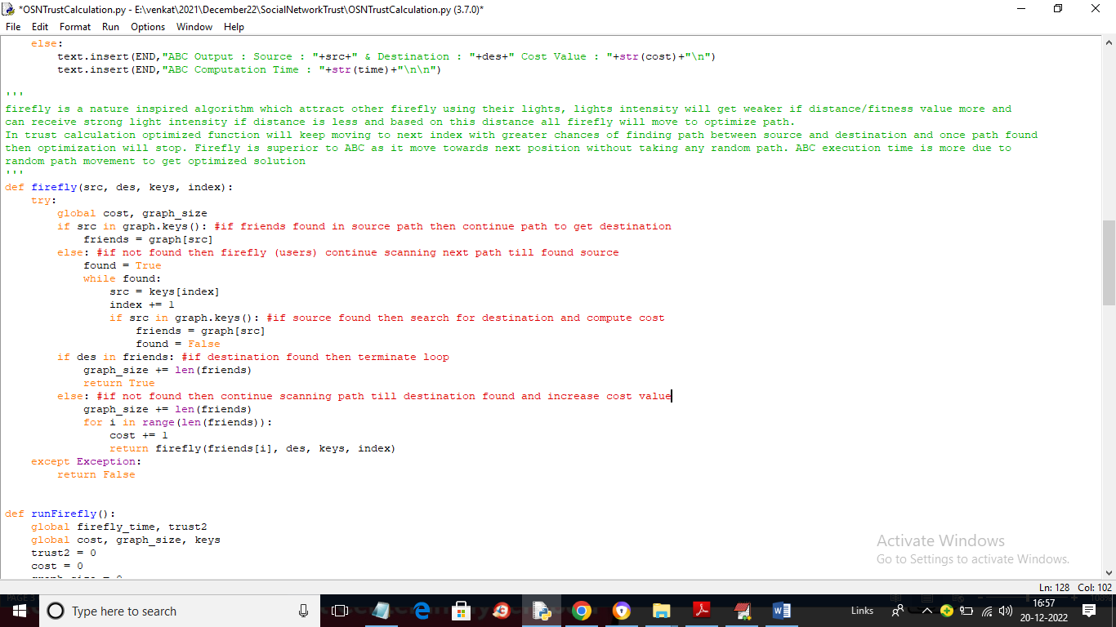

In below screen read about MABC

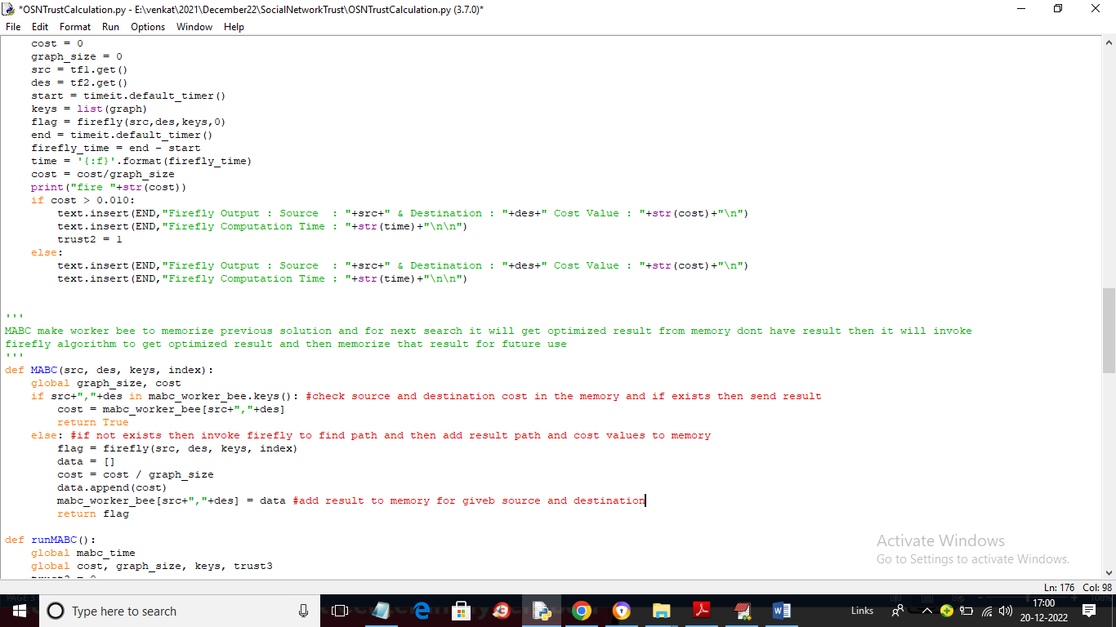

In above screen you can read about MABC algorithm

SCREEN SHOTS

To run project double click on ‘run.bat’ file to get below screen

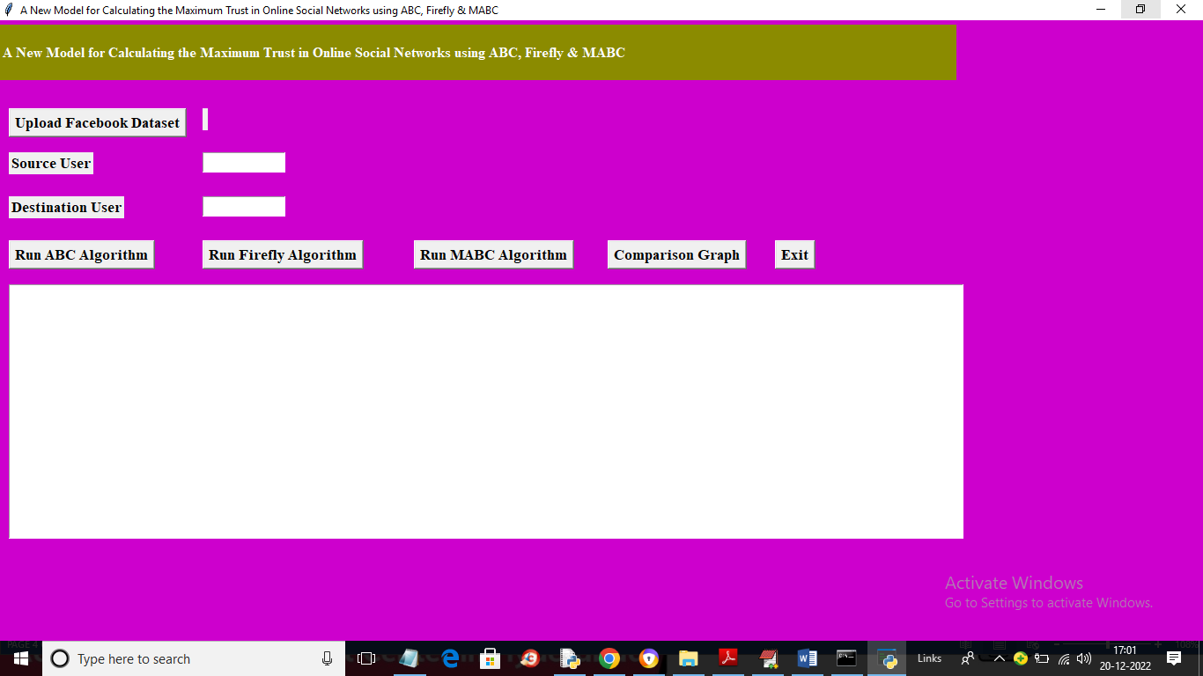

In above screen click on ‘Upload Facebook Dataset’ button to upload dataset and get below output

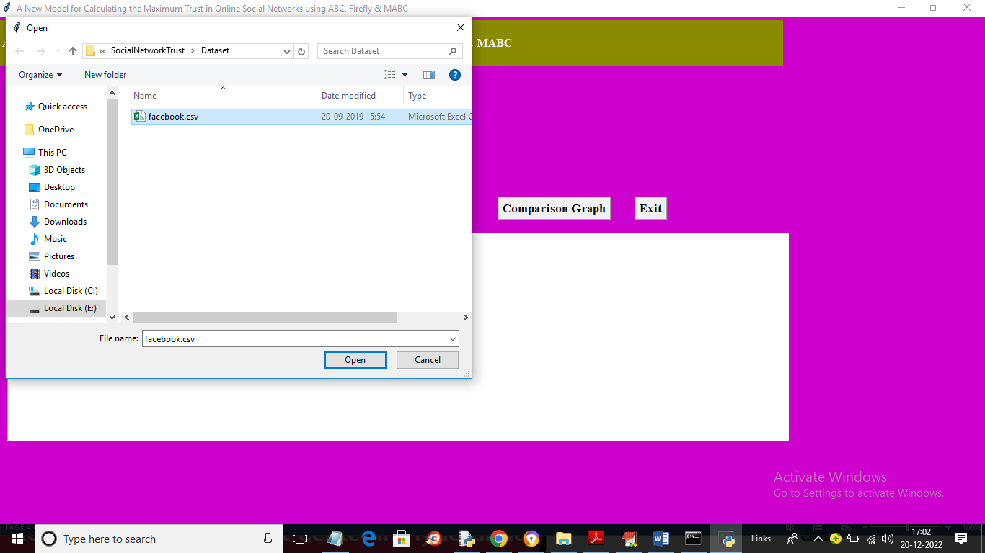

In above screen selecting and uploading ‘Facebook.csv’ file and then click on ‘Open’ button to load dataset and get below output

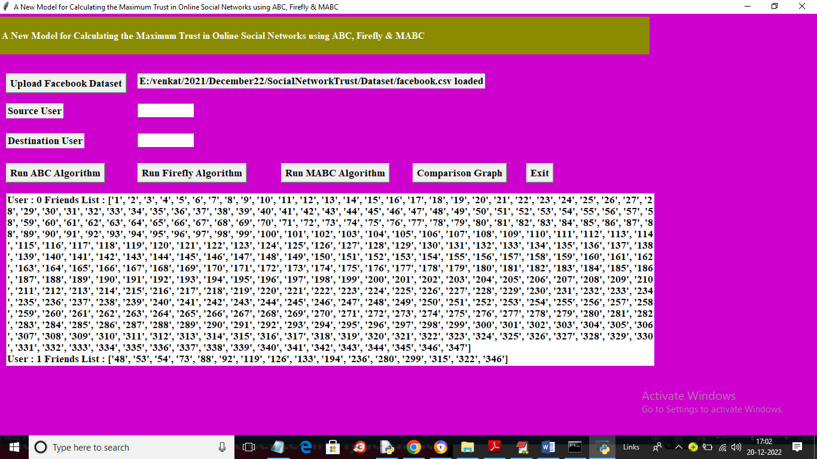

In above screen first we can USER id and then in square brackets we can see the friend list and scroll down above output screen to view all users and their friends list. Now entered source and destination user ID and press all buttons one by one to calculate cost

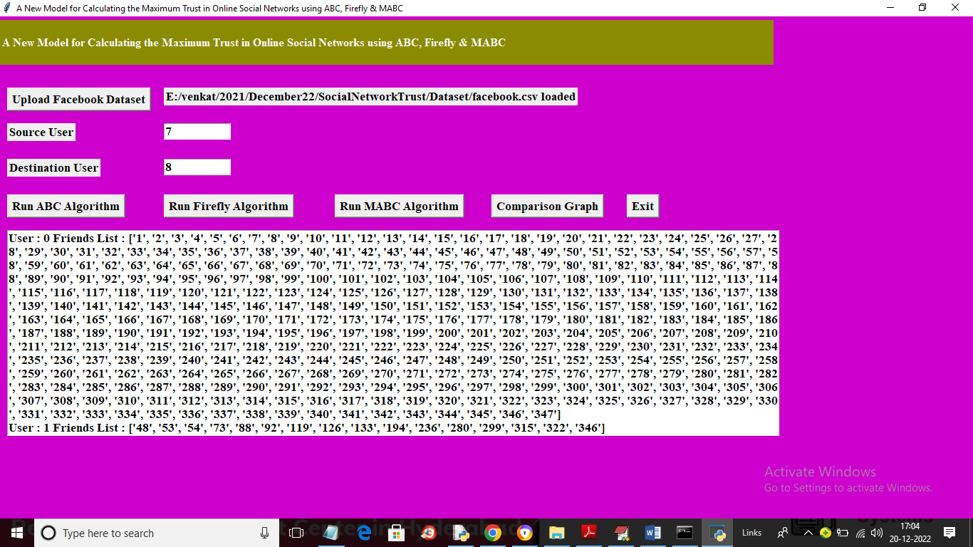

In above screen in text field I entered source and destination as 7 and 8 and then click on ‘Run ABC Algorithm’ button to get below output

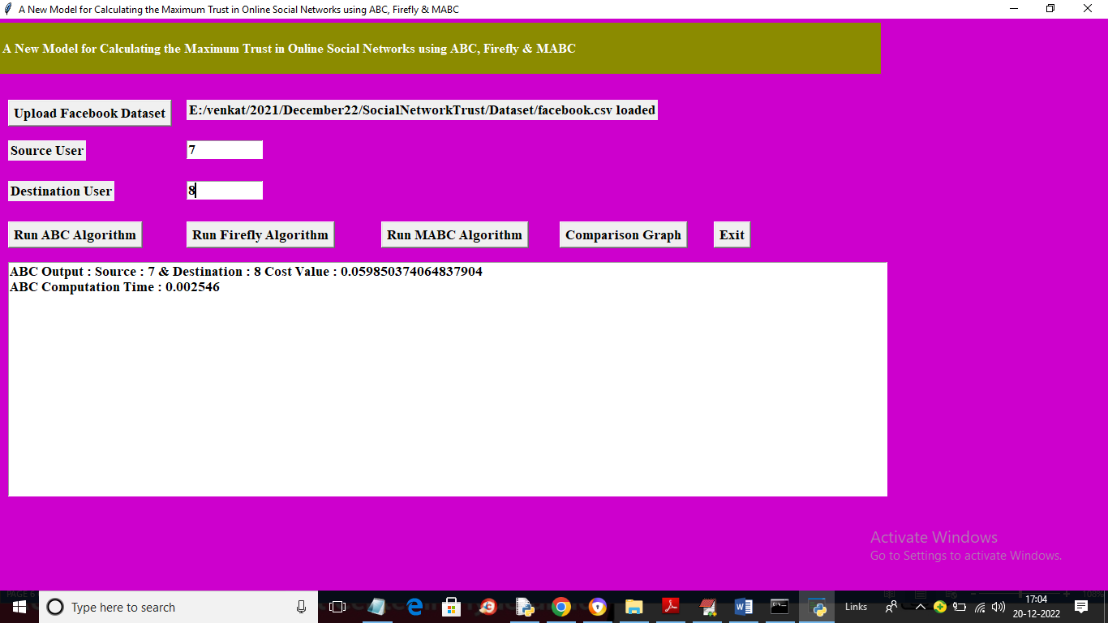

In above screen for 7 and 8 ID we got cost value and then displaying ABC computation time. Now click on ‘Run Firefly Algorithm’ button to get below output

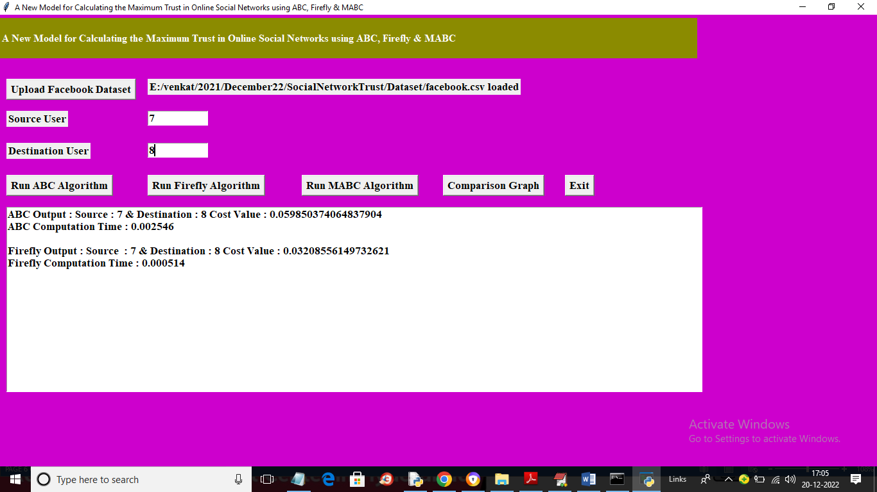

In above screen we can see cost value for 7 and 8 user using Firefly algorithm and now click on ‘Run MABC Algorithm’ button to get below output

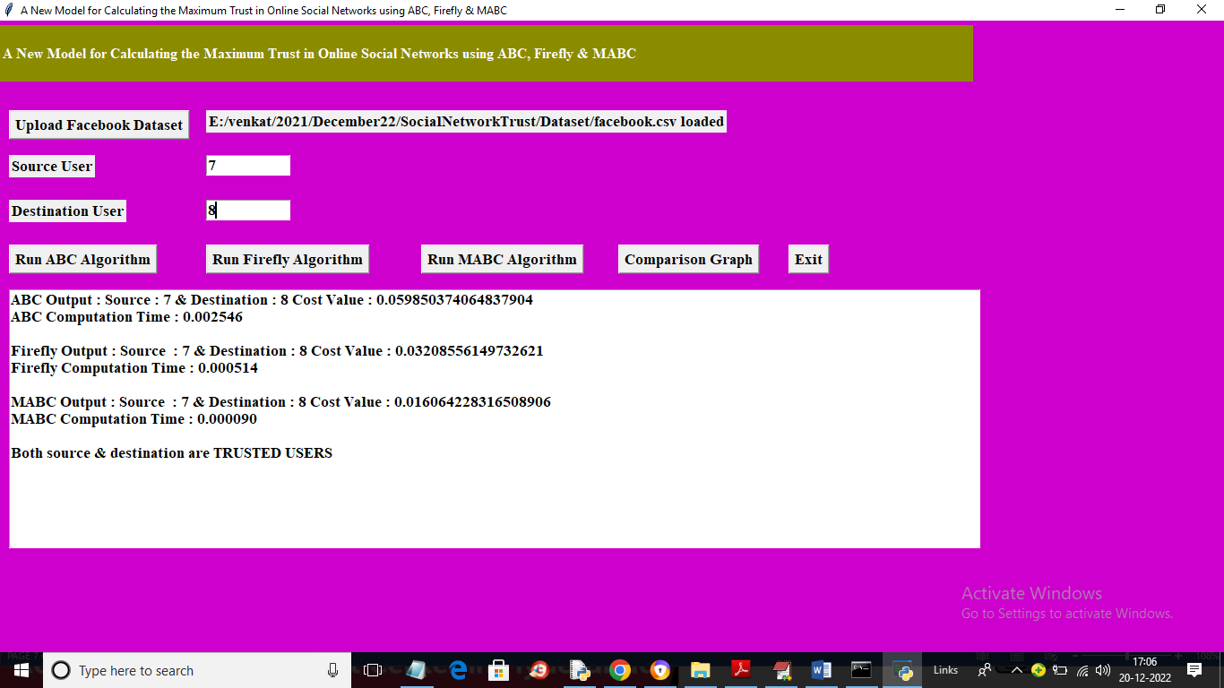

In above screen we got cost value using MABC and then displaying both source and destination is TRUSTED users and now click on ‘Comparison Graph’ button to get below output

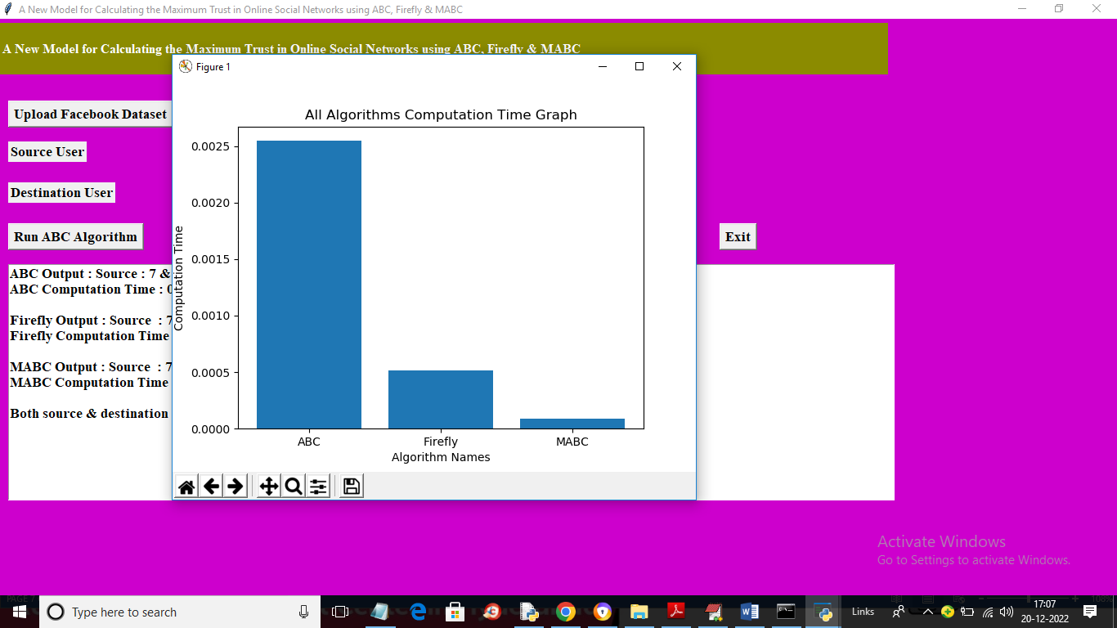

In above graph x-axis represents algorithm names and y-axis represents COMPUTATION or Execution time and in all algorithms MABC took less computation time. Similarly you can enter any source of destination and get cost values and user as trusted or untrusted. If you want you can get source and destination user ID’S from ‘trust_users.txt’ file. Below is another example

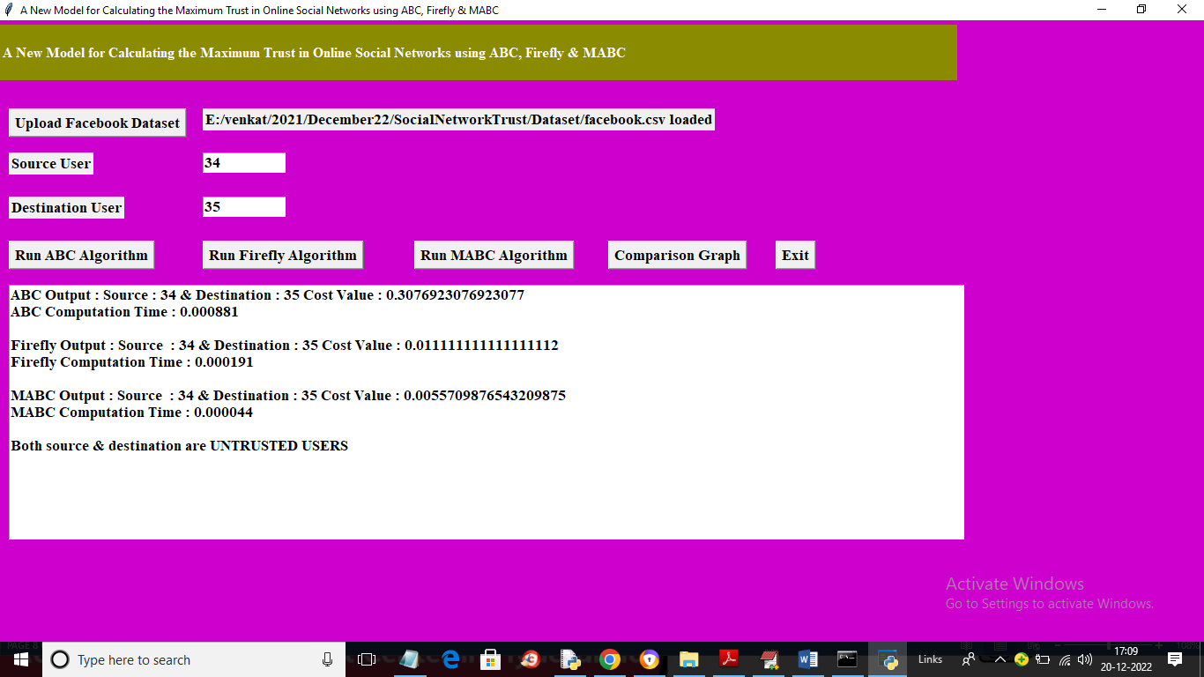

In above screen I gave source and destination as 34 and 35 and we got cost values and source and destination user detected as “UNTRUSTED’

