**Peer to Peer Carpooling using Blockchain**

Carpooling services helps in saving passengers money and driver petrol consumption and can save environment from huge emission of carbon from vehicles fuels. This services were manage using internet services and single centralized server and if this server down or hack then entire carpooling services will be down and sometime some internal database admin can manipulate database to alter passengers or driver’s ward and there is no suitable technique to identify such database tampering under single centralized server.

To overcome from above issues we are employing Blockchain based carpooling services where Blockchain support distributed data access which means data can be access and stored at multiple node and if one node then services will be access from other working node. Blockchain has internal support for data verification which means Blockchain store each data as block/transaction and associate each block with unique hashcode and before storing any new data then Blockchain verify hashcode of all nodes and if data tamper at any data then it will result into different hashcode and verification will be failed and data tamper will be detected.

To store and access data from Blockchain we need to make use of smart contract by using SOLIDITY code. This code contains functions to store and access data from Blockchain. Below screen showing Smart contract code

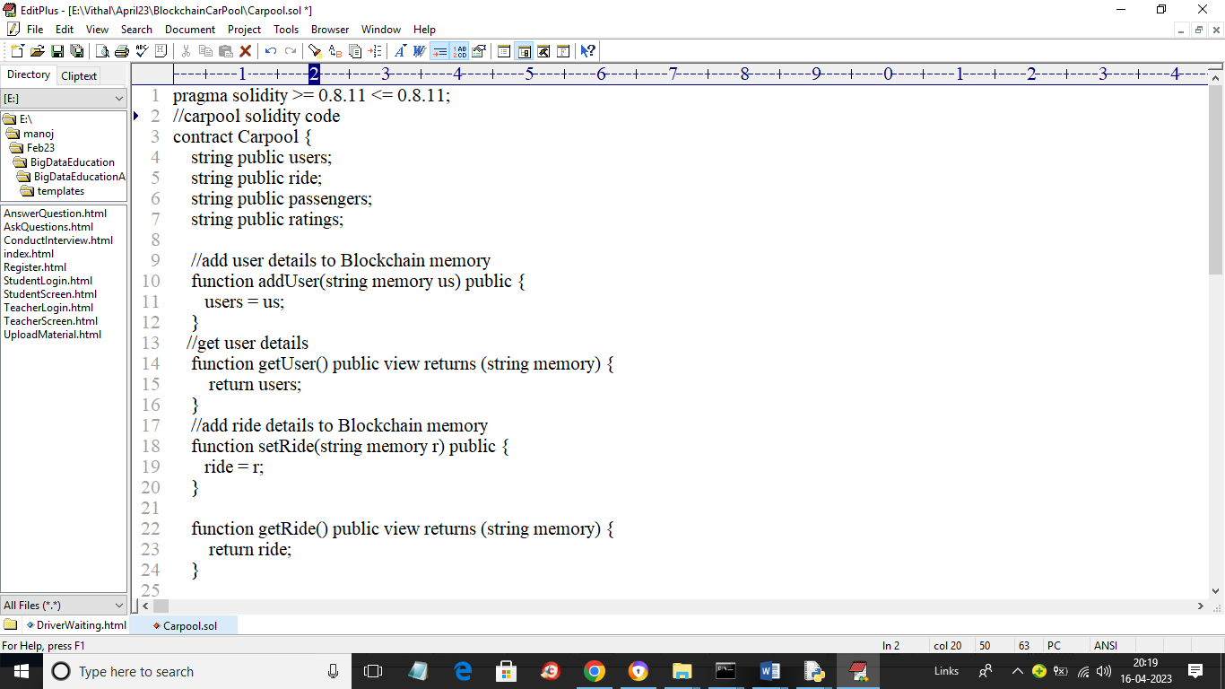

In above solidity code we have functions to set and get user and ride details and now we need to deploy above contract to Blockchain to allow managing of Carpool data. To deploy contract we need to follow below steps

1. First go inside ‘hello-eth/node-modules/.bin’ folder and then click on ‘runBlockchain.bat’ file to get below screen
2. In above screen Blockchain created some default accounts and private keys and now type command as ’migrate’ and press enter key to deploy contract and get below output
3. 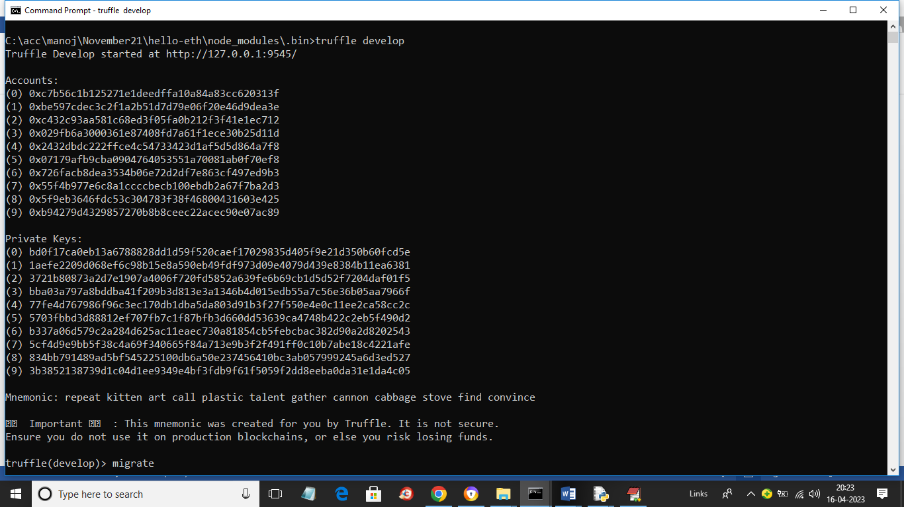
4. In above screen I gave command as ‘migrate’ and press enter key to get below page
5. 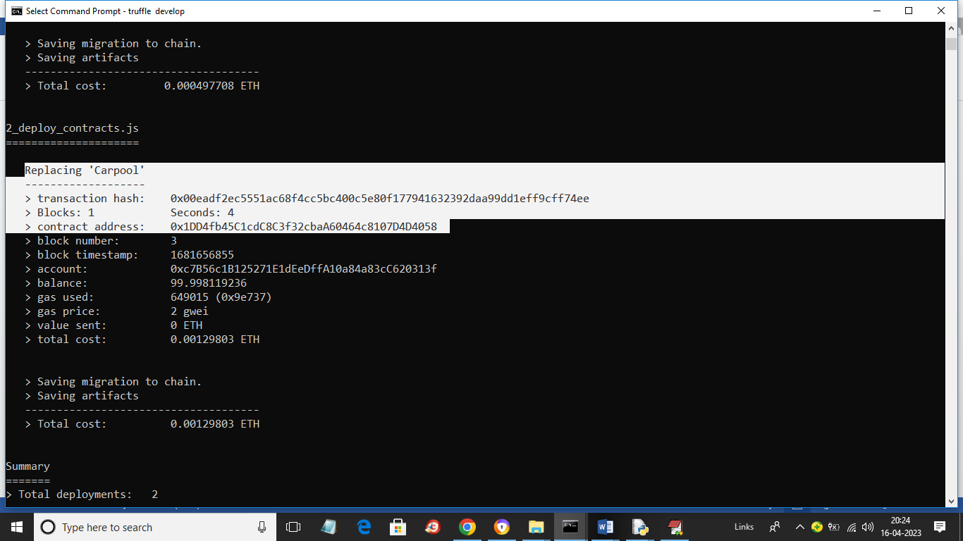
6. In above screen in white colour text we can see ‘Carpool’ contract deployed and let the above console running. In above screen we got contract address also and now we need to specify that address in Python code to store and get data. In below screen showing python code accessing above contract
7. 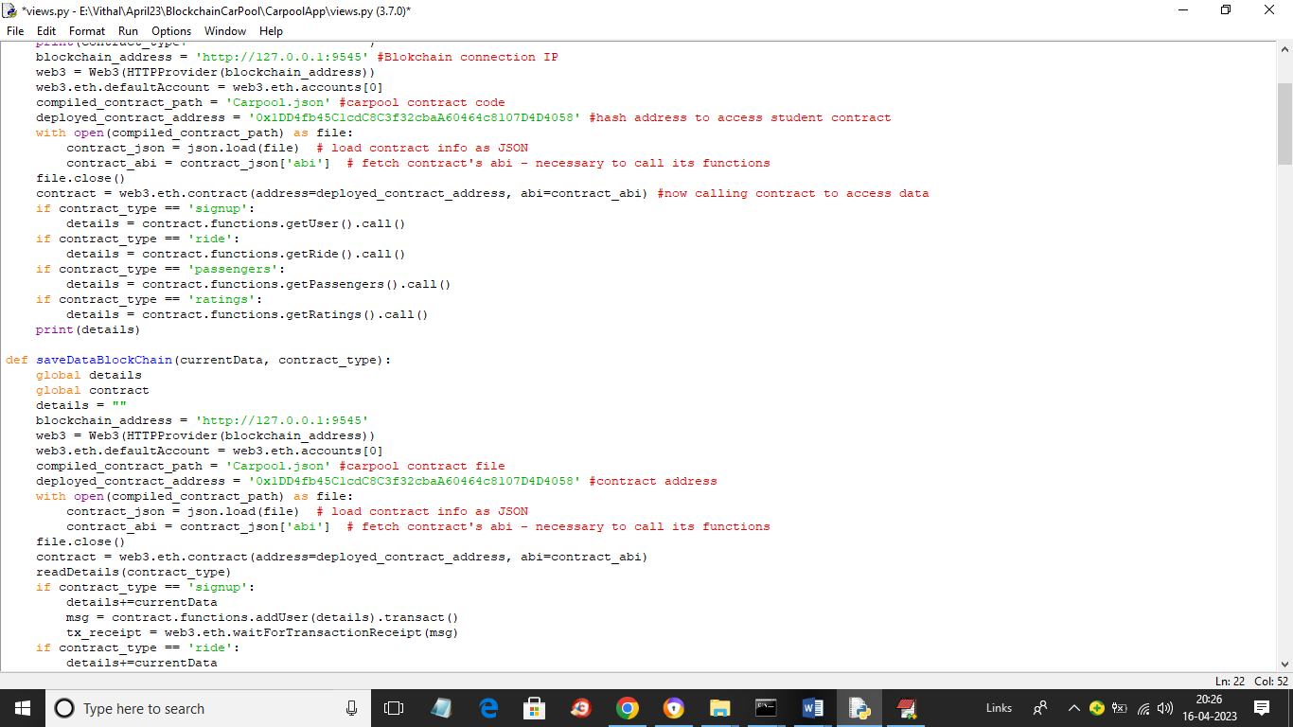
8. In above screen read red colour comments to know about Calling Blockchain function to store and get data.

Above advantages of Blockchain influencing us to migrate existing single centralized server to distributed Blockchain server. This application consists of 2 users called Driver and passengers.

Driver: driver can signup and login and then create a trip with his locations and wait for request from the passengers and if any request arrived then he will accept and wait for passenger at current location and once passenger arrived then he can start ride and collect payment after reaching destination. All details will be managed in the Blockchain

Passengers: Passengers can signup and login to application and then share his trip or location details with driver and then reached to driver place to start ride.

To run project double click on ‘runServer.bat’ file to get below screen

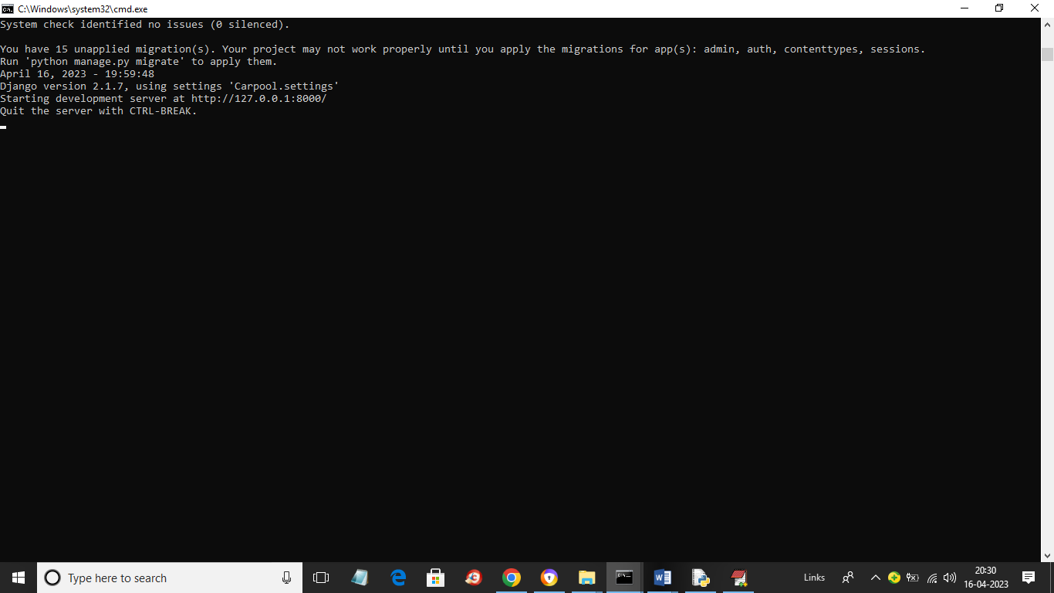

In above screen python server started and now open browser and enter URL as <http://127.0.0.1:8000/index.html> and press enter key to get below page

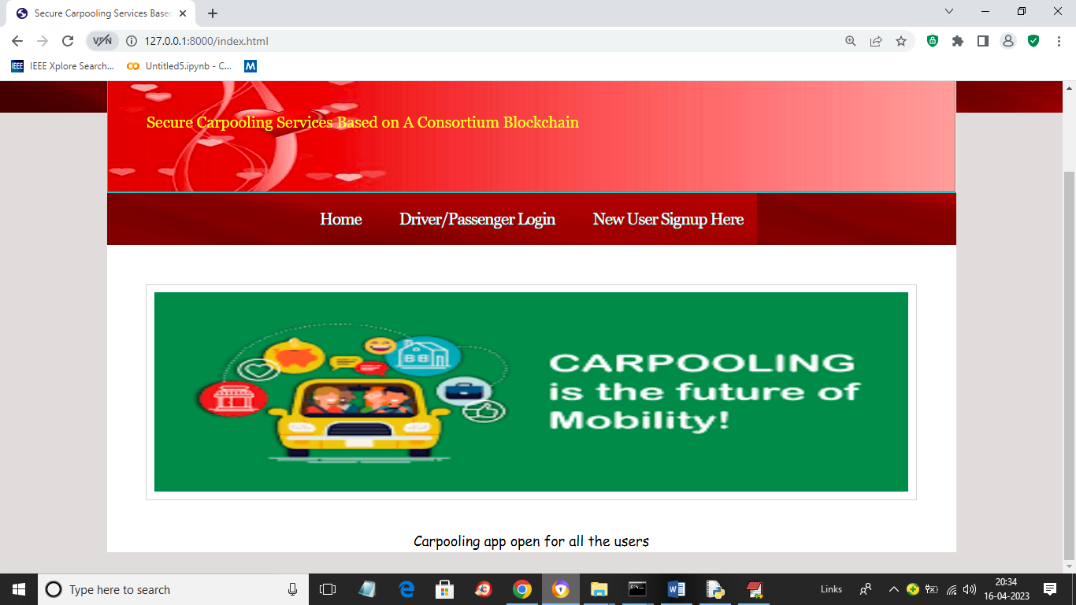

In above screen click on ‘New User Signup Here’ link to signup either driver or passenger

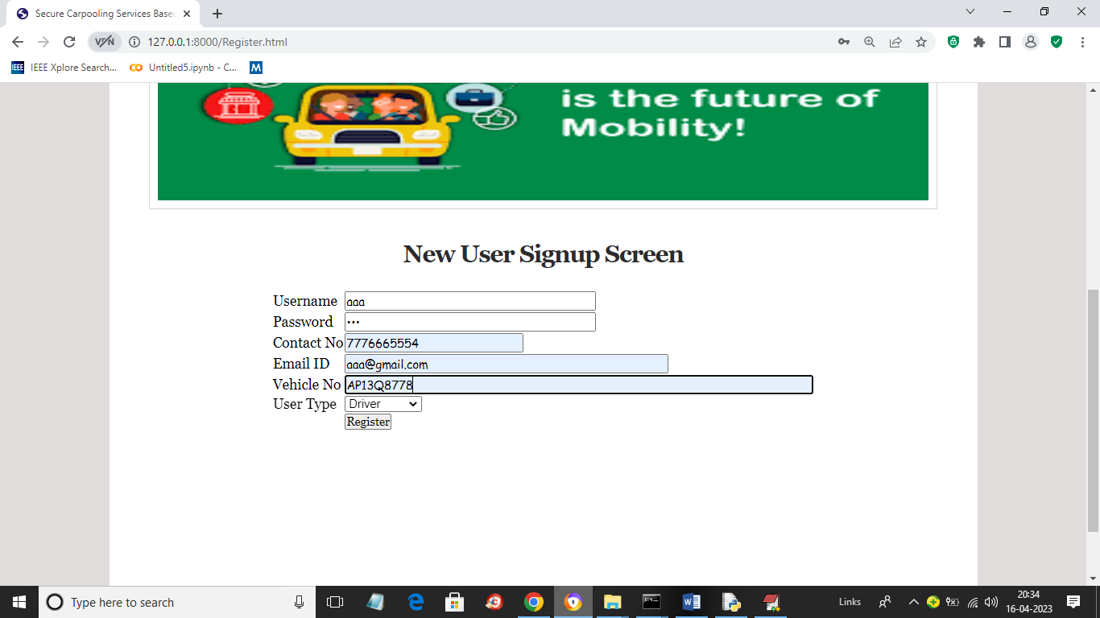

In above screen I am entering driver details and now click on ‘Register’ button to get below page

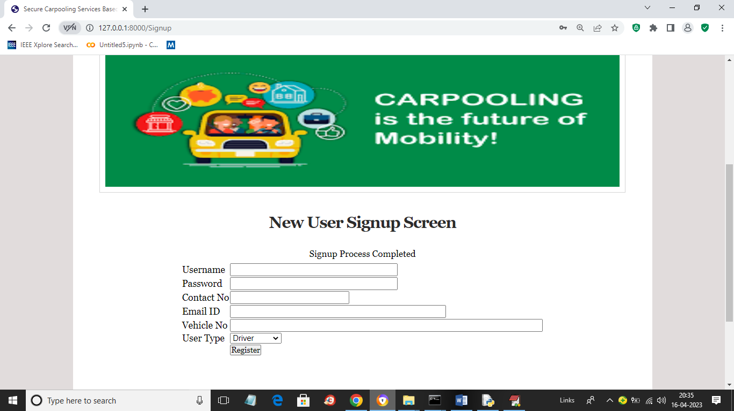

In above screen we can see signup task completed and now similarly add passenger also

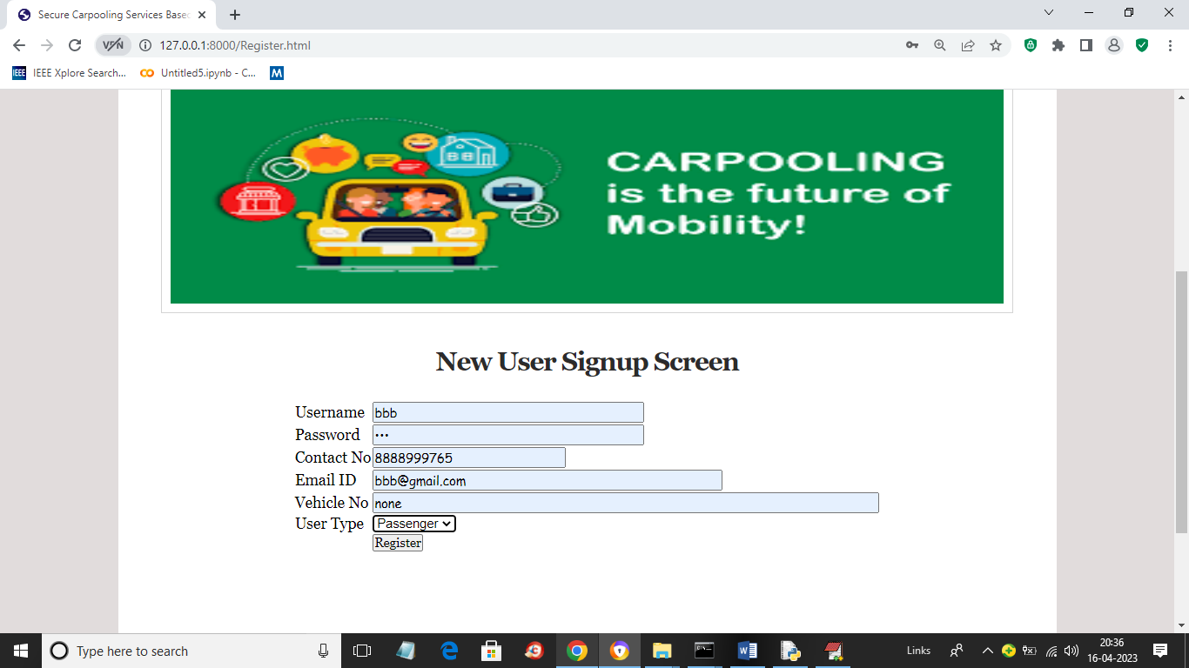

In above screen adding passenger details and now press enter key to get below page

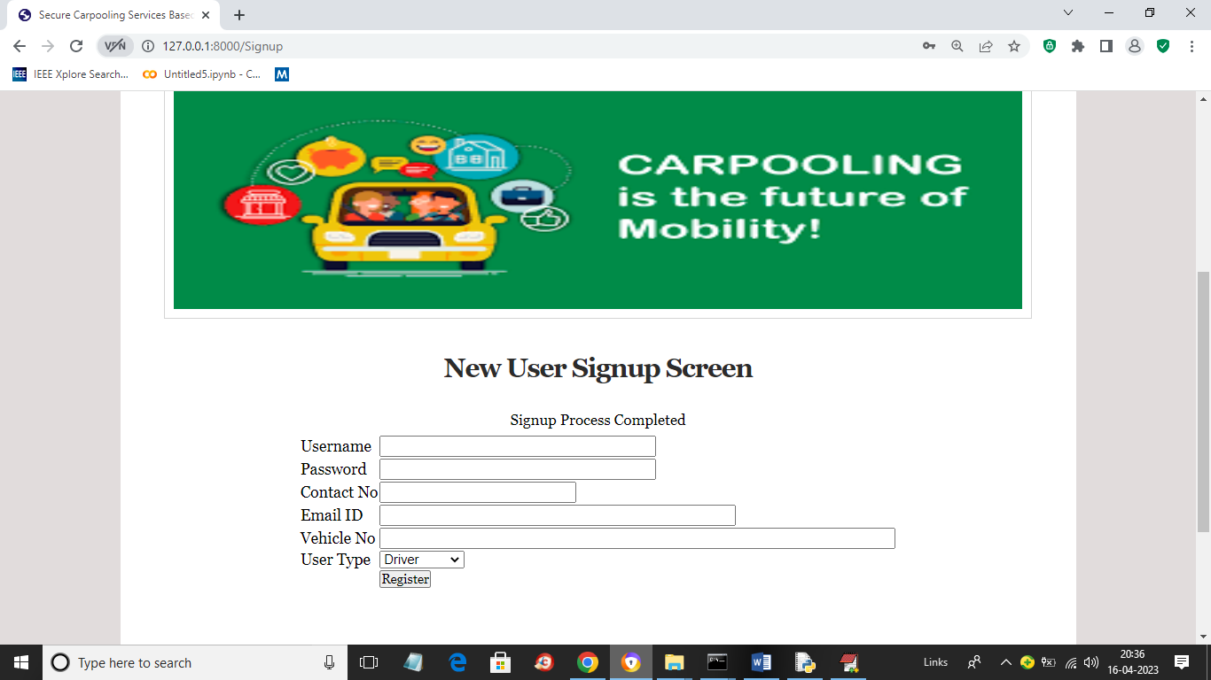

In above screen passenger details added and now click on ‘Driver/Passenger Login’ link to get below page

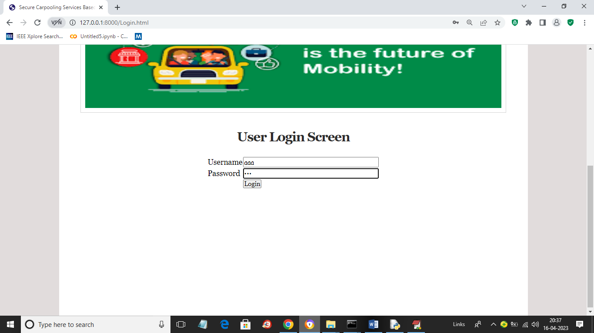

In above screen driver is login and after login will get below page

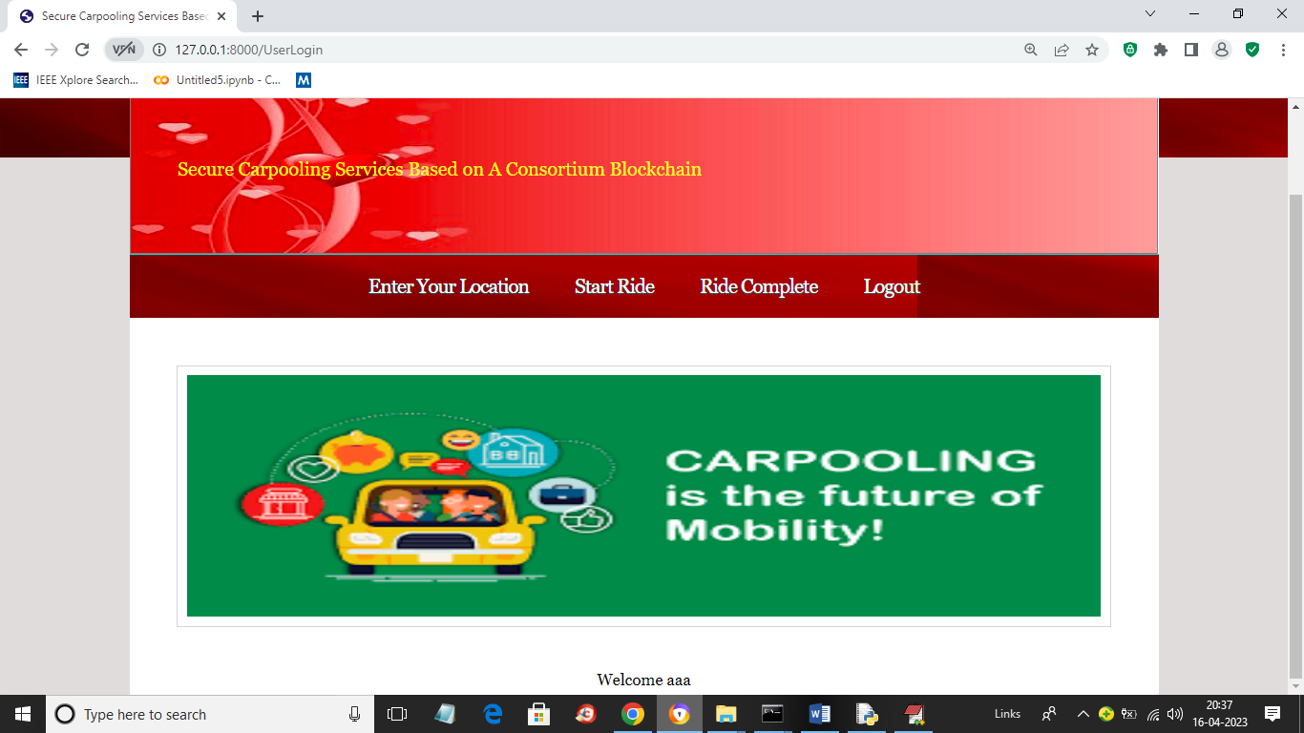

In above screen driver can click on ‘Enter Your Location’ link to add his current location details

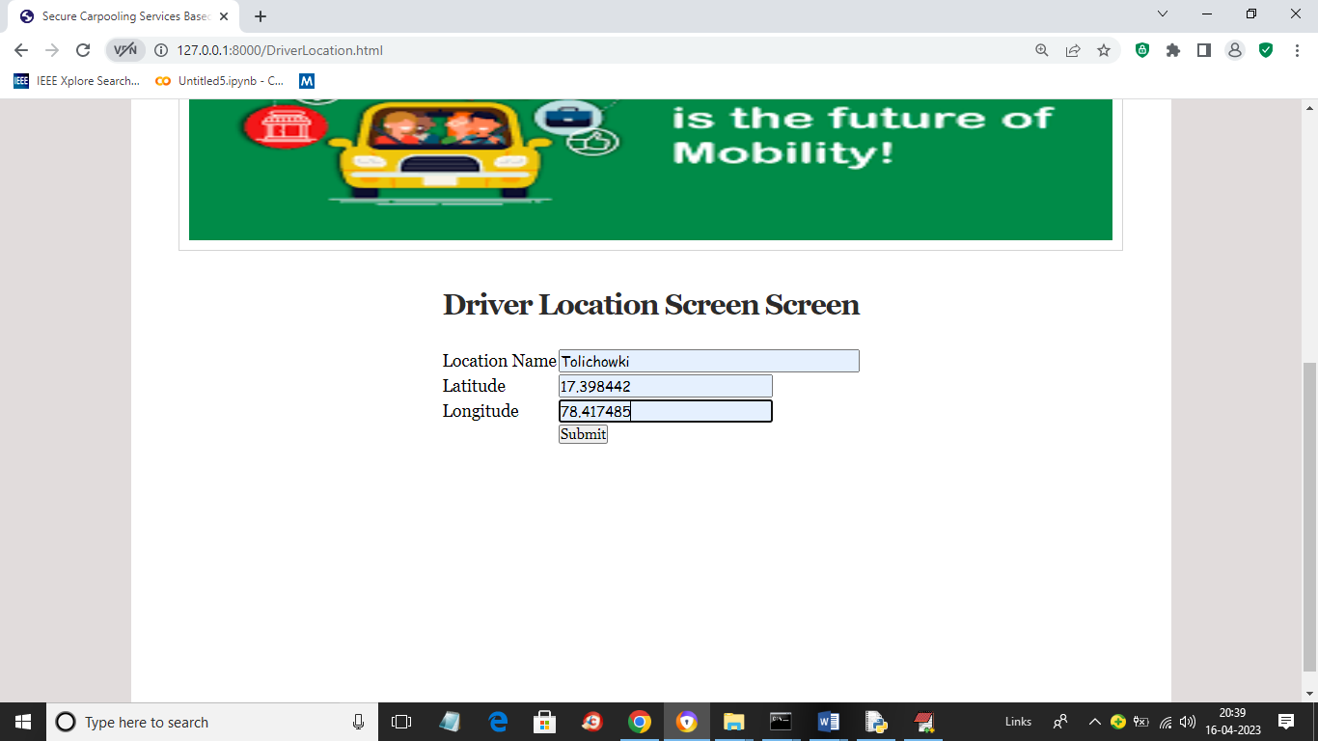

In above screen driver entering current location name, latitude and longitude as we don’t have GPS so we entering latitude and longitude manually and now prees ‘Submit’ button to get below page

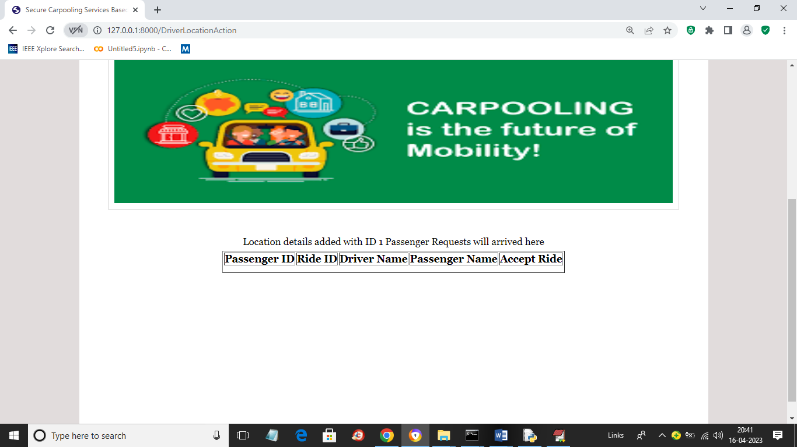

In above screen driver screen waiting for request from passengers and if any request arrived then above table will get updated and driver can accept desired request and wait for passenger to start ride. Now let above screen running and then open new browser tab and login as ‘Passenger’ to send request like below screen

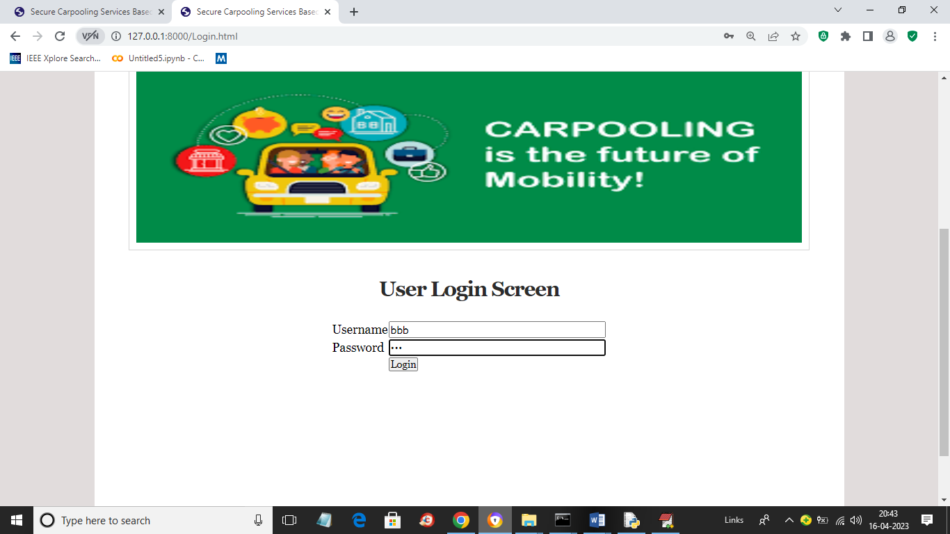

In above screen I am login as passenger and now click on ‘Login’ button to get below page

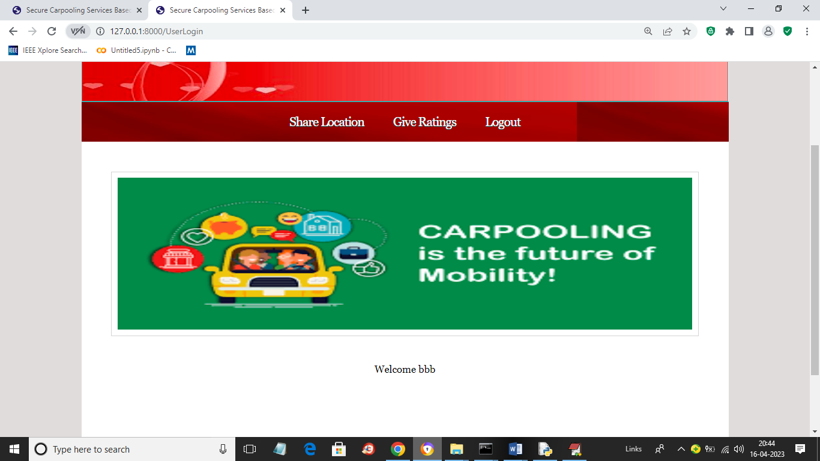

In above screen passenger can click on ‘Share Location’ link to share his location with drivers to accept and start ride

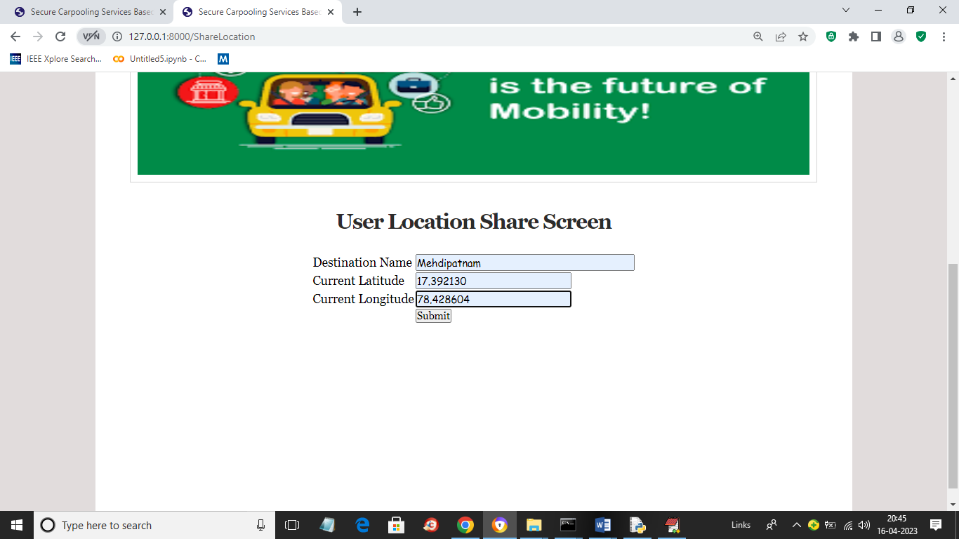

In above screen passenger user is sharing his location and press button to get below page

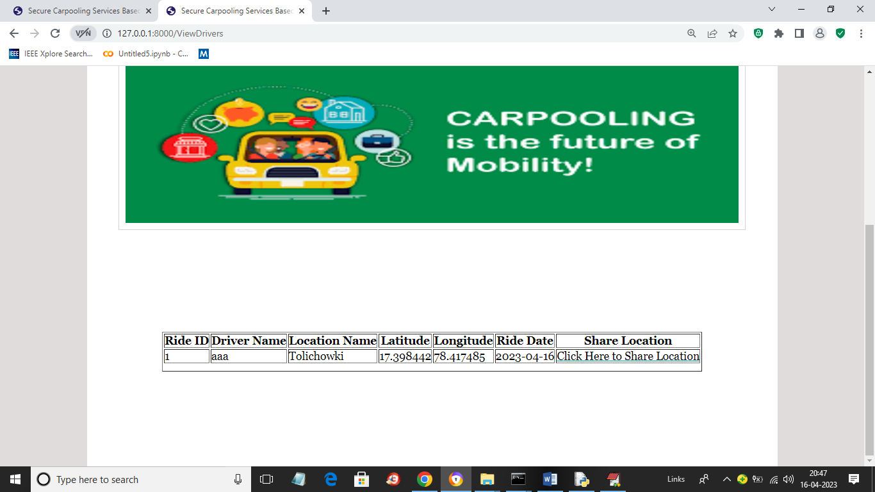

In above screen passenger can click on ‘Click Here to Share Location’ link to send request top driver and if distance between passenger and driver under 3 miles then driver will get below request under driver tab

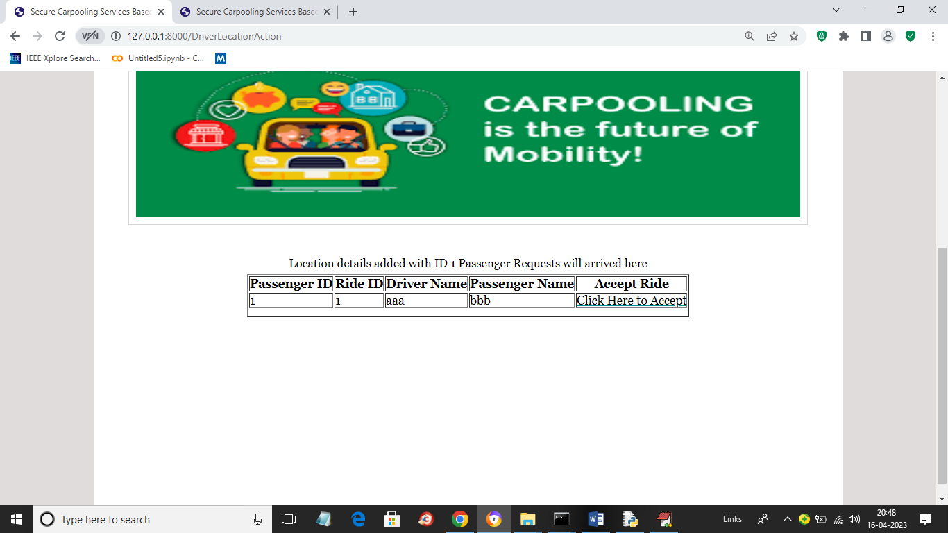

In above screen driver can view request details from passenger ‘bbb’ and now click on ‘Click Here to Accept’ link to accept request and then click on ‘Start Ride’ link once passenger arrived to start ride and get below page

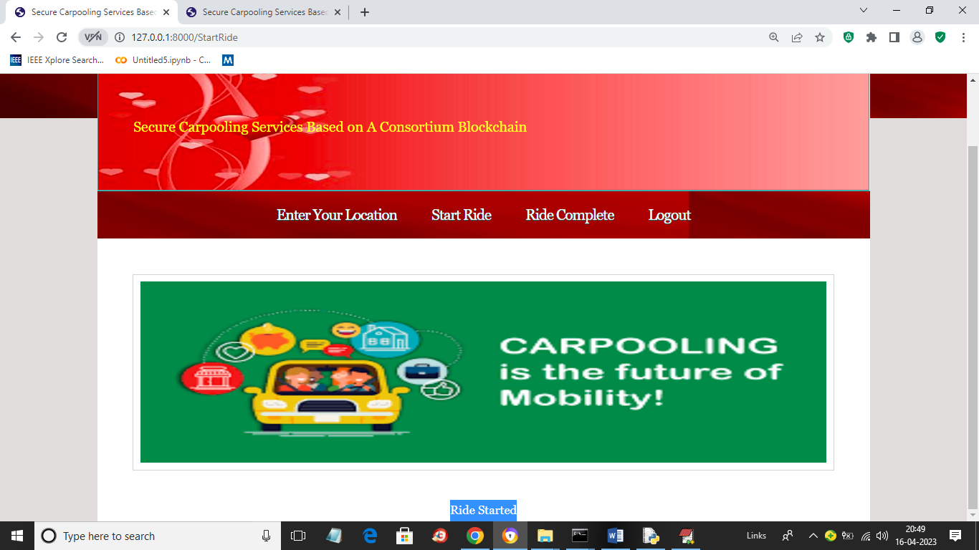

In above screen ride started and once ride completed then driver can click on ‘Ride Complete’ link to get below page

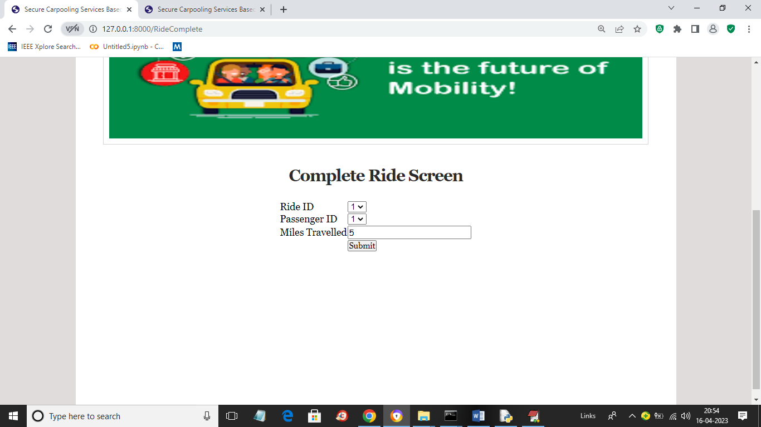

In above screen driver will select ride id and passenger id and then entre number of miles travelled to calculate below fair amount

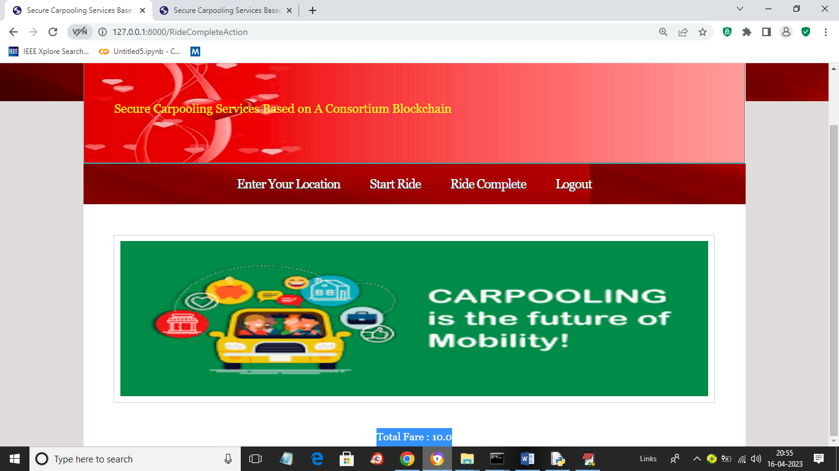

In above screen total fair to collect is 10 and similarly by taking latitude and longitude details from Internet you can add driver and passenger location to share trip. Any time passengers can give ratings to drivers

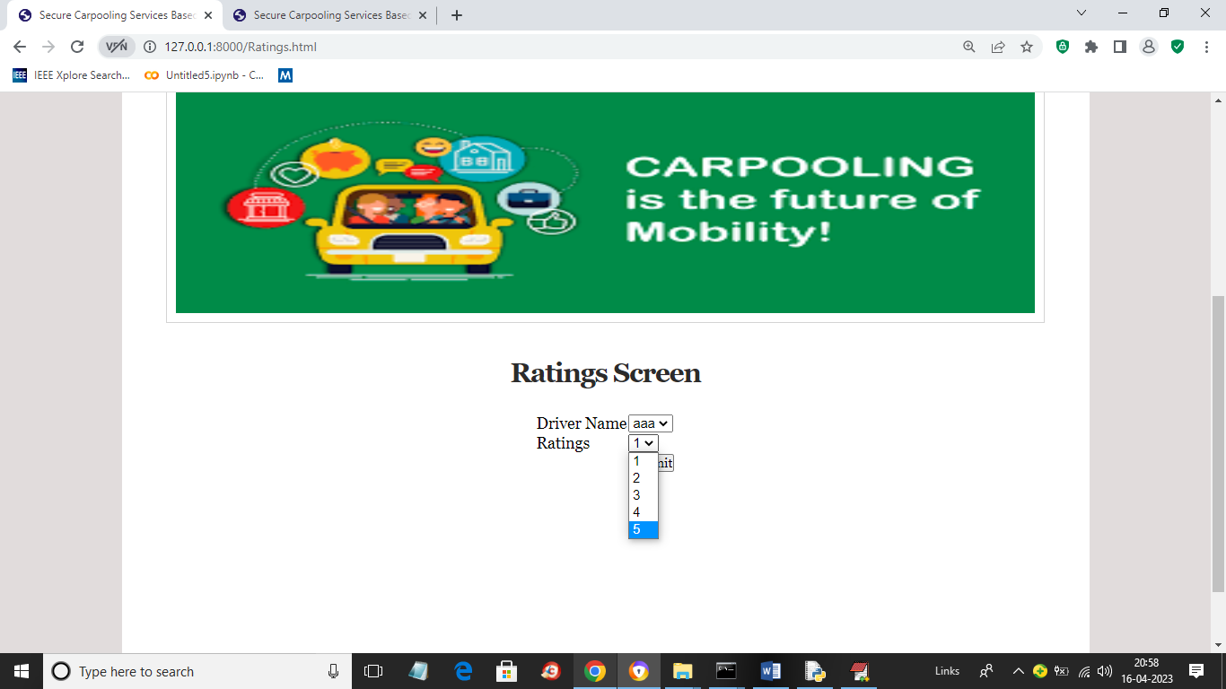

In above screen passenger can select driver name and can give desire rating and press button to get below page

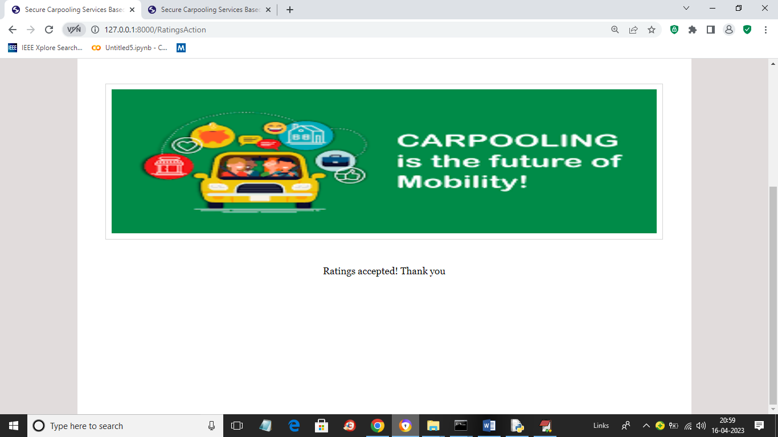

In above screen ratings accepted.