1. 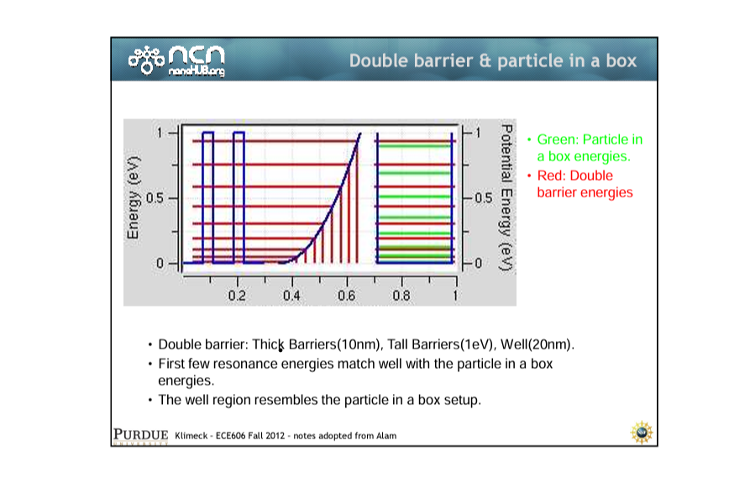
2. 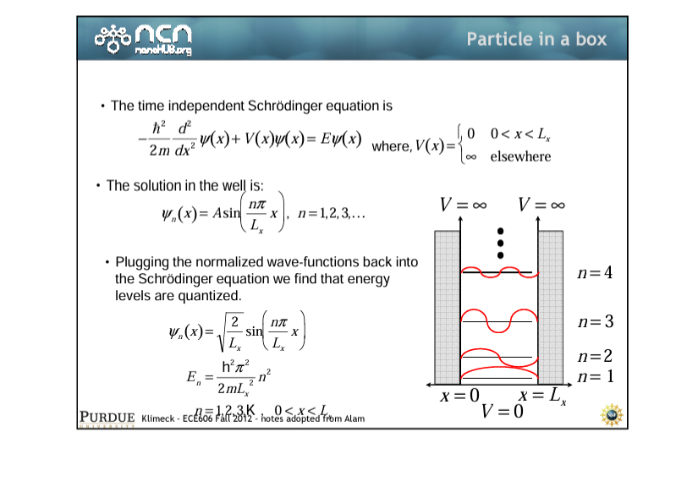
3. On increasing Lx, En increases, gap between resonant energies decreases, and fundamental resonant energy decreases (We see more peaks)