**Booking Lite App**

**Author:** Abhineet Raman([21f1005523@ds.study.iitm.ac.in](mailto:21f1005523@ds.study.iitm.ac.in))

21f1005523

**Description:** Divided tasks of different functionality into smaller tasks and constantly worked upon each task. Although every time I encountered a bug, tried to fix it by own. If doesn’t able to do so, then taking help of different resources like the documentation, few seniors and course instructor and completed the project.

**Database Design:**

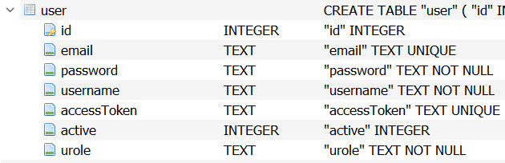 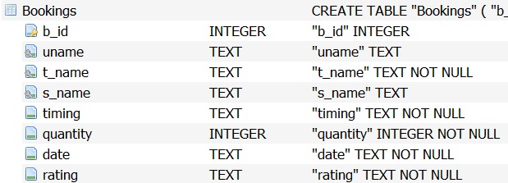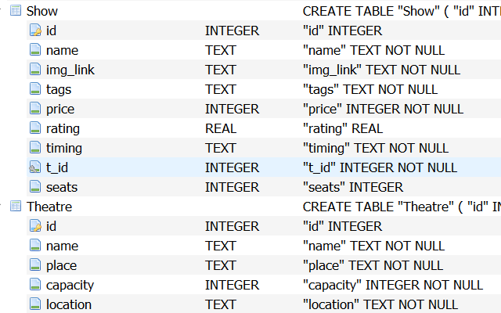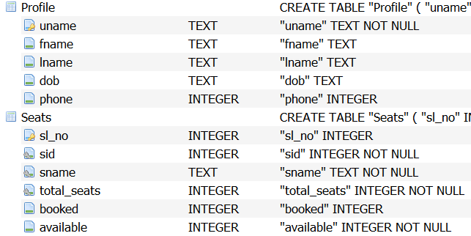

**System Design:**

• **OS:** Any OS is compatible

• **Coding Languages used:** HTML, CSS, JavaScript(Vue.Js), Python(Flask, Flask-SQLAlchemy, Matplotlib, celery, flask-caching, flask-restful, flask-JWT-Extended, Jinja2, SMTPlib and basic modules)

• **Database:** SQLite

• **Platform:** Any Browser which supports HTML5

• **Features:** This project includes 11 components with two different types of users- Admin and Std. User:

1. **Login Page:** To login into the account using token-based Authentication
2. **Signup Page:** To create user in database.
3. **Dashboard:** Two different dashboard for two different types of users for different types of tasks respectively.
4. **Add Venue:** A form which takes some data to create Venue which is done only by Admin.
5. **Add Show:** A form which takes some data to create Show which is done only by Admin.
6. **Edit Show:** A form which takes few data to update Show which is done only by Admin.
7. **Summary:** This component provides summary of the different show tickets sold in graphical chart.
8. **Bookings:** This component displays the bookings done by user and allow them to rate the booked Show.
9. **Book Ticket:** This component allows to book the selected show to the user only.
10. **Search:** This component shows searched keywords dashboard.
11. **Profile:** This component updates/Displays the profile info. Of the users.

**API Design:** API has been designed on the databases used between frontend and backend endpoints where data has been transmitted in JSON format.

**Presentation Link:** https://clipchamp.com/watch/PHpqPAfGii8