Assignment ::- 1
Name | Abhineet Tiwari
Roll No: | 20965
Subject | DBMS

Q.1). Write SQL commands to create a database named SchoolDB. The program should: 1. Create a new database named SchoolDB. 2. Select the database for use. 3. Display confirmation by creating a simple table inside it.
Ans. Create and select SchoolDB
1. Create the database
CREATE DATABASE SchoolDB;
2. Select the database
USE SchoolDB;
3. Create a simple table to confirm the database is being used
CREATE TABLE Student (
StudentID INT PRIMARY KEY,
StudentName VARCHAR(50)
);
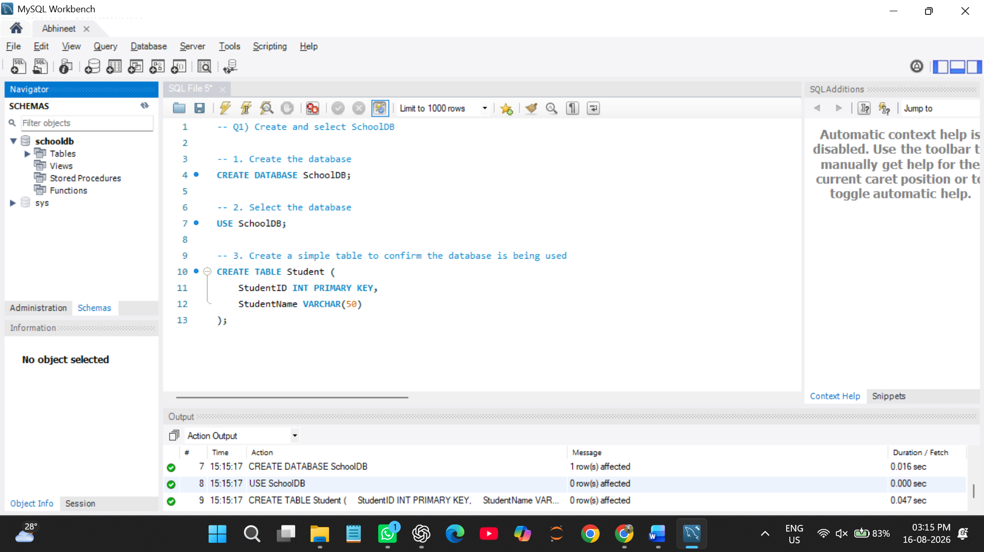

Q2) Create a table named Student with the following columns: Column Name Data Type StudentID INT Constraint StudentName PRIMARY KEY VARCHAR(50) NOT NULL Age ClassName VARCHAR(30) INT VARCHAR(20) City The program should: 1. Create the table. 2. Define proper data types. 3. Apply primary key on StudentID.
Ans.
Create a table named Student
CREATE TABLE Student (
-- Unique ID for each student
StudentID INT PRIMARY KEY,
-- Student name cannot be empty
StudentName VARCHAR(50) NOT NULL,
-- Student age
Age INT,
-- Student's class name
ClassName VARCHAR(20),
-- Student's city
City VARCHAR(30));
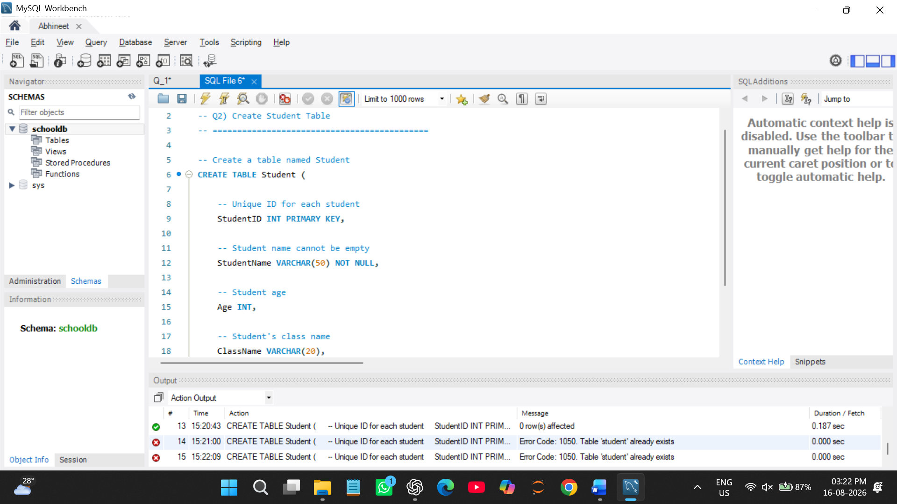

Q3) Insert at least 10 records into the Student table. The records should include: 1. Student ID 2. Student name 3. Age 4. Class name 5. City After inserting data, display all records using the SELECT command.
Ans. -- Insert 10 student records
INSERT INTO Student
(StudentID, StudentName, Age, ClassName, City)
VALUES
(1, 'Rahul Sharma', 20, 'BSc IT', 'Mumbai'),
(2, 'Priya Patil', 19, 'BCA', 'Pune'),
(3, 'Aman Verma', 21, 'BSc CS', 'Nashik'),
(4, 'Sneha Joshi', 20, 'BSc IT', 'Mumbai'),
(5, 'Karan Mehta', 22, 'BCA', 'Thane'),
(6, 'Neha Singh', 19, 'BSc CS', 'Pune'),
(7, 'Rohit Kumar', 21, 'BSc IT', 'Nagpur'),
(8, 'Anjali Deshmukh', 20, 'BCA', 'Pune'),
(9, 'Vikas Shah', 22, 'BSc CS', 'Mumbai'),
(10, 'Pooja Kulkarni', 19, 'BSc IT', 'Nashik');
-- Display all records
SELECT * FROM Student; 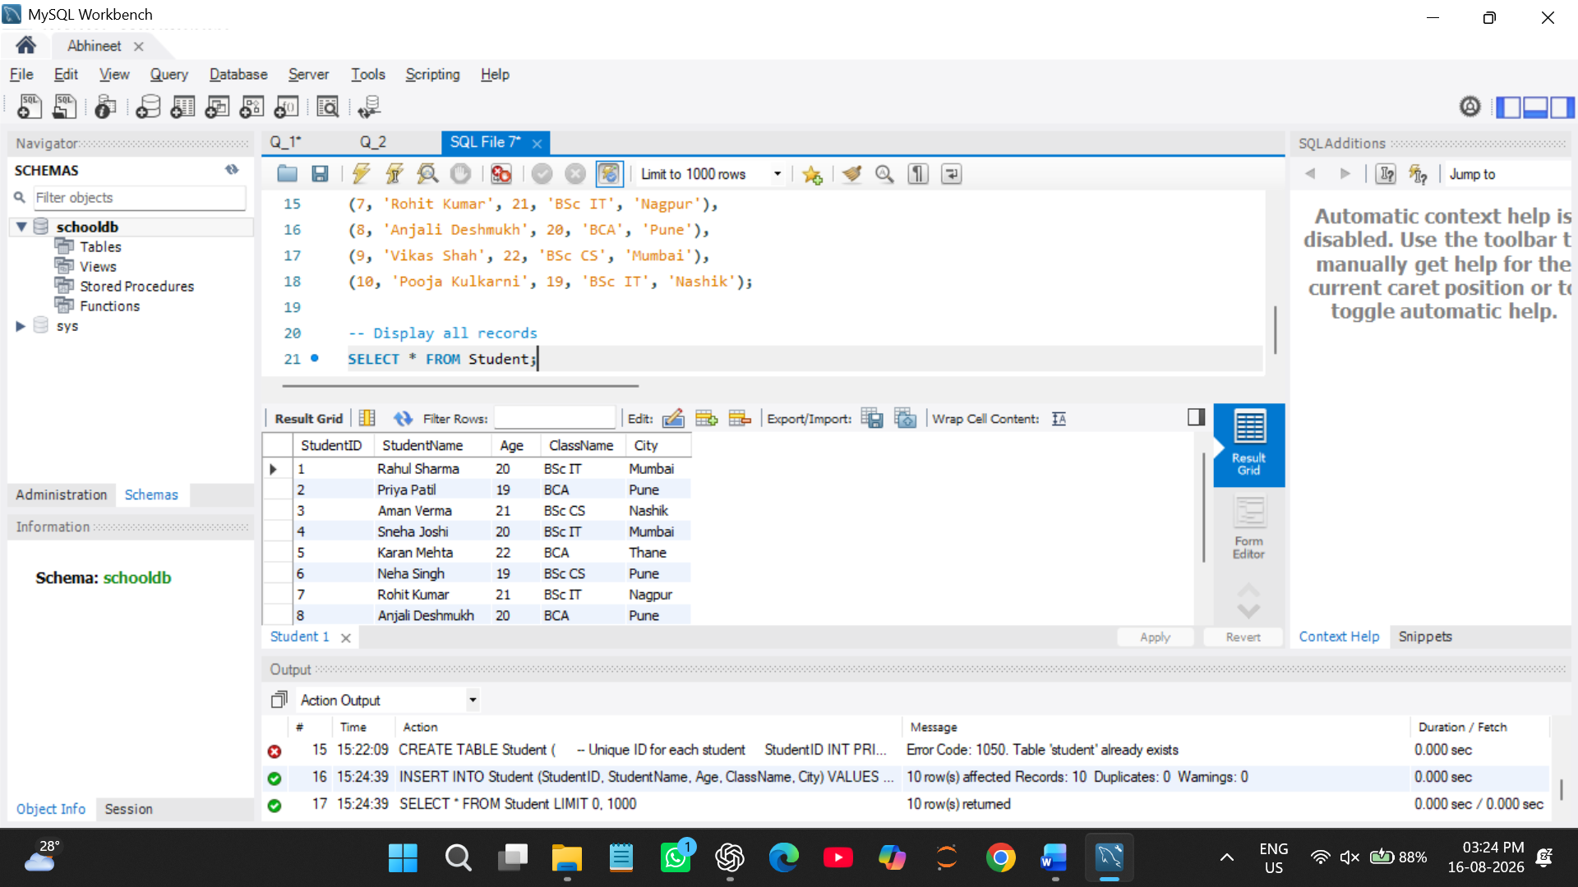

Q4) Create a table named Course with the following fields:

Column Name Data Type CourseID CourseName INT VARCHAR(50) Duration Fees VARCHAR(20) DECIMAL(10,2)

The program should: 1. Create the table. 2. Add a primary key on CourseID. 3. Insert at least 5 course records. 4. Display all course records.
Ans. -- Create the Course table
CREATE TABLE Course (
CourseID INT PRIMARY KEY,
CourseName VARCHAR(50),
Duration VARCHAR(20),
Fees DECIMAL(10,2)
);
-- Insert 5 course records
INSERT INTO Course
(CourseID, CourseName, Duration, Fees)
VALUES
(101, 'BSc IT', '3 Years', 45000.00),
(102, 'BCA', '3 Years', 40000.00),
(103, 'BSc CS', '3 Years', 42000.00),
(104, 'BBA', '3 Years', 38000.00),
(105, 'BCom', '3 Years', 35000.00);
-- Display all course records
SELECT * FROM Course; 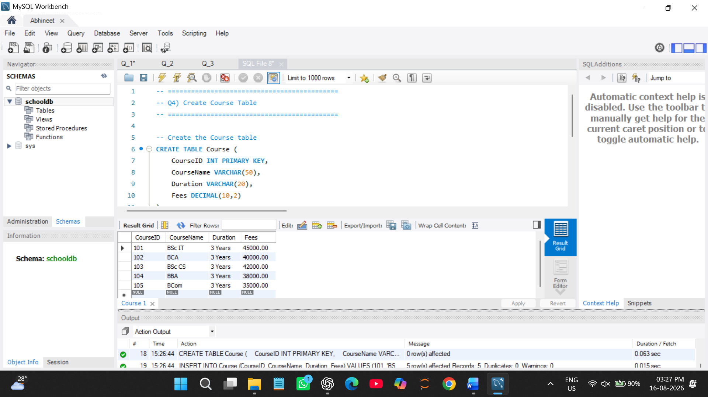

Q5) Write SQL queries to display only selected columns from the Student table. Display: 1. StudentName 2. ClassName 3. City Expected output should show only these three columns.
Ans. -- Display only StudentName, ClassName and City
SELECT StudentName, ClassName, City
FROM Student; 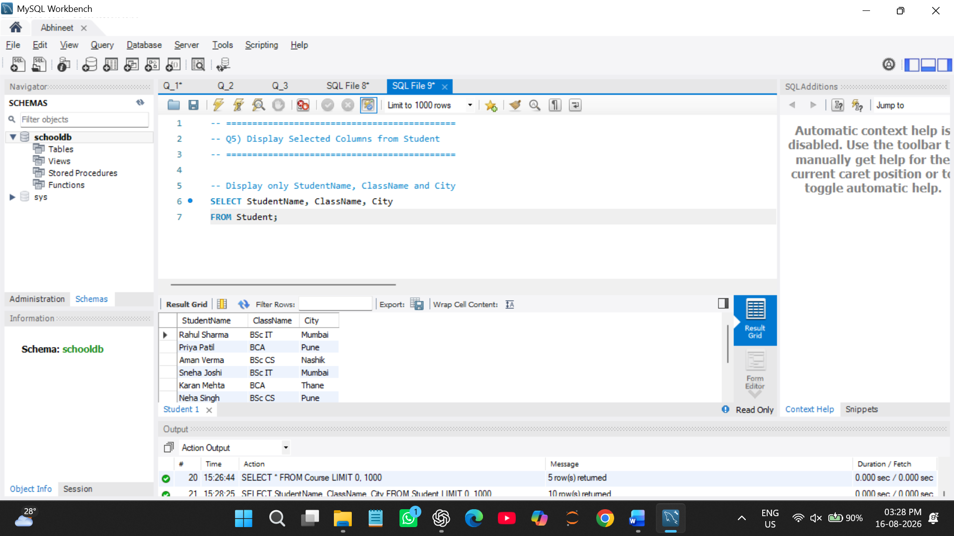

Q6) Write SQL commands to view the structure of the Student table. Use the suitable command according to the database environment: Database Command MySQL DESC Student; PostgreSQL tudent SQLite PRAGMA table_info(Student);
Ans.
-- Display the structure of the Student table
DESC Student; 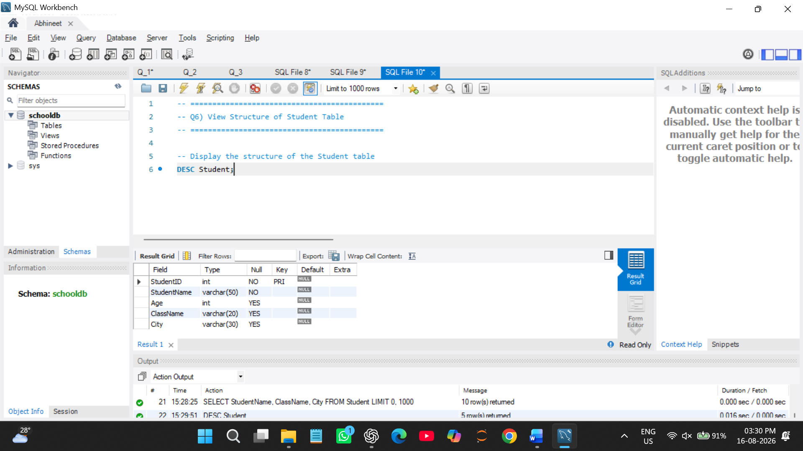

Q7) Prepare a CSV file named students.csv and import it into the Student table. The CSV file should contain: StudentID StudentName 1 Aarav Shah Age ClassName City 18 2 Meera Joshi FYBSc IT Mumbai 19 3 Rohan Patil 20 FYBCA Pune SYBSc IT Nashik The task should include: 1. Creating a matching table. 2. Importing the CSV file. 3. Displaying imported records using SELECT.
Ans.
CREATE TABLE StudentCSV (
StudentID INT PRIMARY KEY,
StudentName VARCHAR(50),
Age INT,
ClassName VARCHAR(20),
City VARCHAR(30)
);

Display imported records
SELECT * FROM StudentCSV; 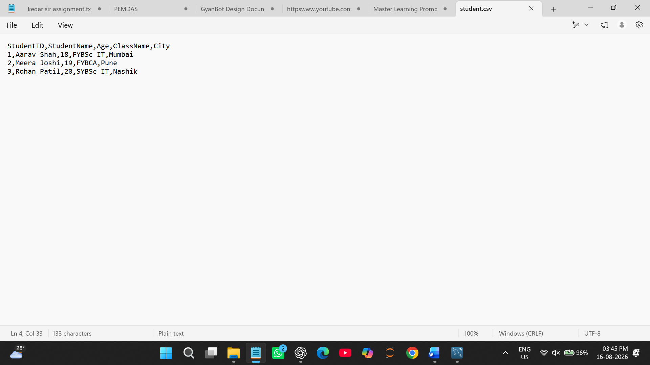 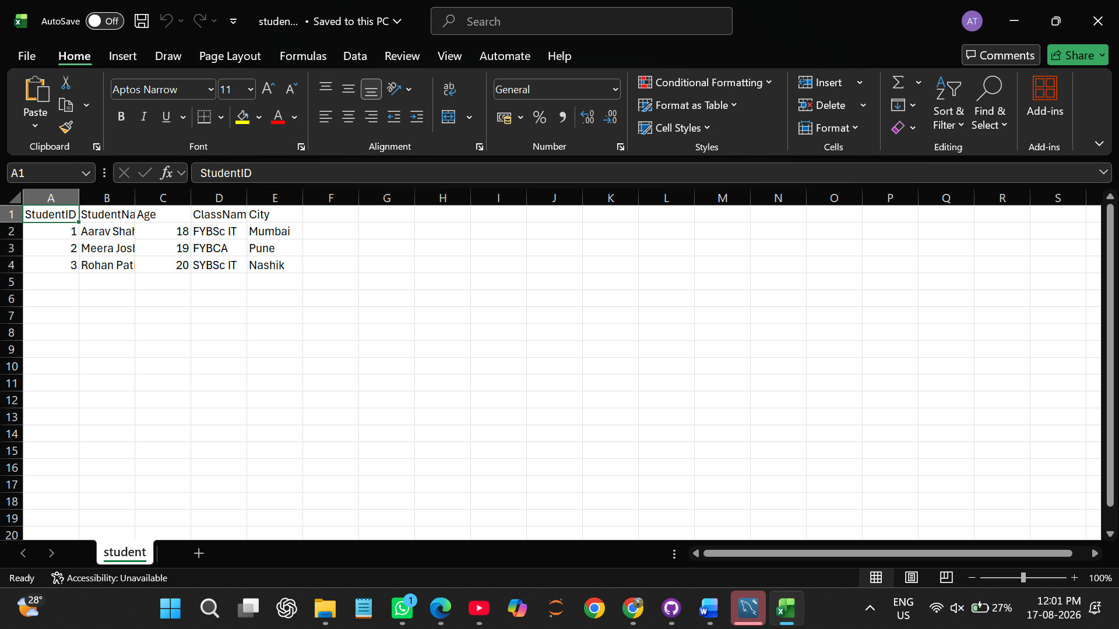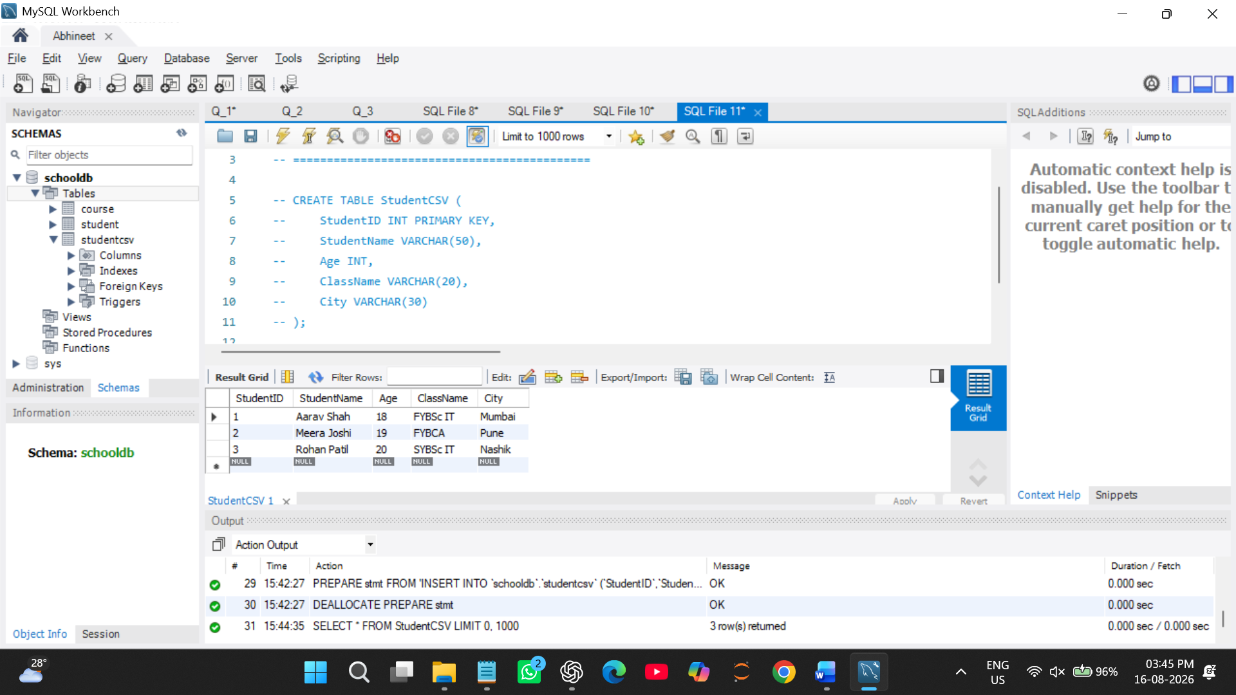

Q8) Create a database named EmployeeDB and a table named Employee. The table should contain: Column Name Data Type EmployeeID INT EmployeeName VARCHAR(50) Department Salary VARCHAR(30) DECIMAL(10,2).
Ans.
-- 1. Create the database
CREATE DATABASE EmployeeDB;

-- Select the database
USE EmployeeDB;
-- 2. Create the Employee table
CREATE TABLE Employee (
EmployeeID INT PRIMARY KEY,
EmployeeName VARCHAR(50),
Department VARCHAR(30),
Salary DECIMAL(10,2),
City VARCHAR(30)
);
-- 3. Insert 8 employee records
INSERT INTO Employee
(EmployeeID, EmployeeName, Department, Salary, City)
VALUES
(1, 'Amit Sharma', 'IT', 55000.00, 'Mumbai'),
(2, 'Priya Patil', 'HR', 48000.00, 'Pune'),
(3, 'Rahul Verma', 'Finance', 60000.00, 'Nashik'),
(4, 'Sneha Joshi', 'IT', 58000.00, 'Mumbai'),
(5, 'Karan Mehta', 'Sales', 45000.00, 'Thane'),
(6, 'Neha Singh', 'HR', 50000.00, 'Pune'),
(7, 'Rohit Kumar', 'Finance', 62000.00, 'Nagpur'),
(8, 'Anjali Shah', 'Sales', 47000.00, 'Mumbai');
-- 4. Display all employee records
SELECT * FROM Employee; 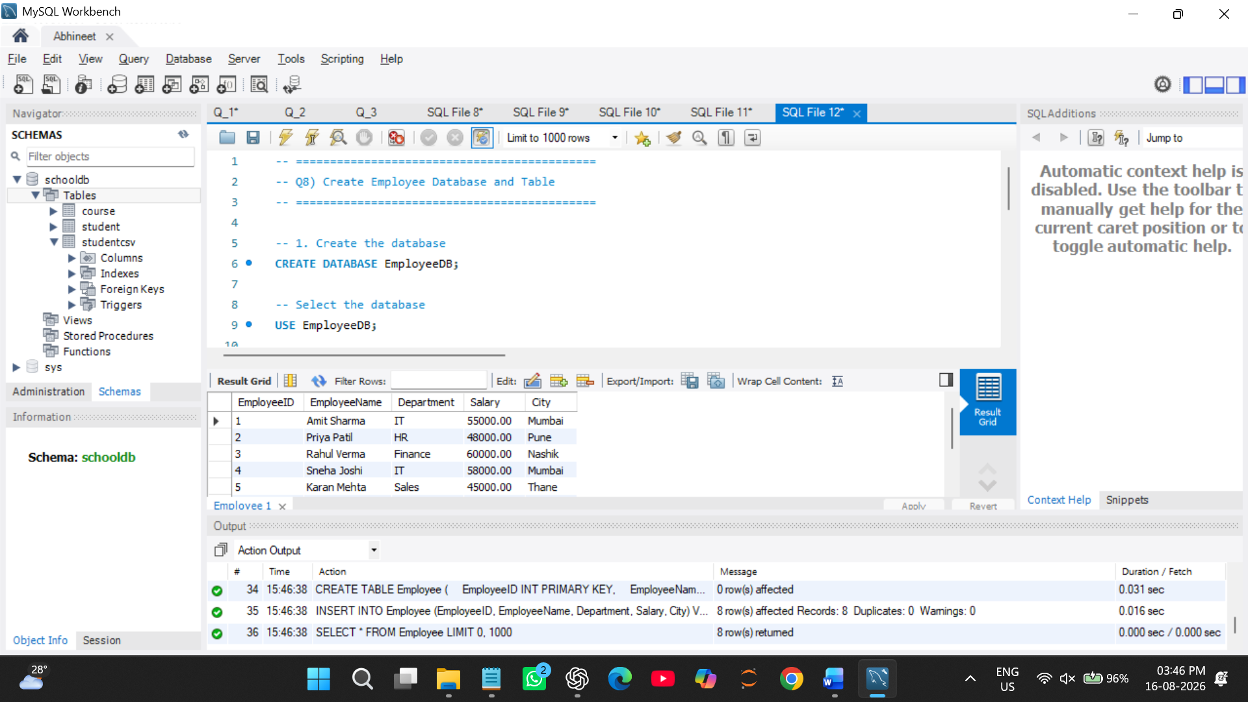

Q9) Write SQL queries to compare the difference between SELECT * and selecting specific columns. The task should include: 1. Query using SELECT * FROM Student; 2. Query using SELECT StudentName, City FROM Student; 3. Write two lines explaining the difference between both outputs.
Ans.
-- Select the database containing the Student table
USE SchoolDB;
-- 1. Display all columns from Student table
SELECT * FROM Student;
-- 2. Display only StudentName and City
SELECT StudentName, City
FROM Student; 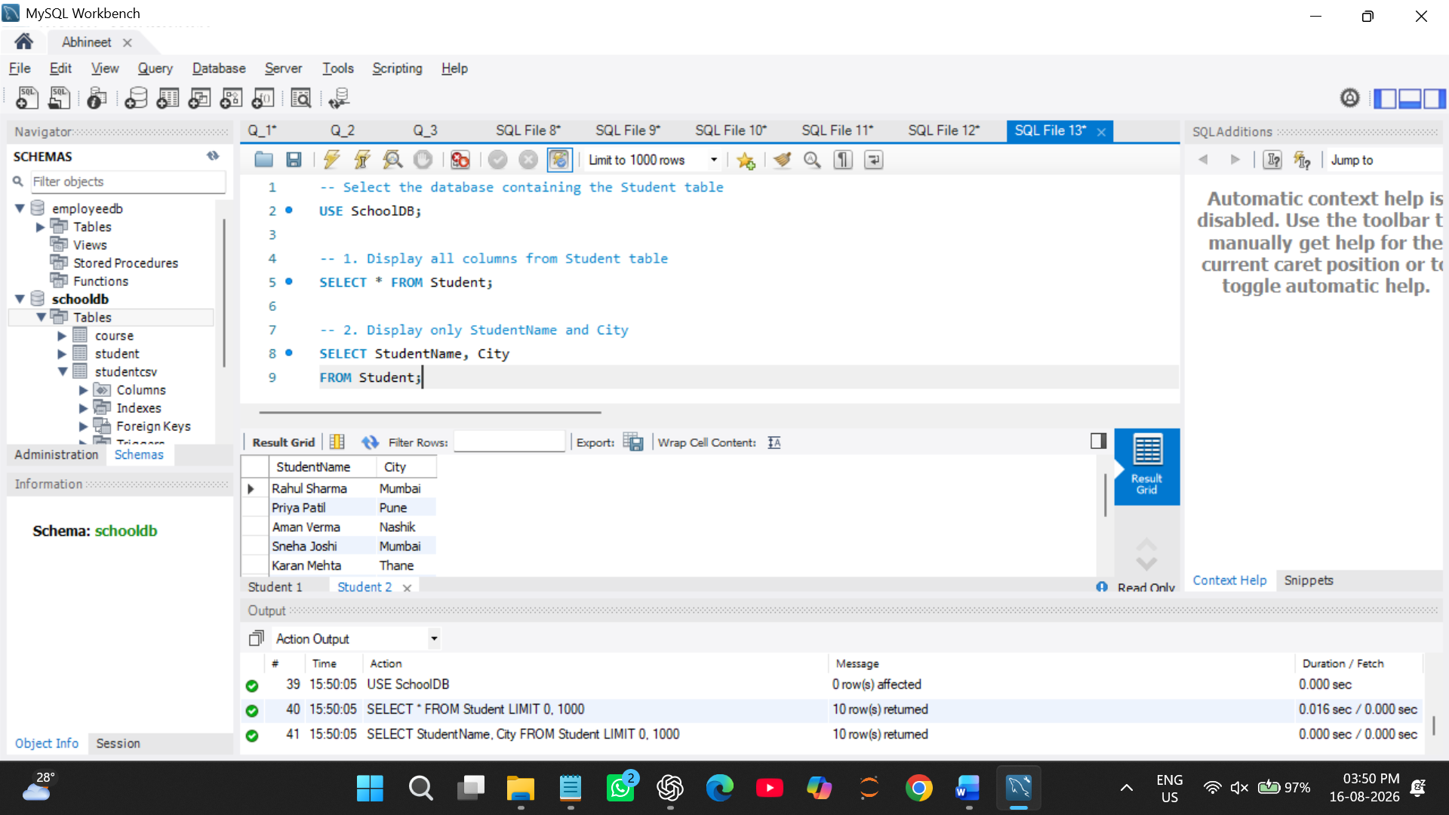

Q10) Create a complete SQL script for a mini college database. The script should include: 1. Creating database MiniCollegeDB. 2. Creating tables Student, Course, and Faculty. 3. Adding suitable columns and data types. 4. Inserting at least 5 records in each table. 5. Displaying all records from each table. 6. Viewing the structure of each table.
Ans.
1. Create the database
CREATE DATABASE MiniCollegeDB;
Select the database
USE MiniCollegeDB;
============================================
2. Create Student Table
============================================
CREATE TABLE Student (
StudentID INT PRIMARY KEY,
StudentName VARCHAR(50) NOT NULL,
Age INT,
CourseID INT,
City VARCHAR(30)
);
============================================
3. Create Course Table
============================================
CREATE TABLE Course (
CourseID INT PRIMARY KEY,
CourseName VARCHAR(50) NOT NULL,
Duration VARCHAR(20),
Fees DECIMAL(10,2)
);
============================================
4. Create Faculty Table
============================================
CREATE TABLE Faculty (
FacultyID INT PRIMARY KEY,
FacultyName VARCHAR(50) NOT NULL,
Department VARCHAR(30),
Salary DECIMAL(10,2),
City VARCHAR(30)
);
============================================
5. Insert 5 Student Records
============================================
INSERT INTO Student
(StudentID, StudentName, Age, CourseID, City)
VALUES
(1, 'Rahul Sharma', 20, 101, 'Mumbai'),
(2, 'Priya Patil', 19, 102, 'Pune'),
(3, 'Aman Verma', 21, 103, 'Nashik'),
(4, 'Sneha Joshi', 20, 101, 'Mumbai'),
(5, 'Karan Mehta', 22, 102, 'Thane');
============================================
6. Insert 5 Course Records
============================================
INSERT INTO Course
(CourseID, CourseName, Duration, Fees)
VALUES
(101, 'BSc IT', '3 Years', 45000.00),
(102, 'BCA', '3 Years', 40000.00),
(103, 'BSc CS', '3 Years', 42000.00),
(104, 'BBA', '3 Years', 38000.00),
(105, 'BCom', '3 Years', 35000.00);
============================================
7. Insert 5 Faculty Records
============================================
INSERT INTO Faculty
(FacultyID, FacultyName, Department, Salary, City)
VALUES
(1, 'Sanjay Sharma', 'IT', 65000.00, 'Mumbai'),
(2, 'Priya Deshmukh', 'Computer Science', 70000.00, 'Pune'),
(3, 'Rajesh Patil', 'Management', 60000.00, 'Nashik'),
(4, 'Neha Joshi', 'Commerce', 58000.00, 'Thane'),
(5, 'Amit Verma', 'IT', 68000.00, 'Mumbai');

============================================
8. Display All Student Records
============================================
SELECT * FROM Student;
============================================
9. Display All Course Records
============================================
SELECT * FROM Course;
============================================
10. Display All Faculty Records
============================================
SELECT * FROM Faculty;
============================================
11. View Student Table Structure
============================================
DESC Student;
============================================
12. View Course Table Structure
============================================
DESC Course;
============================================
13. View Faculty Table Structure
============================================
DESC Faculty; 