Assignment ::- 2
Name | Abhineet Tiwari
Roll No: | 20965
Subject | DBMS

Q1) Create a database named CollegeDB and a table named Student.

The table should contain the following columns:
Column Name | Data Type
StudentID | INT
StudentName | VARCHAR(50)
Age | INT
Course | VARCHAR(30)
City | VARCHAR(30)
Marks | INT
Add a primary key on StudentID and insert at least 10 records.
-- Create the database
CREATE DATABASE CollegeDB;
-- Select the database
USE CollegeDB;
-- Create the Student table
CREATE TABLE Student (
StudentID INT PRIMARY KEY,
StudentName VARCHAR(50),
Age INT,
Course VARCHAR(30),
City VARCHAR(30),
Marks INT
);
-- Insert 10 records into the Student table
INSERT INTO Student
(StudentID, StudentName, Age, Course, City, Marks)
VALUES
(1, 'Rahul Sharma', 20, 'BSc IT', 'Mumbai', 78),
(2, 'Priya Patil', 19, 'BCA', 'Pune', 85),
(3, 'Aman Verma', 21, 'BSc CS', 'Nashik', 67),
(4, 'Sneha Joshi', 20, 'BSc IT', 'Mumbai', 91),
(5, 'Karan Mehta', 22, 'BCA', 'Thane', 74),
(6, 'Neha Shah', 19, 'BSc IT', 'Pune', 88),
(7, 'Rohan Desai', 21, 'BSc CS', 'Mumbai', 69),
(8, 'Meera Kulkarni', 20, 'BCA', 'Nashik', 82),
(9, 'Arjun Gupta', 21, 'BSc CS', 'Pune', 76),
(10, 'Kavya Singh', 19, 'BSc IT', 'Thane', 89);
-- Display all records
SELECT * FROM Student; 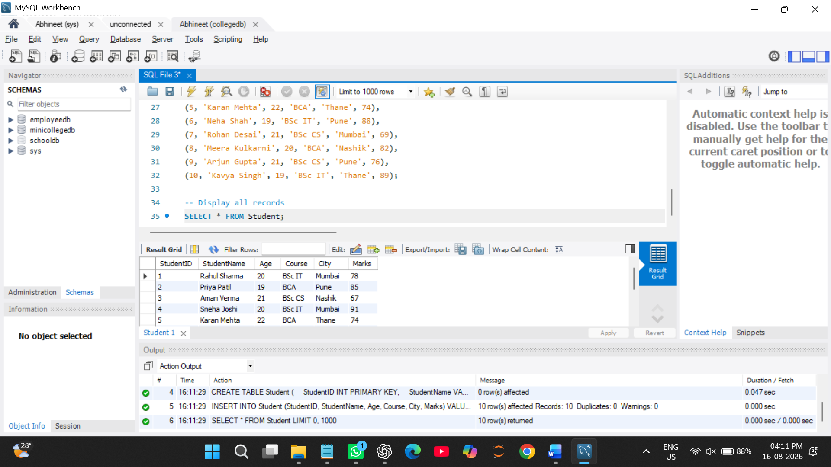

Q2) Write a MySQL query to display all records from the Student table.

The output should display all columns and all rows.
SELECT *
FROM Student;
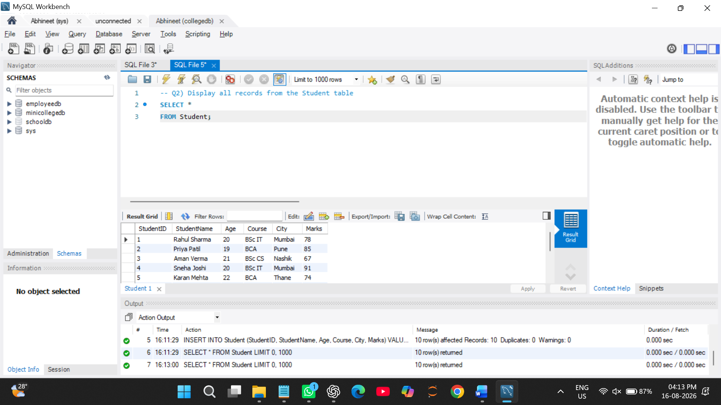

Q3) Write a MySQL query to display only the following columns:
- StudentName
- Course
- City
SELECT StudentName, Course, City
FROM Student;
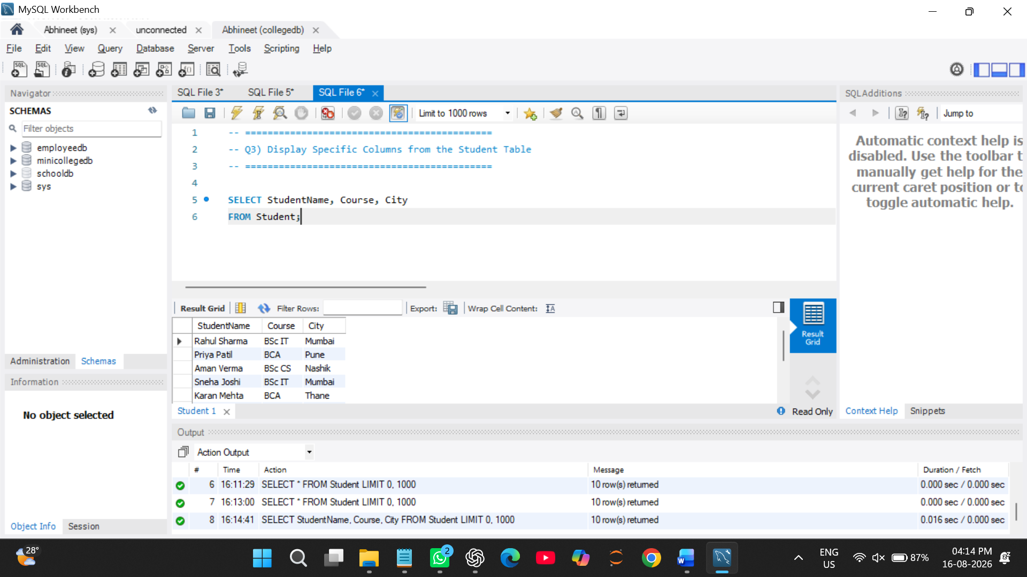 Q4) Write a MySQL query to display students who belong to the city Mumbai. The output should include:
- StudentID
- StudentName
- City
- Marks
SELECT StudentID, StudentName, City, Marks
FROM Student

WHERE City = 'Mumbai'; 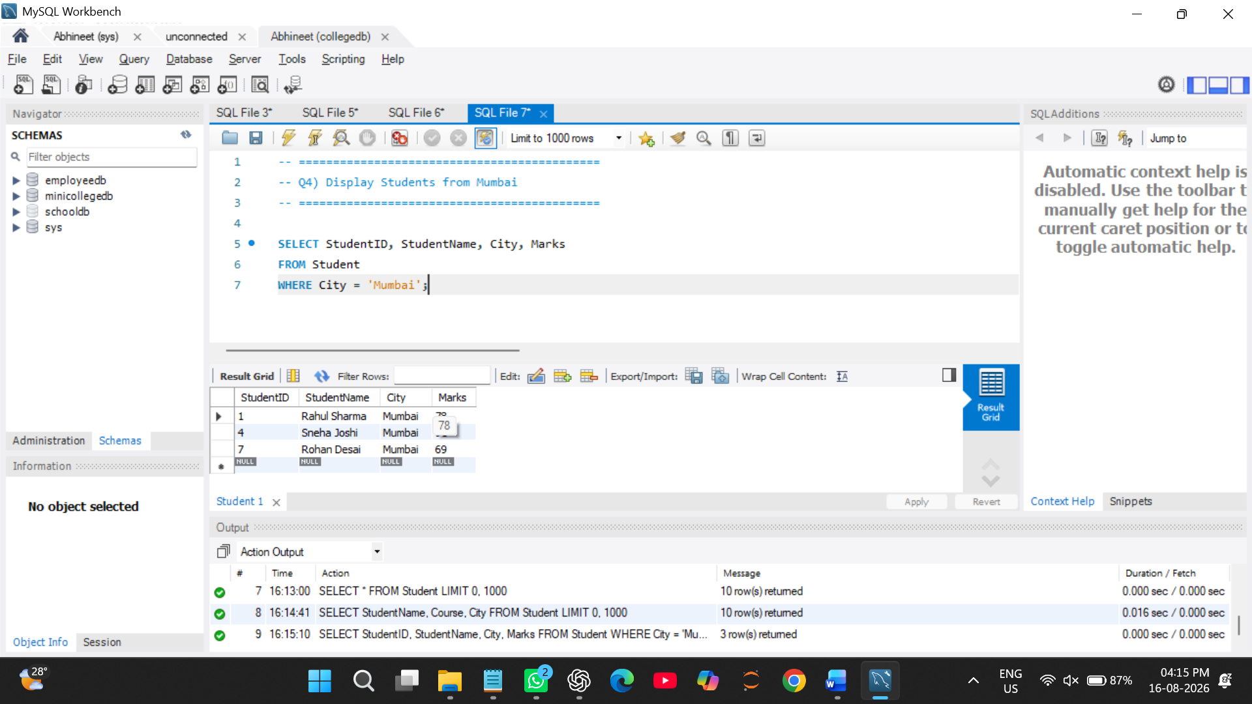

Q5) Write a MySQL query to display students whose marks are greater than 80. The output should be sorted by marks in descending order.

SELECT *
FROM Student
WHERE Marks > 80
ORDER BY Marks DESC; 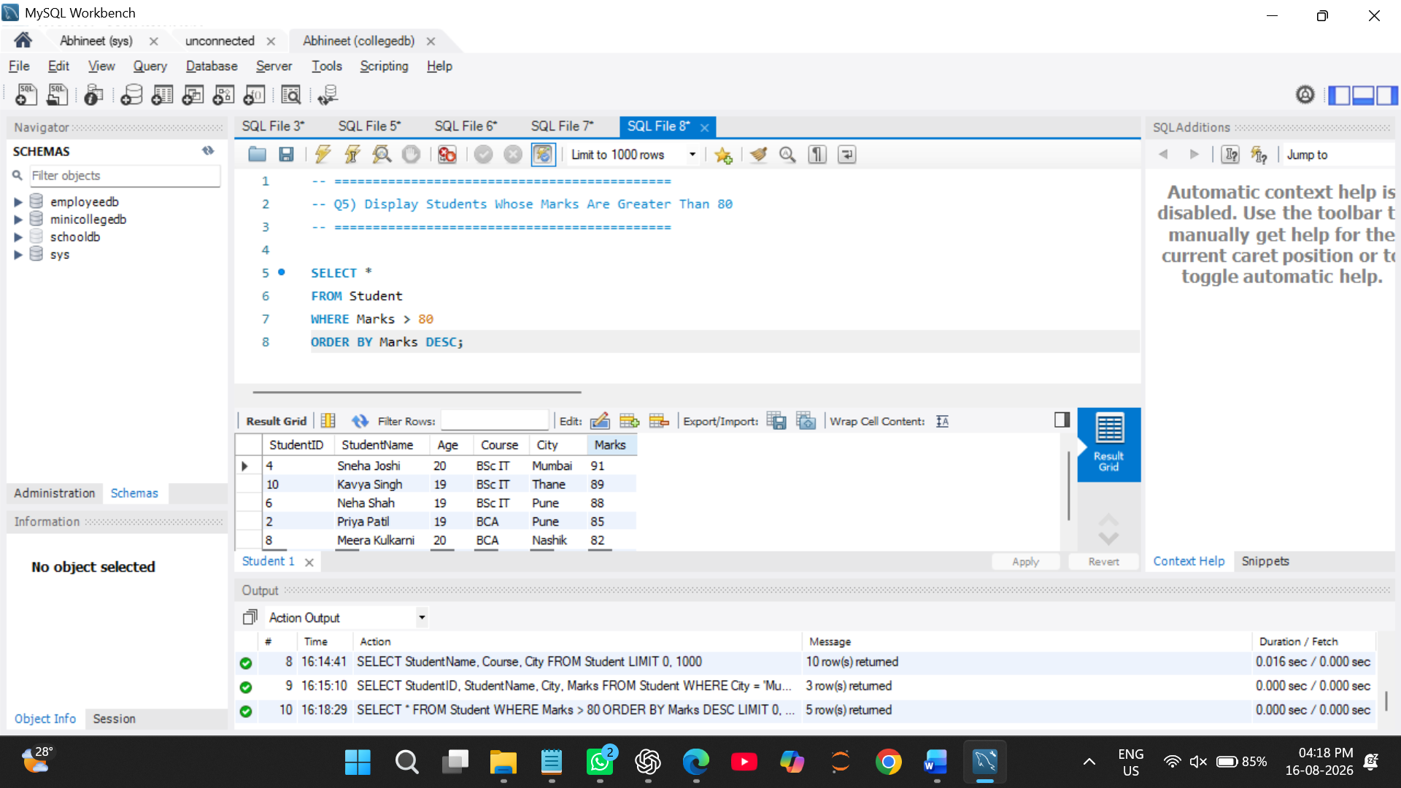

Q6) Write a MySQL query to display the top 3 students based on marks. The query should:
- Display StudentName and Marks.
- Sort marks from highest to lowest.
- Display only 3 records using LIMIT.

SELECT StudentName, Marks
FROM Student
ORDER BY Marks DESC
LIMIT 3; 