Assignment ::- 3
Name | Abhineet Tiwari
Roll No: | 20965
Subject | DBMS

Q1) Create a database named CollegeDB and a table named Student.
The table should contain the following columns:
Column Name | Data Type | Constraint
StudentID | INT | PRIMARY KEY
StudentName | VARCHAR(50)
Age | INT
Course | VARCHAR(30)
City | VARCHAR(30)
Marks | INT
Email | VARCHAR(60)

Insert at least 10 records into the table. Some records should contain NULL values in the Email column.
CREATE DATABASE CollegeDB;

USE CollegeDB;

CREATE TABLE Student (
StudentID INT PRIMARY KEY,
StudentName VARCHAR(50),
Age INT,
Course VARCHAR(30),
City VARCHAR(30),
Marks INT,
Email VARCHAR(60)
);

Insert 10 records
Some Email values are NULL

INSERT INTO Student
(StudentID, StudentName, Age, Course, City, Marks, Email)
VALUES
(1, 'Aarav Joshi', 20, 'BSc IT', 'Pune', 82, 'aarav@gmail.com'),
(2, 'Ananya Shah', 19, 'BCA', 'Mumbai', 91, 'ananya@gmail.com'),
(3, 'Riya Mehta', 21, 'BSc CS', 'Nashik', 76, NULL),
(4, 'Kabir Patil', 20, 'BSc IT', 'Thane', 68, 'kabir@gmail.com'),
(5, 'Ishita Kulkarni', 22, 'BCA', 'Pune', 87, NULL),
(6, 'Aditya More', 19, 'BSc CS', 'Mumbai', 73, 'aditya@gmail.com'),
(7, 'Snehal Deshmukh', 21, 'BSc IT', 'Nashik', 95, 'snehal@gmail.com'),
(8, 'Rahul Naik', 20, 'BCA', 'Thane', 64, NULL),
(9, 'Neha Pawar', 22, 'BSc CS', 'Pune', 89, 'neha@gmail.com'),
(10, 'Omkar Jadhav', 21, 'BSc IT', 'Mumbai', 79, 'omkar@gmail.com');--

SELECT * FROM Student;
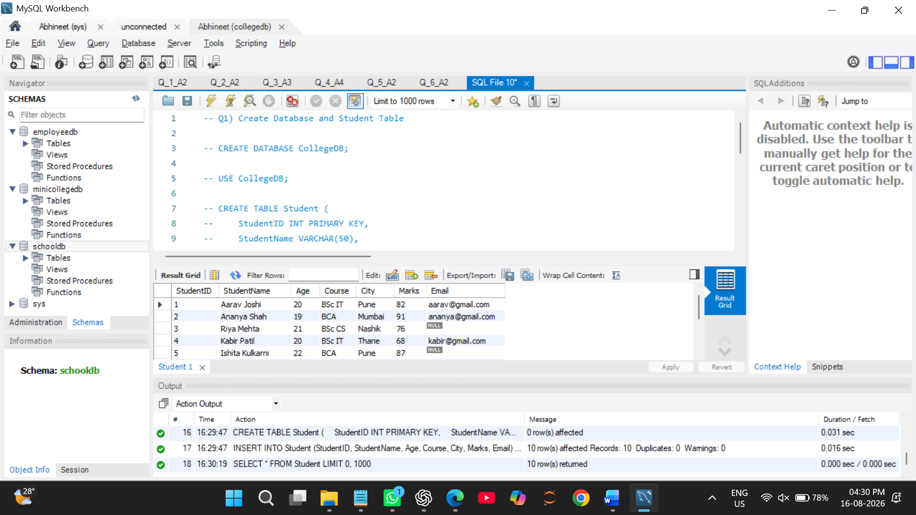

Q2) Write a MySQL query to display students who are from Mumbai and have marks greater than 80.
The output should include:
Column
StudentID
StudentName
City
Marks
SELECT StudentID, StudentName, City, Marks
FROM Student
WHERE City = 'Mumbai'
AND Marks > 80;
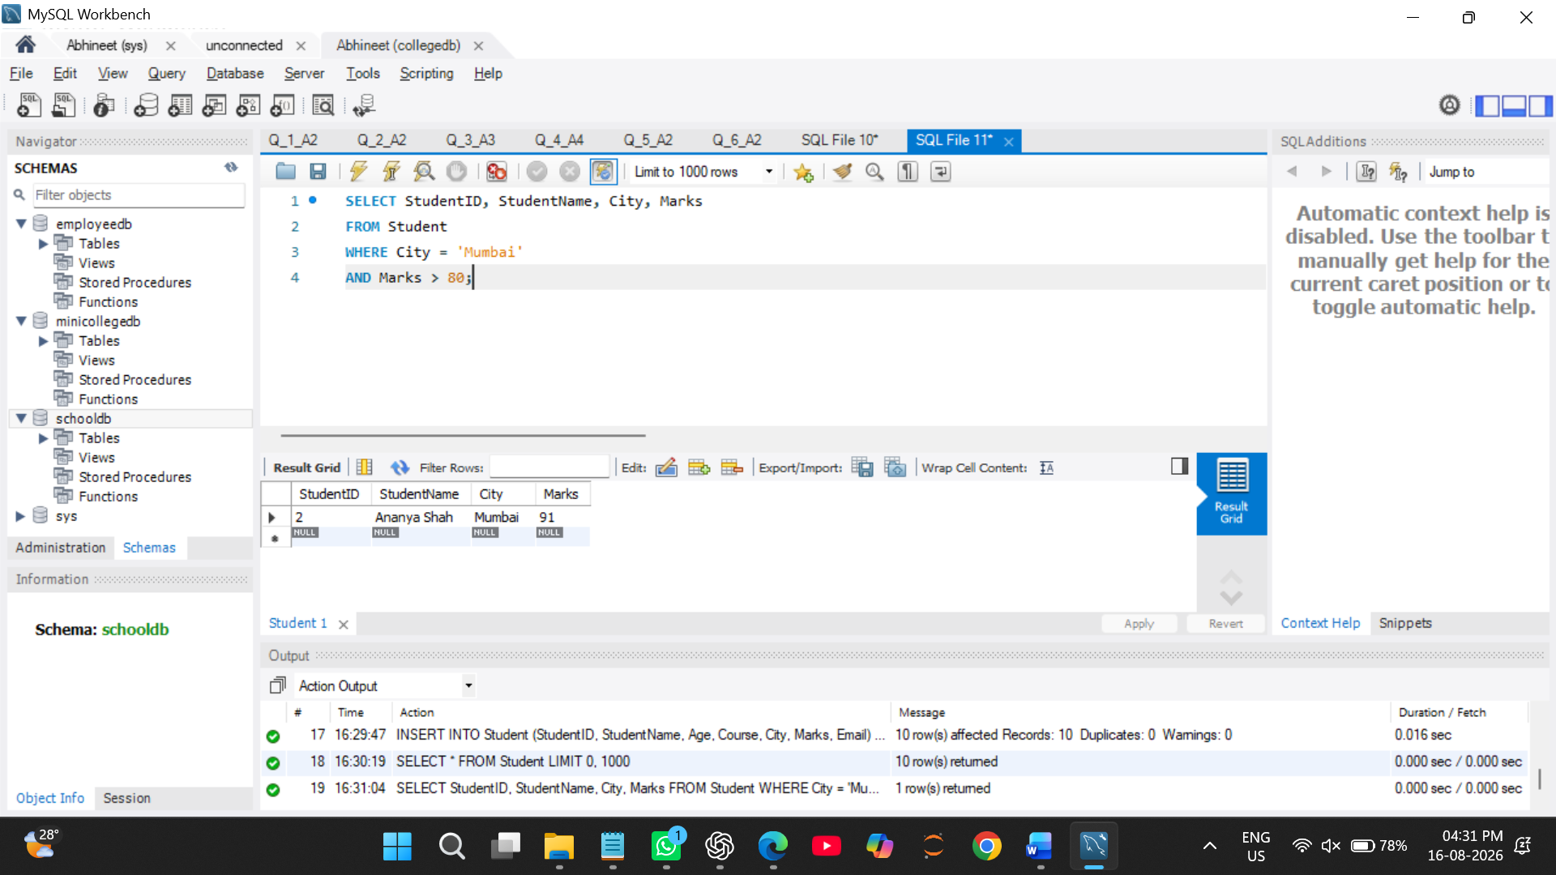

Q3) Write a MySQL query to display students who belong to either Pune or Nashik.

Use the OR operator and display the following column
Column
StudentName
Course
City

-- Use the OR operator and display StudentName, Course, and City.
SELECT StudentName, Course, City
FROM Student
WHERE City = 'Pune'
OR City = 'Nashik'; 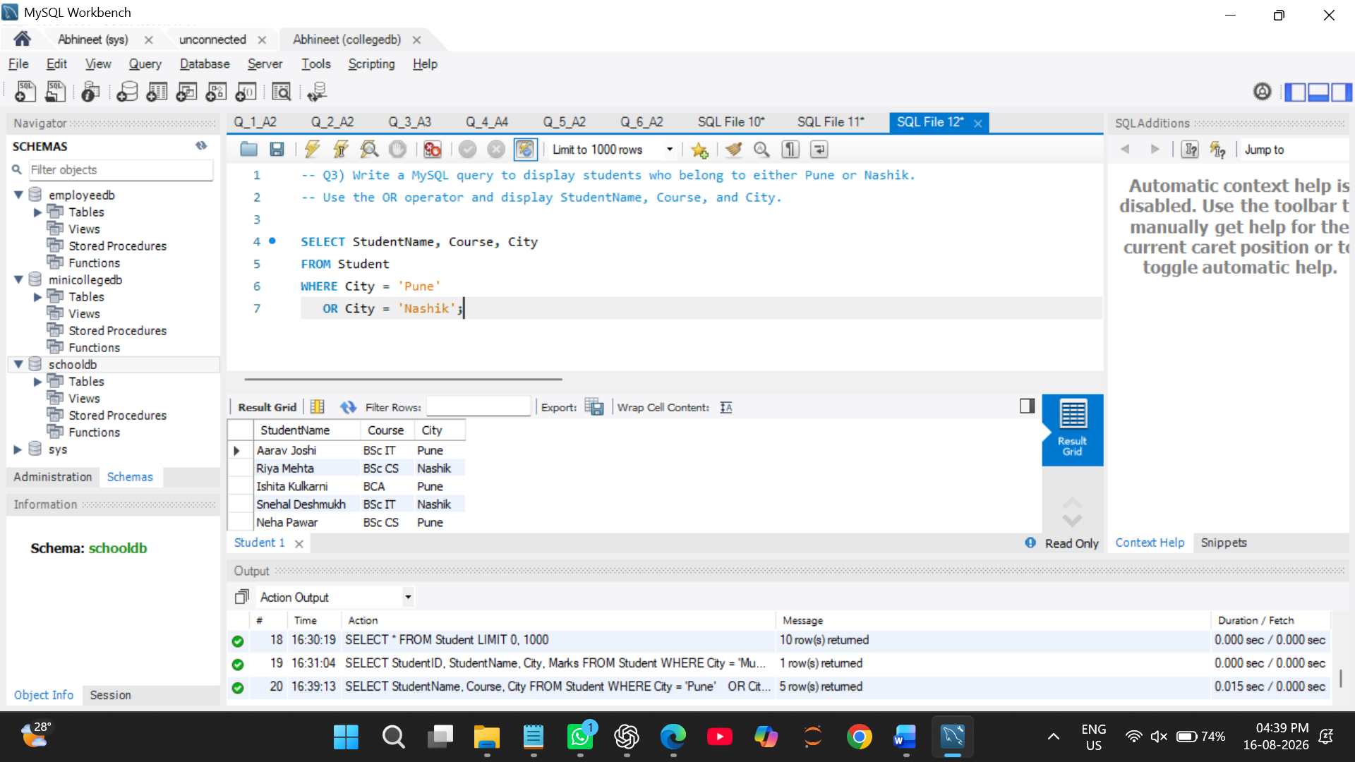

Q4) Write a MySQL query to display students whose marks are between 70 and 90.
Use the BETWEEN operator and display:
Column
StudentName
Marks

-- Use the BETWEEN operator and display StudentName and Marks.
SELECT StudentName, Marks
FROM Student
WHERE Marks BETWEEN 70 AND 90; 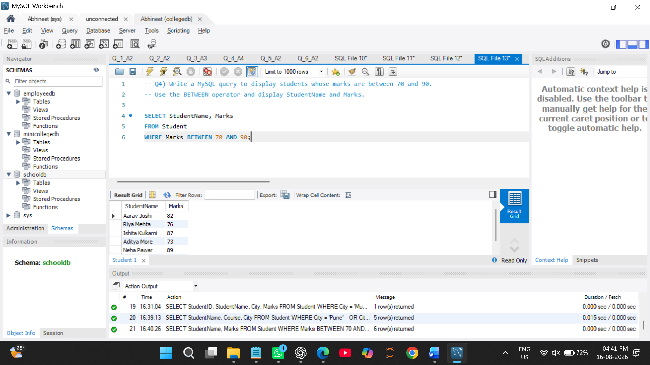

Q5) Write a MySQL query to display students whose names start with the letter A.
Use the LIKE operator and display:
Column
StudentID
StudentName

-- Use the LIKE operator and display StudentID and StudentName.
SELECT StudentID, StudentName
FROM Student
WHERE StudentName LIKE 'A%'; 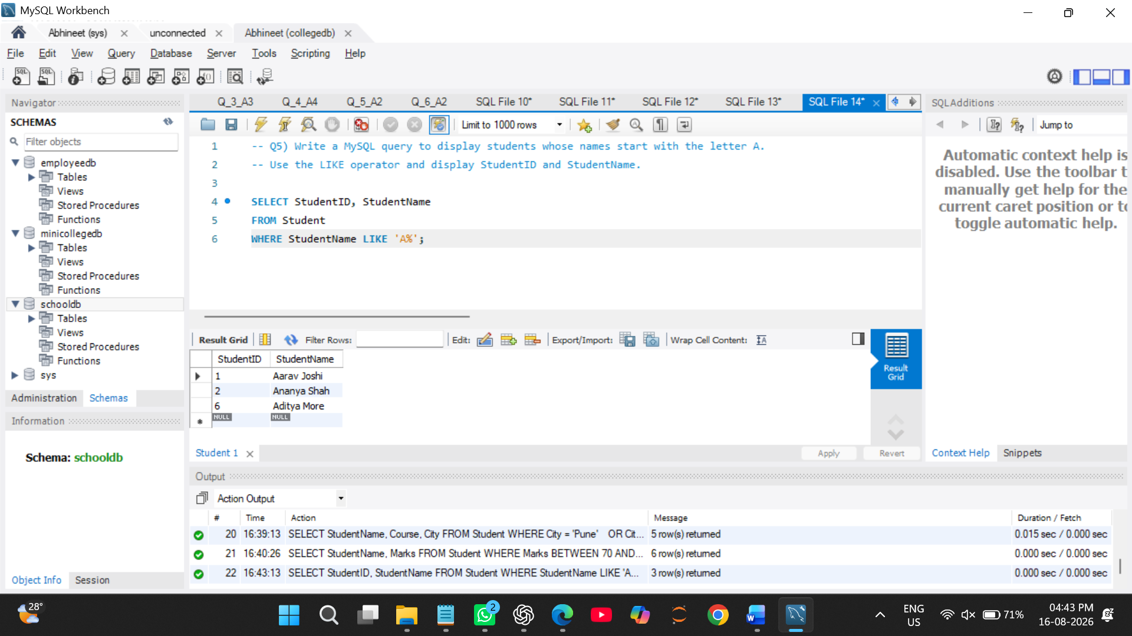

Q6) Write a MySQL query to display students whose email address is missing.
Use the IS NULL operator and display:
Column
StudentID
StudentName
Email
-- Use the IS NULL operator and display StudentID, StudentName, and Email.
SELECT StudentID, StudentName, Email
FROM Student
WHERE Email IS NULL; 