Assignment ::- 4
Name | Abhineet Tiwari
Roll No: | 20965
Subject | DBMS

Q1) Create a MySQL database named CollegeDB and create the following tables:

Student Table
Column Name | Data Type | Constraint
StudentID | INT | PRIMARY KEY
StudentName | VARCHAR(50)
Column Name | Data Type | Constraint
City | VARCHAR(30)

Course Table
Column Name | Data Type | Constraint
CourseID | INT | PRIMARY KEY
CourseName | VARCHAR(50)
Fees | DECIMAL(10,2)

Enrollment Table
Column Name | Data Type | Constraint
EnrollmentID | INT | PRIMARY KEY
StudentID | INT | FOREIGN KEY
CourseID | INT | FOREIGN KEY
EnrollmentDate | DATE
CREATE DATABASE CollegeDB;
USE CollegeDB;
CREATE TABLE Student (
StudentID INT PRIMARY KEY,
StudentName VARCHAR(50),
City VARCHAR(30)
);
CREATE TABLE Course (
CourseID INT PRIMARY KEY,
CourseName VARCHAR(50),
Fees DECIMAL(10,2)
);
CREATE TABLE Enrollment (
EnrollmentID INT PRIMARY KEY,
StudentID INT,
CourseID INT,
EnrollmentDate DATE,
FOREIGN KEY (StudentID) REFERENCES Student(StudentID),
FOREIGN KEY (CourseID) REFERENCES Course(CourseID)
); 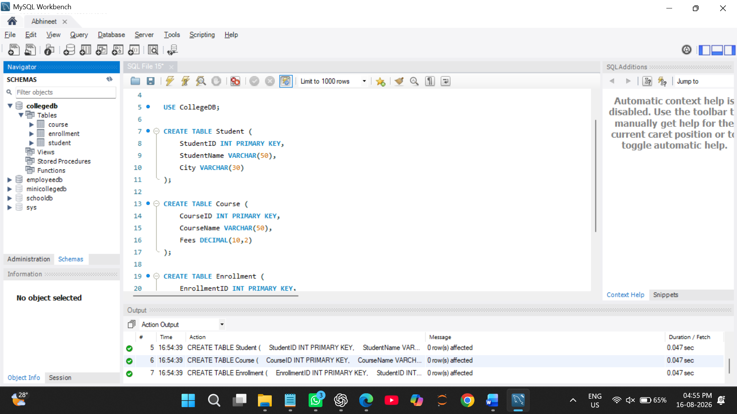

Q2) Insert at least 6 records into the Student table, 4 records into the Course table, and 5 records into the Enrollment table.
Make sure:
Requirement
At least one student should not have enrollment
At least one course should not have any enrolled student
-- Insert records into Student table
INSERT INTO Student (StudentID, StudentName, City)
VALUES
(1, 'Rahul Sharma', 'Mumbai'),
(2, 'Priya Patil', 'Pune'),
(3, 'Aman Verma', 'Nashik'),
(4, 'Sneha Joshi', 'Mumbai'),
(5, 'Karan Mehta', 'Thane'),
(6, 'Neha Shah', 'Pune');
-- Insert records into Course table
INSERT INTO Course (CourseID, CourseName, Fees)
VALUES
(101, 'BSc IT', 45000.00),
(102, 'BCA', 40000.00),
(103, 'BSc CS', 42000.00),
(104, 'Data Science', 55000.00);
-- Insert records into Enrollment table
INSERT INTO Enrollment (EnrollmentID, StudentID, CourseID, EnrollmentDate)
VALUES
(1, 1, 101, '2026-07-01'),
(2, 2, 102, '2026-07-02'),
(3, 3, 103, '2026-07-03'),
(4, 4, 101, '2026-07-04'),
(5, 5, 102, '2026-07-05'); 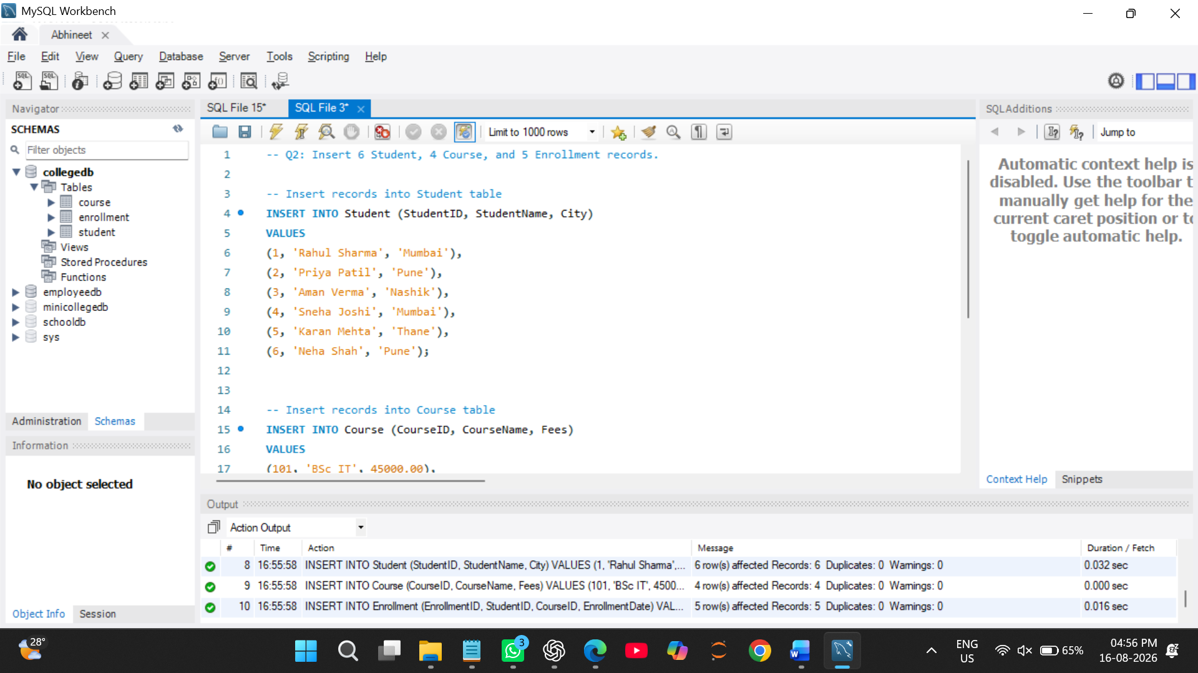

Q3) Write a MySQL query using INNER JOIN to display students who have enrolled in courses.

The output should include:
Column
StudentID
StudentName
CourseID
EnrollmentDate

SELECT
Student.StudentID,
Student.StudentName,
Enrollment.CourseID,
Enrollment.EnrollmentDate
FROM Student
INNER JOIN Enrollment
ON Student.StudentID = Enrollment.StudentID; 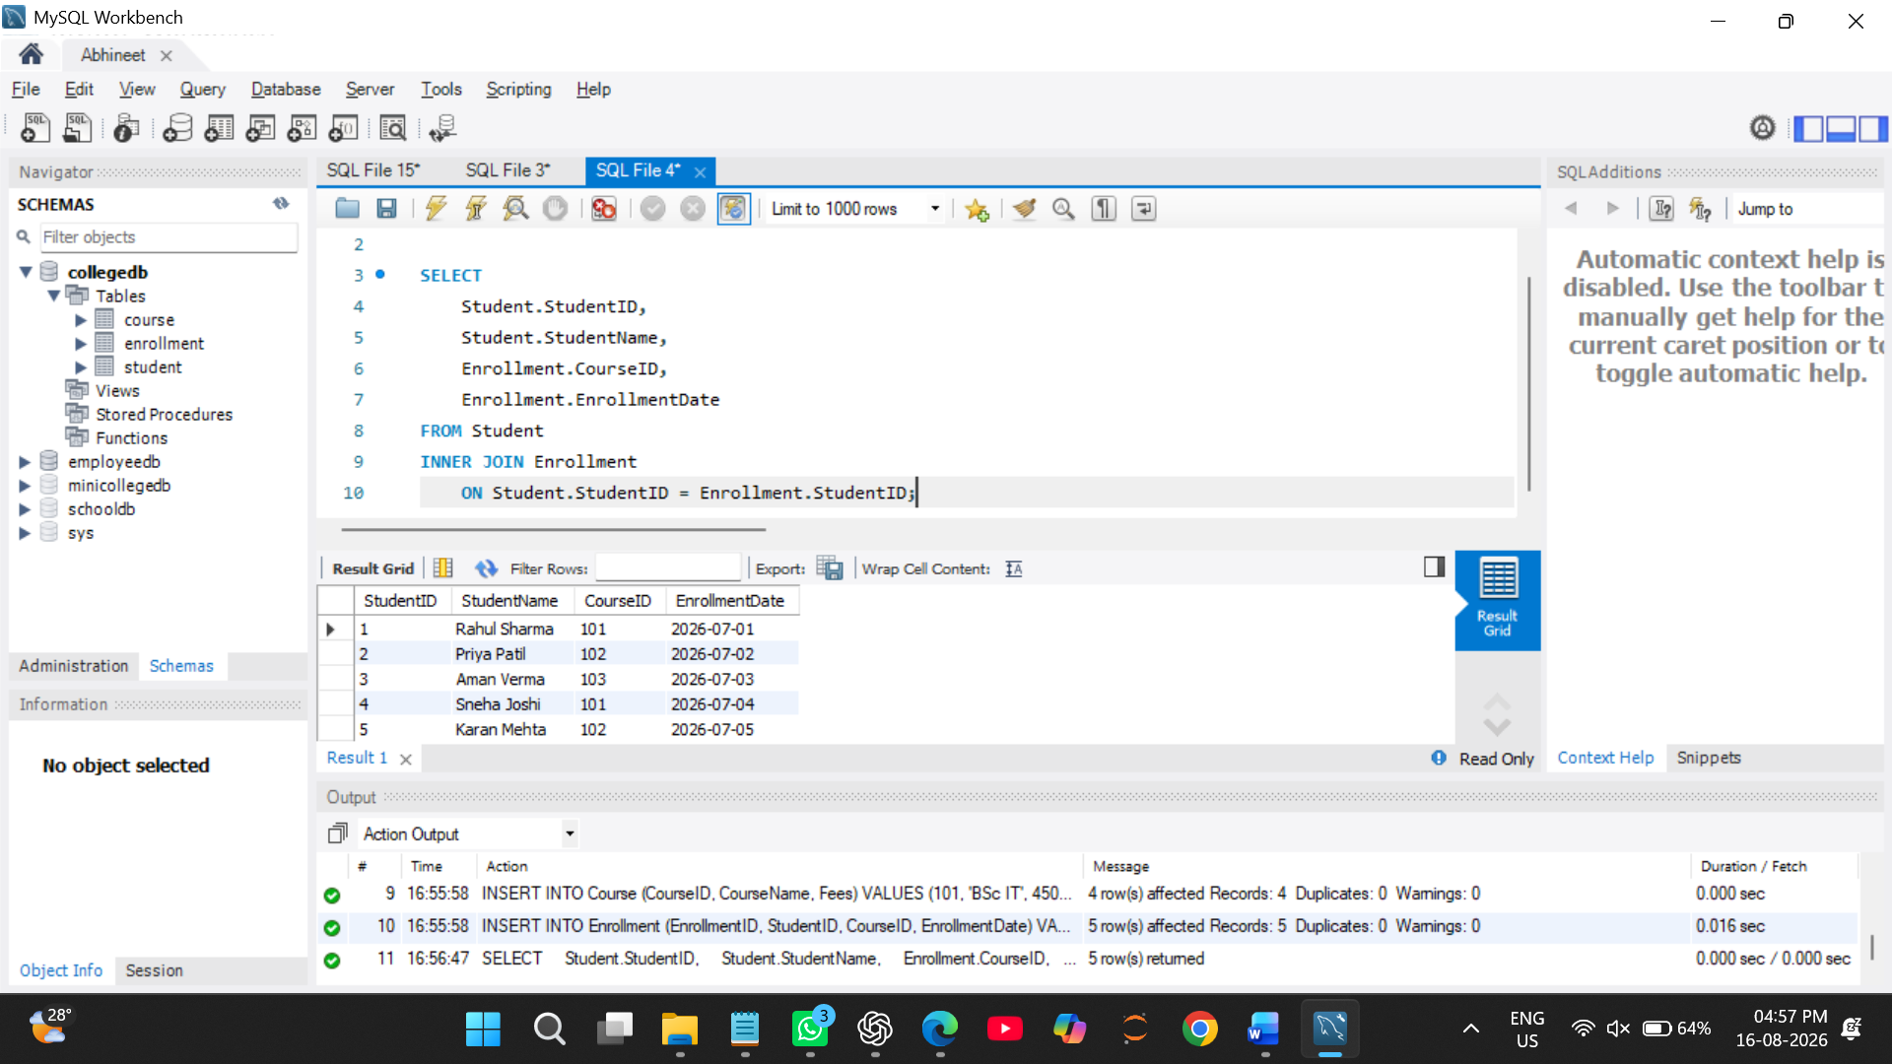

Q4) Write a MySQL query to display student name, city, course name, fees, and enrollment date using multiple tables.
Use:
Tables Required
Student
Course
Enrollment
SELECT
Student.StudentName,
Student.City,
Course.CourseName,
Course.Fees,
Enrollment.EnrollmentDate
FROM Enrollment
INNER JOIN Student
ON Enrollment.StudentID = Student.StudentID
INNER JOIN Course
ON Enrollment.CourseID = Course.CourseID;
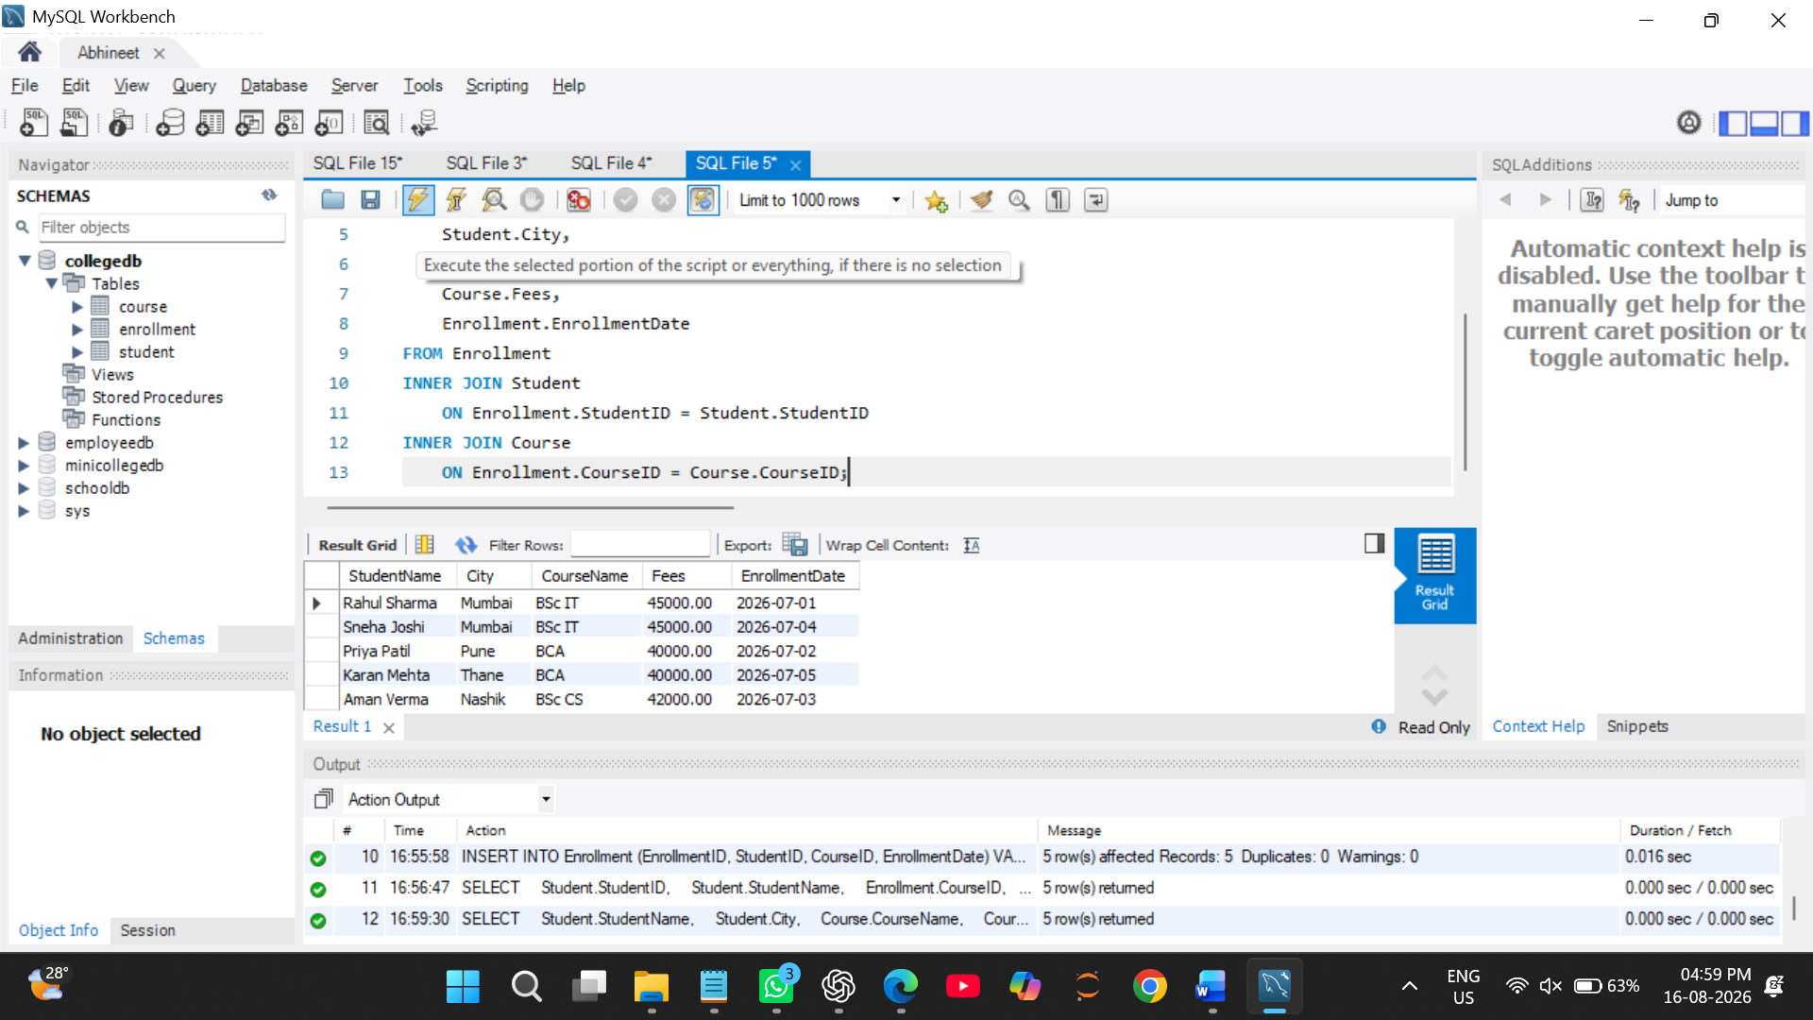

Q5) Write a MySQL query using LEFT JOIN to display all students, including those who have not enrolled in any course.
The output should include:
Column
StudentID
StudentName
City

SELECT
Student.StudentID,
Student.StudentName,
Student.City,
Enrollment.CourseID,
Enrollment.EnrollmentDate
FROM Student
LEFT JOIN Enrollment
ON Student.StudentID = Enrollment.StudentID;
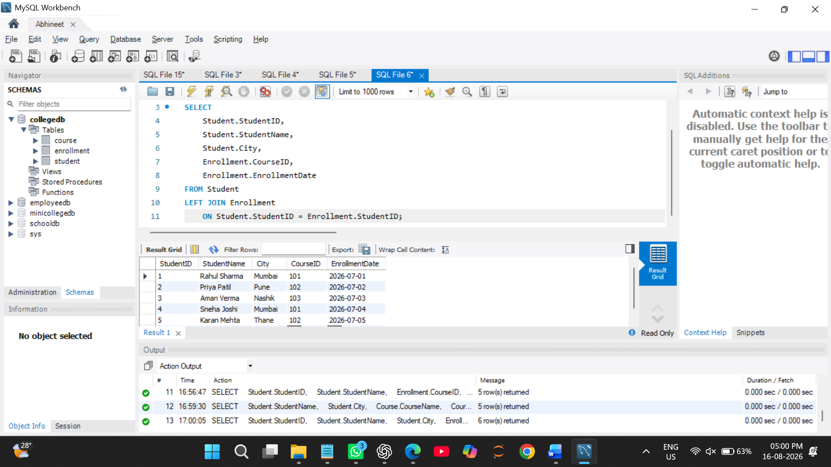

Q6) Write a MySQL query using RIGHT JOIN to display all courses, including courses that have no enrolled students.
The output should include:
Column
StudentName
CourseID
CourseName
Fees
SELECT
Student.StudentName,
Course.CourseID,
Course.CourseName,
Course.Fees
FROM Enrollment
RIGHT JOIN Course
ON Enrollment.CourseID = Course.CourseID
LEFT JOIN Student
ON Enrollment.StudentID = Student.StudentID; 