Assignment ::- 5
Name | Abhineet Tiwari
Roll No: | 20965
Subject | DBMS

Q1) Create a MySQL database named CollegeDB and a table named StudentResult.
The table should contain the following columns:
Column Name | Data Type | Constraint
StudentID | INT | PRIMARY KEY
StudentName | VARCHAR(50)
Course | VARCHAR(30)
City | VARCHAR(30)
Marks | INT
FeesPaid | DECIMAL(10,2)
Insert at least 10 records into the table.
CREATE DATABASE CollegeDB;
USE CollegeDB;
CREATE TABLE StudentResult (
StudentID INT PRIMARY KEY,
StudentName VARCHAR(50),
Course VARCHAR(30),
City VARCHAR(30),
Marks INT,
FeesPaid DECIMAL(10,2)
);
-- Insert 10 records
INSERT INTO StudentResult
(StudentID, StudentName, Course, City, Marks, FeesPaid)
VALUES
(1, 'Rahul Sharma', 'BSc IT', 'Mumbai', 78, 45000.00),
(2, 'Priya Patil', 'BCA', 'Pune', 85, 40000.00),
(3, 'Aman Verma', 'BSc CS', 'Nashik', 67, 42000.00),
(4, 'Sneha Joshi', 'BSc IT', 'Mumbai', 91, 45000.00),
(5, 'Karan Mehta', 'BCA', 'Thane', 74, 40000.00),
(6, 'Neha Shah', 'BSc IT', 'Pune', 88, 45000.00),
(7, 'Rohan Desai', 'BSc CS', 'Mumbai', 69, 42000.00),
(8, 'Meera Kulkarni', 'BCA', 'Nashik', 82, 40000.00),
(9, 'Arjun Nair', 'BSc IT', 'Thane', 59, 45000.00),
(10, 'Divya More', 'BCA', 'Mumbai', 93, 40000.00); 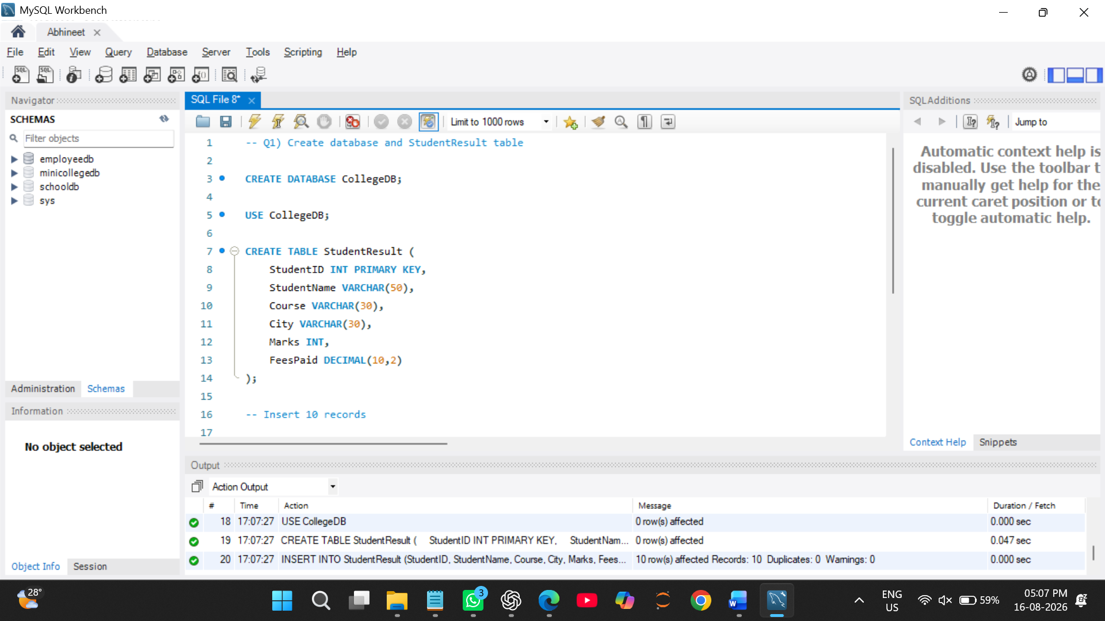

Q2) Write MySQL queries to find the following from the StudentResult table:
Requirement
Total number of students
Total fees paid
Average marks
Lowest marks
Highest marks

-- lowest marks and highest marks

USE CollegeDB;
SELECT
COUNT(*) AS TotalStudents,
SUM(FeesPaid) AS TotalFeesPaid,
AVG(Marks) AS AverageMarks,
MIN(Marks) AS LowestMarks,
MAX(Marks) AS HighestMarks
FROM StudentResult;
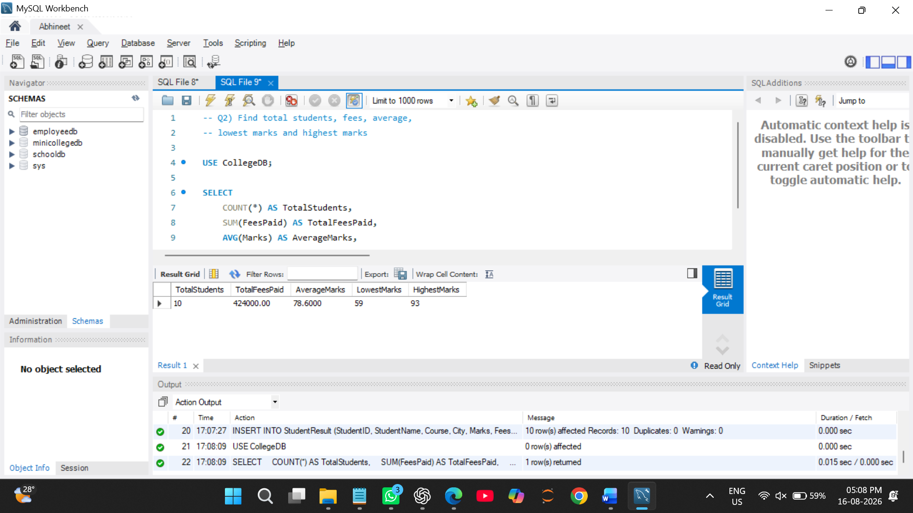
Q3) Write a MySQL query to count the number of students in each course.
The output should contain:
Column
Course
TotalStudents
USE CollegeDB;
SELECT
Course,
COUNT(*) AS TotalStudents
FROM StudentResult
GROUP BY Course; 

Q4) Write a MySQL query to find the average marks of students course-wise.
The output should contain:
Column
Course
AverageMarks

USE CollegeDB;
SELECT
Course,
AVG(Marks) AS AverageMarks
FROM StudentResult
GROUP BY Course; 

Q5) Write a MySQL query to display only those courses where the number of students is greater than 2.
Use:
Clause
GROUP BY
HAVING
USE CollegeDB;
SELECT
Course,
COUNT(*) AS TotalStudents
FROM StudentResult
GROUP BY Course
HAVING COUNT(*) > 2; 

Q6) Write a MySQL query to analyze course performance.
The output should display:
Column
Course
TotalStudents
AverageMarks
LowestMarks
HighestMarks
Sort the result by AverageMarks in descending order.
USE CollegeDB;
SELECT
Course,
COUNT(*) AS TotalStudents,
AVG(Marks) AS AverageMarks,
MIN(Marks) AS LowestMarks,
MAX(Marks) AS HighestMarks
FROM StudentResult
GROUP BY Course
ORDER BY AverageMarks DESC; 

