Assignment ::- 6
Name | Abhineet Tiwari
Roll No: | 20965
Subject | DBMS

Q1) Create a MySQL database named CollegeDB and create two tables: Course and Student.
Course Table
Column Name | Data Type | Constraint
CourseID | INT | PRIMARY KEY
CourseName | VARCHAR(50) | NOT NULL
Fees | DECIMAL(10,2) | NOT NULL

Student Table
Column Name | Data Type | Constraint
StudentID | INT | PRIMARY KEY
StudentName | VARCHAR(50) | NOT NULL
Age | INT
City | VARCHAR(30)
CourseID | INT | FOREIGN KEY
CREATE DATABASE CollegeDB;

USE CollegeDB;

CREATE TABLE Course (
CourseID INT PRIMARY KEY,
CourseName VARCHAR(50) NOT NULL,
Fees DECIMAL(10,2) NOT NULL
);

CREATE TABLE Student (
StudentID INT PRIMARY KEY,
StudentName VARCHAR(50) NOT NULL,
Age INT,
City VARCHAR(30),
CourseID INT,
FOREIGN KEY (CourseID) REFERENCES Course(CourseID)
);
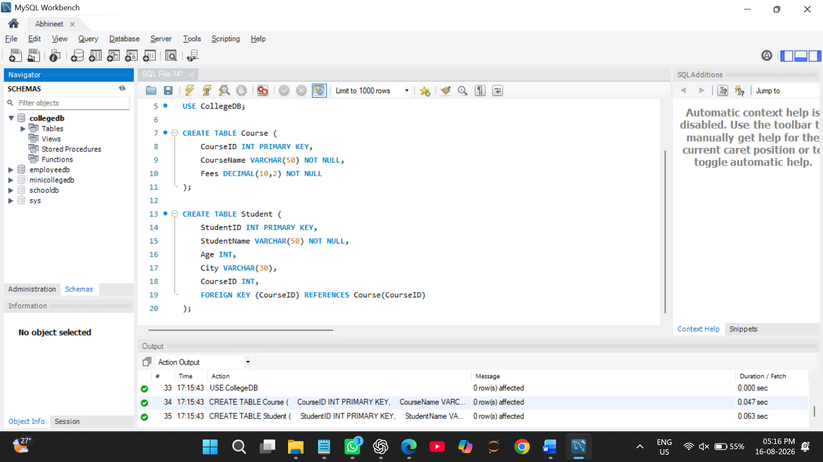
Q2) Insert at least 4 records into the Course table and 6 records into the Student table.
Make sure every student has a valid CourseID from the Course table.
INSERT INTO Course (CourseID, CourseName, Fees)
VALUES
(101, 'BSc IT', 45000.00),
(102, 'BCA', 40000.00),
(103, 'BSc CS', 42000.00),
(104, 'Data Science', 55000.00);
SELECT * FROM COURSE; 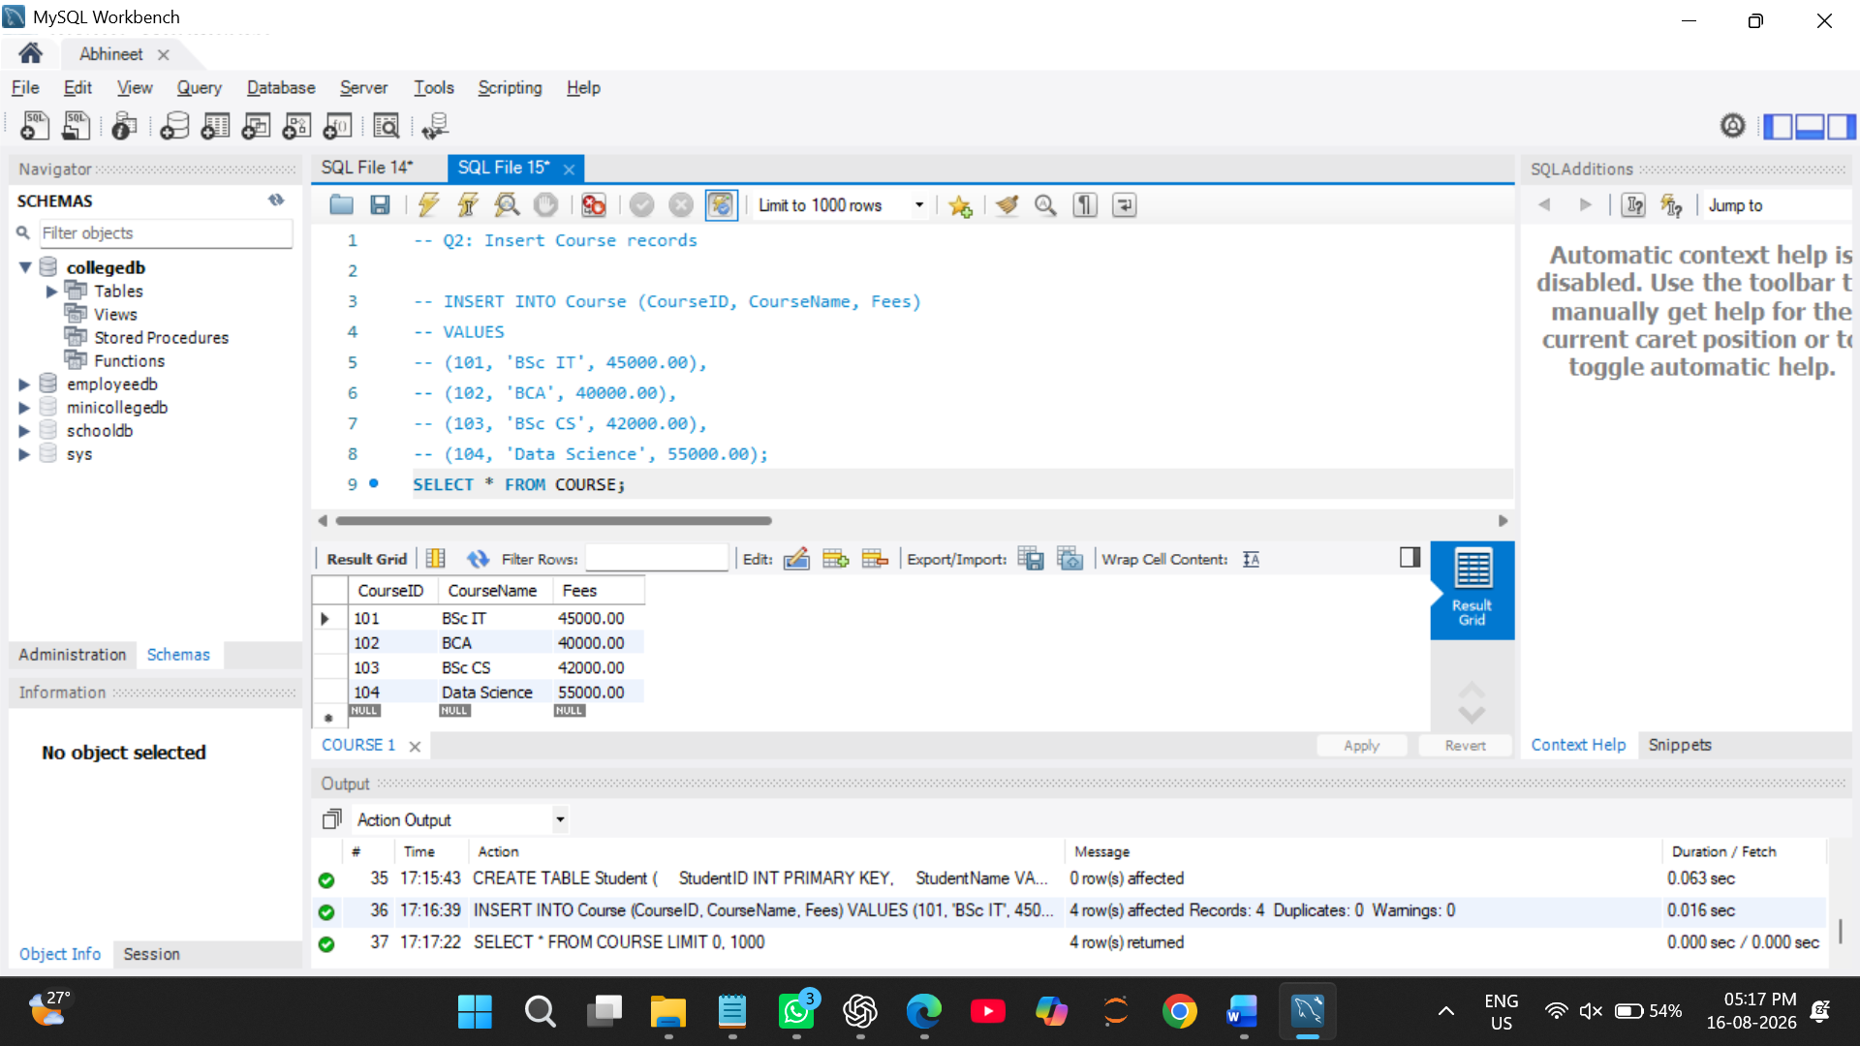

Q3) Write a MySQL query to insert one new student record into the Student table.
The record should include:
Field
StudentID
StudentName
Age
City
CourseID
INSERT INTO Student (StudentID, StudentName, Age, City, CourseID)
VALUES (7, 'Rohan Kulkarni', 20, 'Pune', 104);
select * FROM STUDENT;
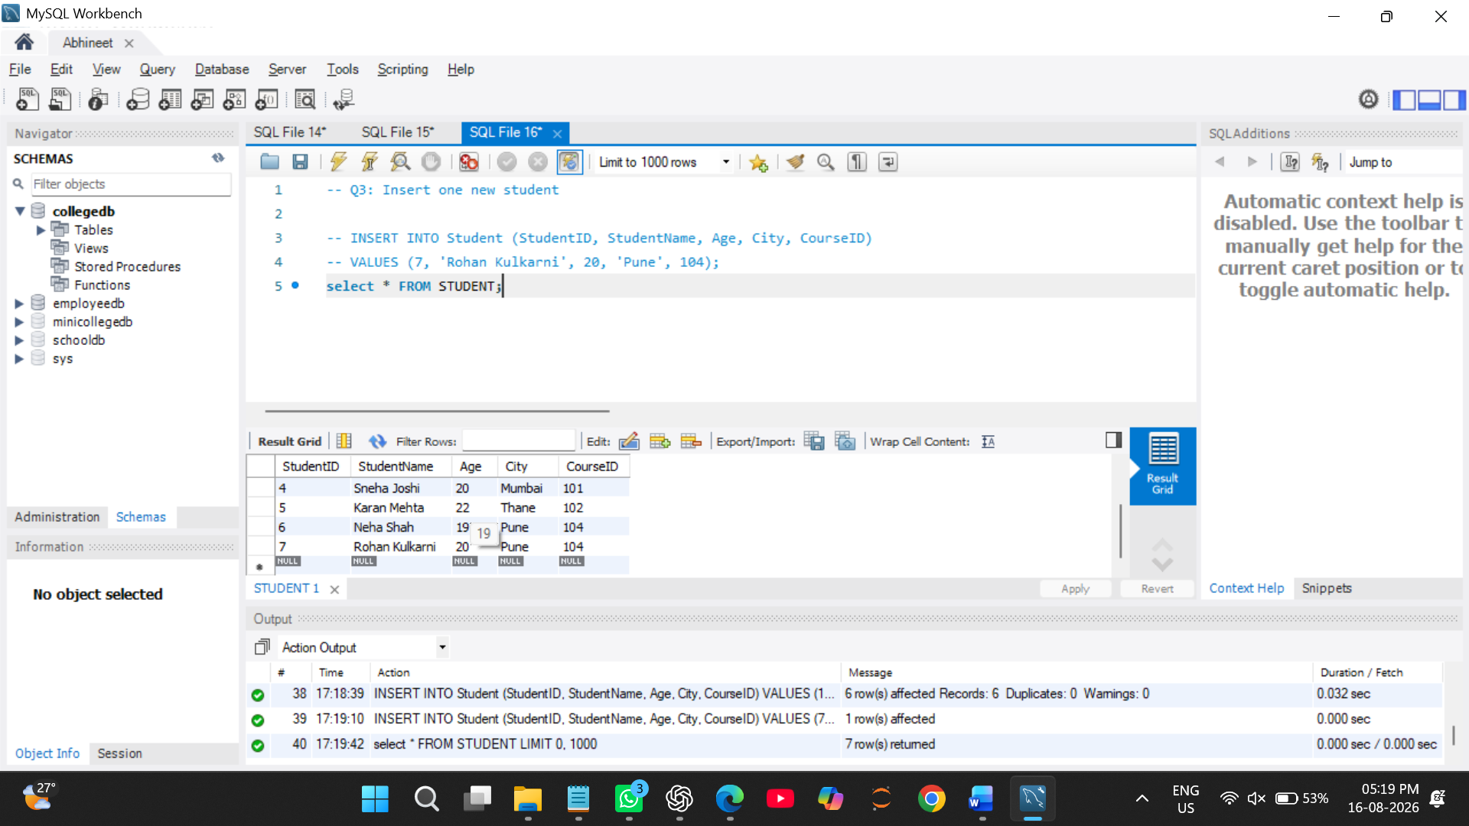

Q4) Write a MySQL query to update the city of a student using StudentID.
Example requirement:
Change Required
Update the city of StudentID 2 to Mumbai
UPDATE Student
SET City = 'Mumbai'
WHERE StudentID = 2;
SELECT * FROM STUDENT; 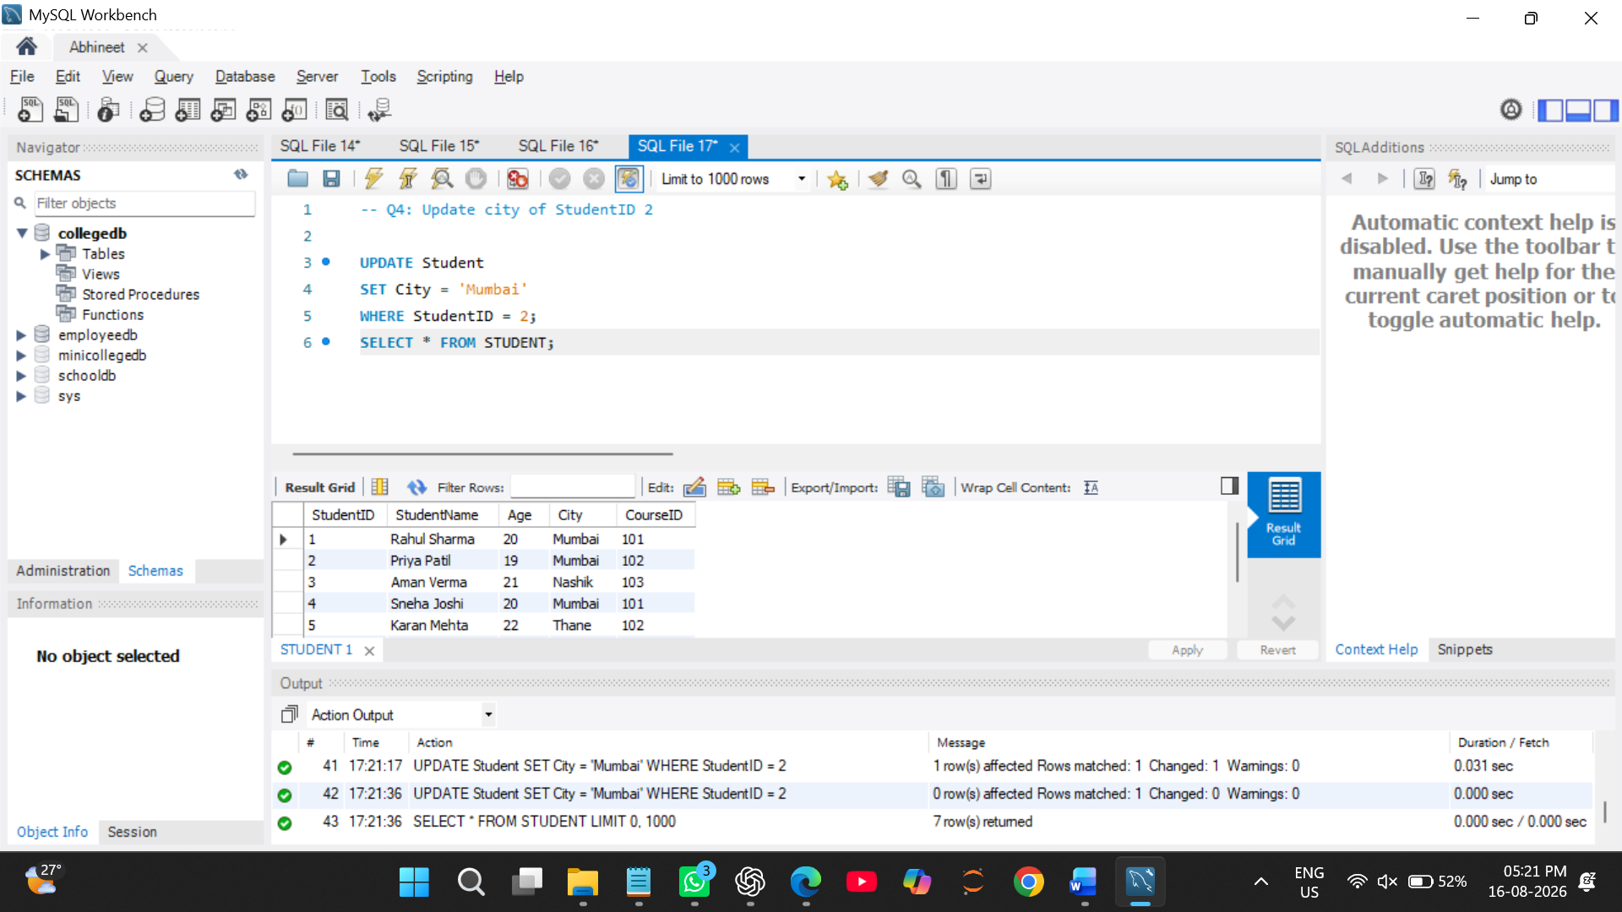

Q5) Write a MySQL query to update the fees of a course using CourseID.
Example requirement:
Change Required
Update the fees of CourseID 101 to 47000
UPDATE Course
SET Fees = 47000.00
WHERE CourseID = 101;
SELECT * FROM COURSE;

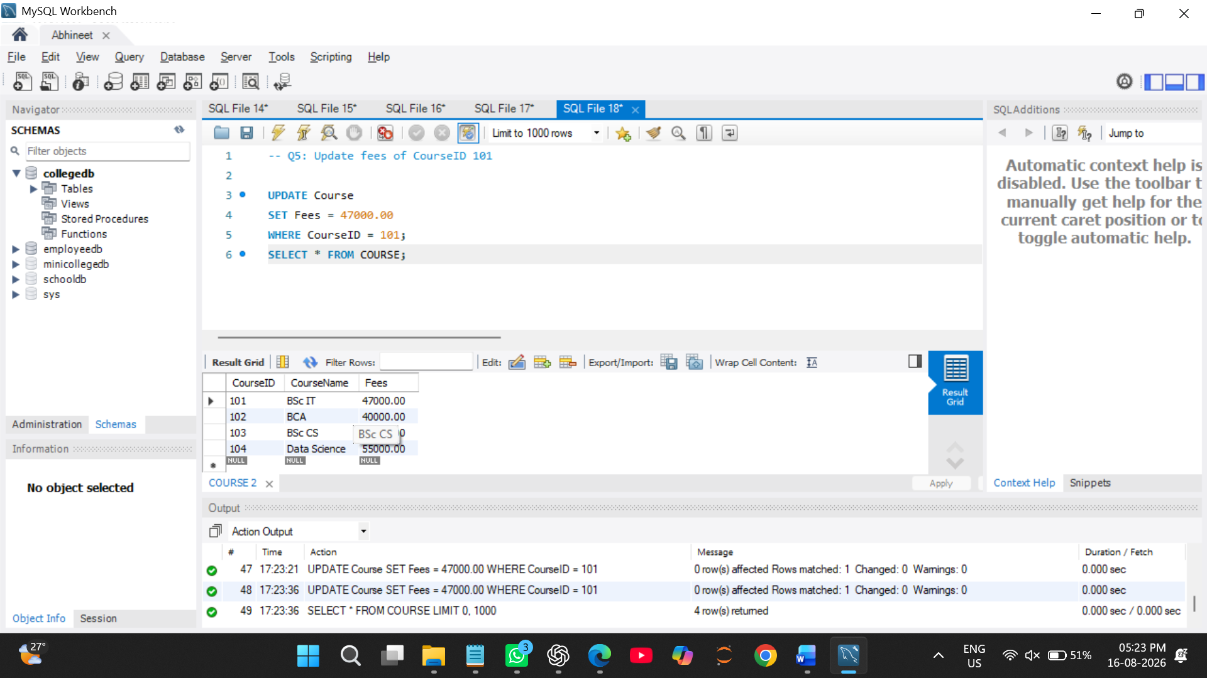

Q6) Write a MySQL query to delete one student record using StudentID.
Also write one line explaining why the WHERE clause is important while using DELETE.
DELETE FROM Student
WHERE StudentID = 6;
SELECT * FROM STUDENT ;
