Name :- Abhineet Tiwari
Division :- S.Y BSc Data Science

Q1. STUDENT and COURSE
- Create the STUDENT table with Student_ID as Primary Key
For this question I created a database and then insert values in it then start solving queries
CREATE TABLE STUDENT (
Student_ID INT PRIMARY KEY,
Student_Name VARCHAR(100),
Course_ID INT,
Marks INT
);

INSERT INTO Student
VALUES(1, 'Aarav Joshi', 101, 82),
(2, 'Ananya Shah', 102,91 ),
(3, 'Riya Mehta',102,76 ),
(4, 'Kabir Patil', 103,68 );
select*from student;
Database ,table created
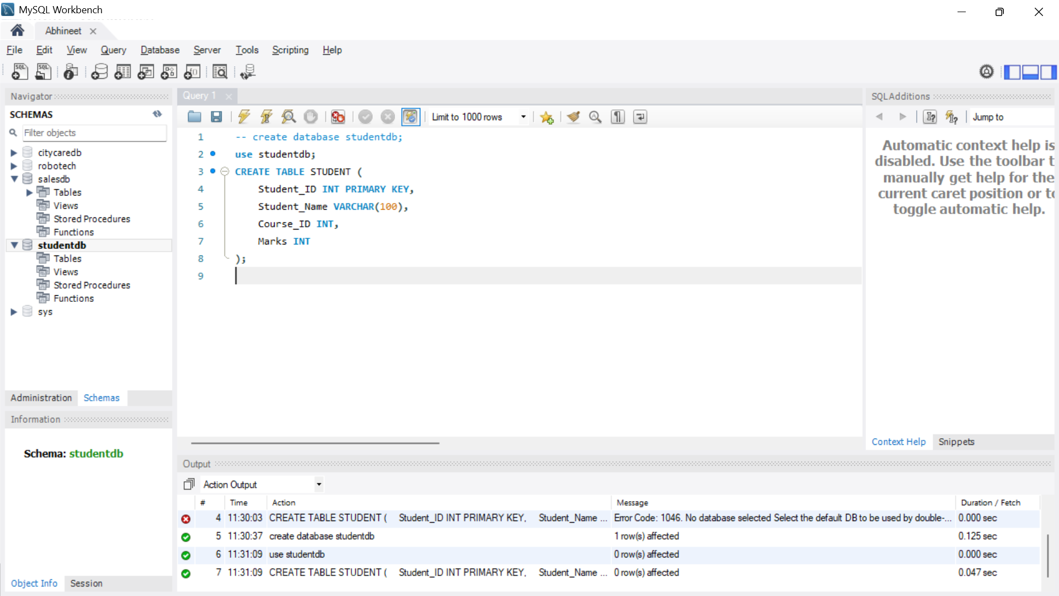
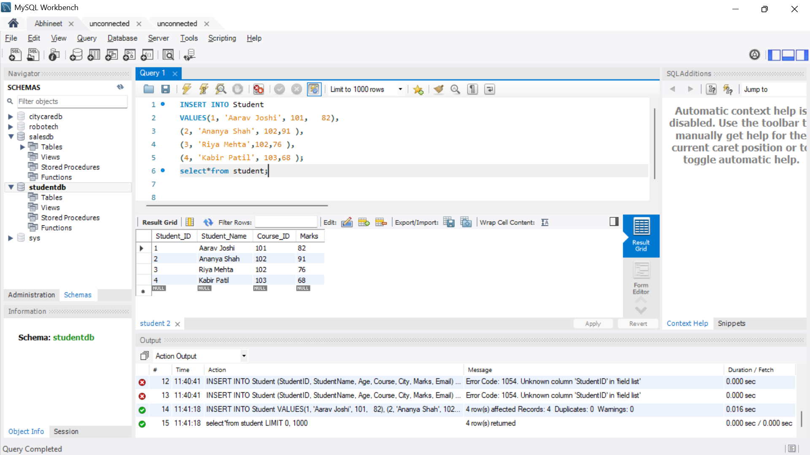
b) Display students who have scored more than 70 marks
SELECT *
FROM STUDENT
WHERE Marks > 70; 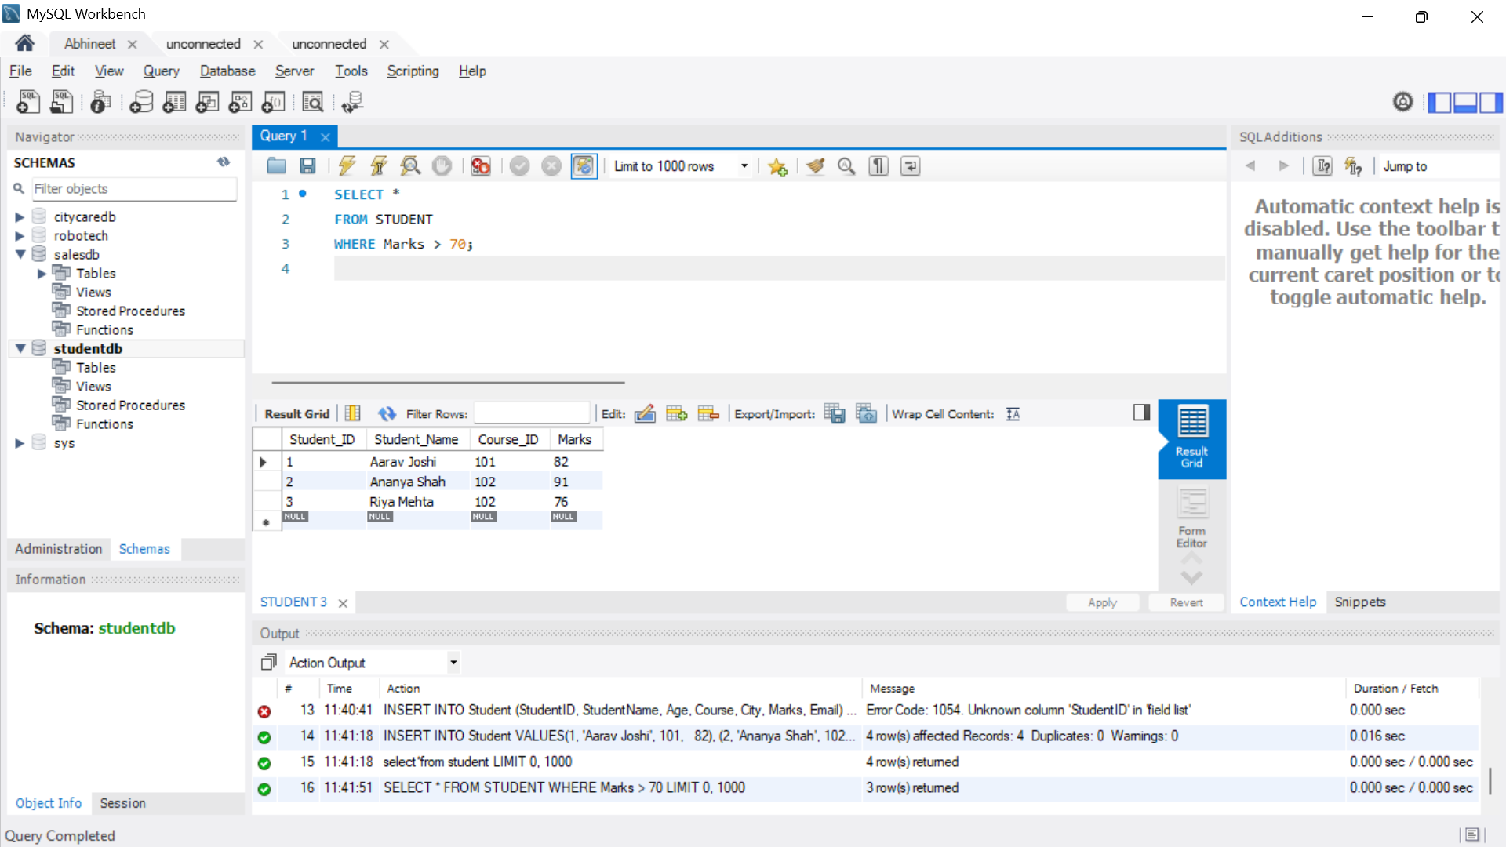
c) Display student names with their corresponding course names
SELECT S.Student_Name, C.Course_Name
FROM STUDENT S
JOIN COURSE C
ON S.Course_ID = C.Course_ID;
d) Find average marks for each Course_ID using GROUP BY
SELECT Course_ID, AVG(Marks) AS Average_Marks
FROM STUDENT
GROUP BY Course_ID;
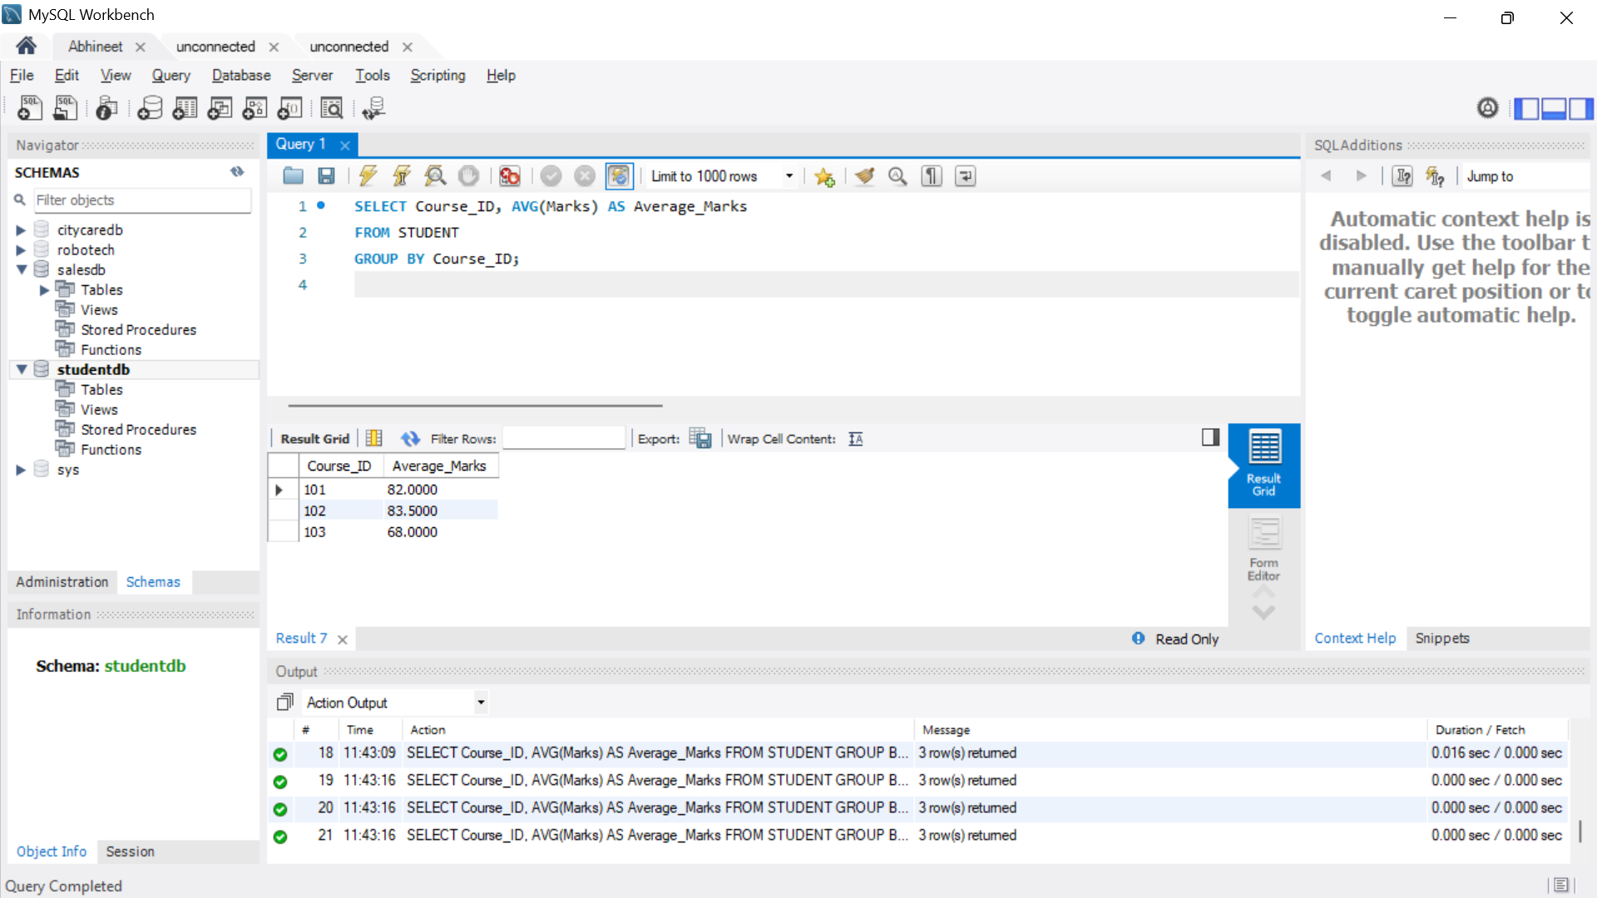
e) Display courses whose average marks are greater than 65 using HAVING
SELECT Course_ID, AVG(Marks) AS Average_Marks
FROM STUDENT
GROUP BY Course_ID
HAVING AVG(Marks) > 65; 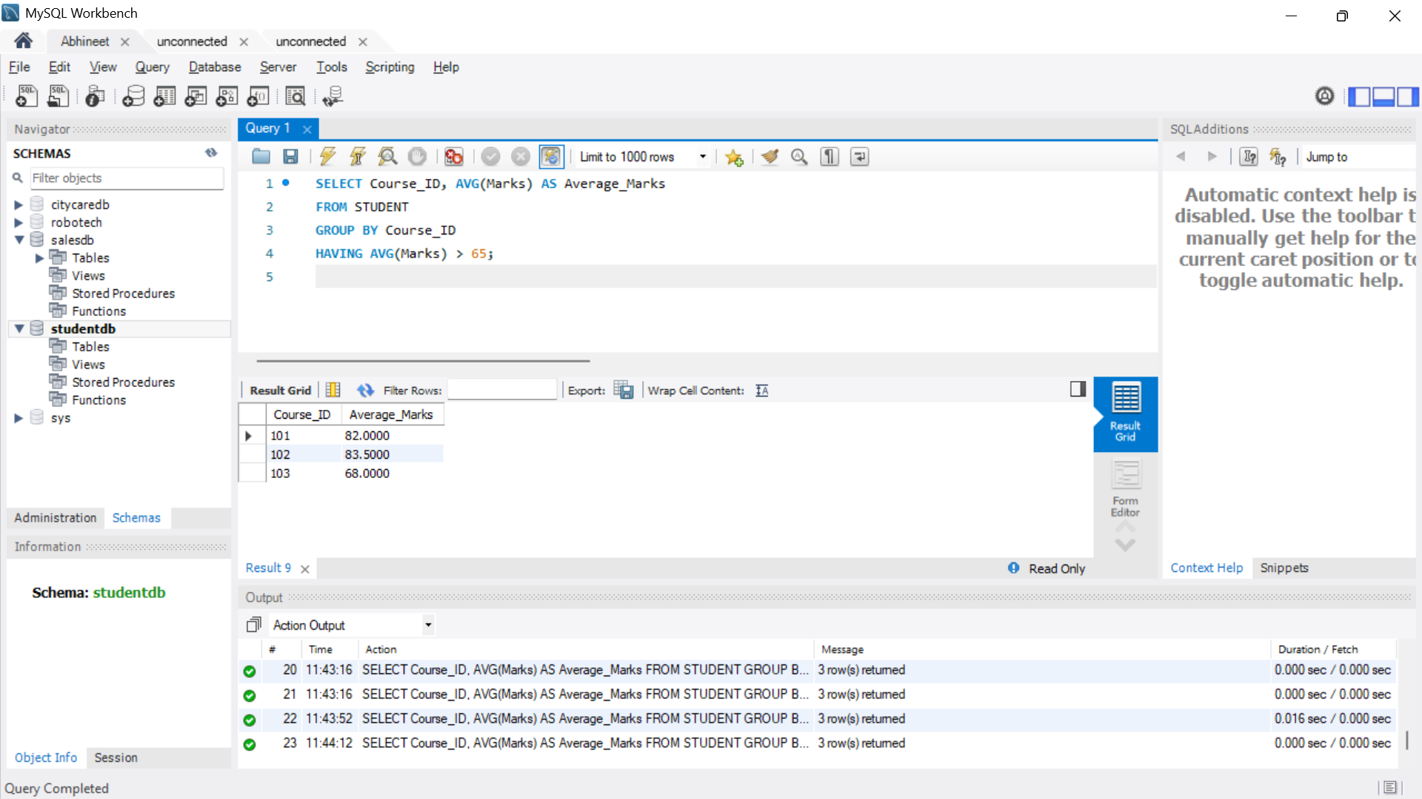

Q2. EMPLOYEE
First of all created a database and table
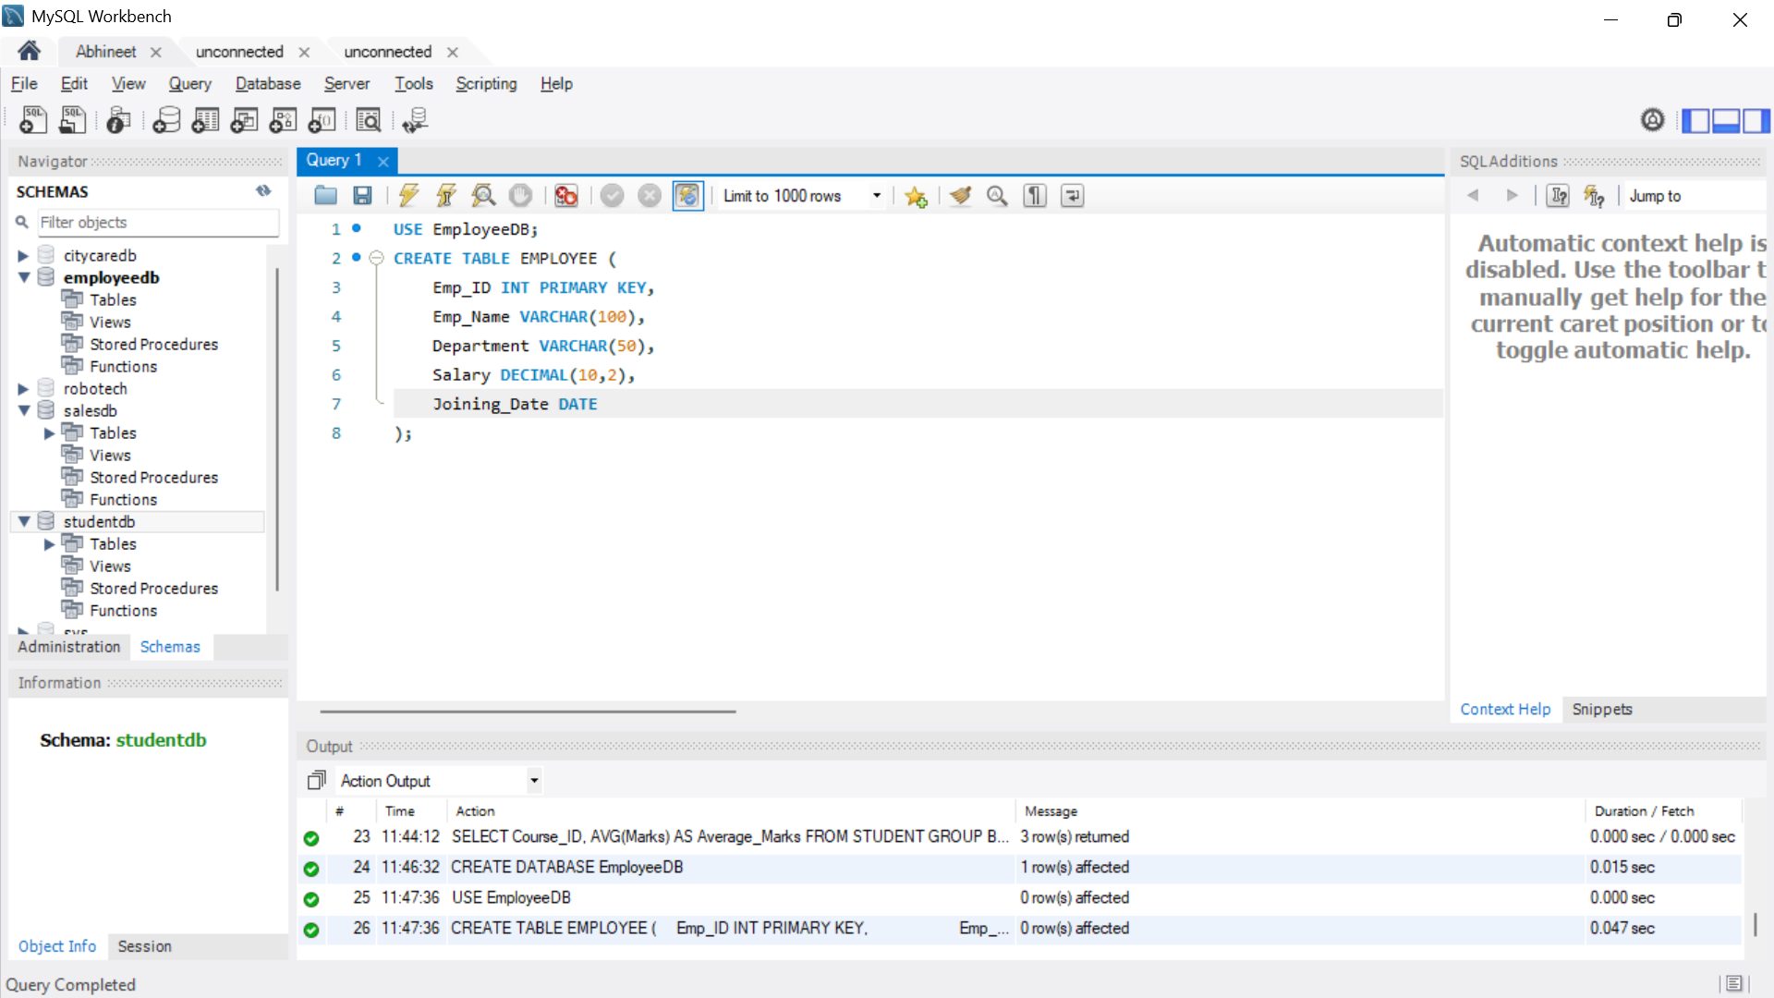
Data inserted
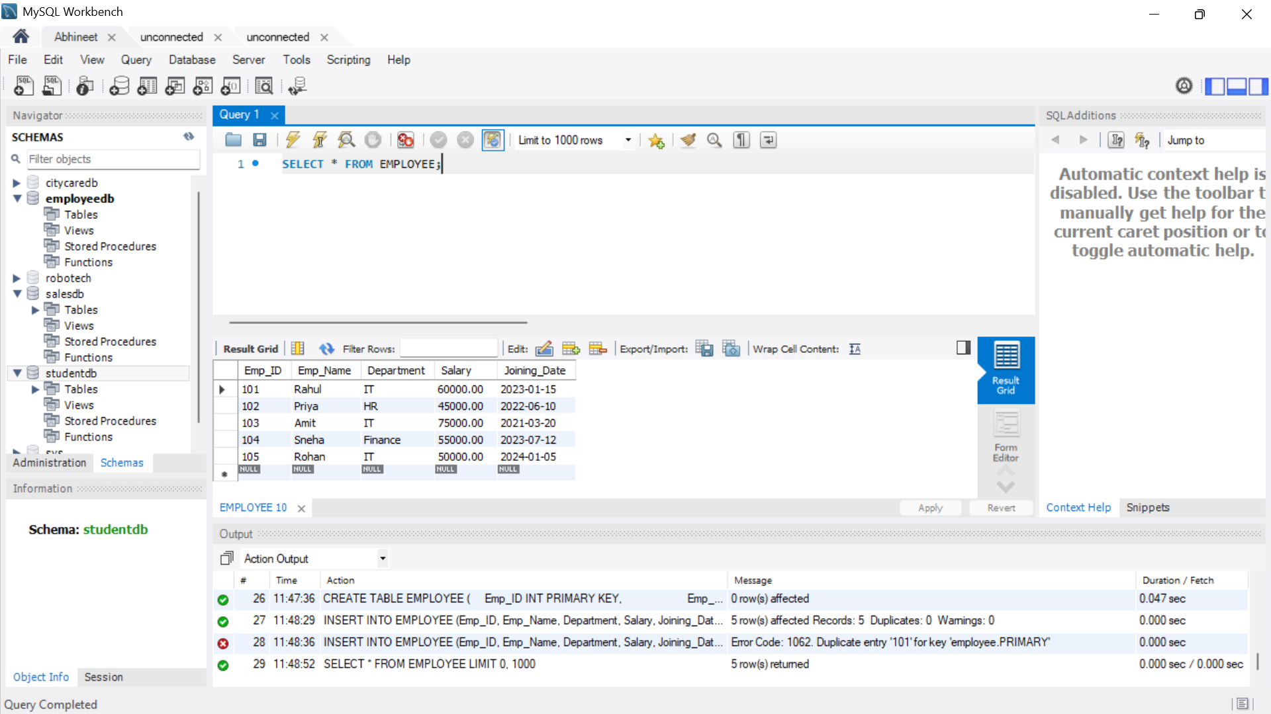
a) Display IT employees in descending order of salary
SELECT *
FROM EMPLOYEE
WHERE Department = 'IT'
ORDER BY Salary DESC; 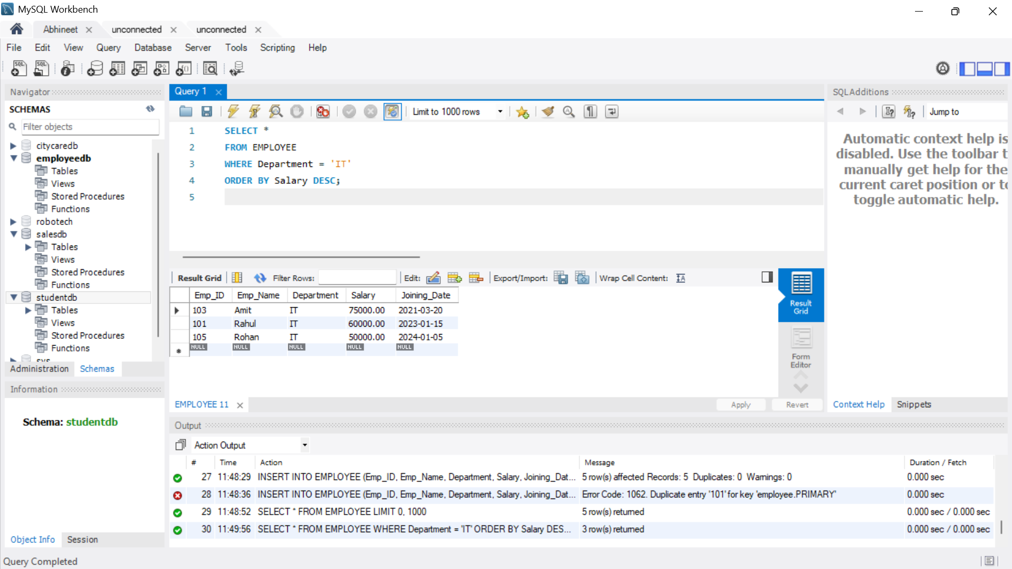
b) Display the highest salary
SELECT MAX(Salary) AS Highest_Salary
FROM EMPLOYEE;
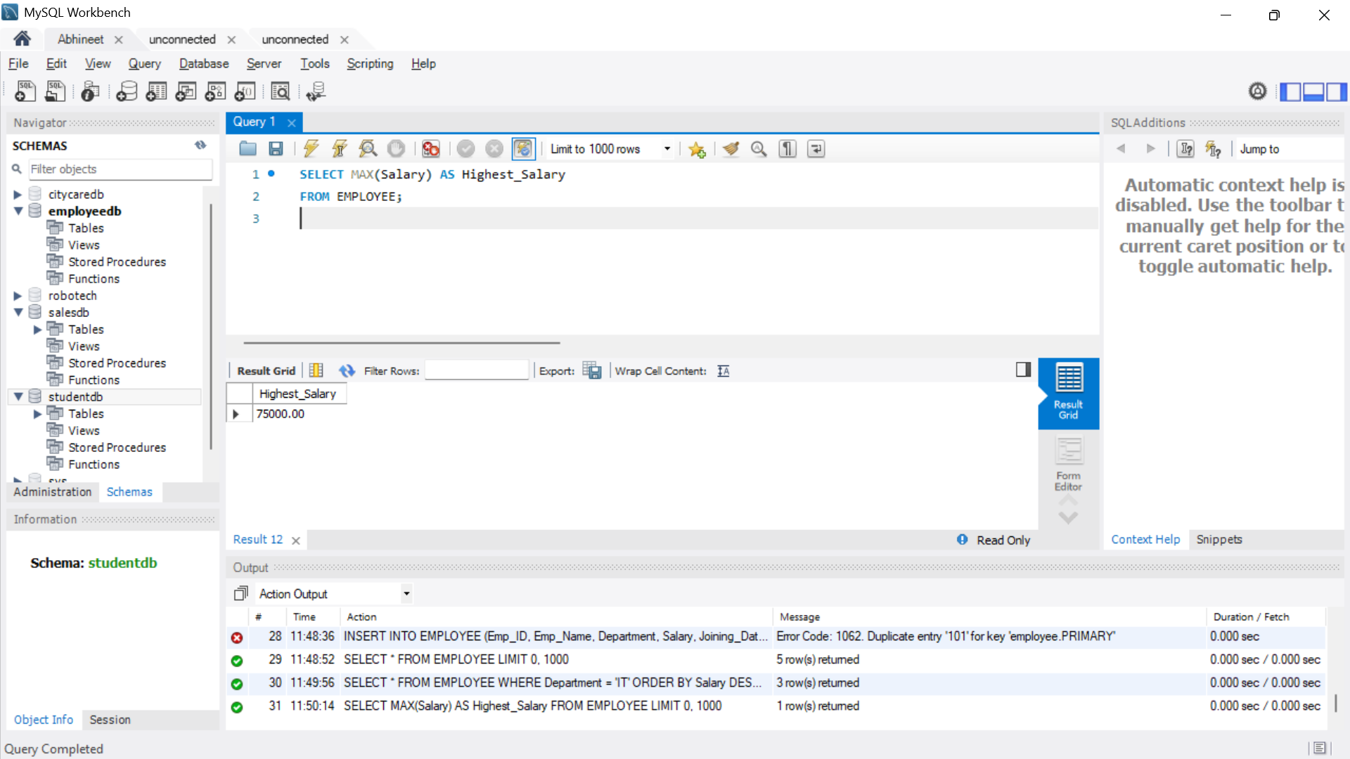
c) Display departments having more than 3 employees
SELECT Department, COUNT(*) AS Employee_Count
FROM EMPLOYEE
GROUP BY Department
HAVING COUNT(*) > 3;

d) Display employees whose salary is greater than the average salary
SELECT *
FROM EMPLOYEE
WHERE Salary > (
SELECT AVG(Salary)
FROM EMPLOYEE
);
e) Create a view named IT_Employees
CREATE VIEW IT_Employees AS
SELECT *
FROM EMPLOYEE
WHERE Department = 'IT';
SELECT *
FROM IT_Employees; 