# Create 2 nodes, One is master and another is slave one

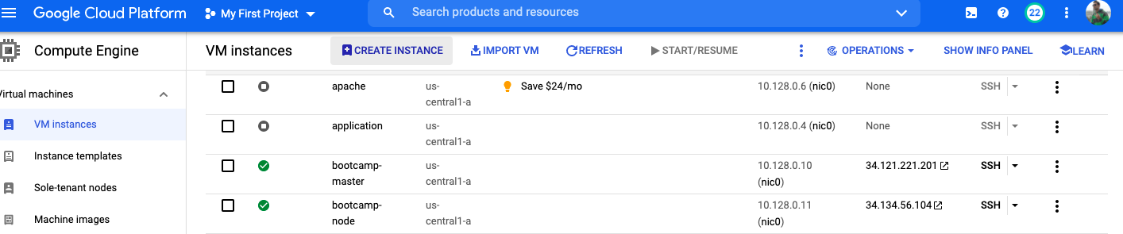

# Configure master for password less authentication

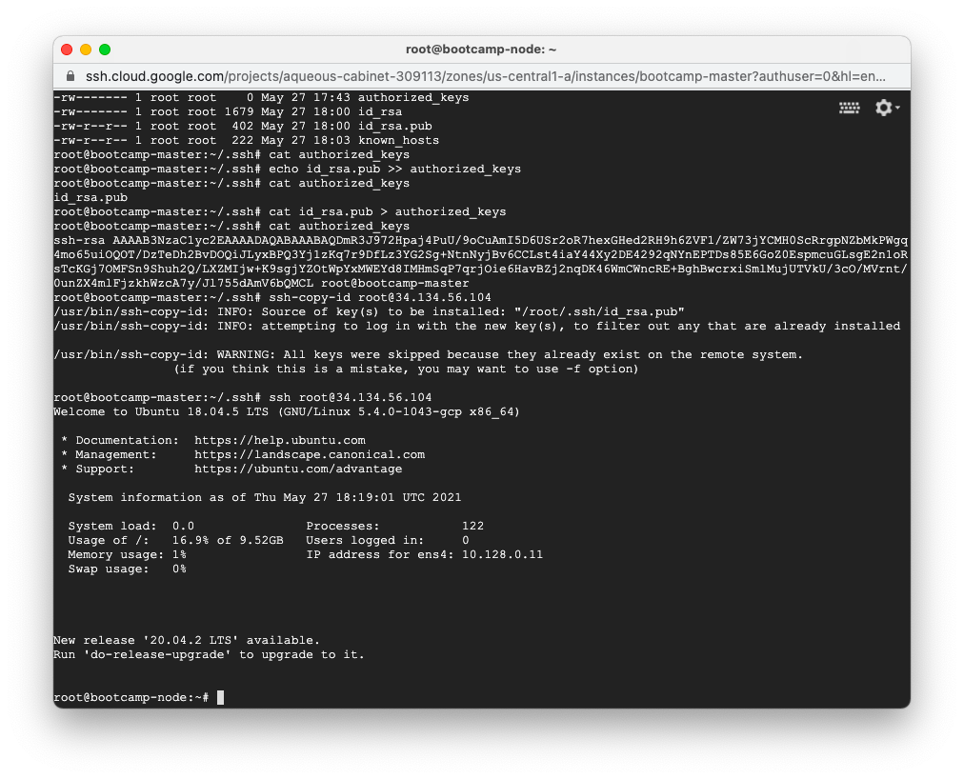

# Install ansible on master node

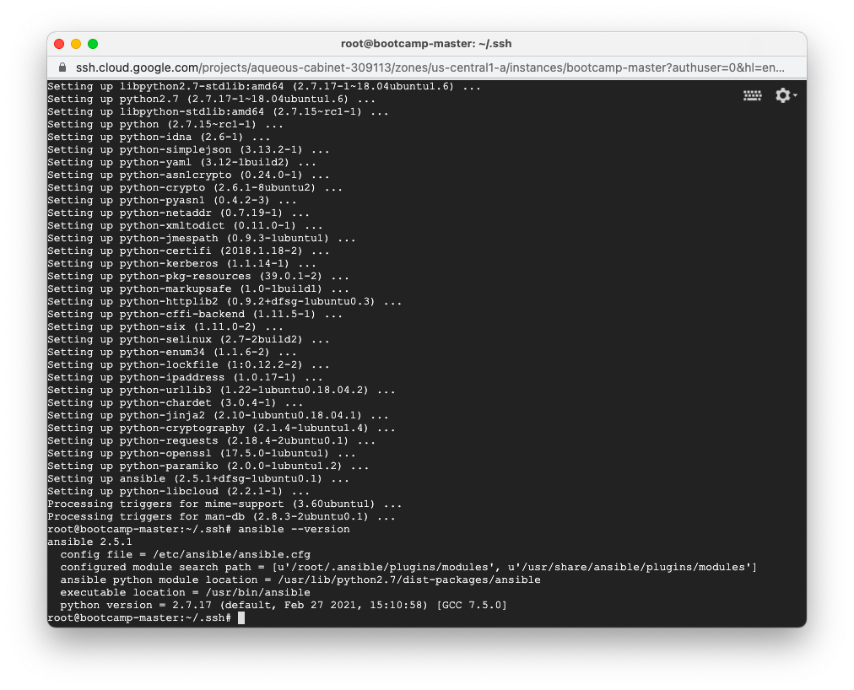

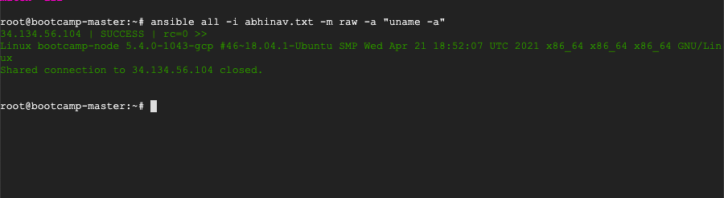

# Write playbook to install following in playbook on slave node

* Java
* Maven
* Nginx
* Docker

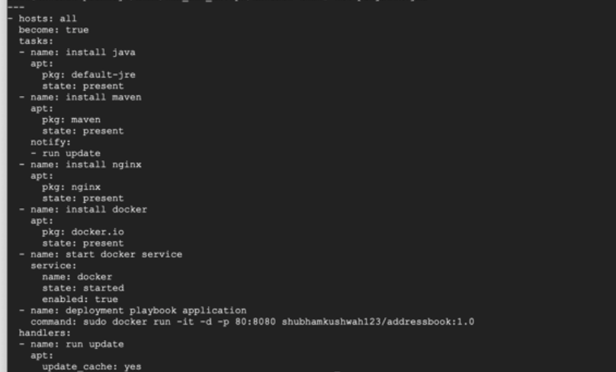

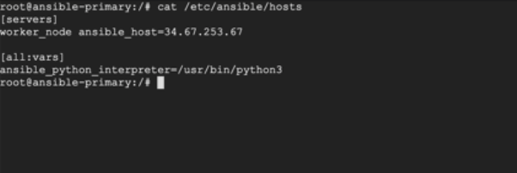

# Run playbook and attach screenshot of output

