Database Authentication Management System

ABHIN KRISHNA K A

ID : ABHI230197

**Introduction**

Database Authentication Management System is a user login system where a user can interact with a graphical interface. The front end is designed with python and backend is handled by mysql server.

**Python Code [Front-end]**

#Including packages

import pymysql

from tkinter import *

#Signup function def

def getdata():

us = u.get()

ps = p.get()

db = pymysql.connect('localhost','root','root','login')

cr = db.cursor()

q = """INSERT INTO user(Username,Password) VALUES(%s,%s);"""

val = (us,ps)

rwCount1 = cr.rowcount

cr.execute(q,val)

rwCount2 = cr.rowcount

db.commit()

cr.execute("SELECT * FROM user")

for i in cr:

print(i)

if(rwCount1<rwCount2):

messagebox.showinfo("Signup", "Signup Successful")

else:

messagebox.showinfo("Signup", "Signup Failed")

cr.close()

db.close()

#Login function def

def val():

db = pymysql.connect('localhost','root','root','login')

cr = db.cursor()

us = u.get()

ps = p.get()

uq = """SELECT Username,Password FROM user WHERE Username = %s"""

s = (us)

cr.execute(uq,s)

flg = 0

for i in cr:

if(i[0]==us and i[1]==ps):

flg = 1

if(us=='' or ps==''):

messagebox.showinfo("Login","Please enter details")

elif(flg==0):

messagebox.showinfo("Login", "Login failed")

else:

messagebox.showinfo("Login", "Login successful")

#tkinter gui starts

window = Tk()

window.title("SignUp")

window.geometry('350x180')

#row 0 [blank]

Label(window,text=" ").grid(row=0)

#row 1 [username row]

Label(window,text=" ").grid(row=1,column=0)

Label(window,text='Username : ').grid(column=1,row=1)

u = Entry(window,width=25)

u.grid(column=2,row=1)

#row 2 [blank]

Label(window,text=" ").grid(row=2)

#row 3 [password row]

Label(window,text=" ").grid(row=3,column=0)

Label(window,text='Password : ').grid(column=1,row=3)

p = Entry(window,width=25,show='*')

p.grid(column=2,row=3)

#row 4 [blank]

Label(window,text=" ").grid(row=4)

#row 5 [buttons]

Label(window,text=" ").grid(row=5,column=0)

SignUpbt = Button(window,text='SignUp',width=20,command=getdata)

SignUpbt.grid(column=1,row=5)

Loginbt = Button(window,text='Login',width=20,command=val)

Loginbt.grid(column=2,row=5)

#mainloop function

window.mainloop()

**Mysql server [back-end]**

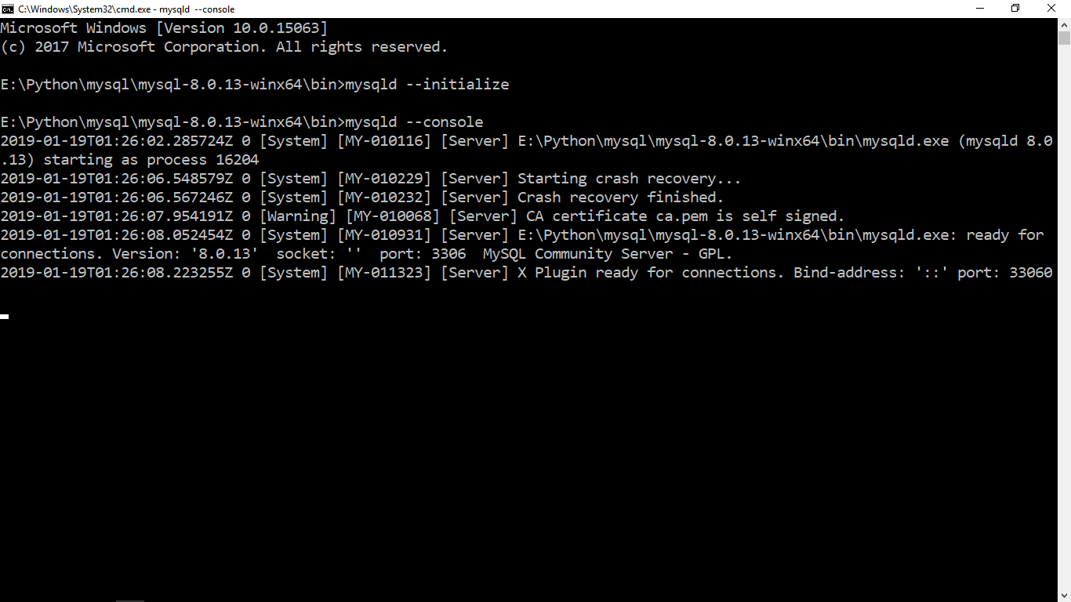

Mysql Database 1

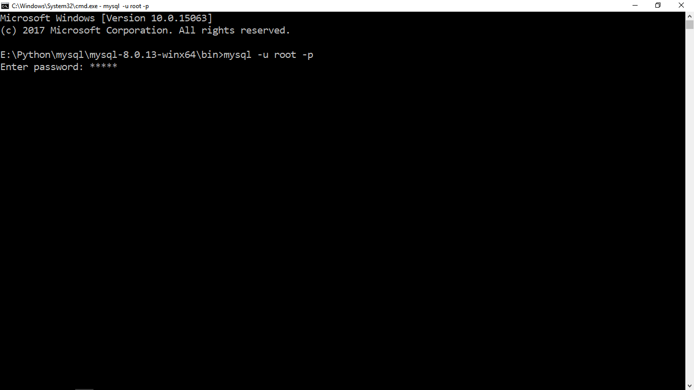

Mysql Database 2 [mysql authentication]

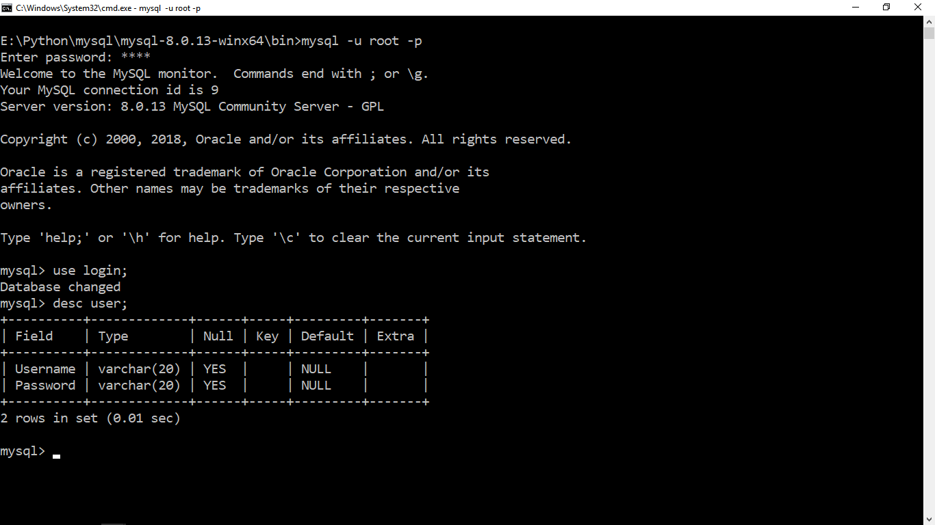

Mysql Database 3 [Data Structure]

Outputs

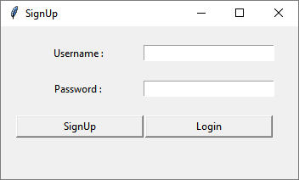

Graphical User Interface 1

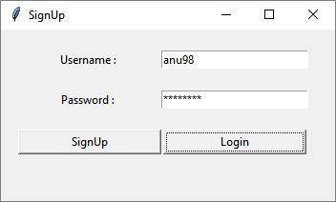

Graphical User Interface 2 [Login]

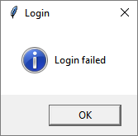

Graphical User Interface 3 [Login Failed]

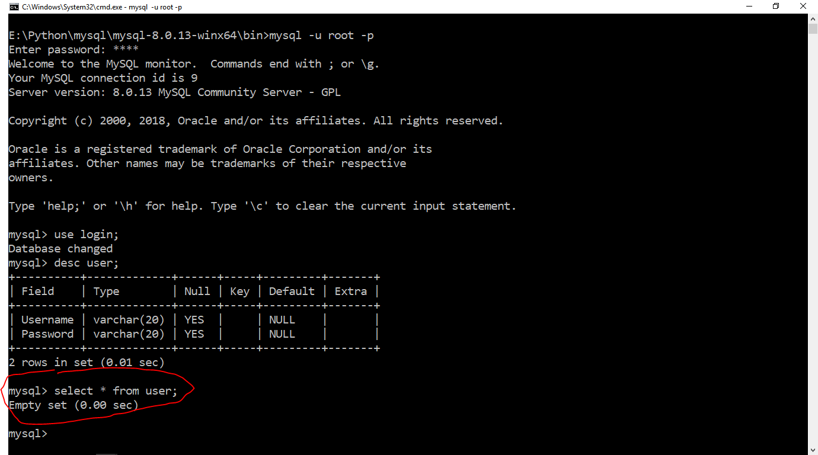

Mysql database 1 [Login Failed because no data at database]

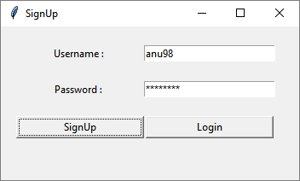

Graphical User Interface 4 [Signup]

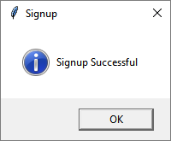

Graphical User Interface 5 [Signup Success]

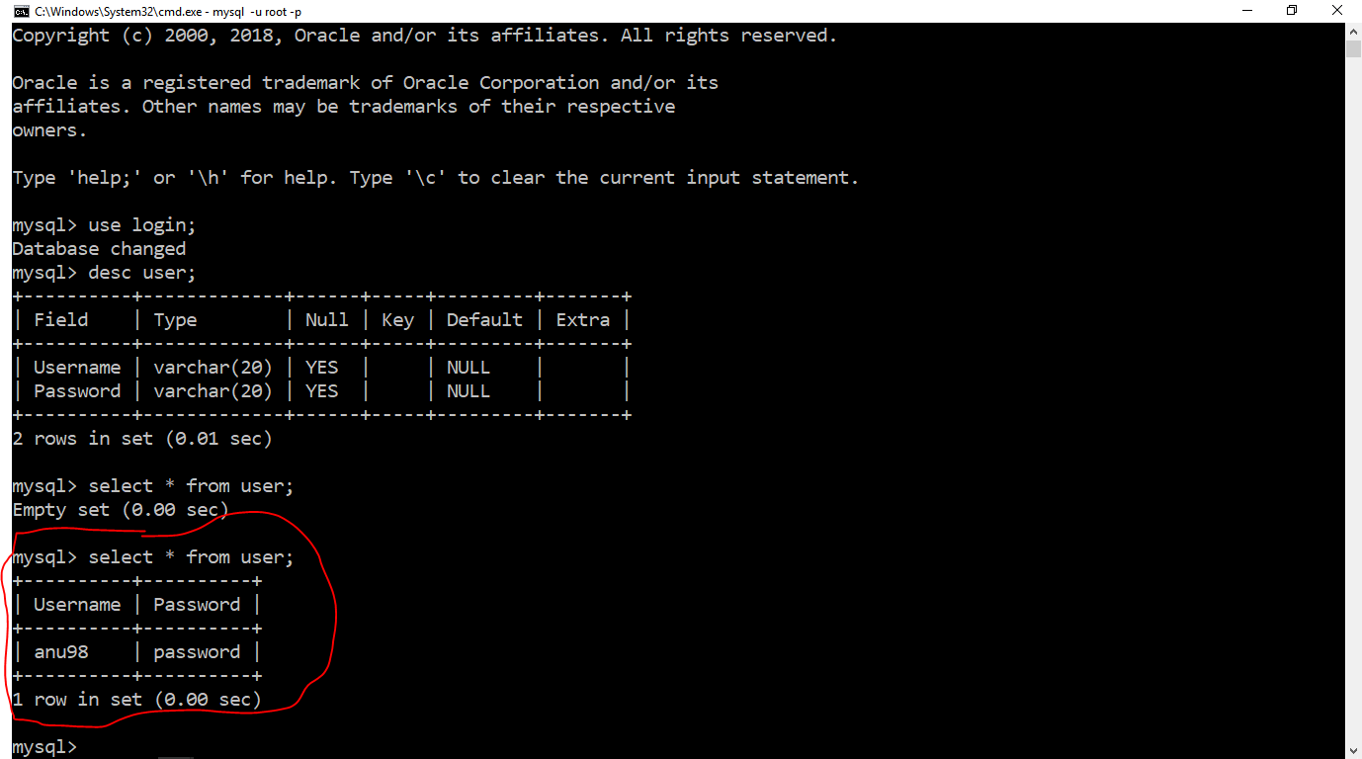

Mysql database 2 [userdata added]



Graphical User Interface 6 [Login again]

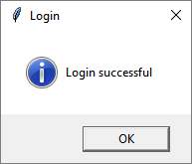

Graphical User Interface 7 [Login success]