# Introduction

Electric vehicles, EVs, are gaining popularity in recent years. The reduction of taxes by various nations on EVs, the consideration of environment, and the ever-depleting petroleum resources has made EVs a possible vehicle in consideration for many drivers and the easier and cheaper availability of electricity further solidifies the case for the choice of EVs. Similarly, recommendation systems are also nowadays used on almost every walk of digital life. The increasing adoption of electric vehicles (EVs) has led to a growing demand for charging infrastructure. However, finding a charging station that is both conveniently located and available can be a challenge for EV drivers. The aim of this project is to address this challenge by providing a user-friendly and efficient solution for recommending charging stations. The system utilizes the technique of cosine similarity to recommend the most suitable electric vehicle charging stations in a specified location. The report will detail the design, implementation and evaluation of the system, as well as its overall performance and potential future improvements.

# Problem Statement

The big problem of Electric Vehicles (EV), is charging. EV charging is not as easy as filling up fuel as in an internal combustion engine-based vehicle as it takes quite a significant time for the EV to be fully charged. So, picking an EV charging station can be a big personal preference-based choice and finding a right one can be a topic of choice. With the scarce availability of the EV charging stations, it can be very difficult to even look for an EV charging station let alone being recommended one that a person may like, trust, and ultimately prefer.

# Objectives

1. To implement user-user-based collaborative filtering using cosine similarity
2. To create a web-based recommendation system that recommends EV charging stations in an area

# Methodology

## Requirement Identification

### Study of Existing System

### Literature Review

### Requirement Analysis

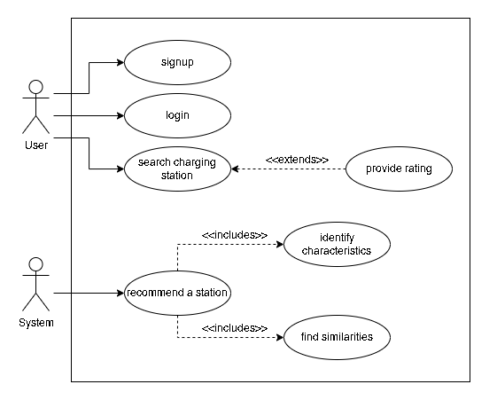

## Feasibility Study

### Technical Feasibility

The dataset to train and test the recommendation system can be available from sources like NEA and Kaggle. Laravel framework would be used to build the recommendation system and the collaborative filtering technique with cosine similarity would be used for the recommendation algorithm. The next step would be to develop the recommendation system using the Laravel framework and the chosen algorithm. This would involve the implementation of various features such as user authentication, data management, and recommendation generation. The developed system would then be tested to ensure its functionality and performance. This would involve evaluating the system's accuracy and efficiency in generating recommendations, as well as user satisfaction with the system. Once the system has been tested and evaluated, it would be deployed for use by EV owners. This would involve the integration of the system with existing EV charging stations and the implementation of any necessary security measures.

All in all, the technical feasibility of this project is high as the Laravel framework is a robust and widely used platform for web development, and collaborative filtering with cosine similarity is a well-established recommendation algorithm. With the appropriate data and resources, the development, testing, and deployment of this system is achievable.

### Operational Feasibility

The system will be able to recommend the EV charging station to the user in the specified location. This recommendation will be based on the ratings the user has provided to the EV charging stations that the user has already been to and rated. This solves the problem for the user to manually search the EV charging station and make a guess of whether the one they found may be one of their liking or not and whether they will be able to trust their expensive vehicles on the said charging station or not. Furthermore, having a system of authentication and authorisation will also help prevent fake ratings and make the system more reliable and robust.

### Schedule Feasibility

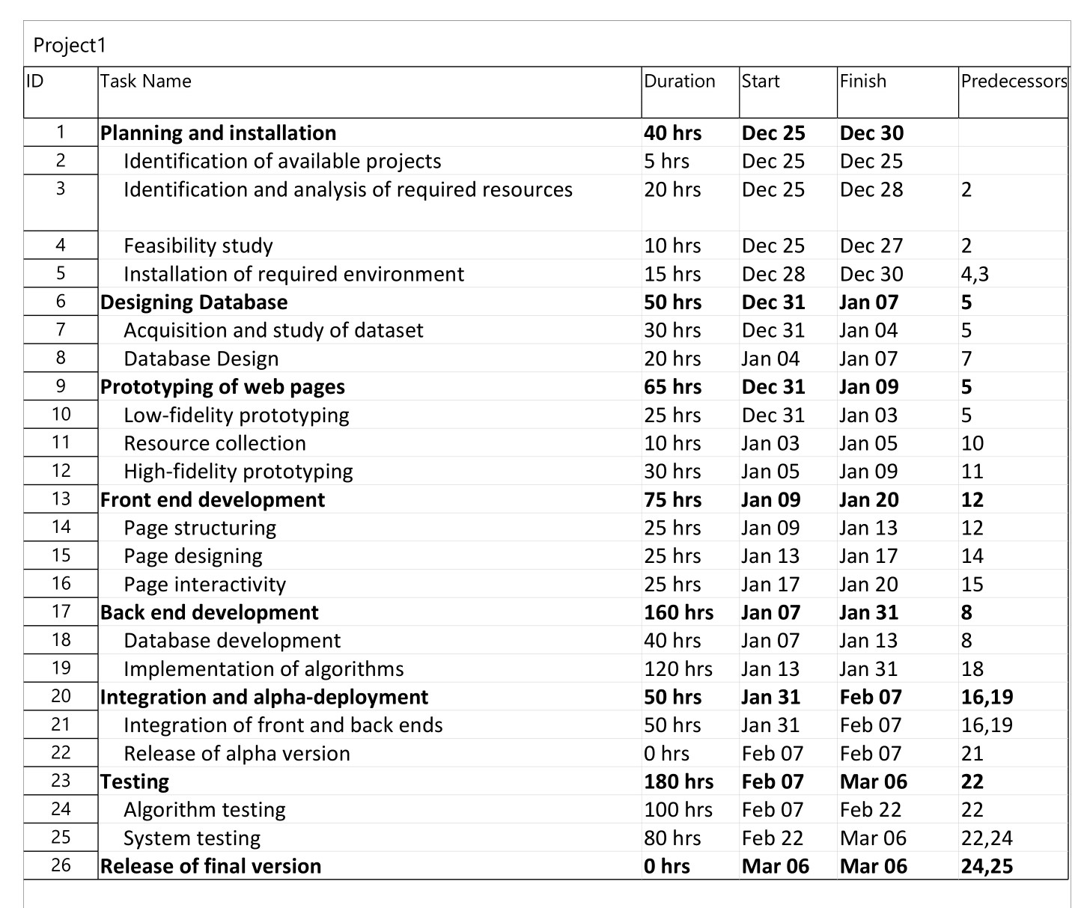

## High Level Design of System

### Working Mechanism of Proposed System

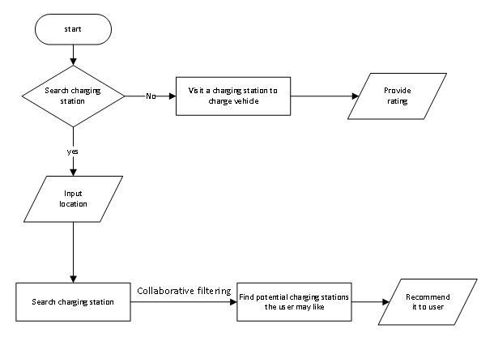

### Description of Algorithm

#### Collaborative Filtering

Collaborative filtering uses algorithms to filter data from user reviews to make personalized recommendations for users with similar preferences. Collaborative filtering is a method of making automatic predictions (filtering) about the interests of a user by collecting preferences or taste information from many users. The cosine-based approach defines the cosine-similarity between two users x and y as:

$$similarity\left(x, y\right)=\cos\left(\vec{x}, \vec{y}\right)= \frac{\vec{x}.\vec{y}}{\left|\left|\vec{x}\right|\right|.\left|\left|\vec{y}\right|\right|}= \frac{\sum_{i∈I_{xy}}{r_{x,i}r_{y,i}}}{\sqrt{\sum_{i∈I_{x}}{r_{x,i}^{2}}}.\sqrt{\sum_{i∈I_{y}}{r_{y,i}^{2}}}}$$

#### Cosine Similarity

Cosine similarity is a measure of similarity between two sequences of numbers. The cosine similarity always belongs to the interval [-1, 1]. The cosine of two non-zero vectors can be derived by using the Euclidean dot product formula:

$$A.B= \left|\left|A\right|\right|.\left|\left|B\right|\right|.\cos{θ}$$

Given two n-dimensional vectors of attributes, A and B, the cosine similarity, cos(θ), is represented using a dot product and magnitude as:

$$S_{c}\left(A, B\right)=\cos{(θ)}= \frac{A. B}{\left|\left|A\right|\right| . \left|\left|B\right|\right|}= \frac{\sum_{i=1}^{n}{A_{i}.B_{i}}}{\sqrt{\sum_{i=1}^{n}{A_{i}^{2}}}. \sqrt{\sum_{i=1}^{n}{B_{i}^{2}}}}$$

where Ai and Bi are components of vector A and B respectively.

## Proposed tools and technologies

1. Hyper-text Markup Language 5 (HTML5)
2. Cascading Style Sheets 3 (CSS3) with Syntactically Awesome Style Sheets (SCSS)
3. JavaScript (JS)
4. Hyper-text Pre-processor (PHP) with Laravel 8 framework

# Expected Outcome

# References