Visual Inspection Details
Building Name | 24129
Apartment Name | 172
Location Name | Deck
Visual Report
Exterior Elements | Decks, Railings, Integrations, Door Threshold, Stucco Interface
Water Proofing Elements | Flashings, Waterproofing, Coatings, Sealants
Visual Review | Bad
Any Visual Signs of leaks | No
Further Invasive Review Required | No
Condition Assessment | Fail
Additional Considerations or Concerns | Surface peeling at the deck waterproofing coating. Open condition adjacent to guardrail post. Repair is necessary
Life Expectancy (EEE) | 1-4 Years
Life Expectancy (LBC) | 4-7 Years
Life Expectancy (AWE) | 0-1 Years

Visual Photos
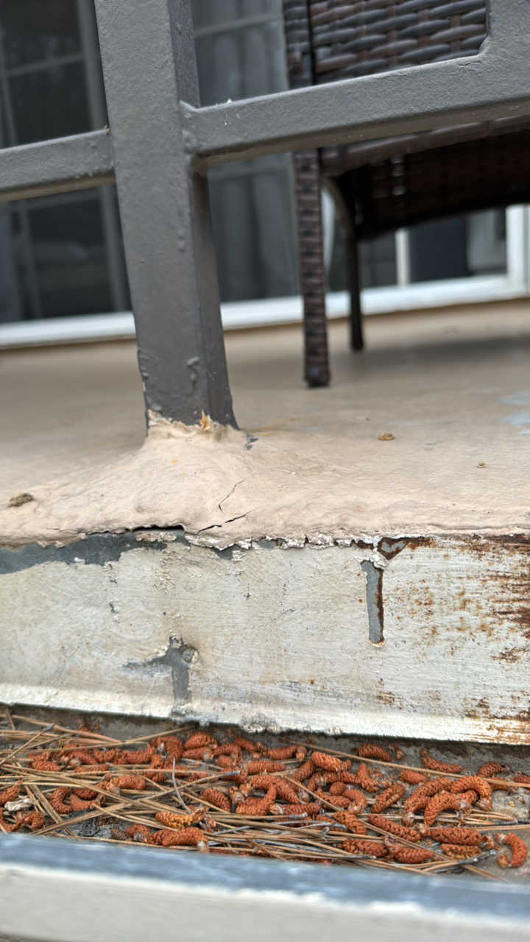 | 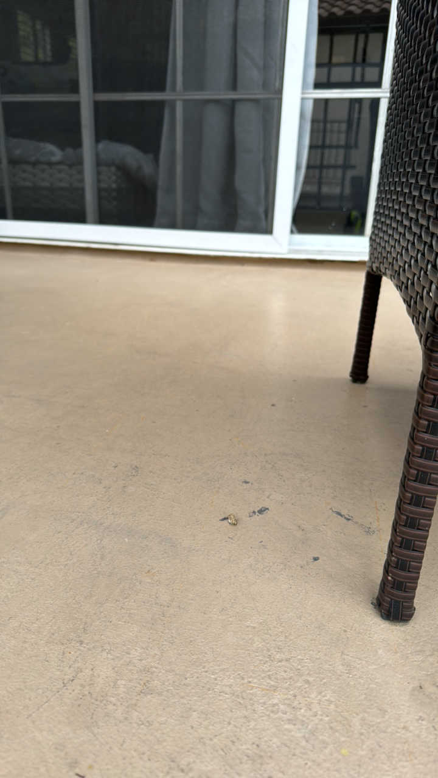 | 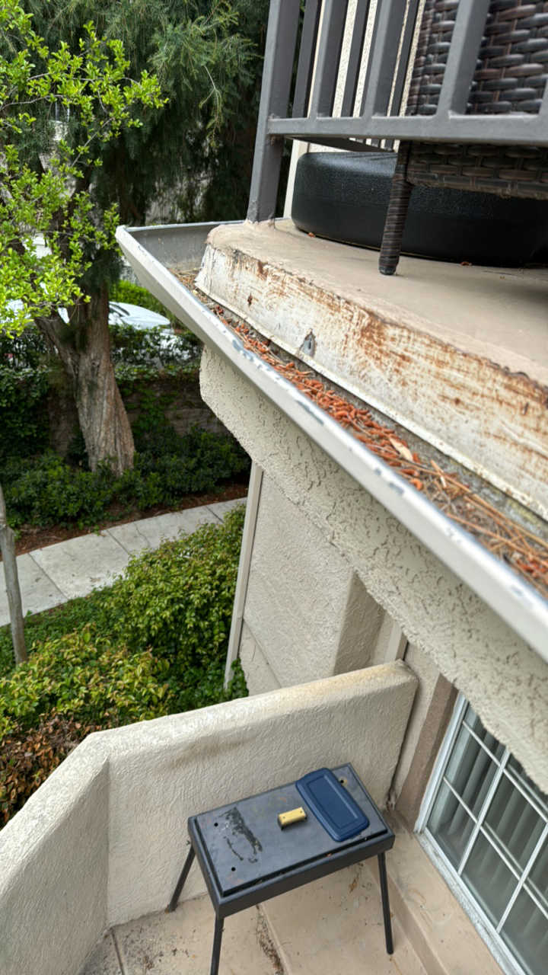 | 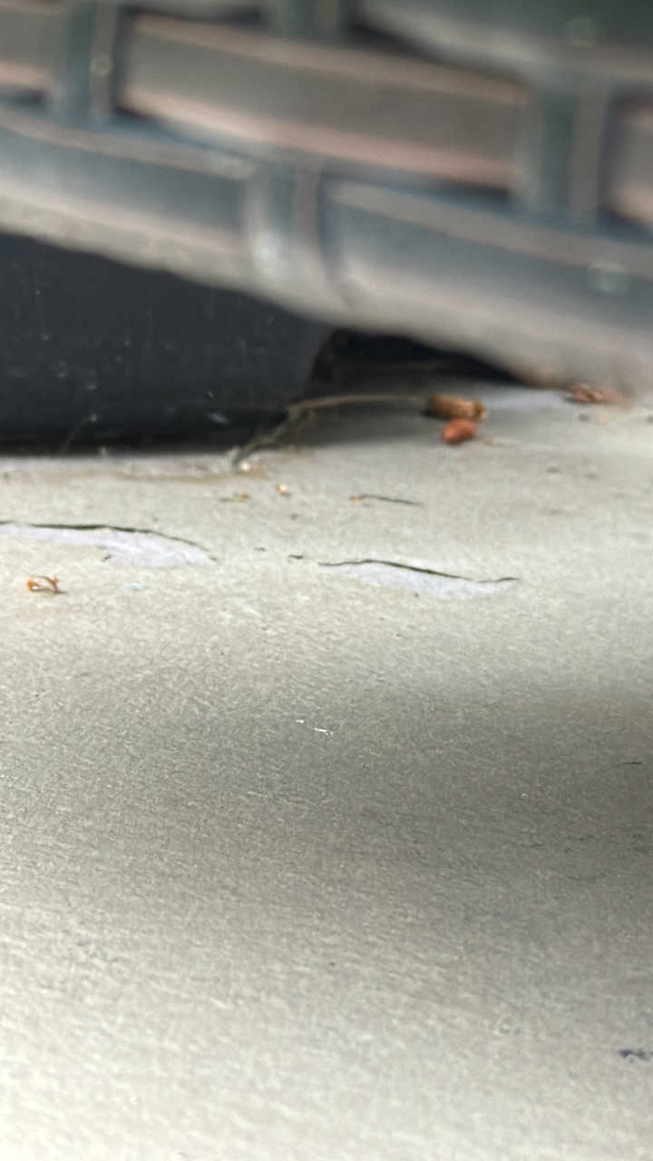
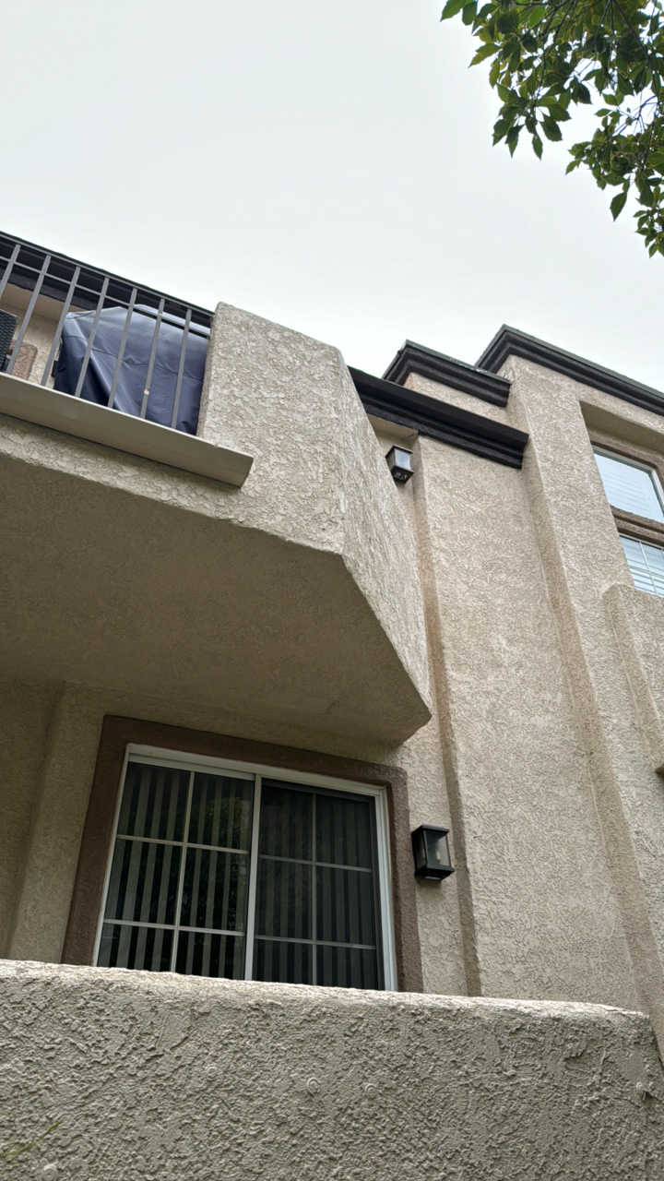 | 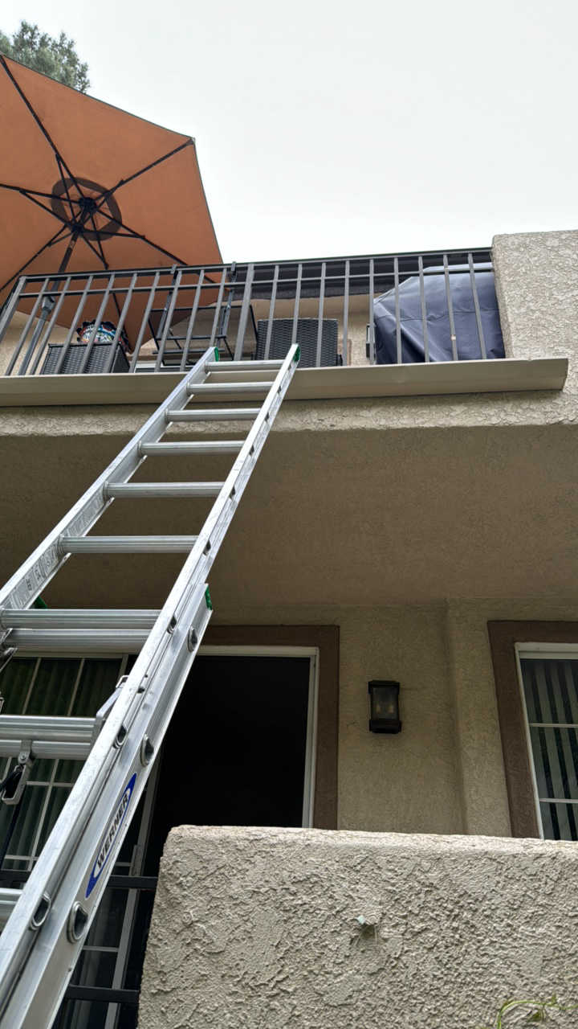 | 