Visual Inspection Details
Building Name | 24133
Apartment Name | 200
Location Name | Entry Deck
Visual Report
Exterior Elements | Decks, Railings, Integrations, Door Threshold, Stucco Interface
Water Proofing Elements | Flashings, Waterproofing, Coatings, Sealants
Visual Review | Good
Any Visual Signs of leaks | No
Further Invasive Review Required | No
Condition Assessment | Pass
Additional Considerations or Concerns
Life Expectancy (EEE) | 1-4 Years
Life Expectancy (LBC) | 4-7 Years
Life Expectancy (AWE) | 1-4 Years

Visual Photos
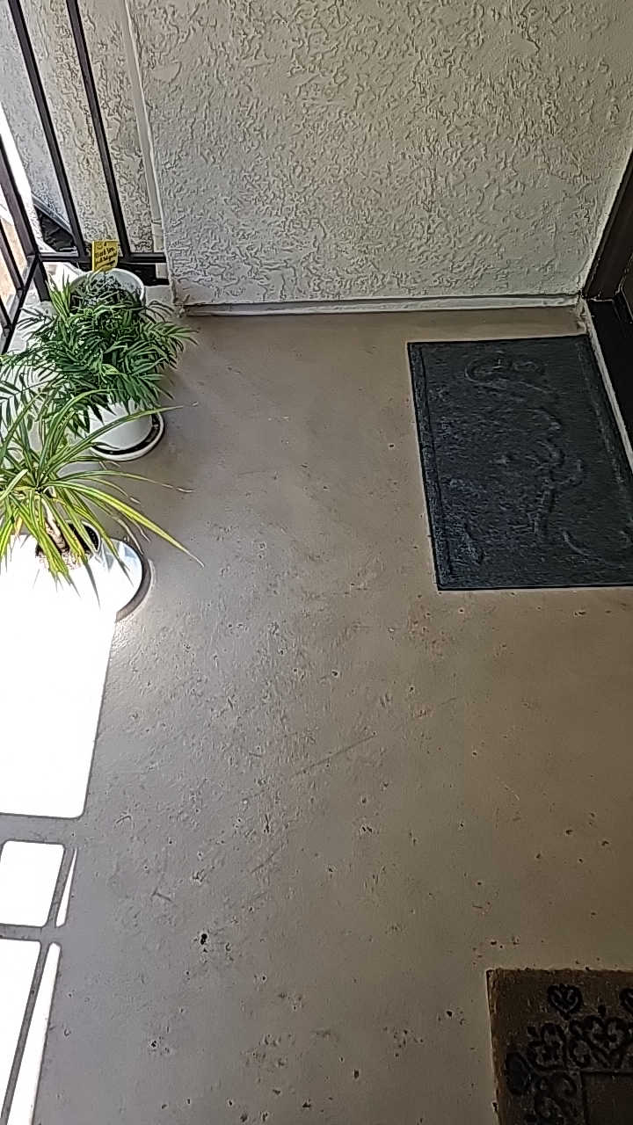 | 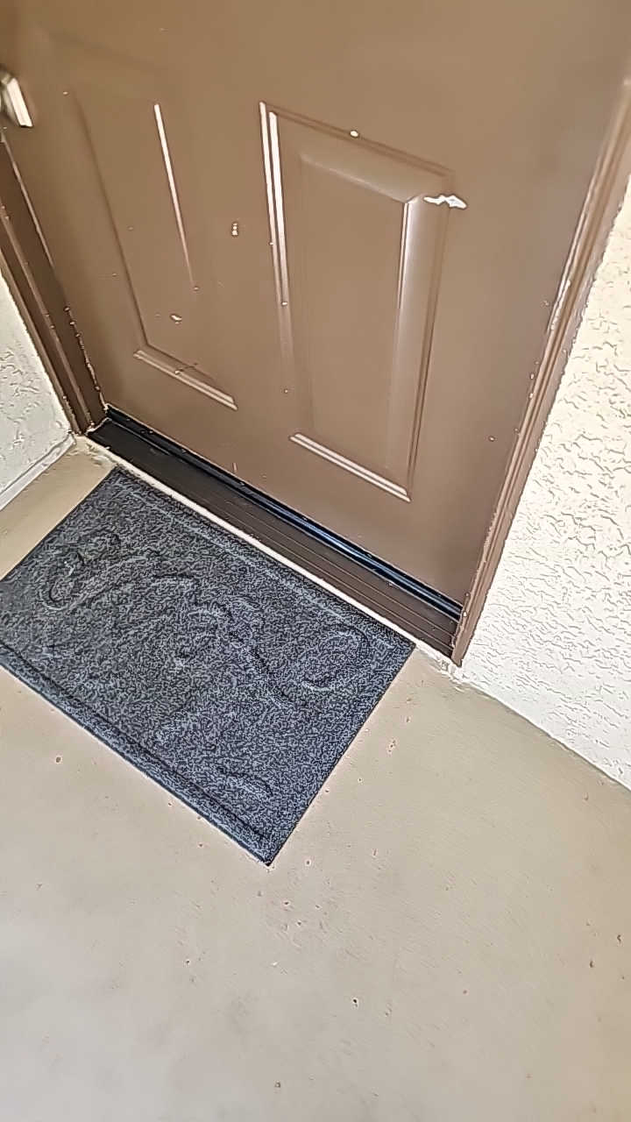 | 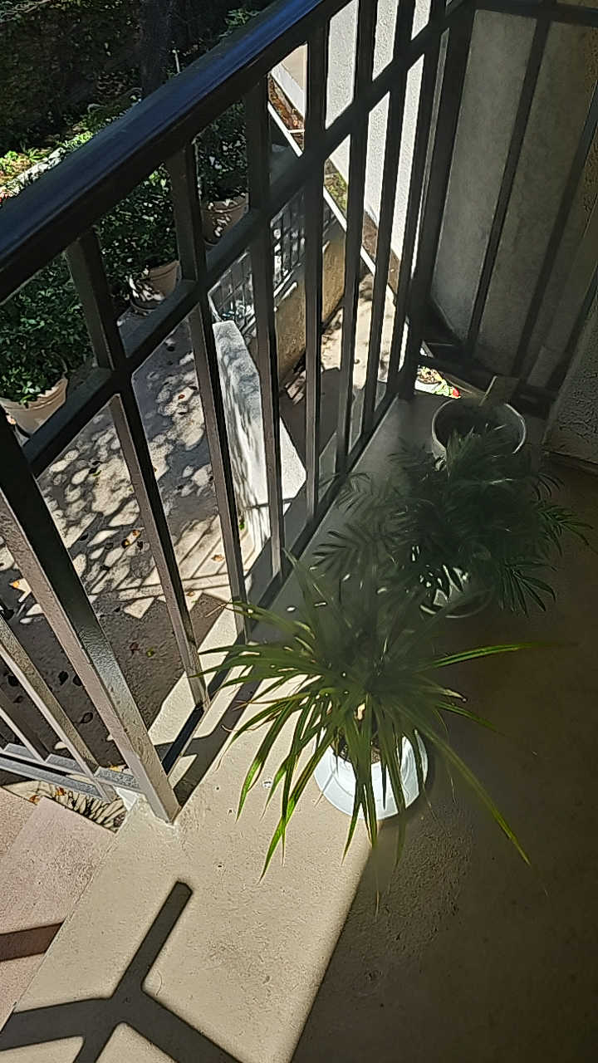 | 