Visual Inspection Details
Building Name | 24137
Building Common Name | Entry Stairs 5
Location Name | Stairs
Visual Report
Exterior Elements | Stairs, Stairs Landing, Railings, Integrations
Water Proofing Elements | Flashings, Sealants
Visual Review | Bad
Any Visual Signs of leaks | Yes
Further Invasive Review Required | No
Condition Assessment | Fail
Additional Considerations or Concerns | Significant crack in the top stair landing. Crack along top of guardrail and underside of dropped beam. Repair is necessary.
Life Expectancy (EEE) | 1-4 Years
Life Expectancy (LBC) | 1-4 Years
Life Expectancy (AWE) | 0-1 Years

Visual Photos
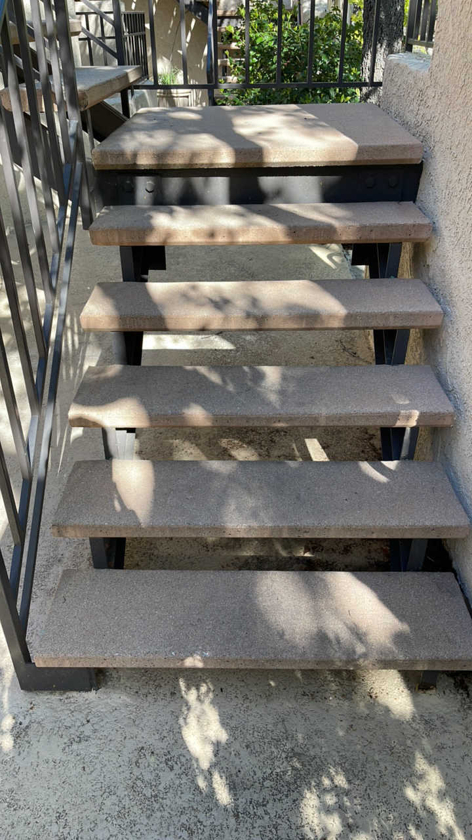 | 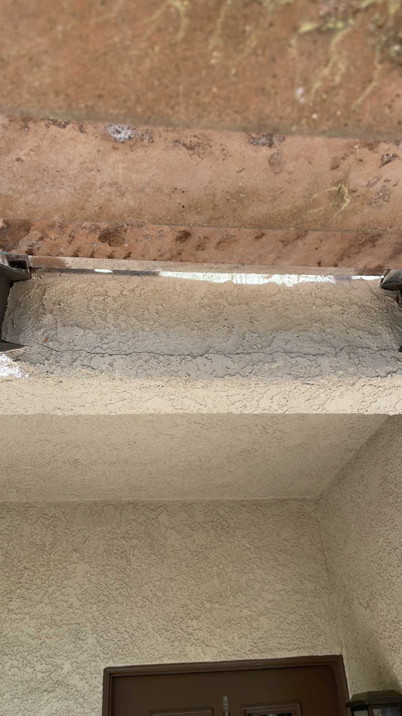 | 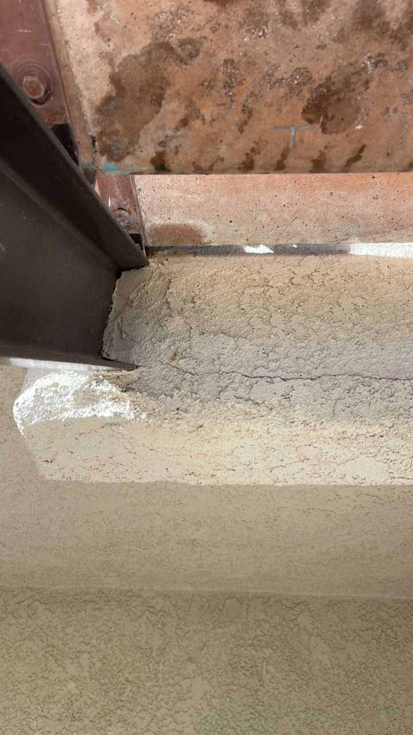 | 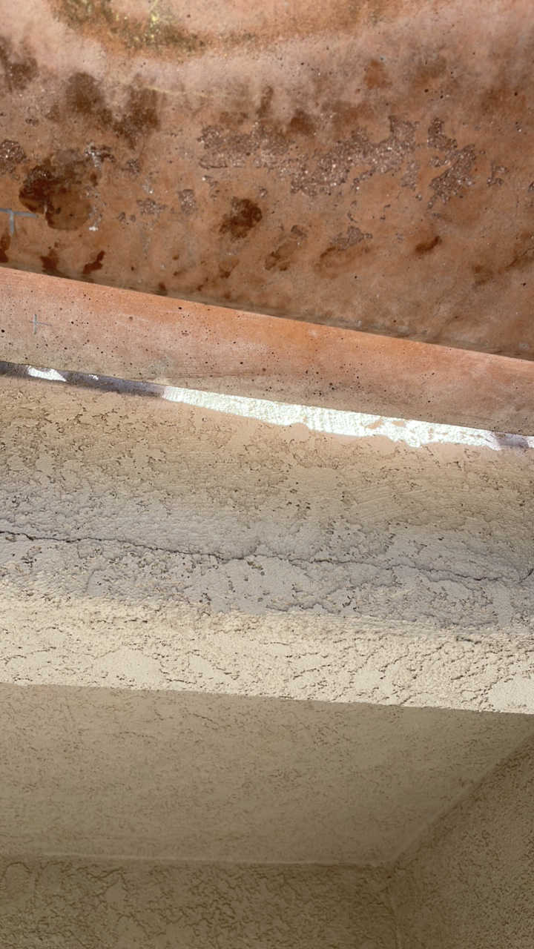
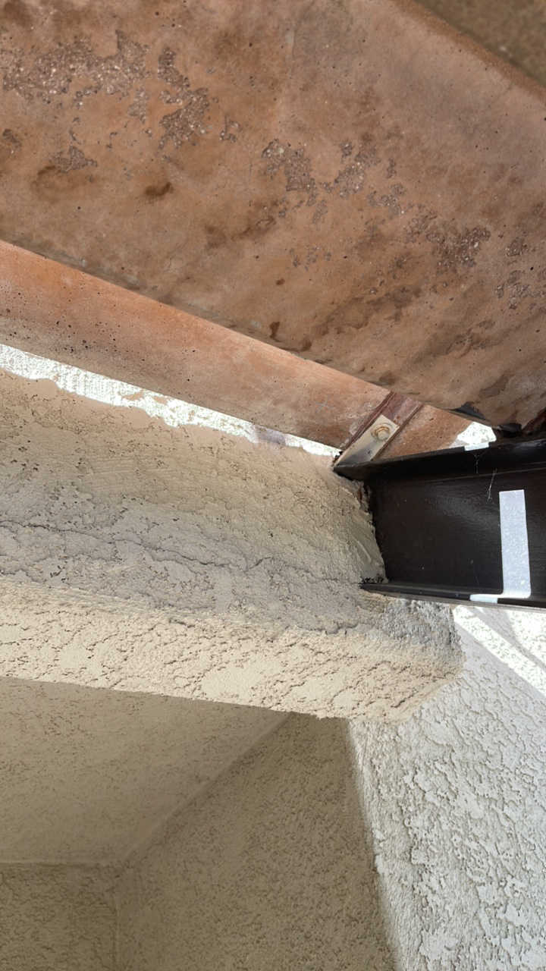 | 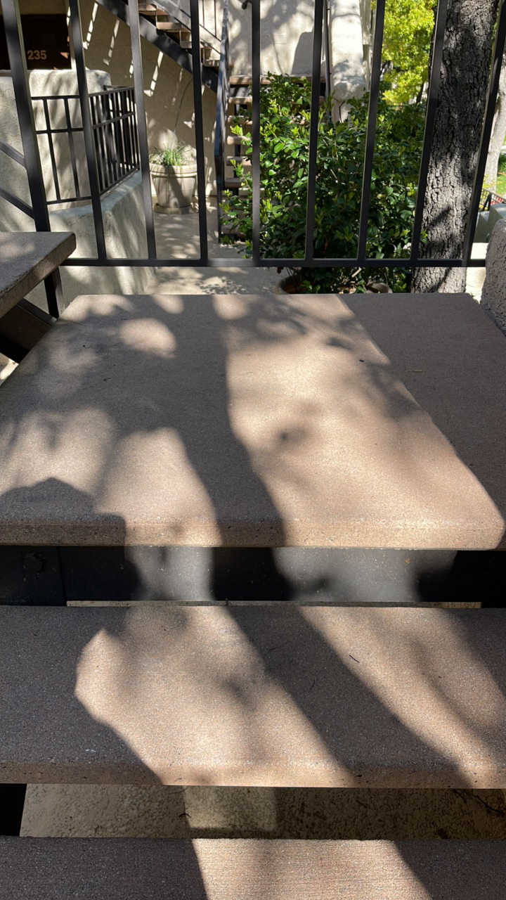 | 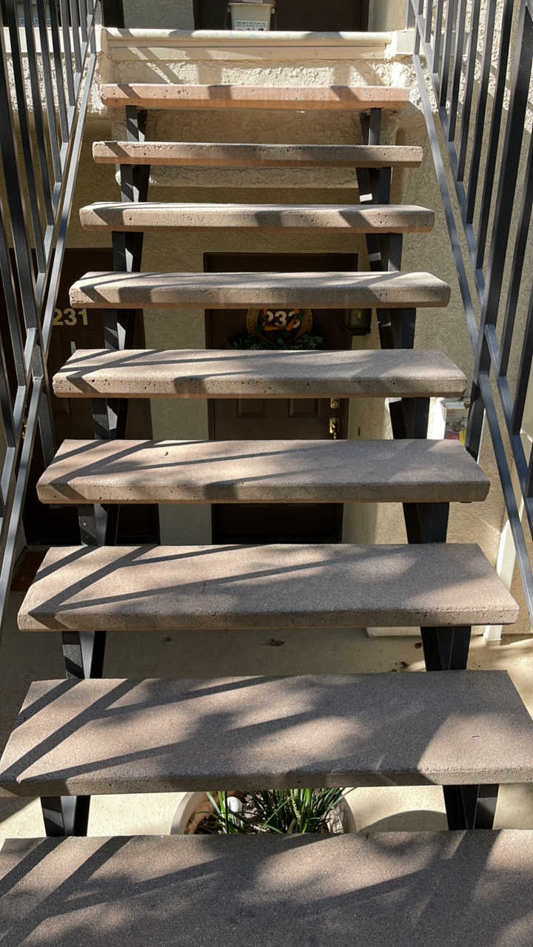 | 