Visual Inspection Details
Building Name | 24151
Building Common Name | Entry Stairs 3
Location Name | Stairs
Visual Report
Exterior Elements | Stairs, Stairs Landing, Railings, Integrations
Water Proofing Elements | Flashings, Sealants
Visual Review | Good
Any Visual Signs of leaks | No
Further Invasive Review Required | No
Condition Assessment | Pass
Additional Considerations or Concerns
Life Expectancy (EEE) | 1-4 Years
Life Expectancy (LBC) | 4-7 Years
Life Expectancy (AWE) | 4-7 Years

Visual Photos
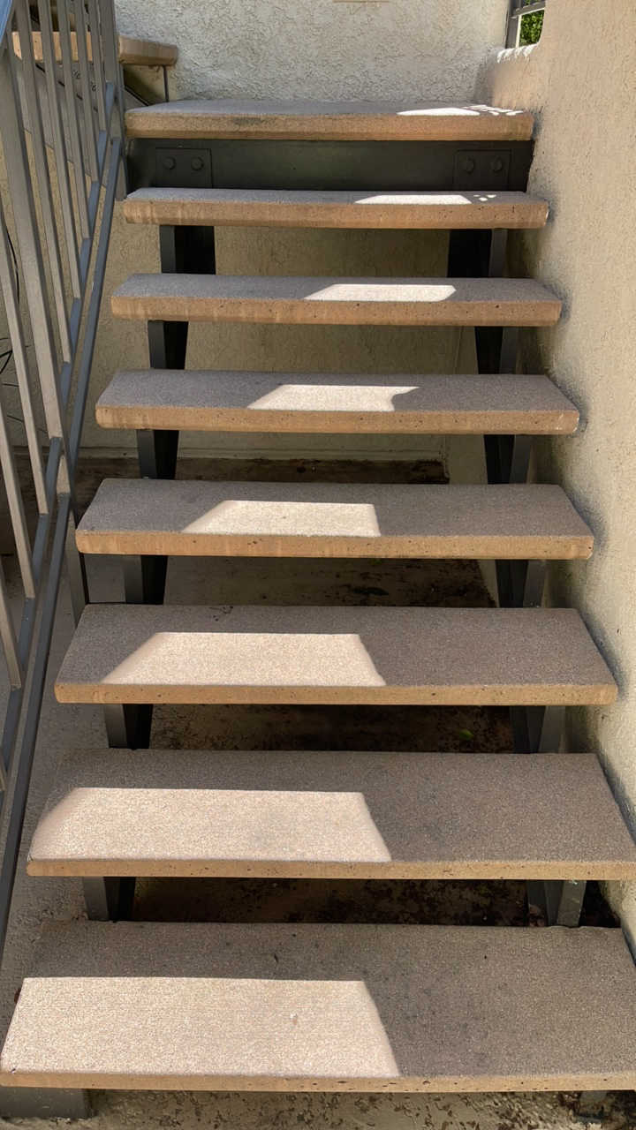 | 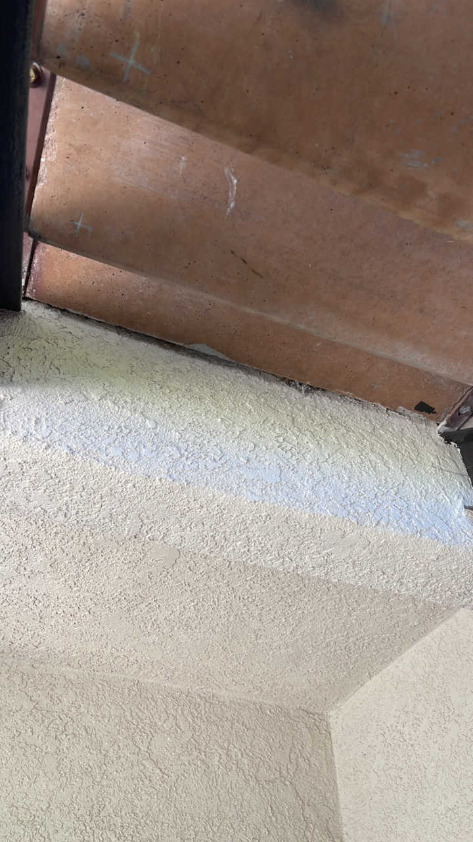 | 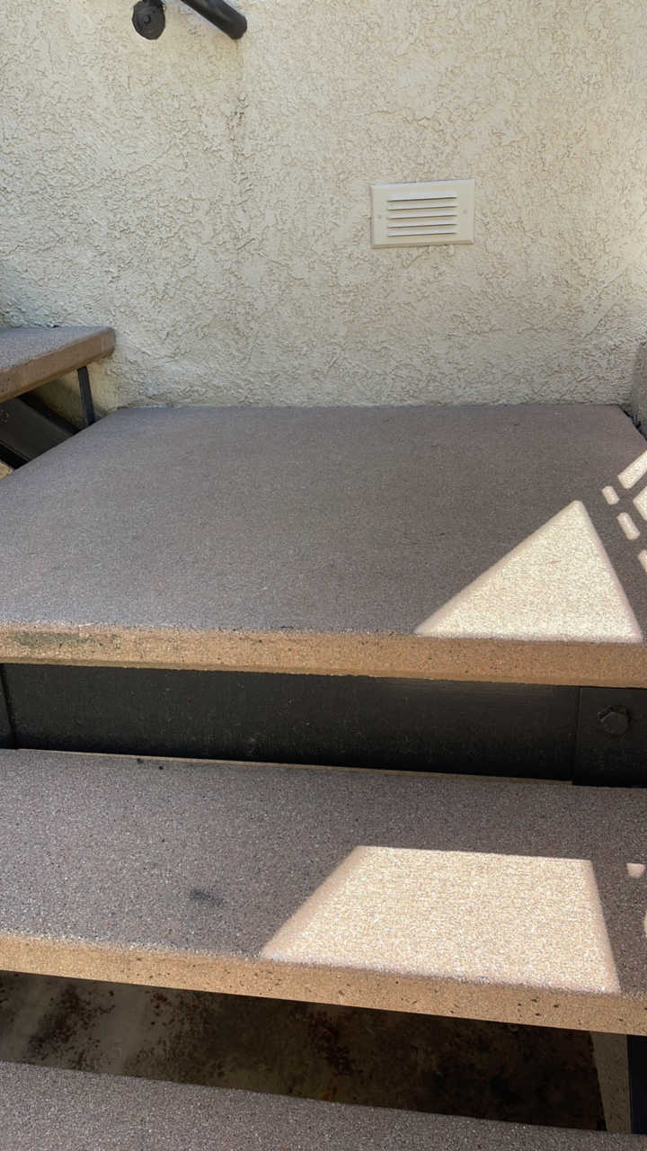 | 