Visual Inspection Details
Building Name | sdfs
Apartment Name | apartment1
Location Name | locationforreport ediyted
Visual Report
Exterior Elements | Porches/Entry, Stucco Interface, Door Threshold, Stairs, Stairs Landing, Walkways
Water Proofing Elements | Waterproofing, Coatings, Sealants
Visual Review | Fair
Any Visual Signs of leaks | No
Further Invasive Review Required | No
Condition Assessment | Pass
Additional Considerations or Concerns | sc
Life Expectancy (EEE) | 0-1 Years
Life Expectancy (LBC) | 1-4 Years
Life Expectancy (AWE) | 1-4 Years

Visual Photos
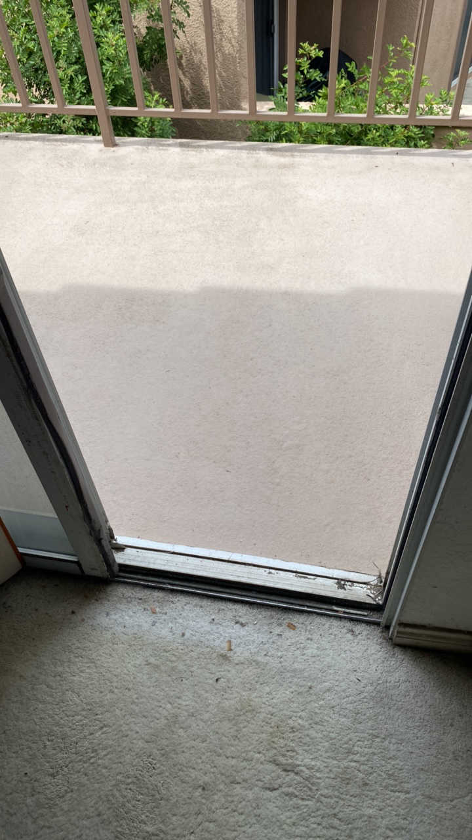 | 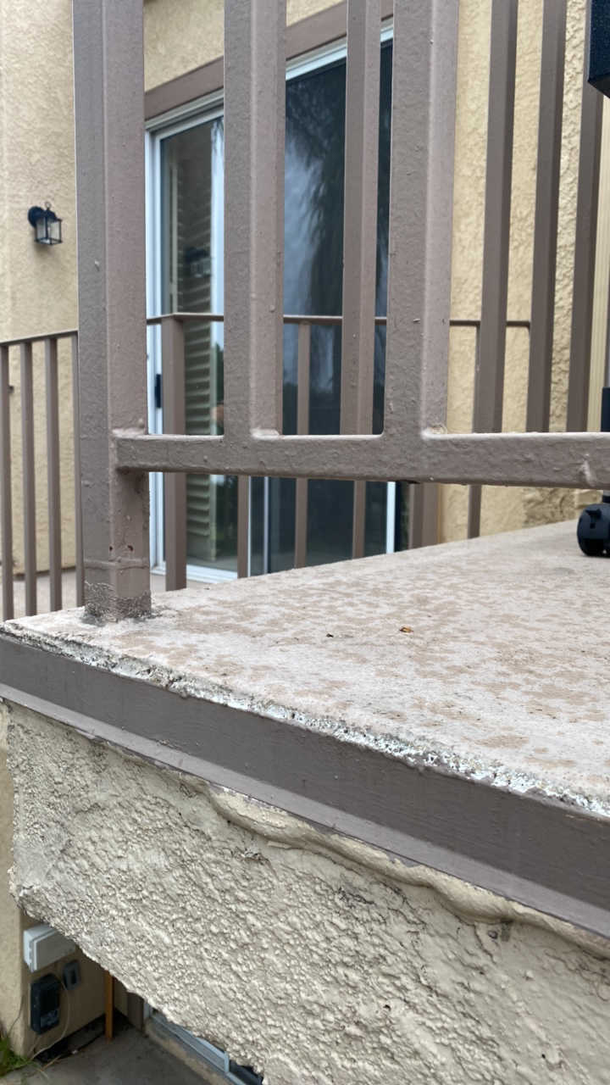 | 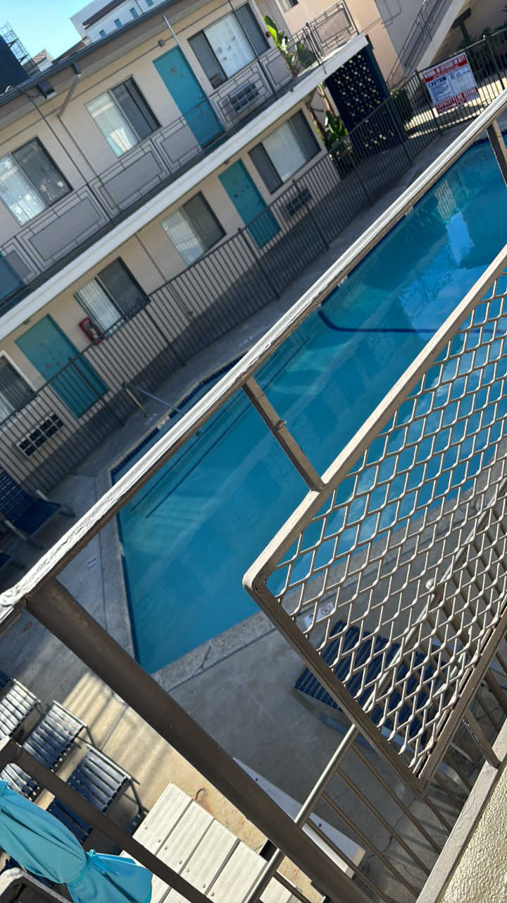 | 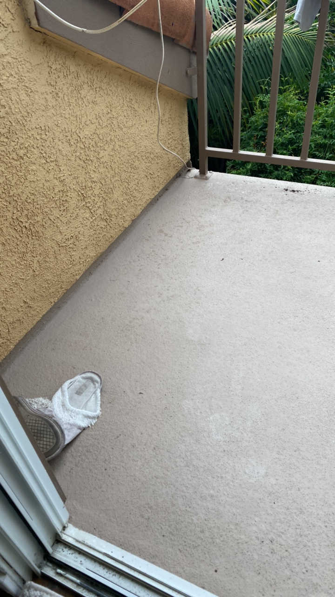
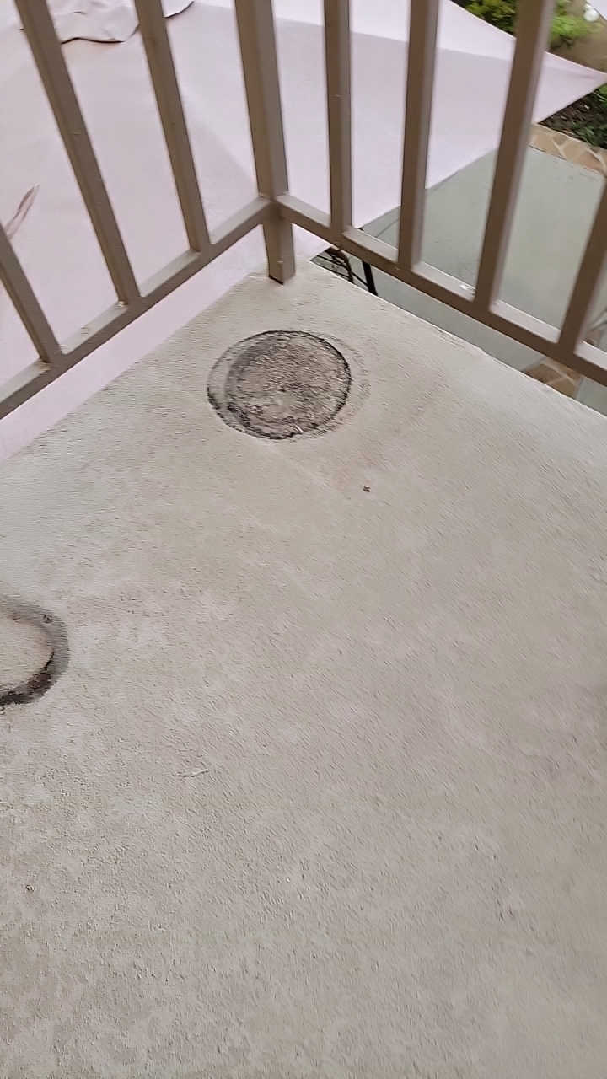 | 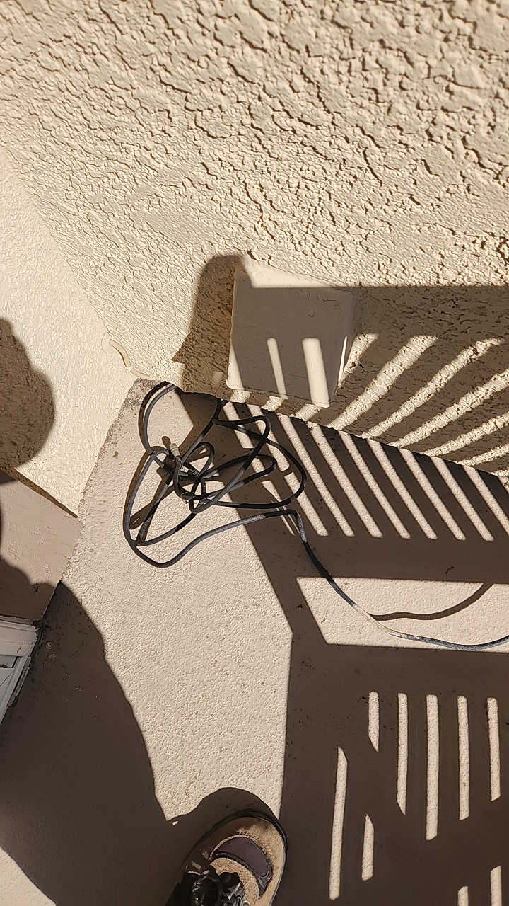 | 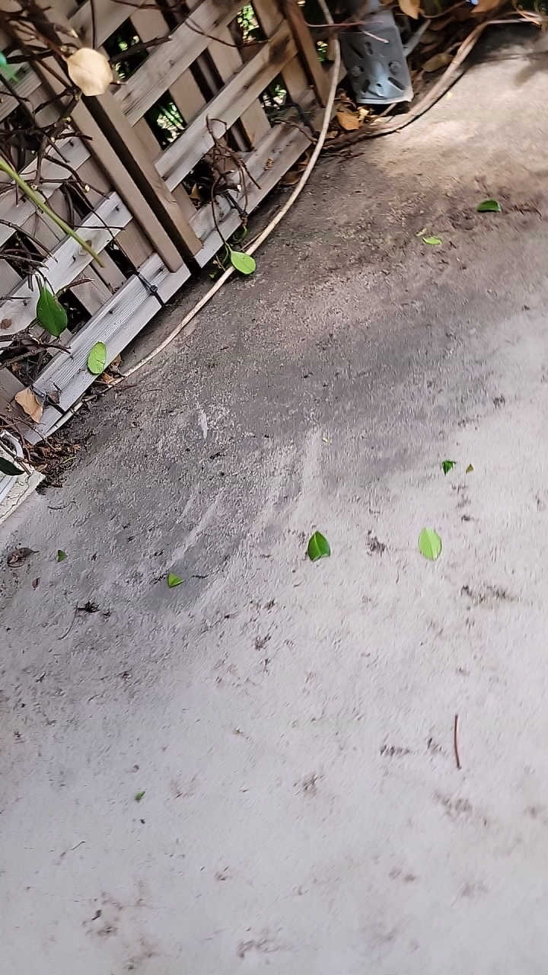 | 
