MARKET SENTIMENT AND TRADER PERFORMANCE
A Study of Hyperliquid Trading Data Against the Bitcoin Fear & Greed Index
Submitted by: Abhinraj
Data Analysis Submission

Executive Summary
This report looks at whether the mood of the crypto market ... measured through the Bitcoin Fear & Greed Index ... lines up with how traders actually performed on Hyperliquid. I combined roughly 19,000 individual trades from five accounts with the daily sentiment index and looked at profitability, win/loss patterns, and how specific coins behaved under each sentiment label.
The short version: the data does not support the common assumption that greedy, bullish markets are the most profitable ones to trade in. In this dataset, the opposite showed up ... trades placed during Extreme Fear had the highest average profit, while Extreme Greed had the lowest. Neutral conditions produced the most consistent win rate. None of this proves that fear causes profit; it simply shows a pattern worth paying attention to, along with a few important caveats about sample size that are covered later in the report.

Introduction
Markets don't move on numbers alone ... a lot of it comes down to how people feel about risk at any given moment. In crypto, that mood swing is tracked fairly closely by the Bitcoin Fear & Greed Index, which buckets each day into one of five categories: Extreme Fear, Fear, Neutral, Greed, or Extreme Greed.
This project sets out to check whether that sentiment score actually lines up with anything measurable in real trading outcomes. I took historical trade data from Hyperliquid and matched every trade to the sentiment score recorded on that same date, then looked at what happened to profitability, trade outcomes, and individual coin performance as sentiment shifted.
Rather than picking one metric and building the whole report around it, I looked at the question from a few different angles ... average profit, win/loss/break-even split, and per-coin behaviour ... since any one of these on its own can be misleading.

Objectives
- Check whether market sentiment shows any relationship with trader profitability.
- Compare how trades resolve ...win, loss, or break-even ... across sentiment categories.
- See how major coins behave differently depending on the prevailing sentiment.
- Pull out any behavioural patterns that could actually inform trading decisions.
- Turn the findings into practical, business-facing recommendations.

Dataset Description
Two datasets were combined for this analysis.
Dataset 1 : Hyperliquid Historical Trading Data
Raw trade-level records pulled from Hyperliquid, covering:
- Account
- Coin
- Execution Price
- Size (USD)
- Direction
- Closed PnL
- Timestamp
In total, the dataset holds 19,119 trades spread across 5 trading accounts.
Dataset 2 : Bitcoin Fear & Greed Index
A daily sentiment reading with two fields: the date, and the sentiment label for that day (Extreme Fear, Fear, Neutral, Greed, or Extreme Greed).

Data Preparation
Before any analysis could happen, the two datasets needed to actually talk to each other. The steps involved were:
- Loaded both datasets into Pandas.
- Standardised the trade timestamp into a plain date format so it could be matched against the sentiment data.
- Merged the two datasets on trading date.
- Checked the merge for gaps to make sure every trade had a sentiment value attached.
- Added a Trade Result column, classifying each trade as Winning (Closed PnL > 0), Losing (Closed PnL < 0), or Break-even (Closed PnL = 0).
With that in place, every single trade could be viewed alongside the market mood on the day it happened.

Exploratory Data Analysis
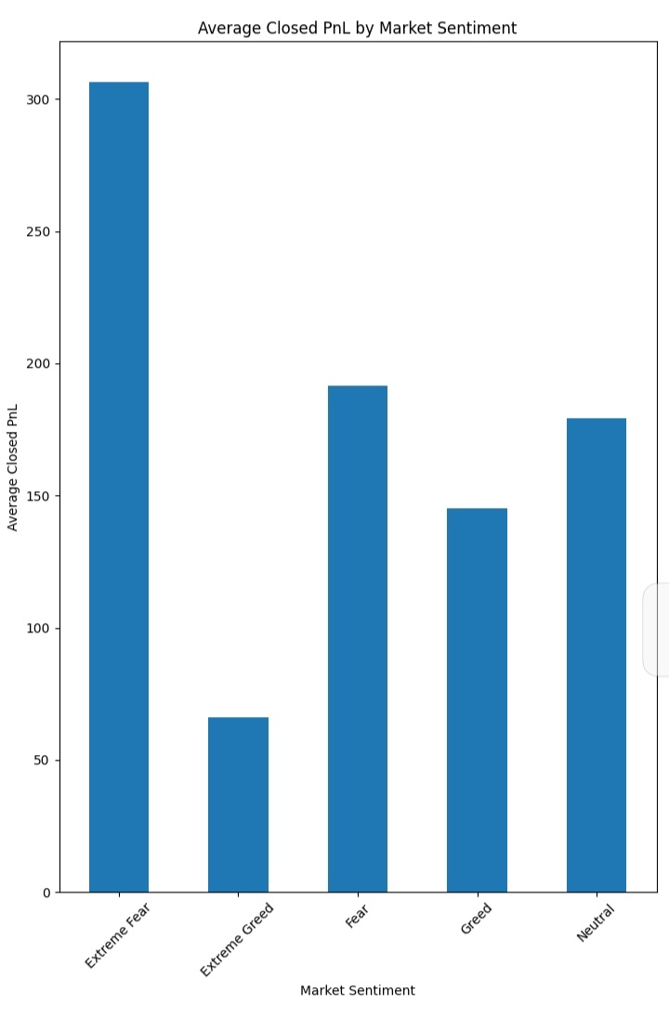
Figure 1. Average Closed PnL by Market Sentiment
Observation
Extreme Fear posted the highest average Closed PnL of all five categories, while Extreme Greed came in lowest. Fear and Neutral both held up reasonably well too.
Discussion
This was the part of the analysis that went against what I expected going in. Average profitability clearly isn't flat across sentiment ...trades placed during fearful conditions came out ahead of trades placed during greedy ones, at least in this dataset. A reasonable explanation is that traders tend to tighten up and get more selective when the market feels shaky, whereas a euphoric market may pull people into looser, more impulsive entries. That's a plausible story, not a proven one ... the data shows a relationship, not a cause.
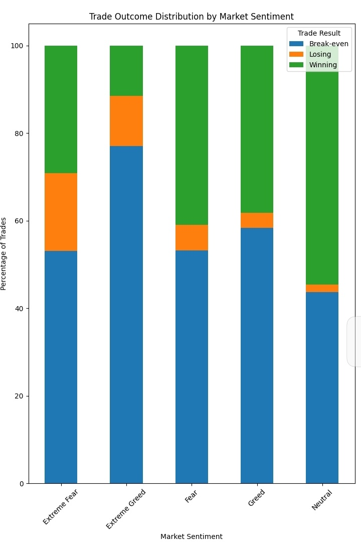
Figure 2. Trade Outcome Distribution by Market Sentiment
Observation
Neutral sentiment had the highest share of winning trades of any category. Extreme Greed carried the largest share of break-even trades, and Extreme Fear had a noticeably higher share of losing trades than the other categories.
Discussion
So it's not just average profit that shifts with sentiment ... the whole shape of outcomes changes too. Neutral markets seem to give traders a steadier, more balanced setup to work with, while the more emotionally charged conditions (both extremes) come with messier, less predictable results. Interestingly, Extreme Fear had both the best average PnL and a higher share of losses, which suggests a small number of large wins were doing most of the work in that category rather than consistent performance across the board.
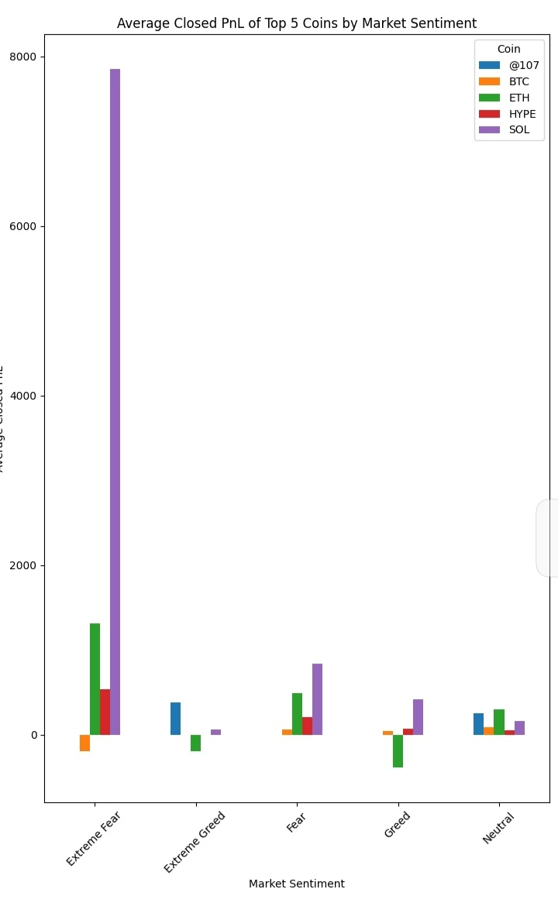
Figure 3. Average Closed PnL of Top Coins by Market Sentiment
Observation
Individual coins didn't move together. ETH did noticeably better during Fear than during Greed, and SOL showed an unusually large average Closed PnL under Extreme Fear.
Discussion
Different assets clearly respond to sentiment in their own way, which means treating "the market" as one uniform thing during strategy design probably isn't the right approach. That said, the SOL spike under Extreme Fear needs a caveat attached to it ... it's built on only two trades, so it's more of an outlier than a trend, and I'd be cautious about reading anything strategic into it without more data.
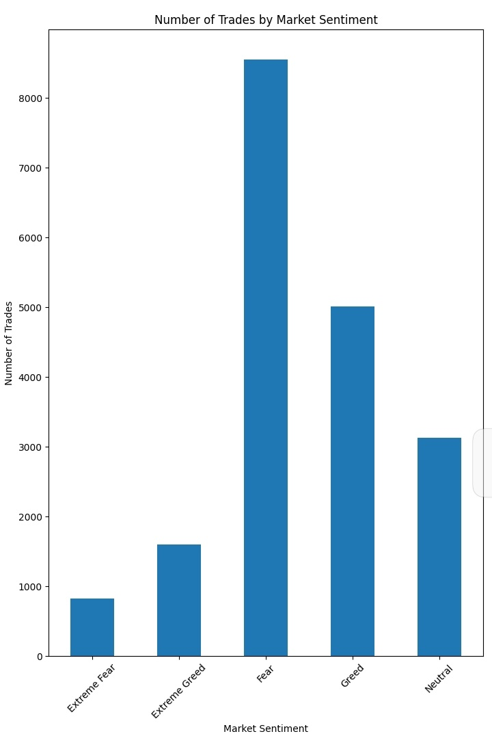
Figure 4. Number of Trades by Market Sentiment
Observation
Fear had by far the highest trade count, followed by Greed and Neutral. Extreme Fear had the fewest trades of any category.
Discussion
This chart matters because it puts the earlier profitability numbers in context. A category with a lot more trading activity naturally has more weight in the overall picture, so average PnL and trade volume need to be read together, not separately. High activity in a category doesn't automatically mean it's the most profitable one ... Fear had the most trades but not the highest average return, for example.

Key Findings
- Market sentiment does appear to be associated with differences in trader performance ... this isn't flat across categories.
- Extreme Fear produced the highest average Closed PnL of the five sentiment categories in this dataset.
- Neutral sentiment had the highest percentage of winning trades.
- Coin-level performance varied a lot by sentiment, meaning no single asset reacts to market mood the same way.
- SOL's average Closed PnL during Extreme Fear was unusually high, but it rests on just two trades and should be treated as an outlier, not a pattern.
- Trade volume was heavily concentrated in Fear, confirming that activity is not spread evenly across sentiment categories.

Business Recommendations
1. Treat sentiment as a supporting signal, not a standalone one
Sentiment data can be layered on top of existing technical indicators as an additional filter for evaluating trade timing ... it shouldn't replace them.
2. Tighten risk controls during Extreme Greed
Since average profitability was weakest in Extreme Greed conditions in this dataset, platforms and traders alike may want to apply stricter risk limits when sentiment reaches that extreme.
3. Build strategies at the coin level, not the market level
Because coins reacted differently to the same sentiment conditions, a one-size-fits-all strategy is likely leaving performance on the table. Coin-specific playbooks would make better use of this kind of data.
4. Sanity-check outliers before acting on them
Any unusually large average ... like the SOL figure under Extreme Fear ... should be checked against sample size before it's used to justify a decision.
5. Keep expanding the picture
Sentiment on its own is one lens. Adding volatility, leverage, and volume data alongside it would give a much fuller read on trader behaviour.

Limitations
- The dataset covers only five trading accounts, which limits how far these findings can be generalised.
- Some coin-.sentiment combinations have very few trades, which makes those specific averages fragile.
- This analysis surfaces relationships in the data ... it does not establish that sentiment causes changes in trading outcomes.
- Variables like leverage, holding duration, and volatility weren't part of this dataset and could meaningfully change the picture.

Future Work
A natural next step would be running this same analysis over more accounts, a longer time window, and a wider set of market indicators ... volatility and leverage in particular. Beyond that, there's room to build a predictive model that estimates likely trading performance under a given sentiment reading, rather than just describing what already happened.

Conclusion
Putting it all together, this project set out to see whether market sentiment lines up with how traders actually perform, using Hyperliquid trade data matched against the Bitcoin Fear & Greed Index. It does ...profitability, outcome consistency, and coin-level behaviour all shifted depending on the sentiment label attached to a given day. The most notable result was that Extreme Fear, not Extreme Greed, was associated with the strongest average returns, while Neutral conditions gave the most reliable win rate. Some of these findings need to be read with the sample-size caveats in mind, but overall, sentiment looks like a genuinely useful piece of context for anyone evaluating trading performance or building a trading strategy.

Personal Reflection
Going into this, I assumed Greed would come out on top - bullish, high-momentum markets are usually where the bigger price swings happen, so I expected the profit numbers to follow that. The data didn't agree with me. Extreme Fear outperformed everything else on average, and that was the point in the analysis where I had to stop and actually question the assumption instead of the data. It's a useful reminder that trader behaviour and discipline probably matter more than market direction alone, and that it's worth checking an assumption against the numbers before building a strategy around it, however obvious that assumption feels going in.

