**EXTRACTING DATA**

**1. Create table and insert values**

Firstly, Creating the table student and inserted the values to perform the operations such as SELECT, WHERE, ORDER BY, LIMIT, LIKE, BETWEEN & AND...

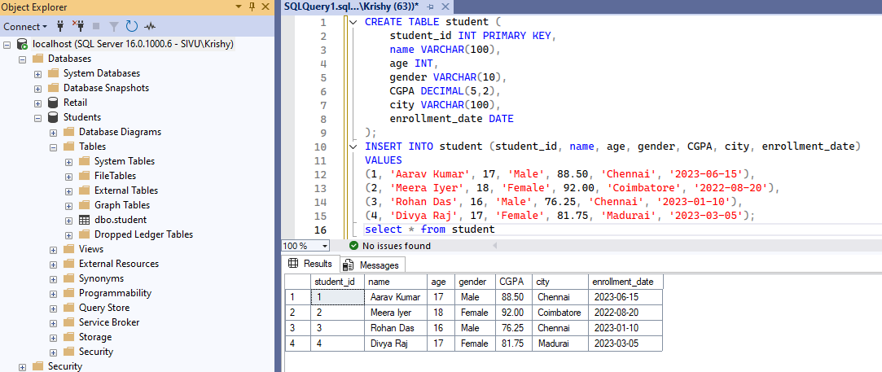

**2. Select Statement**

Filtering the values using various conditions by using select query with orderby

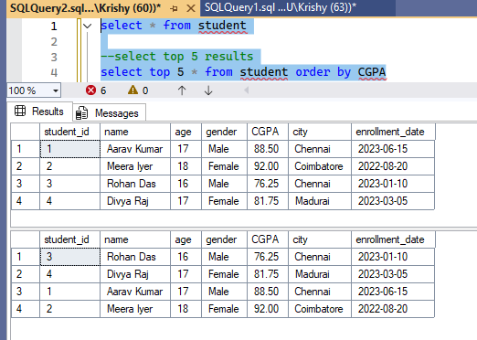

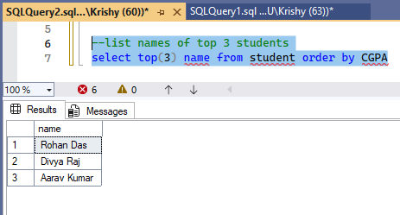

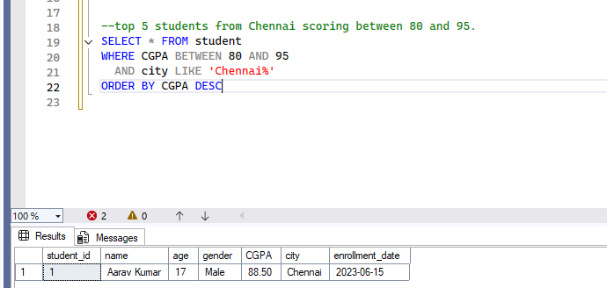

**3. Where Condition**

Here we see how Where clause can be used with different functions…

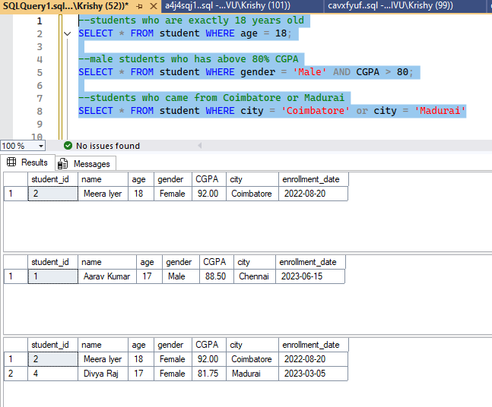

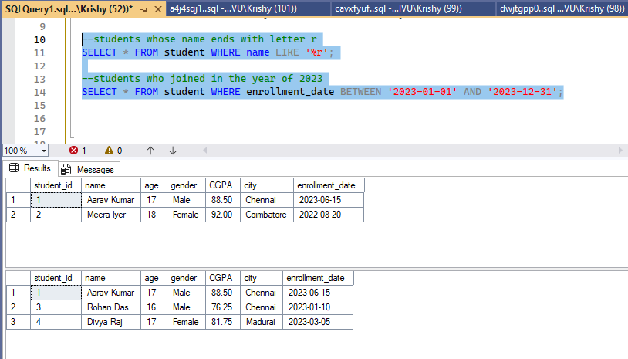

**4. Limit with orderby**

SQL Server does not support LIMIT. Instead, it uses the TOP keyword or OFFSET and FETCH.

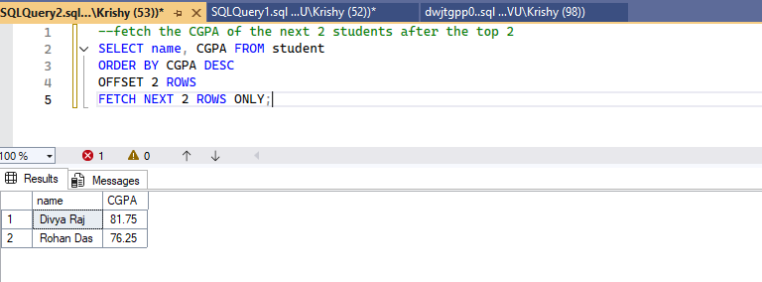

Limit will be supported by MySQL, PostgreSQL, SQLite

To get the top 3 students by CGPA:

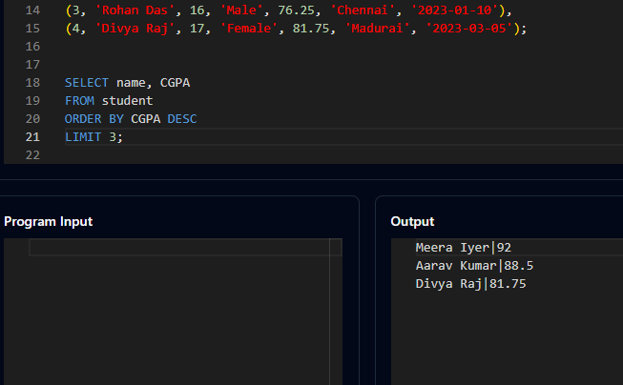

To get the next 3 after top 3 students by CGPA:

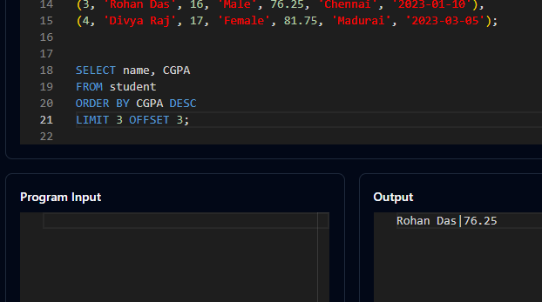

**5. Distinct**

Give unique entries of the record without any duplicates.

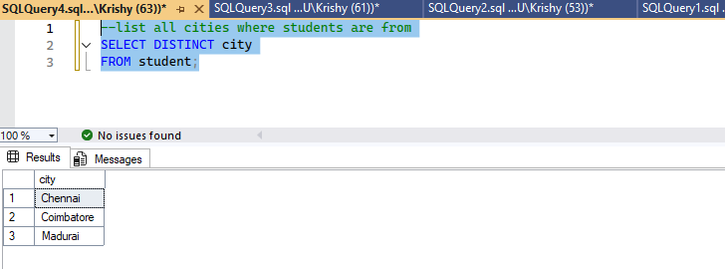

Thank you!