**JOINS AND ITS TYPES**

**1. Create table and insert values**

Firstly, Created the table Customers and Orders as we are going to perform Join operations

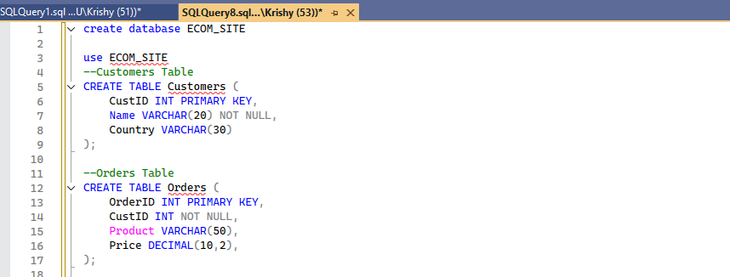

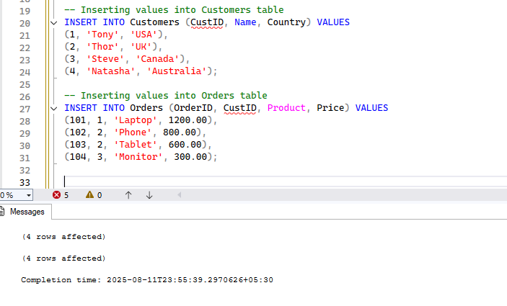

**Types of Joins.**

There are 6 types are as follows…

* Inner join
* Outer join
* Right join
* Left join
* Cross join
* Self join

Now we will see one by one…

**Inner join**

Returns rows that have matching values in both tables.

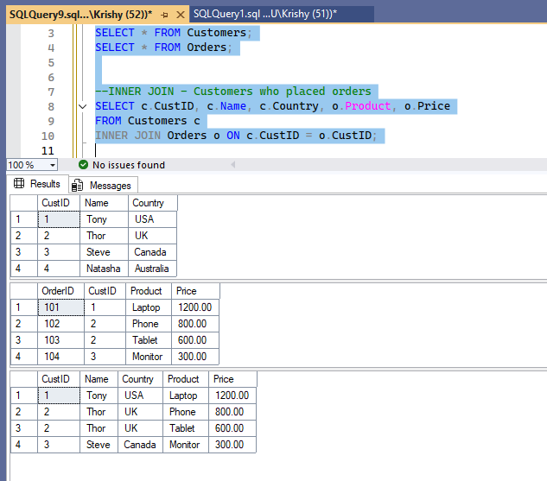

The last table is the result of Inner join.

**Left join**

Returns all rows from the left table, and matched rows from the right. Unmatched rows get NULLs.

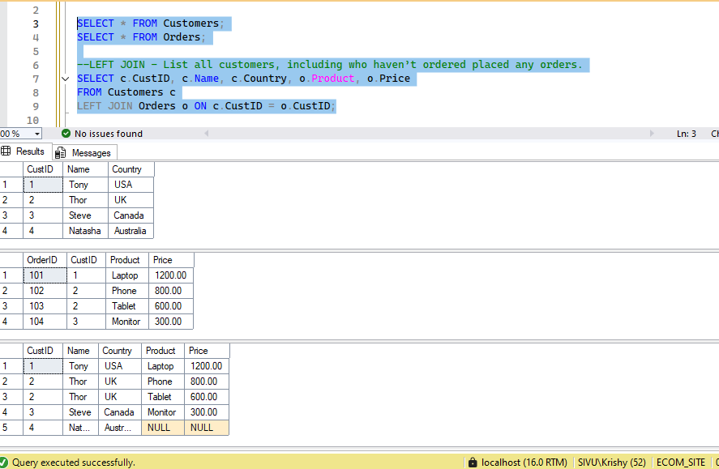

The last table is the result of left join.

**Right join**

Returns all rows from the right table, and matched rows from the left. Unmatched rows get NULLs.

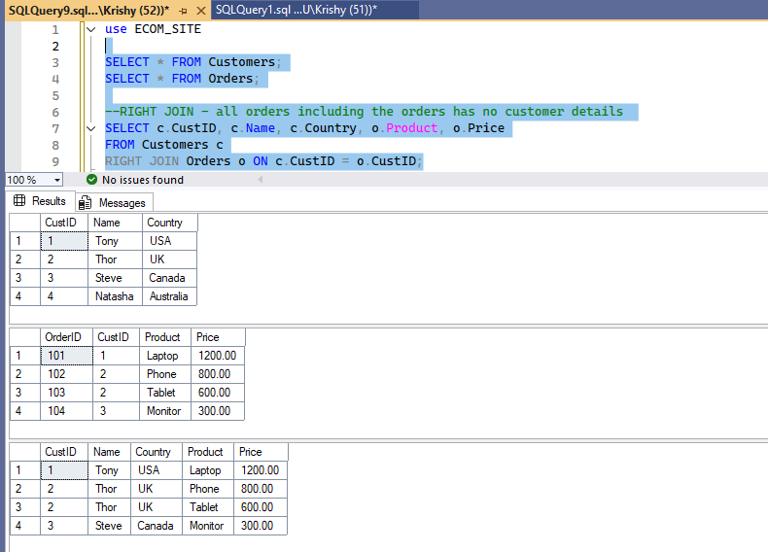

The last table is the result of right join.

**Full outer join**

Returns all rows from both tables. Unmatched rows get NULLs on the side that’s missing.

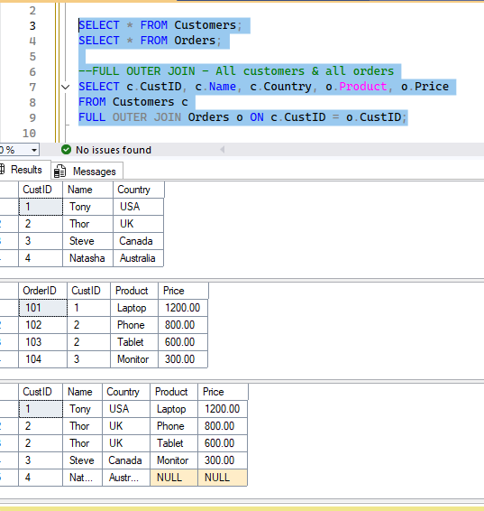

**Cross join**

* Returns the **Cartesian product** of two tables. That means **every row from the first table is paired with every row from the second table**, regardless of any matching keys.
* For instance – Table A has m rows and Table B has n rows.
* The product of m and n will be the output of the Cross join more like a Matrix Multiplication.
* Table A has 3 rows and Table B has 3 rows – the ouput has 9 rows.

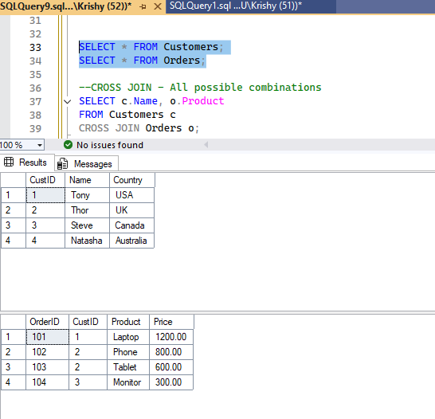

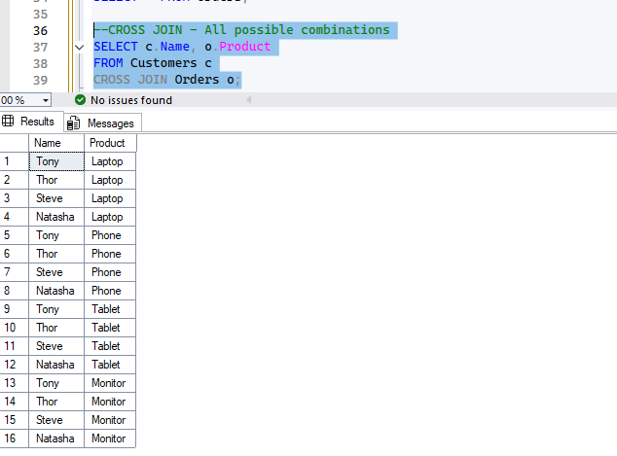

This is the output of cross join.

**Self join**

A table joins with itself to compare rows.

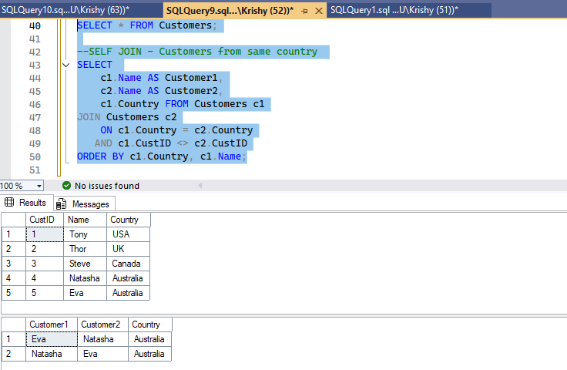

Thank you!