**Network Architecture and Protocol**

Project 1 – A Client -Server Application

Date – 5th October 2017

Report by – Abhinuv Nitin Pitale (906039146)

**Tools Used** – Python 2.7.13, Command Prompt (Windows command Line utility), Git

**Python libraries used** - Socket, Re, CxFreeze, math, os

**Operation System Tested on** – Windows 10, Linux (Ubuntu)

**Implementation**

1. **Server**

**Design Considerations**:

BUFFERSIZE = 1024

Uses a polling type of server, which is always on and gets activated for incoming requests

Does not involve multithreading, hence only sequential sockets can be accepted.

**Algorithm/Code Flow:**

1. Get user input for selecting the port number for the server to be set-up on.
2. Create a TCP socket and bind it to the port.
3. Wait for the server to listen to incoming requests.
4. Accept the incoming socket and create a new connection socket for receiving and sending data.
5. Receive a HTTP query from the incoming socket. (Assumption : The incoming query length will be less than 1024 bits.)
6. Decode the query –
   1. Split the query into 3 parts
      1. Method Used (for eg – GET,POST
      2. Filename Requested (for eg – docTest.txt)
      3. HTTP version
   2. Check if the method used and the Http version is valid. If not, set the state as 400
   3. Check if the filename queried exists on the server. If not, set the state as 404
   4. If b and c is true, set the state as 200
   5. Return state and filename(if exists)
7. Create the Http Response to be sent over the server.
8. Check state and return the query to be sent over the server.
   1. If it is 400, output the following query

HTTP/1.0 400 Bad Request

* 1. If it is 404, output the following query

HTTP/1.0 404 Not Found

* 1. If it is 200,
     1. Read the file as binary.
     2. Compute it’s length
     3. Send the query in this particular format-

HTTP/1.0 404 Not Found

Content-Length: *length*

*CONTENT*

1. Send the data over the socket by computing it’s length and sending it by parts, if the buffersize is overloaded.
2. Close the connection socket and go back to step 3.
3. **Client**

**Design Considerations:**

BUFFERSIZE = 1024

**CodeFlow/Algorithm:**

1. Query the user for host and port number.
2. Create a TCP socket connected to that port.
3. Display connection as success, if it passes step 2.
4. Query user for a filename to retrieve from the server.
5. Create the Http Request:

query = GET /filename HTTP/1.0

1. Send the query via socket
2. Receive the server response and parse it
   1. Read the state from the response
      1. If 400, display ‘Bad Request’
      2. If 404, display ‘File Not Found’
      3. If 200, parse the data in the request.

Open a file with the same name and store the *filecontent* in it.

1. Close the socket.

**Error Checking implemented in the code:**

1. If the user input is blank during querying for host and portnumber, a default port and localhost is specified.
2. Exception handling is implemented on both server and client side, which prevents the server from loading in case of a crash at the client side.

**Testing Procedure**

1. **My client with the test server**
   1. Positive Testing

Server--

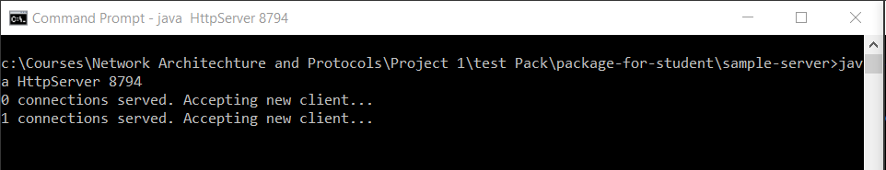

Client--

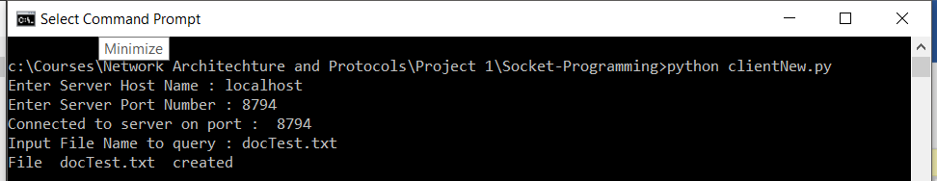

* File Correctly received over the connection.
  1. Negative testing
     1. No localhost port specified.

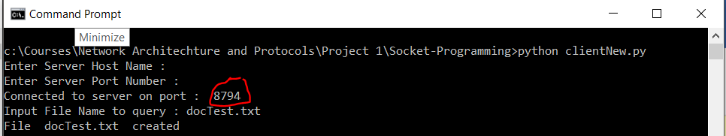

* Even without specifying the port number/host, the client takes the default values and runs correctly.
  + 1. Incorrect Filename

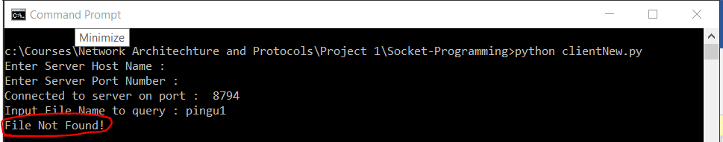

* Displays error message without crashing!

1. **My server with test client**
   1. Positive Testing

Client

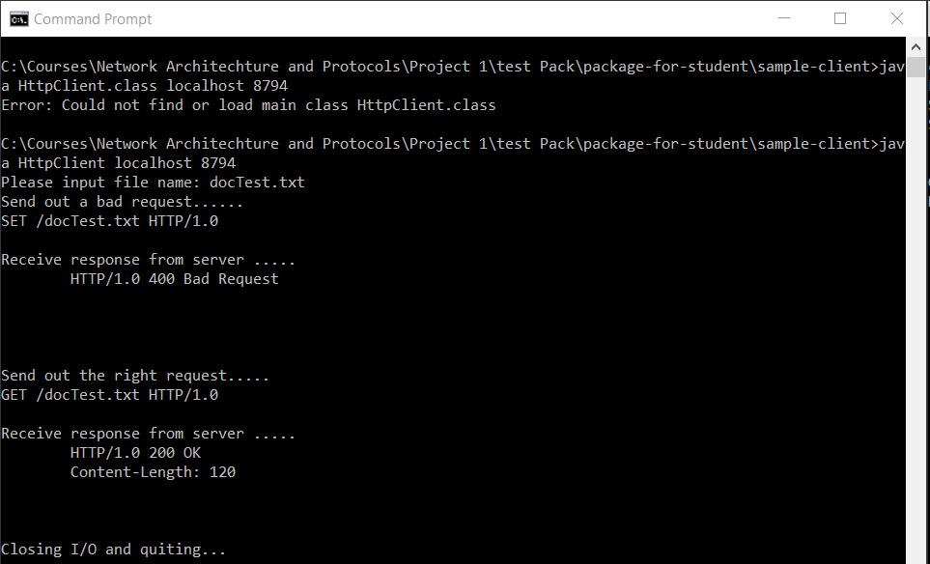

Server

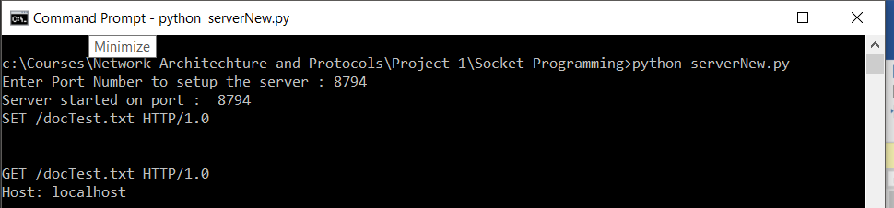

* 1. Negative Testing

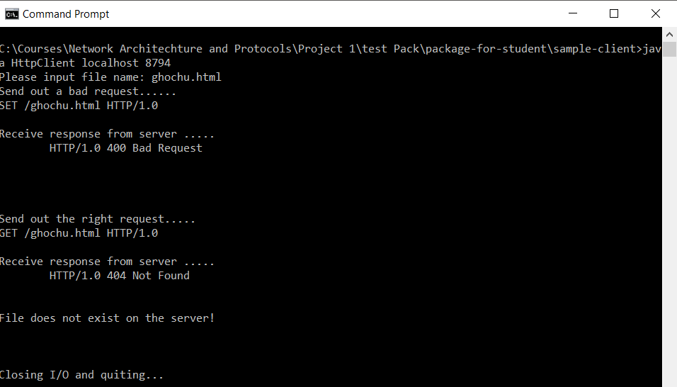

1. **My server with my client**
   1. Positive Testing

Client

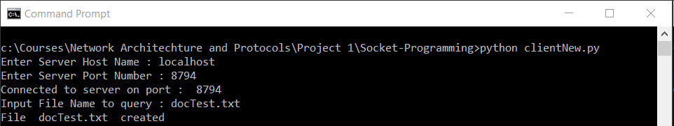

Server

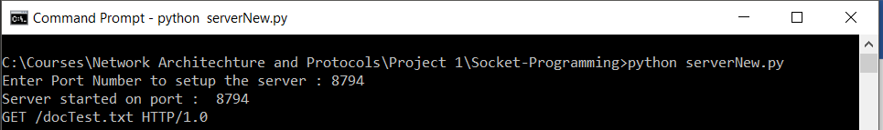

* 1. Negative Testing

Nonexistent file queried!

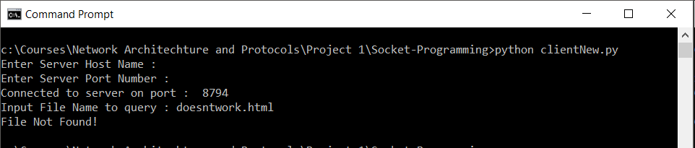

**Exception testing**

1. Incorrect port/host connected - Client

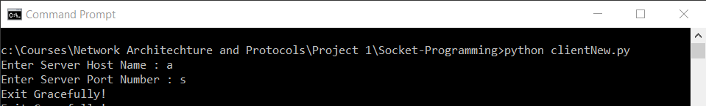

**Testing Procedure Used**

1. Manual Testing -> Input incorrect input for negative testing
2. Automated Testing -> Used for testing 400 Bad Format. Developed python script to send incorrect format.

Summary:

The following implementation of the Http protocol over TCP works for a typical single threaded system where the requests are sent sequentially.

Features Implemented

1. Request Format check

2. File handling

3. Exception handling for TCP socket errors and file I/O errors

4. Incorrect host/port correction

5. Server can handle multiple sequential requests

Features not implemented

1. A request (filename) greater than 1024 bytes cannot be processed

2. Multiple requests cannot be handled simultaneously by the server.