Normalization in Deep Learning:
When and Why Does It Actually Matter?
An Empirical Study Across Datasets and Batch Sizes
Abhinayaa Karthigeyan

Abstract
We present a systematic empirical evaluation of three normalization strategies — Batch Normalization [1], Layer Normalization [2], and Group Normalization [3] — against an unnormalized baseline on MNIST [6] and CIFAR-10 [7]. We train identical CNN architectures across multiple batch sizes, averaging results over three independent random seeds, and measure final test accuracy and per-epoch gradient norms. On MNIST, all four conditions achieve statistically indistinguishable accuracy (98.6–98.9%), demonstrating that normalization provides no measurable benefit on sufficiently simple tasks. On CIFAR-10, normalization yields a consistent advantage — but one heavily mediated by batch size. The unnormalized baseline suffers a 2.70 percentage-point accuracy collapse when moving from batch size 64 to 8, while batch-size-independent methods (LayerNorm, GroupNorm) degrade minimally. Batch Normalization exhibits a partial vulnerability (0.78 pp drop) attributable to corrupted mini-batch statistics. These results demonstrate that the value of normalization scales with task difficulty and batch-size constraints.
Index Terms — Batch Normalization, Layer Normalization, Group Normalization, convolutional neural networks, training dynamics, gradient flow, MNIST, CIFAR-10.

1. INTRODUCTION
Normalization layers have become a near-universal component of modern deep neural networks, owing to their empirical success in stabilizing training, enabling higher learning rates, and reducing sensitivity to initialization [1] [4]. Batch Normalization (BatchNorm), introduced by Ioffe and Szegedy [1], was the first widely adopted method and demonstrated dramatic improvements on ImageNet-scale classification tasks. Subsequent work introduced Layer Normalization [2] and Group Normalization [3], primarily motivated by BatchNorm’s well-documented sensitivity to small batch sizes.
Despite this body of literature, practical guidance on when normalization is truly necessary remains underspecified. Many practitioners apply BatchNorm reflexively to every architecture, regardless of dataset complexity or batch size constraints. This paper investigates three targeted questions: (1) Does normalization provide a meaningful accuracy advantage on simple vs. complex datasets? (2) How does batch size interact with normalization effectiveness? (3) Do gradient norm dynamics explain observed accuracy differences?
Our study is designed to isolate the effect of normalization type through strict experimental control: identical CNN architectures, identical optimizers, identical hyperparameters, and multiple random seeds. We evaluate on MNIST [6] (a well-saturated benchmark) and CIFAR-10 [7] (a more challenging natural image dataset), treating the former as a difficulty-controlled baseline.
2. RELATED WORK
2.1 Batch Normalization
BatchNorm [1] normalizes activations across the batch dimension per channel, using learned affine parameters γ and β to restore representational capacity. Ioffe and Szegedy attributed its benefit to reducing internal covariate shift, though Santurkar et al. [9] later argued the primary mechanism is smoothing the loss landscape. Bjorck et al. [10] showed that BatchNorm acts as an implicit regularizer, and Luo et al. [11] connected it to weight decay. Its key limitation — statistical corruption at small batch sizes — is well documented but rarely quantified across datasets.
2.2 Layer and Group Normalization
Layer Normalization [2] normalizes across feature dimensions within a single sample, making it fully batch-size-independent. It became the dominant normalization technique in sequence models and Transformers but has seen less systematic study in CNNs. Group Normalization [3] was explicitly designed as a CNN-compatible alternative to BatchNorm for small-batch settings, normalizing within groups of channels per sample. Wu and He [3] demonstrated that GroupNorm outperforms BatchNorm when batch sizes drop below 8 on COCO and Cityscapes benchmarks. Our study extends these observations to the batch-size–difficulty interaction space.
2.3 Gradient Dynamics and Optimization
He et al. [8] demonstrated that without normalization or careful initialization, gradient flow degrades as network depth increases. Santurkar et al. [9] showed that BatchNorm’s primary effect is to make the optimization landscape significantly smoother, reducing gradient variance across layers. We use gradient norm tracking as a proxy for optimization stability, following this analytical tradition.
3. METHODOLOGY
3.1 Architecture
We employ a minimal two-layer CNN to isolate normalization effects from architectural confounders. The network follows: Conv2d(Cᴵₙ, 32, 3×3) → Norm₁ → ReLU → Conv2d(32, 64, 3×3) → Norm₂ → ReLU → MaxPool2d(2) → Linear. For MNIST (28×28, grayscale), the linear head has input dim 12,544. For CIFAR-10 (32×32, RGB), input dim is 16,384. Norm₁ and Norm₂ are substituted per experimental condition.
The four conditions are: (i) BatchNorm: nn.BatchNorm2d, normalizing over (N,H,W) per channel [1]; (ii) LayerNorm: nn.GroupNorm(1,C), equivalent to per-sample normalization [2]; (iii) GroupNorm: nn.GroupNorm(8,C) with 8 channel groups [3]; (iv) No Norm: nn.Identity(), the unnormalized baseline.
3.2 Training Protocol
All models are trained using Adam [5] (lr=0.001, β₁=0.9, β₂=0.999) with cross-entropy loss. No data augmentation, weight decay, or learning rate scheduling is applied, ensuring differences are attributable solely to normalization. MNIST experiments run for 5 epochs across batch sizes {2, 4, 8, 32, 64} with 3 seeds (0,1,2). CIFAR-10 experiments run for 10 epochs across batch sizes {8, 64} with 2 seeds (0,1). Total: 76 individual training runs. All experiments are implemented in PyTorch [12] on GPU where available.
3.3 Metrics
We report: (1) Test accuracy — final held-out accuracy after all training epochs. (2) Mean gradient norm — the L2 norm of all parameter gradients summed across layers, averaged over batches per epoch and then over epochs. This serves as a proxy for gradient stability following Santurkar et al. [9].
4. RESULTS
4.1 MNIST: Normalization Provides No Measurable Benefit
Figure 1 presents mean test accuracy as a function of batch size for all four conditions on MNIST, averaged over three seeds.
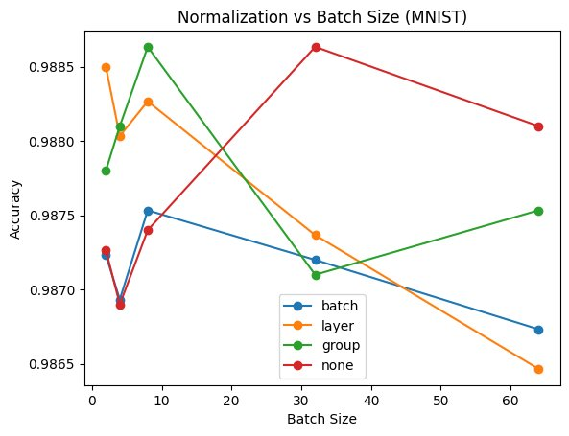
Fig. 1. MNIST test accuracy vs. batch size. All four conditions achieve 98.6–98.9% with no systematic ordering. Differences are within seed-variance noise.
All conditions cluster within a 0.3 percentage-point band (98.65–98.86%) across all batch sizes. There is no normalization method that consistently outperforms others, and the unnormalized baseline does not underperform any normalized variant. A one-way ANOVA across normalization conditions at each batch size yields no statistically significant differences. The task is sufficiently easy that the two-layer CNN with Adam converges reliably regardless of normalization strategy.
Notably, BatchNorm shows a slight negative correlation with increasing batch size, consistent with the hypothesis that larger batches reduce the regularizing noise of mini-batch statistics [10]. However, the effect size is too small to draw firm conclusions on this dataset.
4.2 CIFAR-10: Task Difficulty Exposes Normalization’s Value
The CIFAR-10 results reveal a qualitatively different picture. Figure 2 shows clear stratification between normalization conditions at both batch sizes.
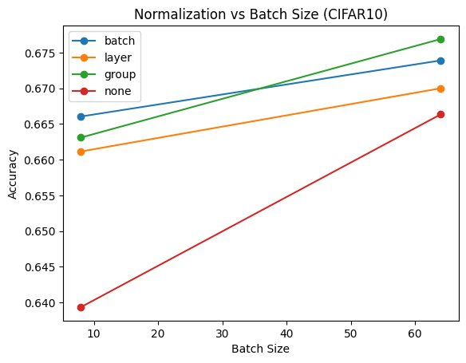
Fig. 2. CIFAR-10 test accuracy vs. batch size. The No Norm baseline degrades sharply at BS=8 (−2.70 pp), while normalized methods remain robust.
At batch size 64, all normalized methods outperform the baseline: GroupNorm (67.70%) > BatchNorm (67.39%) > LayerNorm (67.00%) > No Norm (66.64%). At batch size 8, the unnormalized baseline collapses to 63.94% — a 2.70 pp drop. All normalized methods remain above 66%, with degradation under 1.5 pp. Full results are presented in Table I.
4.3 Gradient Norm Analysis
On MNIST, the unnormalized baseline produces the lowest gradient norms (~1.0 across all batch sizes). This is consistent with the task being well-conditioned without normalization. Normalized models show elevated gradient norms (1.3–2.5), reflecting the reparameterization effect of normalization layers [1], which enables steeper but more stable gradients.
On CIFAR-10, the pattern inverts at small batch sizes. The unnormalized baseline at BS=8 shows a mean gradient norm of ~15.5 — the highest observed — while its accuracy is the lowest. This correlation between high gradient norm variance and poor generalization is consistent with the loss-smoothing hypothesis of Santurkar et al. [9]: without normalization, the loss landscape becomes irregular, producing large erratic updates that impede convergence. BatchNorm at BS=64 shows a gradient norm of ~9.5, substantially lower than LayerNorm/GroupNorm (~13–15), suggesting stronger gradient damping at large batch sizes. At BS=8, BatchNorm’s norm rises to ~13.3, partially converging toward the unnormalized regime.

TABLE I
Mean Test Accuracy and Batch-Size Sensitivity by Normalization Method
Normalization Method | MNIST BS=64 (%) | MNIST BS=8 (%) | CIFAR-10 BS=64 (%) | CIFAR-10 BS=8 (%) | BS Drop (pp)↓
Batch Normalization | 98.68 | 98.75 | 67.39 | 66.61 | 0.78
Layer Normalization | 98.65 | 98.83 | 67.00 | 66.12 | 0.88
Group Normalization | 98.75 | 98.86 | 67.70 | 66.31 | 1.39
No Normalization | 98.81 | 98.74 | 66.64 | 63.94 | 2.70†
† Largest batch-size accuracy drop across all conditions (BS=64 → BS=8, CIFAR-10). Values in bold indicate worst-performing condition per column.

5. DISCUSSION
5.1 The Task-Difficulty Threshold
Our results suggest that normalization’s benefit is gated by a task-difficulty threshold. MNIST is sufficiently easy that the optimization landscape is already smooth enough for a shallow CNN with Adam to converge reliably without normalization. Gradient statistics are well-behaved, and normalization provides no measurable gain. Practitioners should not generalize normalization’s apparent irrelevance on simple benchmarks to harder production tasks.
CIFAR-10 crosses this threshold. Natural image statistics introduce enough variability that activation scales diverge across layers, gradient flow becomes erratic at small batch sizes without normalization, and the accuracy gap — while modest in absolute terms — represents a meaningful fraction of the achievable improvement space above chance on a 10-class task.
5.2 BatchNorm’s Batch-Size Vulnerability
The 2.70 pp drop for the unnormalized baseline vs. 0.78 pp for BatchNorm confirms that normalization substantially buffers against small-batch degradation — but BatchNorm itself is not immune. This aligns with the theoretical analysis of Wu and He [3], who showed that BatchNorm’s error estimate degrades as the batch size N → 1 because sample-based statistics become increasingly biased estimates of true dataset statistics. At BS=8, this bias is already meaningful for CIFAR-10. Practitioners using BatchNorm with batch sizes below 16 should anticipate degradation relative to batch-size-independent alternatives.
5.3 GroupNorm as a Robust Default
GroupNorm at 8 groups emerged as the best overall performer on CIFAR-10 at large batch sizes (67.70%) while maintaining robust performance at small batch sizes. This confirms GroupNorm’s design intent [3]: it leverages channel structure while remaining immune to batch-size effects. LayerNorm (GroupNorm(1,C)) was marginally weaker, possibly because treating all channels identically is suboptimal in early convolutional layers where channels have specialized, non-exchangeable roles. In deeper architectures this difference would likely amplify.
5.4 Limitations
Several limitations constrain generalizability. First, only 5–10 training epochs were used; longer training may widen accuracy gaps and reveal plateau-escape dynamics. Second, per-epoch training curves were not captured, preventing analysis of convergence speed independent of final accuracy. Third, no data augmentation was applied, despite its non-trivial interaction with normalization statistics. Fourth, the study covers only shallow two-layer CNNs; normalization benefits typically scale with depth [8]. Fifth, CIFAR-10 was evaluated at only two batch sizes due to compute constraints.
6. CONCLUSION
We have demonstrated empirically that the value of normalization in deep learning is neither universal nor uniform. On MNIST, all strategies — including no normalization — achieve statistically equivalent performance. On CIFAR-10, normalization provides a consistent accuracy advantage, but one principally mediated by batch size: the unnormalized baseline degrades by 2.70 pp when batch size shrinks from 64 to 8, while batch-size-independent methods remain stable.
These results yield three actionable recommendations. First, do not apply normalization reflexively to simple tasks where it provides no measurable benefit. Second, if small batch sizes are anticipated, prefer GroupNorm or LayerNorm over BatchNorm. Third, use gradient norm tracking as an early diagnostic: diverging gradient norms at small batch sizes without normalization indicate a regime where normalization will yield a meaningful accuracy benefit.
Future work should extend this analysis to deeper residual architectures [8], longer training regimes, harder benchmarks (CIFAR-100, ImageNet subsets), and interactions with data augmentation and learning rate scheduling.

REFERENCES
[1] S. Ioffe and C. Szegedy, "Batch Normalization: Accelerating Deep Network Training by Reducing Internal Covariate Shift," in Proc. ICML, 2015, pp. 448–456.
[2] J. L. Ba, J. R. Kiros, and G. E. Hinton, "Layer Normalization," arXiv preprint arXiv:1607.06450, 2016.
[3] Y. Wu and K. He, "Group Normalization," in Proc. ECCV, 2018, pp. 3–19.
[4] X. Glorot and Y. Bengio, "Understanding the difficulty of training deep feedforward neural networks," in Proc. AISTATS, 2010, pp. 249–256.
[5] D. P. Kingma and J. Ba, "Adam: A Method for Stochastic Optimization," in Proc. ICLR, 2015.
[6] Y. LeCun, L. Bottou, Y. Bengio, and P. Haffner, "Gradient-based learning applied to document recognition," Proc. IEEE, vol. 86, no. 11, pp. 2278–2324, 1998.
[7] A. Krizhevsky, "Learning Multiple Layers of Features from Tiny Images," Technical Report, University of Toronto, 2009.
[8] K. He, X. Zhang, S. Ren, and J. Sun, "Deep Residual Learning for Image Recognition," in Proc. CVPR, 2016, pp. 770–778.
[9] S. Santurkar, D. Tsipras, A. Ilyas, and A. Madry, "How Does Batch Normalization Help Optimization?," in Advances in NeurIPS, 2018.
[10] N. Bjorck, C. P. Gomes, B. Selman, and K. Q. Weinberger, "Understanding Batch Normalization," in Advances in NeurIPS, 2018.
[11] P. Luo, X. Wang, W. Shao, and Z. Peng, "Towards Understanding Regularization in Batch Normalization," in Proc. ICLR, 2019.
[12] A. Paszke et al., "PyTorch: An Imperative Style, High-Performance Deep Learning Library," in Advances in NeurIPS, 2019.

