Proportional reasoning across formats

Abhi Patel

Proportional reasoning across formats

# Introduction

Comparing proportions is sometimes very hard! But, even infants seem to be able to do it a little bit. The purpose of this science project was better understand how well people compare proportions when the proportions are presented in different formats. The purpose of this class assignment is to take the R code and plots we’ve been generating over the last several weeks and put it all together into one poster format. In order to make this a cohesive and insightful poster, we have put together these three connected research questions.

**Research Questions**

1. **Does average performance vary across format type?**  
   Average performance appears to vary. Tasks with lower reaction times tend to have higher accuracies.
2. **How are reaction time and accuracy related?**  
   Reaction time and accuracy seem to be positively correlated. As reaction time increases, accuracy also tends to increase.
3. **How does numerator congruency interact with format type?**  
   Numerator congruency interacts with format type, as the proportion correct differs across congruency levels and format types.

# Methods

A total of $99$ adults participated in the study.

First, participants were introduced to a story about a magic ball and that the outcome (i.e., blue or orange) depended on the proportions. They were then asked to compare the proportions of different images.

In other words, participants were shown two images of the same kind at the same time and asked to decide which had a higher proportion of the shape (or dots) colored in blue. You can notice this in Figure 1.

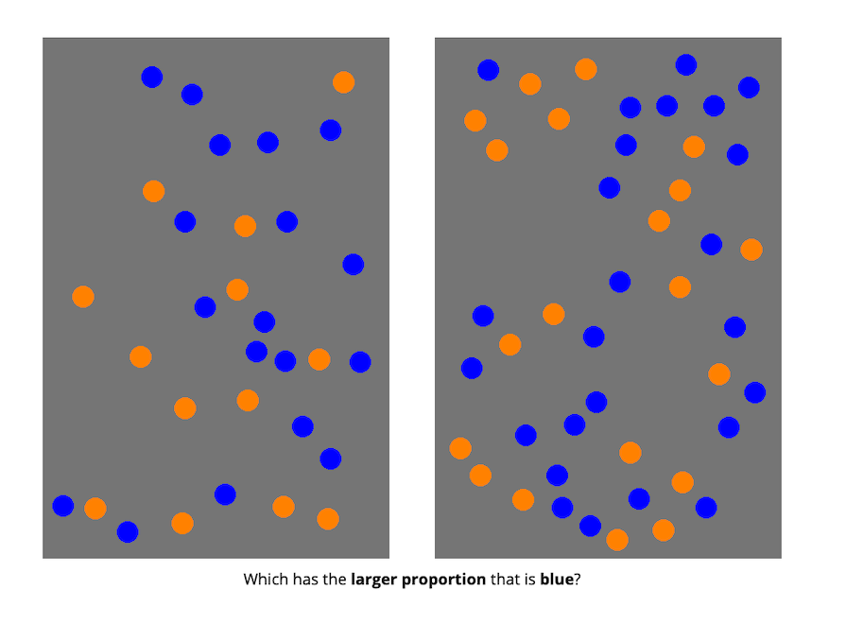

*Figure* 1. Dot Proportion Task

## Conditions

There were four different conditions that changed what kinds of images participants saw:

* divided blobs: blue and orange were entirely separate.
* segmented blobs: blue and orange could be part blue and part orange.
* separated dots: blue and orange dots were on opposite sides of the image.
* interleaved dots: blue and orange dots were intermixed. The task is shown in figure 2.

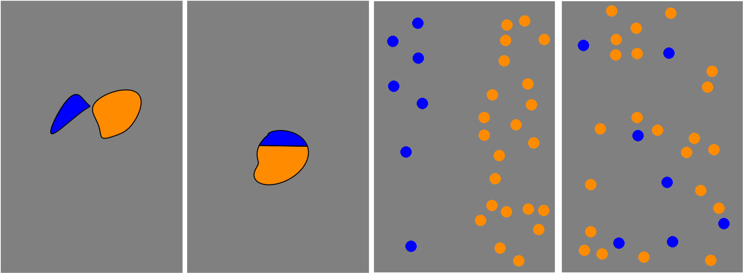

*Figure* 2. Blob Task

## Data Analysis

The data analysis was conducted using the following R packages: dplyr (Wickham, François, Henry, & Müller, 2024) for data wrangling and summarization, and ggplot2 (Wickham, Chang, et al., 2024) for data visualization.

# Results

1. **Does average performance vary across format type, ignoring all other aspects of the stimuli?**

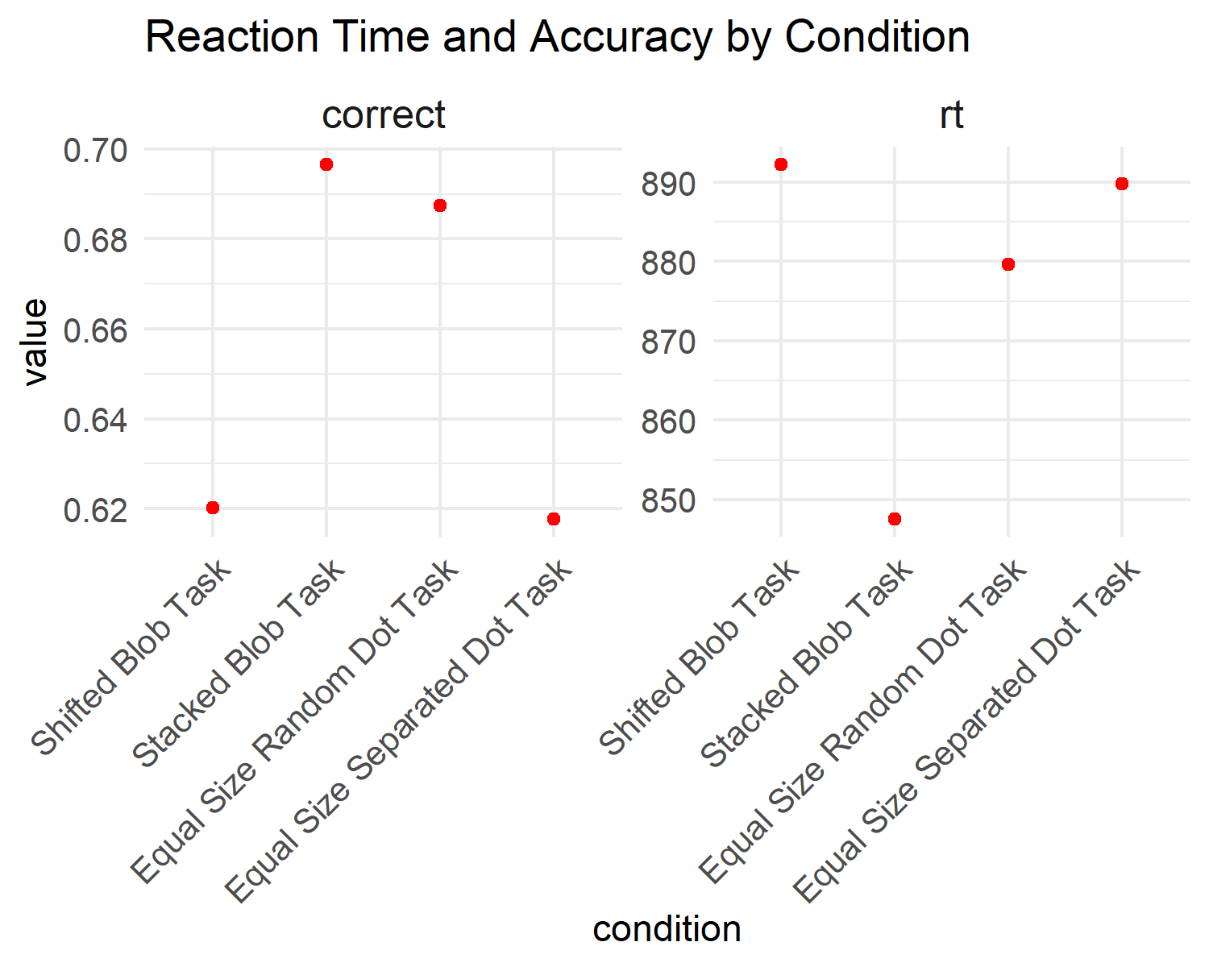

*Figure* 3. Reaction Time and Accuracy by Condition

Average performance seems to vary. It seems that the tasks with the lower reaction times have higher accuracies. Please refer to Figure 3 to notice the pattern.

1. **How are reaction time and accuracy related?**

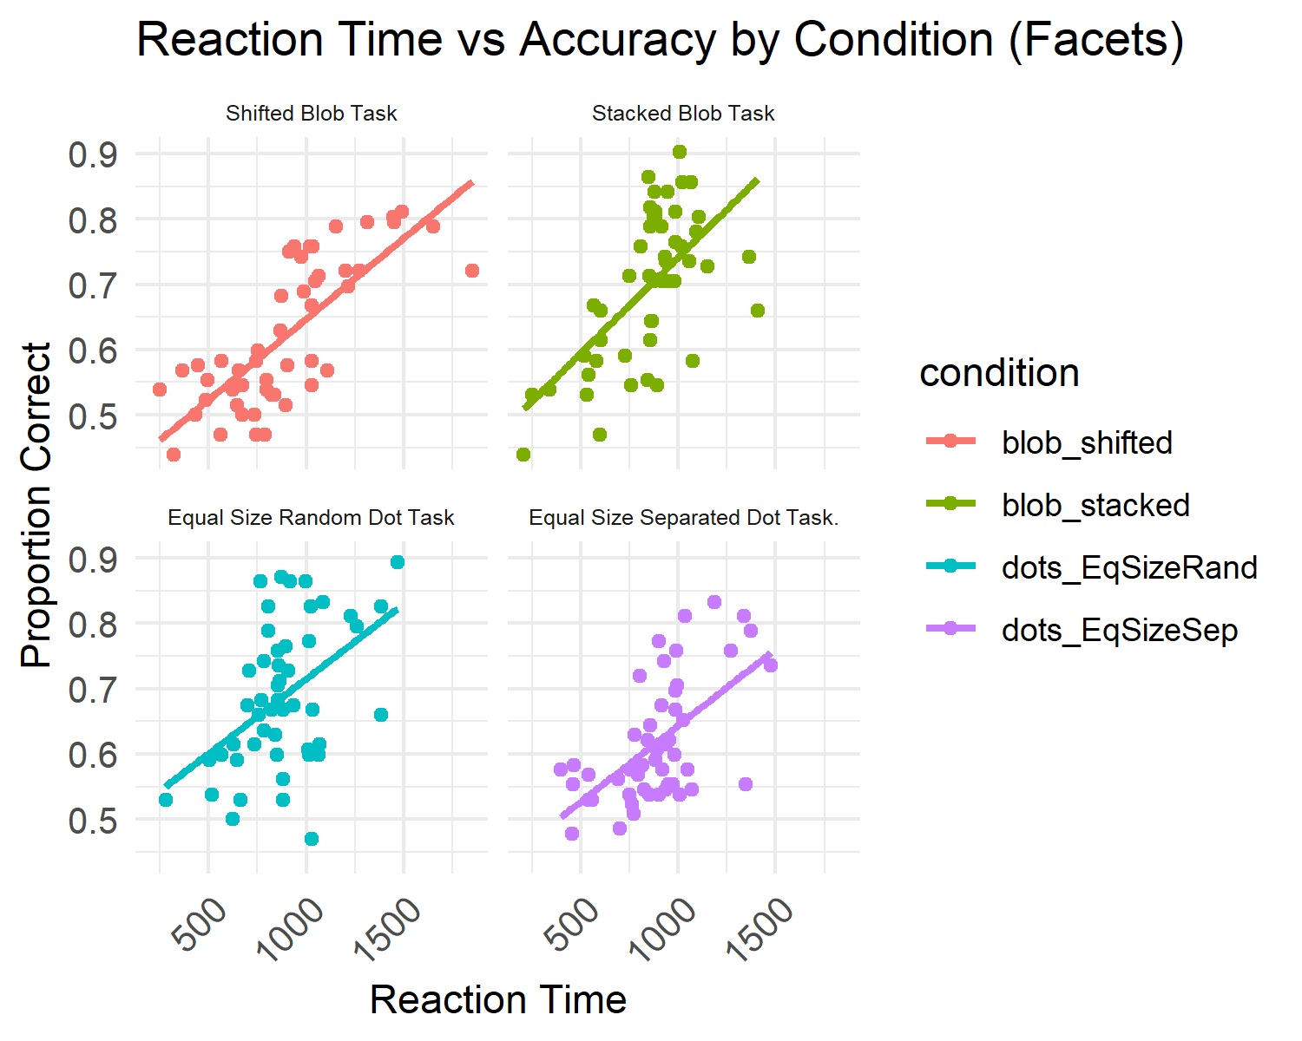

*Figure* 4. Reaction Time vs. Accuracy by Condition

Reaction Time and Accuracy seem to be positively correlated with each other.Please refer to Figure 4 to notice the pattern.

1. **How does numerator congruency interact with format type?**

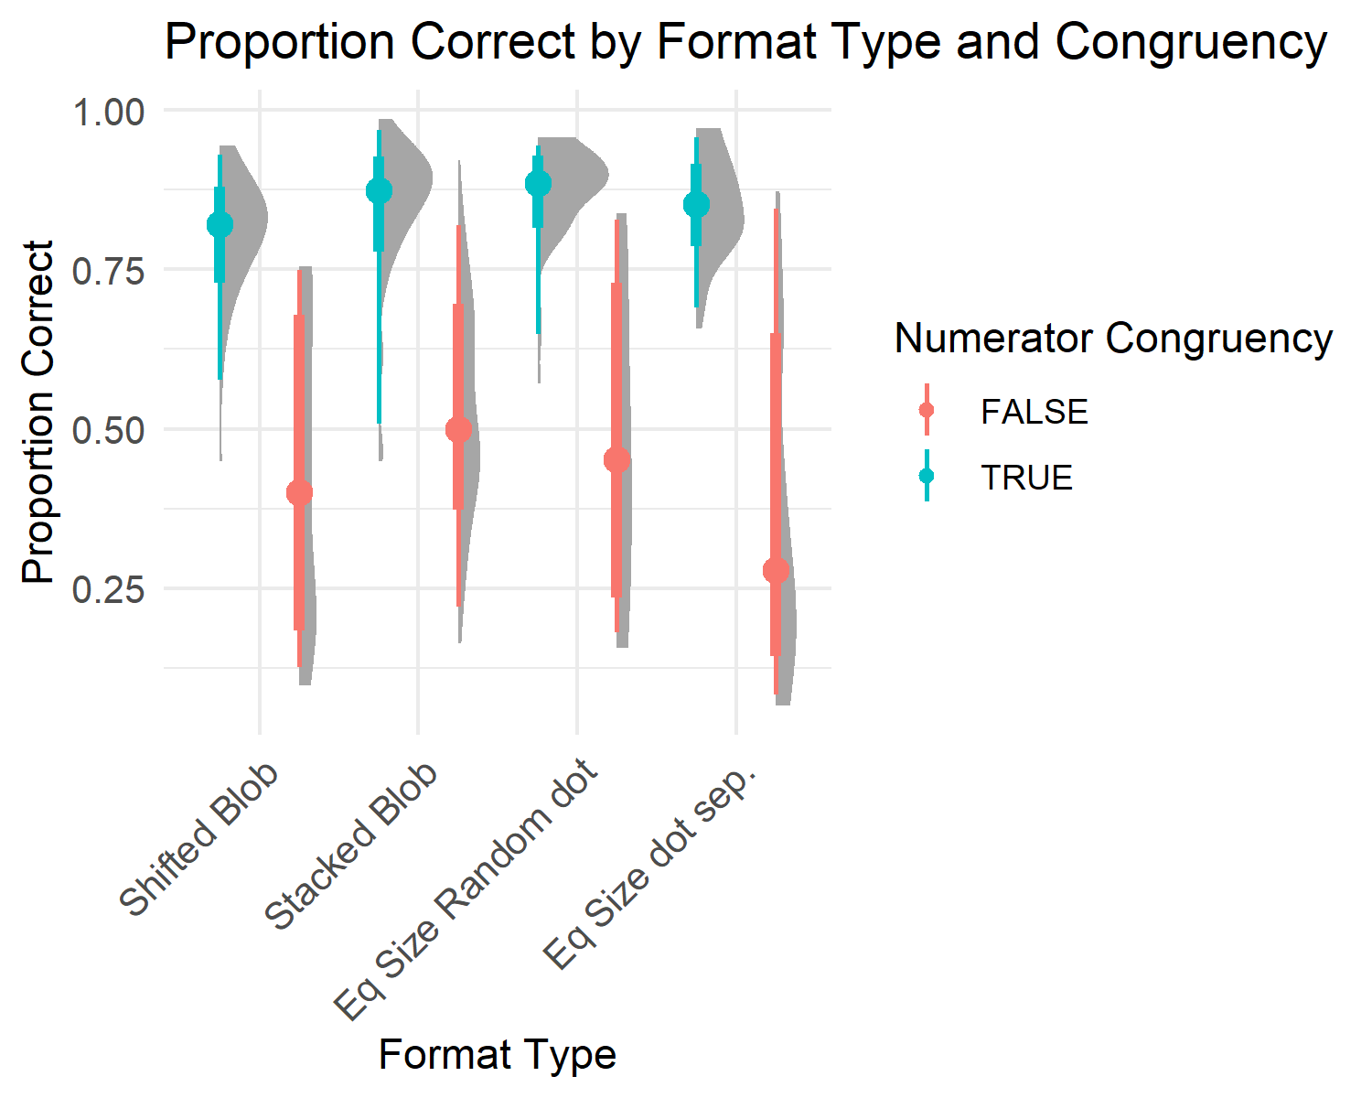

*Figure* 5. Proportion Correct by Format Type and Congruency

Numerator Congruency interacts with format type by seeming to result in consistently higher accuracies in “True” rather than “False”, Please refer to Figure 5 to notice the pattern.

# Discussion

Overall, we found that the tasks that resulted in the lower reaction times had the higher accuracies. This also makes sense as we found an overall positive relationship between reaction time and accuracy. To further investigate the accuracies, we looked at numerator congruency. We found that when the numerator congruency is true, there is overall higher accuracies than when it is false. Provide two summaries of your experience during this assignment:

# References

Wickham, H., Chang, W., Henry, L., Pedersen, T. L., Takahashi, K., Wilke, C., … Dunnington, D. (2024). *ggplot2: Create elegant data visualisations using the grammar of graphics*. Retrieved from <https://CRAN.R-project.org/package=ggplot2>

Wickham, H., François, R., Henry, L., & Müller, K. (2024). *Dplyr: A grammar of data manipulation*. Retrieved from <https://CRAN.R-project.org/package=dplyr>