WEB-DEVELOPMENT- GDGC MEMBERS WEBSITE

Title:
Task Round Submission – Web Development
Domain:
Web Development
Candidate Details:
- Name: ABHISHEK TIWARI
- College: VIT BHOPAL, Branch (e.g., B.Tech CSE, 2nd Year)
- Email: abhishek.24bce11220@vitbhopal.ac.in
- Phone: +91-XXXXXXXXXX
- GitHub: https://github.com/abhipandit2027
Project Title:
GDGC MEMBERS

Task Title:
Task Round – Web Development
Task Objective:
The objective of this task is to build a functional and visually appealing website that demonstrates front-end web development skills, including clean structure, responsive design, and deployment.
Task Requirements:
- Design and develop a website using HTML, CSS, and JavaScript.
- Implement a clean and user-friendly layout with multiple sections.
- Ensure the website is responsive for mobile and desktop.
- Host the website online and provide a deployment link and GitHub repository link.

Project Overview:
This submission contains a complete web project built for the Web Development task round. The website is designed as a modern, responsive site with a focus on clear structure, readable typography, and a “premium” visual feel.
Key Highlights:
- Structured multi-section layout (e.g., Home, About, Projects, Contact).
- Responsive design that adapts to different screen sizes.
- Use of modern CSS for layout, colors, and simple animations.
- Deployed to a live URL so it can be viewed in a browser.

Technologies Used:
- HTML5 for page structure and content.
- CSS3 for styling, layout (Flexbox/Grid), and basic animations.
- JavaScript (ES6) for interactivity and DOM manipulation.
- VS Code for development and Git/GitHub for version control and hosting.
Project Structure:
- index.html – Main entry page of the website.
- style.css – Global styles, layout, colors, and responsive rules.
- script.js – JavaScript for interactive features (if used).
- assets/ – Folder containing images, icons, or other media.

Main Features:
- A navigation bar that allows users to jump to different sections.
- A hero/intro section that briefly introduces you and the purpose of the website.
- A Projects/Work section listing your projects with short descriptions and buttons/links.
- A Contact section that provides ways to reach you (email, GitHub, LinkedIn, etc.).
UI/UX Choices:
- Consistent color palette and typography across the website.
- Proper spacing and alignment for readability.
- Buttons and links styled with clear hover effects to show interactivity.

Responsive Design:
- Layout tested on different screen widths (mobile, tablet, desktop).
- Navigation and sections adjust width and stacking order for smaller screens.
- Text and images scale appropriately without breaking the layout.
Design Enhancements:
- Use of shadows, borders, or subtle gradients to create depth.
- Smooth transitions on hover for buttons, cards, or links.
- Organized sections with clear headings and content blocks

Mobile view(home):
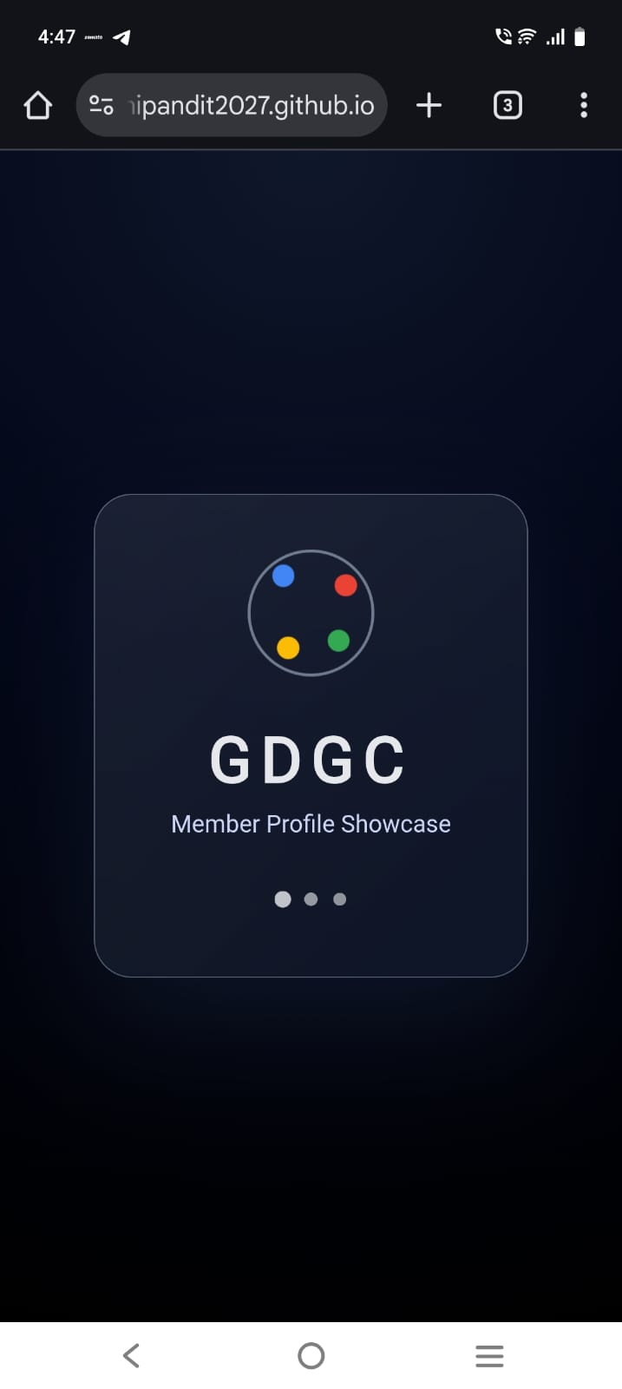
Laptop view:

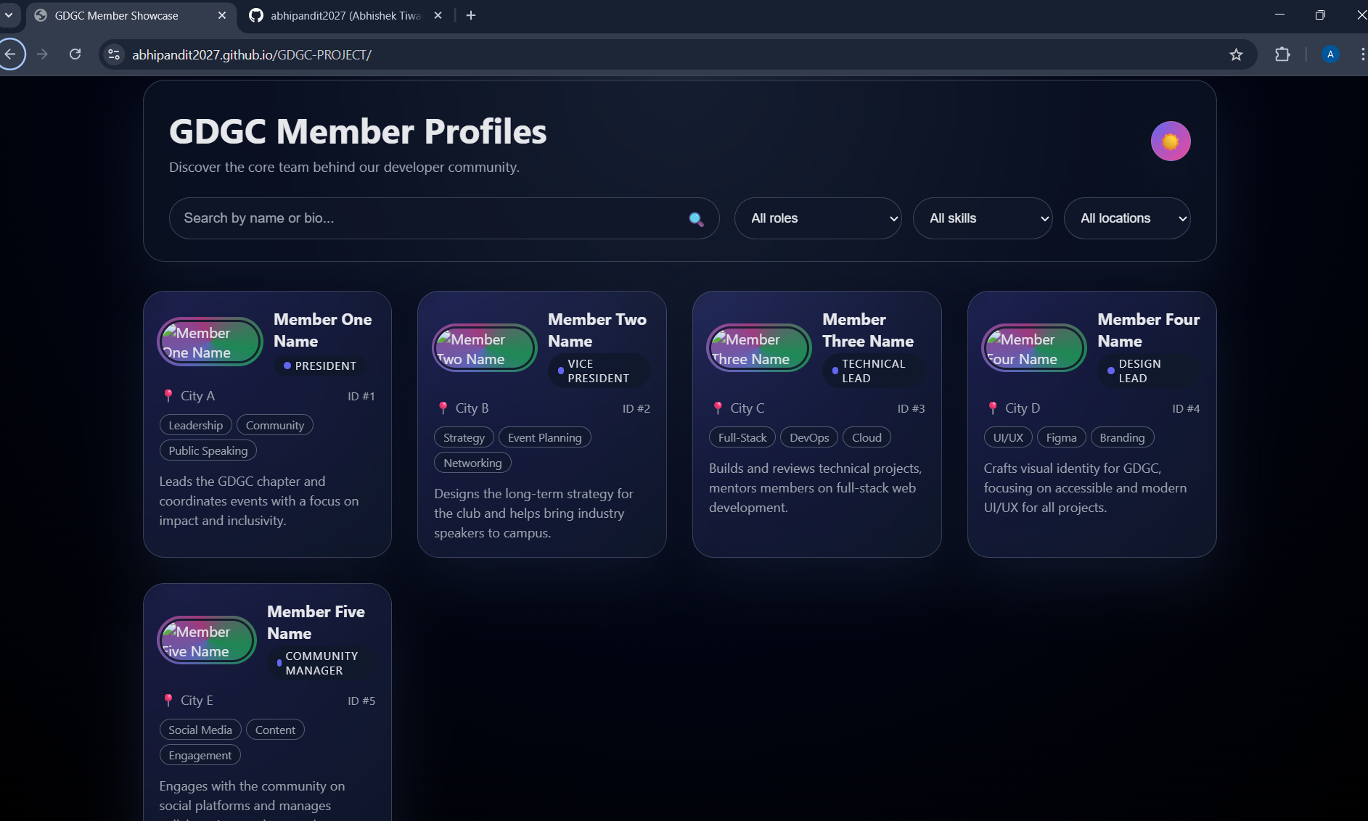

GitHub Repository Link: https://github.com/abhipandit2027/GDGC-PROJECT.git

Live Deployment Link:
https://abhipandit2027.github.io/GDGC-PROJECT/

