**Acknowledgement**

**Index**

**Introduction**

**Abstract** -

This Project will help in accessing the information related to the travel to the particular destination with great ease. The users can track the information related to their tours with great ease through this application.

**Problem Statement**:

**Fragmented Booking Process:** The tourism industry lacks a unified platform for travelers to seamlessly discover destinations, browse available accommodations, and make bookings. This fragmented process leads to inconvenience and inefficiency for both customers and hotel owners

**Limited Visibility for Customers:** Customers often struggle to find reliable information about trending destinations and available properties. Lack of visibility into property details and booking options hampers their ability to make informed travel decisions.

**Inefficient Property Management:** Hotel owners face challenges in managing their properties efficiently and ensuring maximum occupancy. Existing systems often lack features for easy property listing, booking management, and communication with customers.

**Administration Complexity:** Current solutions lack comprehensive administrative controls, making it difficult for administrators to monitor and manage the entire system effectively. This results in potential security vulnerabilities and operational inefficiencies.

**Aims & Objective**:

To develop an online tourism management system that bridges the gap between travelers and property owners, streamlining booking processes and enhancing user experience.

Facilitate customer registration and login to explore trending destinations and available properties.

Enable customers to book properties hassle-free, enhancing their travel planning experience.

Empower hotel owners to register, add properties, and manage bookings efficiently.

Provide the admin with complete control over the application, ensuring smooth operations and user satisfaction.

**Overview**

Tourism has turned out to be an economic booster contributing to the economic development of many countries over the last few decades. People see holidays as a necessity, and not as luxury in the present scenario. Tourism calls for coordination and cooperation between travel agents, tour operators, and tourists. Tourism has a few major elements − destinations, attractions, sites, accommodation, and all ancillary services. The need for a robust and dynamic tour management application has been around since the advent of the tourism concept.

**Overall Project Description**

**Purpose**:

The purpose of the online tourism management system is to simplify the process of travel planning and accommodation booking for customers while offering hotel owners a platform to showcase their properties and manage bookings effectively. Additionally, the system aims to streamline administrative tasks, ensuring the smooth functioning of the entire application.

**Scope**:

The scope of the project encompasses the development of user-friendly interfaces for customers, hotel owners, and admins.

It includes features such as registration, login, property listing, booking management, and administrative controls.

The system will prioritize security measures to safeguard user data and financial transactions.

Integration with trending destination information and property availability databases will enhance user experience and decision-making processes.

Continuous updates and maintenance will ensure scalability and adaptability to evolving industry trends and user needs.

**Description:**

The main objective of the Tourism Management System is to manage the details of Customer, Hotel Booking, Cancellation and Tourism places. It manages all the information about Users, Hotel, Packages etc. The project is totally built at administrative end and thus only the administrator is guaranteed the access to the backend database. The purpose of this project is to build an application program to reduce the manual work for managing Tourists, Booking, Places etc. This application will also help in accessing the information related to the travel to the particular destination with great ease.

Through this system, the propose system is highly automated and makes the travelling activities much easier and flexible. The user can get the very right information at the very right time. This system will include all the necessary fields which are required during online reservation time. This system will be easy to use and can be used by any person. The basic idea behind this project is to save data in a central database which can be accessed by any authorize person to get information and saves time and burden which are being faced by their customers.

Administrator can access and modify the information stored in the database of this system, this includes adding and updating of details, and it will give accurate information and simplifies manual work and also it minimizes the documentation related work. Provides up to date information. Finally booking confirmation notification will be send to the users.

Tourists can register by providing personal details, make new reservation and book hotel and can make cancellation.

This project is designed with SQL Server as back end. All the data will be stored in the server and in case of any data losing situation, a backup will be available by this server. The details related to every aspect of the tourist will be available separately. The admins just must click once and all the details will be available to them.

**Use – Case Diagram**

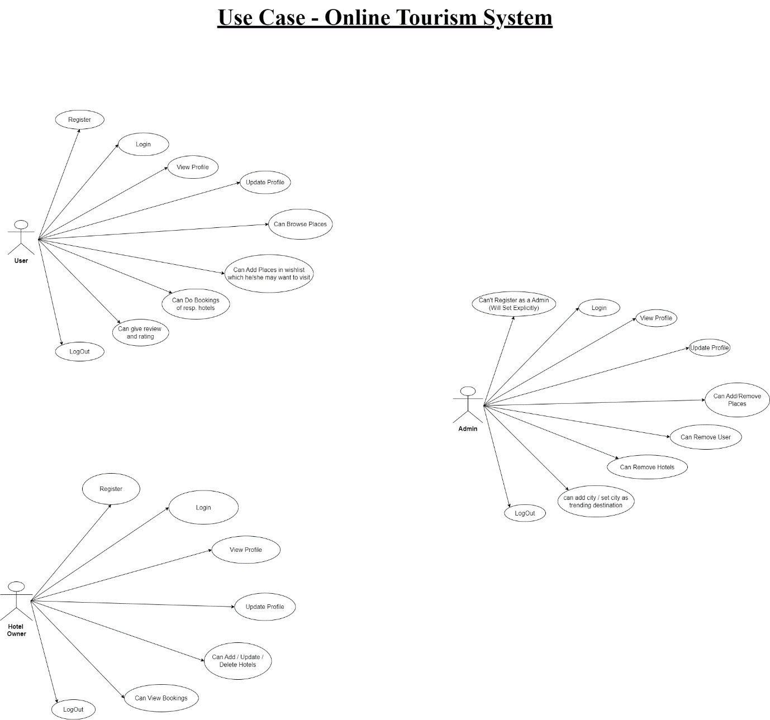

**Entity – Relationship (ER) Diagram**

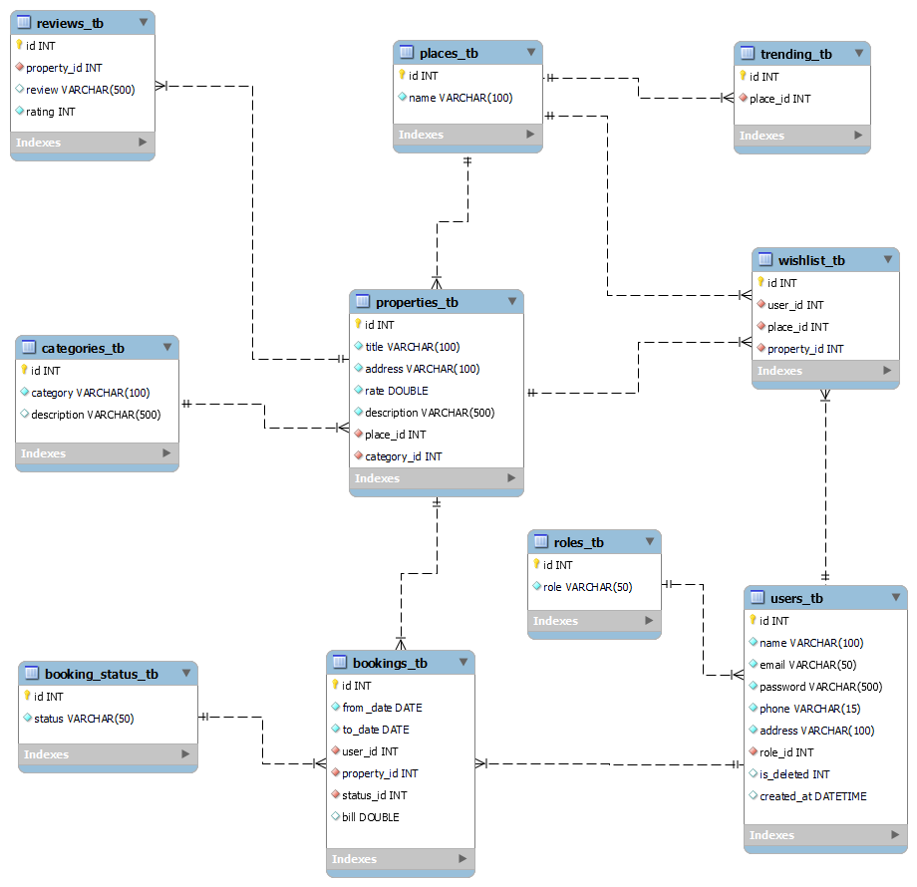

**Table Structure**

1. **user_tb**

|  |  |  |  |  |  |
| --- | --- | --- | --- | --- | --- |
| Field | Type | Null | Key | Default | Extra |
| id | INTEGER | NO | PK | NULL | AUTO  INCREMENT |
| name | VARCHAR (50) | NO |  | NULL | UNIQUE |
| email | VARCHAR (50) | NO |  | NULL | UNIQUE |
| password | VARCHAR (200) | NO |  | NULL | NA |
| phone | VARCHAR (15) | NO |  | NULL | UNIQUE |
| address | VARCHAR (100) | YES |  | NULL | NA |
| role_id | INTEGER | NO | FK | NULL | NA |
| is_deleted | INTEGER (1) | NO |  | 0 | NA |
| created_at | DATETIME | NO |  | CURRENT_TIMESTAMP | NA |

|  |  |  |  |  |  |
| --- | --- | --- | --- | --- | --- |
| Field | Type | Null | Key | Default | Extra |
| id | INTEGER | NO | PK | NULL | AUTO  INCREMENT |
| title | VARCHAR (100) | NO |  | NULL | UNIQUE |
| address | VARCHAR (100) | NO |  | NULL | NA |
| rate | DOUBLE | NO |  | NULL | NA |
| description | VARCHAR (500) | NO |  | NULL | NA |
| place_id | INTEGER | NO | FK | NULL | NA |
| category_id | INTEGER | NO | FK | NULL | NA |
| created_at | DATETIME | NO |  | CURRENT_TIMESTAMP | NA |

1. **properties_tb**
2. **reviews_tb**

|  |  |  |  |  |  |
| --- | --- | --- | --- | --- | --- |
| Field | Type | Null | Key | Default | Extra |
| id | INTEGER | NO | PK | NULL | AUTO  INCREMENT |
| review | VARCHAR (500) | YES |  | NULL | NA |
| rating | INTEGER | NO |  | NULL | NA |
| property_id | INTEGER | NO | FK | NULL | NA |
| created_at | DATETIME | NO |  | CURRENT_TIMESTAMP | NA |

1. **bookings_tb**

|  |  |  |  |  |  |
| --- | --- | --- | --- | --- | --- |
| Field | Type | Null | Key | Default | Extra |
| id | INTEGER | NO | PK | NULL | AUTO  INCREMENT |
| from_date | DATE | NO |  | NULL | NA |
| to_date | DATE | NO |  | NULL | NA |
| bill | DOUBLE | NO |  | NULL | NA |
| user_id | INTEGER | NO | FK | NULL | NA |
| property_id | INTEGER | NO | FK | NULL | NA |
| status_id | INTEGER | NO | FK | NULL | NA |
| created_at | DATETIME | NO |  | CURRENT_TIMESTAMP | NA |

1. **wishlist_tb**

|  |  |  |  |  |  |
| --- | --- | --- | --- | --- | --- |
| Field | Type | Null | Key | Default | Extra |
| id | INTEGER | NO | PK | NULL | AUTO  INCREMENT |
| user_id | INTEGER | NO | FK | NULL | NA |
| property_id | INTEGER | NO | FK | NULL | NA |
| place_id | INTEGER | NO | FK | NULL | NA |
| created_at | DATETIME | NO |  | CURRENT_TIMESTAMP | NA |

1. **trending_tb**

|  |  |  |  |  |  |
| --- | --- | --- | --- | --- | --- |
| Field | Type | Null | Key | Default | Extra |
| id | INTEGER | NO | PK | NULL | AUTO  INCREMENT |
| place_id | INTEGER | NO | FK | NULL | NA |
| created_at | DATETIME | NO |  | CURRENT_TIMESTAMP | NA |

1. **booking_status_tb**

|  |  |  |  |  |  |
| --- | --- | --- | --- | --- | --- |
| Field | Type | Null | Key | Default | Extra |
| id | INTEGER | NO | PK | NULL | AUTO  INCREMENT |
| status | VARCHAR (50) | NO |  | NULL | UNIQUE |
| created_at | DATETIME | NO |  | CURRENT_TIMESTAMP | NA |

1. **categories_tb**

|  |  |  |  |  |  |
| --- | --- | --- | --- | --- | --- |
| Field | Type | Null | Key | Default | Extra |
| id | INTEGER | NO | PK | NULL | AUTO  INCREMENT |
| category | VARCHAR (100) | NO |  | NULL | UNIQUE |
| description | VARCHAR (500) | YES |  | NULL | NA |
| created_at | DATETIME | NO |  | CURRENT_TIMESTAMP | NA |

1. **places_tb**

|  |  |  |  |  |  |
| --- | --- | --- | --- | --- | --- |
| Field | Type | Null | Key | Default | Extra |
| id | INTEGER | NO | PK | NULL | AUTO  INCREMENT |
| name | VARCHAR (100) | NO |  | NULL | UNIQUE |
| created_at | DATETIME | NO |  | CURRENT_TIMESTAMP | NA |

1. **roles_tb**

|  |  |  |  |  |  |
| --- | --- | --- | --- | --- | --- |
| Field | Type | Null | Key | Default | Extra |
| id | INTEGER | NO | PK | NULL | AUTO  INCREMENT |
| role | VARCHAR (50) | NO |  | NULL | NA |
| created_at | DATETIME | NO |  | CURRENT_TIMESTAMP | NA |

**Conclusion**

**References**