5/12/2021

2.1.0

[Get updates, docs & report issues here](https://github.com/fbdesignpro/sweetviz)

Created & maintained by [Francois Bertrand](https://www.fbdesignpro.com/)

Graphic design by [Jean-Francois Hains](https://www.fbdesignpro.com/)

* **10percentage**

|  |  |  |
| --- | --- | --- |
| VALUES: | 3,958 | (100%) |
| MISSING: | --- |  |
| DISTINCT: | 844 | (21%) |
| ZEROES: | --- |  |

* **12percentage**

|  |  |  |
| --- | --- | --- |
| VALUES: | 3,958 | (100%) |
| MISSING: | --- |  |
| DISTINCT: | 797 | (20%) |
| ZEROES: | --- |  |

* **CollegeTier**

|  |  |  |
| --- | --- | --- |
| VALUES: | 3,958 | (100%) |
| MISSING: | --- |  |
| DISTINCT: | 2 | (<1%) |

* **collegeGPA**

|  |  |  |
| --- | --- | --- |
| VALUES: | 3,958 | (100%) |
| MISSING: | --- |  |
| DISTINCT: | 1,275 | (32%) |
| ZEROES: | --- |  |

* **CollegeCityTier**

|  |  |  |
| --- | --- | --- |
| VALUES: | 3,958 | (100%) |
| MISSING: | --- |  |
| DISTINCT: | 2 | (<1%) |

|  |  |  |  |
| --- | --- | --- | --- |
| **6** | **English** |  |  |
|  | VALUES: | 3,958 | (100%) |
|  | MISSING: | --- |  |
|  | DISTINCT: | 111 | (3%) |
|  | ZEROES: | --- |  |

|  |  |  |  |
| --- | --- | --- | --- |
| **7** | **Logical** |  |  |
|  | VALUES: | 3,958 | (100%) |
|  | MISSING: | --- |  |
|  | DISTINCT: | 107 | (3%) |
|  | ZEROES: | --- |  |

|  |  |  |  |
| --- | --- | --- | --- |
| **8** | **Quant** |  |  |
|  | VALUES: | 3,958 | (100%) |
|  | MISSING: | --- |  |
|  | DISTINCT: | 138 | (3%) |
|  | ZEROES: | --- |  |

|  |  |  |  |
| --- | --- | --- | --- |
| **9** | **Domain** |  |  |
|  | VALUES: | 3,958 | (100%) |
|  | MISSING: | --- |  |

SWEETVIZ_REPORT.html

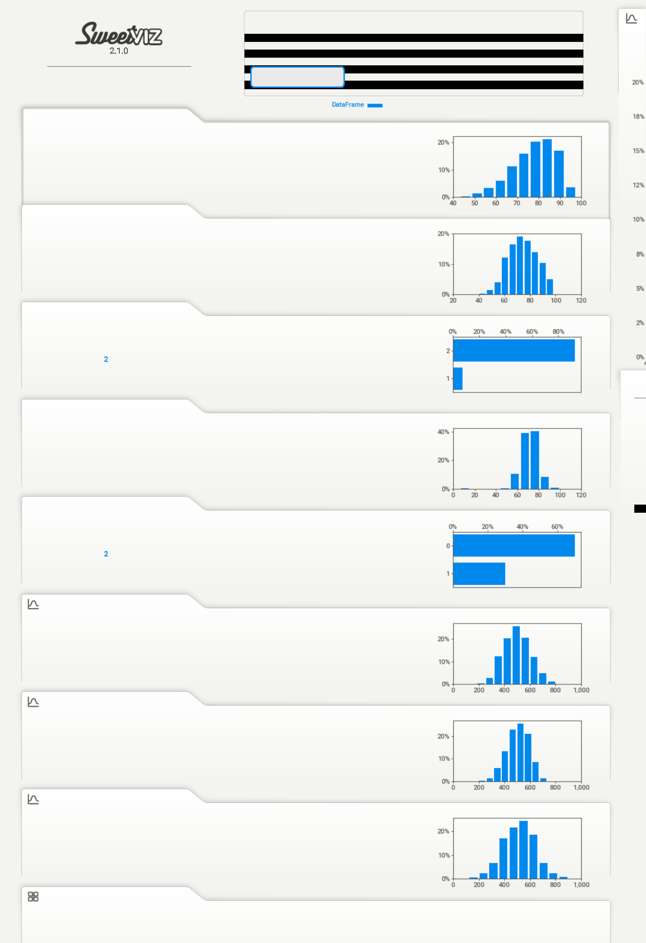

|  |  |  |  |  |
| --- | --- | --- | --- | --- |
| **DataFrame** |  | **NO COMPARISON TARGET** | **1** |  |
|  |  |  |
| 3958 | ROWS |  | M |  |
|  |  |  |

* DUPLICATES

1.2 MB RAM

1. FEATURES
2. CATEGORICAL

ASSOCIATIONS 17 NUMERICAL

* TEXT

|  |  |  |  |  |
| --- | --- | --- | --- | --- |
| MAX | 97.8 | RANGE | 54.8 |  |
| 95% | 91.6 | IQR | 13.9 |  |
| Q3 | 85.7 | STD | 9.85 |  |
| MEDIAN | 79.2 | VAR | 96.9 |  |
| AVG | 77.9 | KURT. | -0.096 |  |
| Q1 | 71.8 |  |
| 5% | 60.0 | SKEW | -0.597 |  |
|  |  | SUM | 309k |  |
| MIN | 43.0 |  |
| MAX | 98.7 | RANGE | 58.7 |  |
| 95% | 92.9 | IQR | 16.6 |  |
| Q3 | 82.6 | STD | 11.0 |  |
| AVG | 74.5 | VAR | 121 |  |
| MEDIAN | 74.4 | KURT. | -0.627 |  |
| Q1 | 66.0 |  |
| 5% | 56.8 | SKEW | -0.037 |  |
|  |  | SUM | 295k |  |
| MIN | 40.0 |  |

**MO**

|  |  |  |  |  |  |
| --- | --- | --- | --- | --- | --- |
|  |  |  |  | 78. |  |
|  |  |  |  | 82. |  |
|  |  |  |  | 85. |  |
| MAX | 99.9 | RANGE | 93.5 | 76. |  |
| 80. |  |
| 95% | 84.0 | IQR | 10.0 |  |
| 73. |  |
| Q3 | 76.4 | STD | 8.18 |  |
| 86. |  |
| MEDIAN | 71.7 | VAR | 67.0 |  |
| 72. |  |
| AVG | 71.5 |  |  |  |
| KURT. | 10.2 | 75. |  |
| Q1 | 66.4 |  |
| 87. |  |
| 5% | 60.0 | SKEW | -1.25 |  |
| 83. |  |
|  |  | SUM | 283k |  |
| MIN | 6.5 |  |
| 84. |  |
|  |  |  |  |  |
|  |  |  |  | 74. |  |

81.

77.

|  |  |  |  |  |
| --- | --- | --- | --- | --- |
| MAX | 875 | RANGE | 695 |  |
| 95% | 675 | IQR | 145 |  |
| Q3 | 570 | STD | 105 |  |
| AVG | 502 | VAR | 11,012 |  |
| MEDIAN | 500 | KURT. | -0.255 |  |
| Q1 | 425 |  |
| 5% | 335 | SKEW | 0.194 |  |
|  |  | SUM | 2.0M |  |
| MIN | 180 |  |
| MAX | 795 | RANGE | 600 |  |
| 95% | 640 | IQR | 120 |  |
| Q3 | 565 | STD | 86.8 |  |
| MEDIAN | 505 | VAR | 7,529 |  |
| AVG | 502 | KURT. | -0.225 |  |
| Q1 | 445 |  |
| 5% | 355 | SKEW | -0.215 |  |
|  |  | SUM | 2.0M |  |
| MIN | 195 |  |
| MAX | 900 | RANGE | 780 |  |
| 95% | 715 | IQR | 165 |  |
| Q3 | 595 | STD | 122 |  |
| MEDIAN | 515 | VAR | 14,939 |  |
| AVG | 513 | KURT. | -0.100 |  |
| Q1 | 430 |  |
| 5% | 310 | SKEW | -0.019 |  |
|  |  | SUM | 2.0M |  |
| MIN | 120 |  |

file:///C:/Users/sudee/Desktop/Capstone Project/SWEETVIZ_REPORT.html 1/4

5/12/2021

|  |  |
| --- | --- |
| DISTINCT: | 2 (<1%) |

1. **ComputerProgramming**

|  |  |  |
| --- | --- | --- |
| VALUES: | 3,958 | (100%) |
| MISSING: | --- |  |
| DISTINCT: | 2 | (<1%) |

1. **ElectronicsAndSemicon**

|  |  |  |
| --- | --- | --- |
| VALUES: | 3,958 | (100%) |
| MISSING: | --- |  |
| DISTINCT: | 2 | (<1%) |

1. **ComputerScience**

|  |  |  |
| --- | --- | --- |
| VALUES: | 3,958 | (100%) |
| MISSING: | --- |  |
| DISTINCT: | 2 | (<1%) |

1. **MechanicalEngg**

|  |  |  |
| --- | --- | --- |
| VALUES: | 3,958 | (100%) |
| MISSING: | --- |  |
| DISTINCT: | 2 | (<1%) |

1. **ElectricalEngg**

|  |  |  |
| --- | --- | --- |
| VALUES: | 3,958 | (100%) |
| MISSING: | --- |  |
| DISTINCT: | 2 | (<1%) |

1. **TelecomEngg**

|  |  |  |
| --- | --- | --- |
| VALUES: | 3,958 | (100%) |
| MISSING: | --- |  |
| DISTINCT: | 2 | (<1%) |

1. **CivilEngg**

|  |  |  |
| --- | --- | --- |
| VALUES: | 3,958 | (100%) |
| MISSING: | --- |  |
| DISTINCT: | 2 | (<1%) |

1. **conscientiousness**

SWEETVIZ_REPORT.html

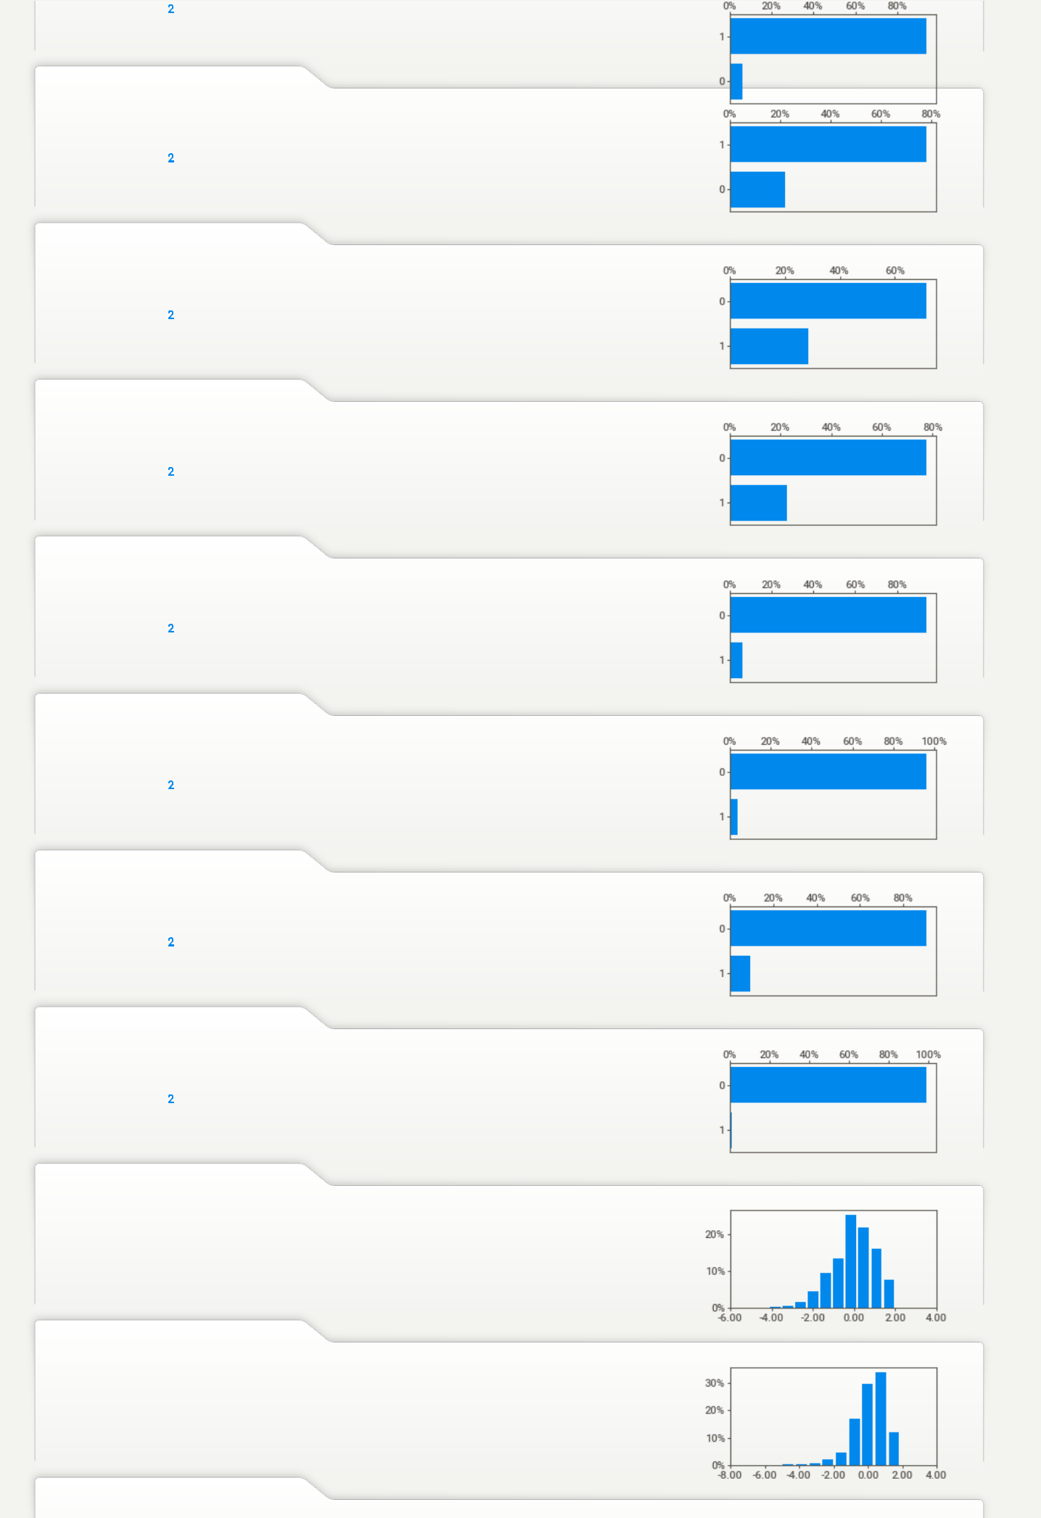

|  |  |  |
| --- | --- | --- |
| VALUES: | 3,958 | (100%) |
| MISSING: | --- |  |
| DISTINCT: | 141 | (4%) |
| ZEROES: | --- |  |

1. **agreeableness**

|  |  |  |
| --- | --- | --- |
| VALUES: | 3,958 | (100%) |
| MISSING: | --- |  |
| DISTINCT: | 148 | (4%) |
| ZEROES: | --- |  |

1. **extraversion**

|  |  |
| --- | --- |
| MAX | 2.00 |
| 95% | 1.44 |
| Q3 | 0.70 |
| MEDIAN | 0.05 |
| AVG | -0.04 |
| Q1 | -0.73 |
| 5% | -1.88 |
| MIN | -4.13 |
| MAX | 1.90 |
| 95% | 1.44 |
| Q3 | 0.81 |
| MEDIAN | 0.21 |
| AVG | 0.14 |
| Q1 | -0.29 |
| 5% | -1.53 |
| MIN | -5.78 |

|  |  |
| --- | --- |
| RANGE | 6.12 |
| IQR | 1.43 |
| STD | 1.03 |
| VAR | 1.06 |
| KURT. | 0.114 |
| SKEW | -0.523 |
| SUM | -159 |
| RANGE | 7.69 |
| IQR | 1.10 |
| STD | 0.942 |
| VAR | 0.888 |
| KURT. | 3.41 |
| SKEW | -1.21 |
| SUM | 573 |

file:///C:/Users/sudee/Desktop/Capstone Project/SWEETVIZ_REPORT.html 2/4

5/12/2021

|  |  |  |
| --- | --- | --- |
| VALUES: | 3,958 | (100%) |
| MISSING: | --- |  |
| DISTINCT: | 153 | (4%) |
| ZEROES: | --- |  |

1. **nueroticism**

|  |  |  |
| --- | --- | --- |
| VALUES: | 3,958 | (100%) |
| MISSING: | --- |  |
| DISTINCT: | 217 | (5%) |
| ZEROES: | --- |  |

1. **openess_to_experience**

|  |  |  |
| --- | --- | --- |
| VALUES: | 3,958 | (100%) |
| MISSING: | --- |  |
| DISTINCT: | 141 | (4%) |
| ZEROES: | --- |  |

1. **SubjectCount**

|  |  |  |
| --- | --- | --- |
| VALUES: | 3,958 | (100%) |
| MISSING: | --- |  |
| DISTINCT: | 6 | (<1%) |

1. **SubjectTotal**

|  |  |  |  |
| --- | --- | --- | --- |
|  | VALUES: | 3,958 | (100%) |
|  | MISSING: | --- |  |
|  | DISTINCT: | 1,471 | (37%) |
|  | ZEROES: | 107 | (3%) |
| **24** | **Age** |  |  |
|  | VALUES: | 3,958 | (100%) |
|  | MISSING: | --- |  |
|  | DISTINCT: | 116 | (3%) |
|  | ZEROES: | --- |  |
| **25** | **YOE** |  |  |
|  | VALUES: | 3,958 | (100%) |
|  | MISSING: | --- |  |
|  | DISTINCT: | 62 | (2%) |
|  | ZEROES: | 15 | (<1%) |

1. **Enc_Designation**

|  |  |  |
| --- | --- | --- |
| VALUES: | 3,958 | (100%) |
| MISSING: | --- |  |
| DISTINCT: | 379 | (10%) |
| ZEROES: | 35 | (<1%) |

1. **Enc_Gender**

|  |  |  |
| --- | --- | --- |
| VALUES: | 3,958 | (100%) |
| MISSING: | --- |  |
| DISTINCT: | 2 | (<1%) |

1. **Enc_Degree**

|  |  |  |
| --- | --- | --- |
| VALUES: | 3,958 | (100%) |
| MISSING: | --- |  |
| DISTINCT: | 4 | (<1%) |

|  |  |
| --- | --- |
| MAX | 2.54 |
| 95% | 1.39 |
| Q3 | 0.67 |
| MEDIAN | 0.09 |
| AVG | -0.00 |
| Q1 | -0.60 |
| 5% | -1.68 |
| MIN | -4.60 |
| MAX | 3.35 |
| 95% | 1.54 |
| Q3 | 0.53 |
| AVG | -0.17 |
| MEDIAN | -0.23 |
| Q1 | -0.87 |
| 5% | -1.76 |
| MIN | -2.64 |
| MAX | 1.82 |
| 95% | 1.25 |
| Q3 | 0.50 |
| MEDIAN | -0.09 |
| AVG | -0.14 |
| Q1 | -0.67 |
| 5% | -1.83 |
| MIN | -7.38 |

|  |  |
| --- | --- |
| MAX | 1.94 |
| 95% | 1.52 |
| Q3 | 1.23 |
| MEDIAN | 0.98 |
| AVG | 0.94 |
| Q1 | 0.69 |
| 5% | 0.25 |
| MIN | 0.00 |
| MAX | 38.2 |
| 95% | 28.2 |
| Q3 | 26.1 |
| AVG | 25.1 |
| MEDIAN | 24.8 |
| Q1 | 23.8 |
| 5% | 22.7 |
| MIN | 18.6 |
| MAX | 24.6 |
| 95% | 4.1 |
| Q3 | 2.4 |
| AVG | 1.7 |
| MEDIAN | 1.5 |
| Q1 | 0.9 |
| 5% | 0.3 |
| MIN | 0.0 |
| MAX | 378 |
| 95% | 351 |
| Q3 | 321 |
| MEDIAN | 252 |
| AVG | 227 |
| Q1 | 152 |
| 5% | 15 |
| MIN | 0 |

SWEETVIZ_REPORT.html

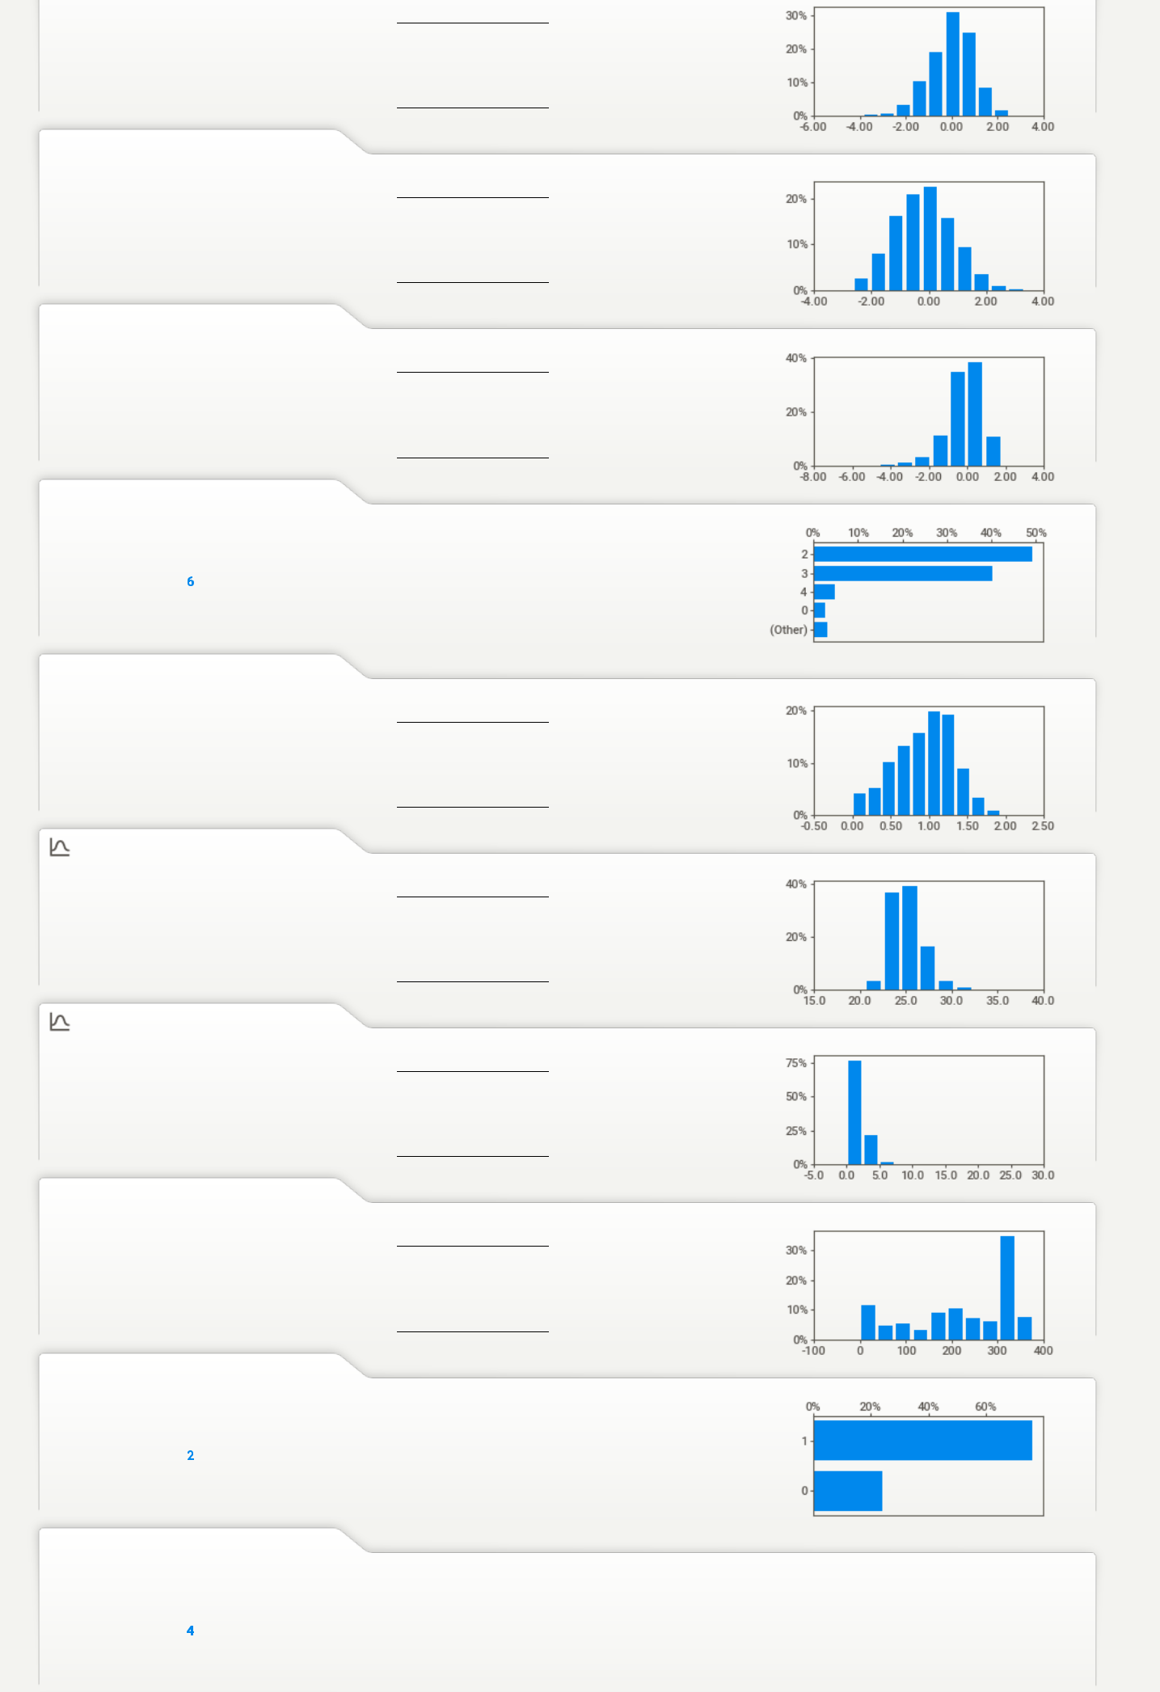

|  |  |
| --- | --- |
| RANGE | 7.14 |
| IQR | 1.28 |
| STD | 0.953 |
| VAR | 0.908 |
| KURT. | 0.636 |
| SKEW | -0.522 |
| SUM | -4.37 |
| RANGE | 6.00 |
| IQR | 1.39 |
| STD | 1.01 |
| VAR | 1.01 |
| KURT. | -0.197 |
| SKEW | 0.167 |
| SUM | -670 |
| RANGE | 9.20 |
| IQR | 1.17 |
| STD | 1.01 |
| VAR | 1.01 |
| KURT. | 5.79 |
| SKEW | -1.50 |
| SUM | -557 |

|  |  |
| --- | --- |
| RANGE | 1.94 |
| IQR | 0.540 |
| STD | 0.388 |
| VAR | 0.151 |
| KURT. | -0.338 |
| SKEW | -0.367 |
| SUM | 3,723 |
| RANGE | 19.6 |
| IQR | 2.30 |
| STD | 1.75 |
| VAR | 3.08 |
| KURT. | 1.89 |
| SKEW | 0.913 |
| SUM | 99,316 |
| RANGE | 24.6 |
| IQR | 1.50 |
| STD | 1.21 |
| VAR | 1.47 |
| KURT. | 32.7 |
| SKEW | 2.62 |
| SUM | 6,915 |
| RANGE | 378 |
| IQR | 169 |
| STD | 115 |
| VAR | 13,144 |
| KURT. | -1.00 |
| SKEW | -0.613 |
| SUM | 898k |

file:///C:/Users/sudee/Desktop/Capstone Project/SWEETVIZ_REPORT.html 3/4

5/12/2021 SWEETVIZ_REPORT.html

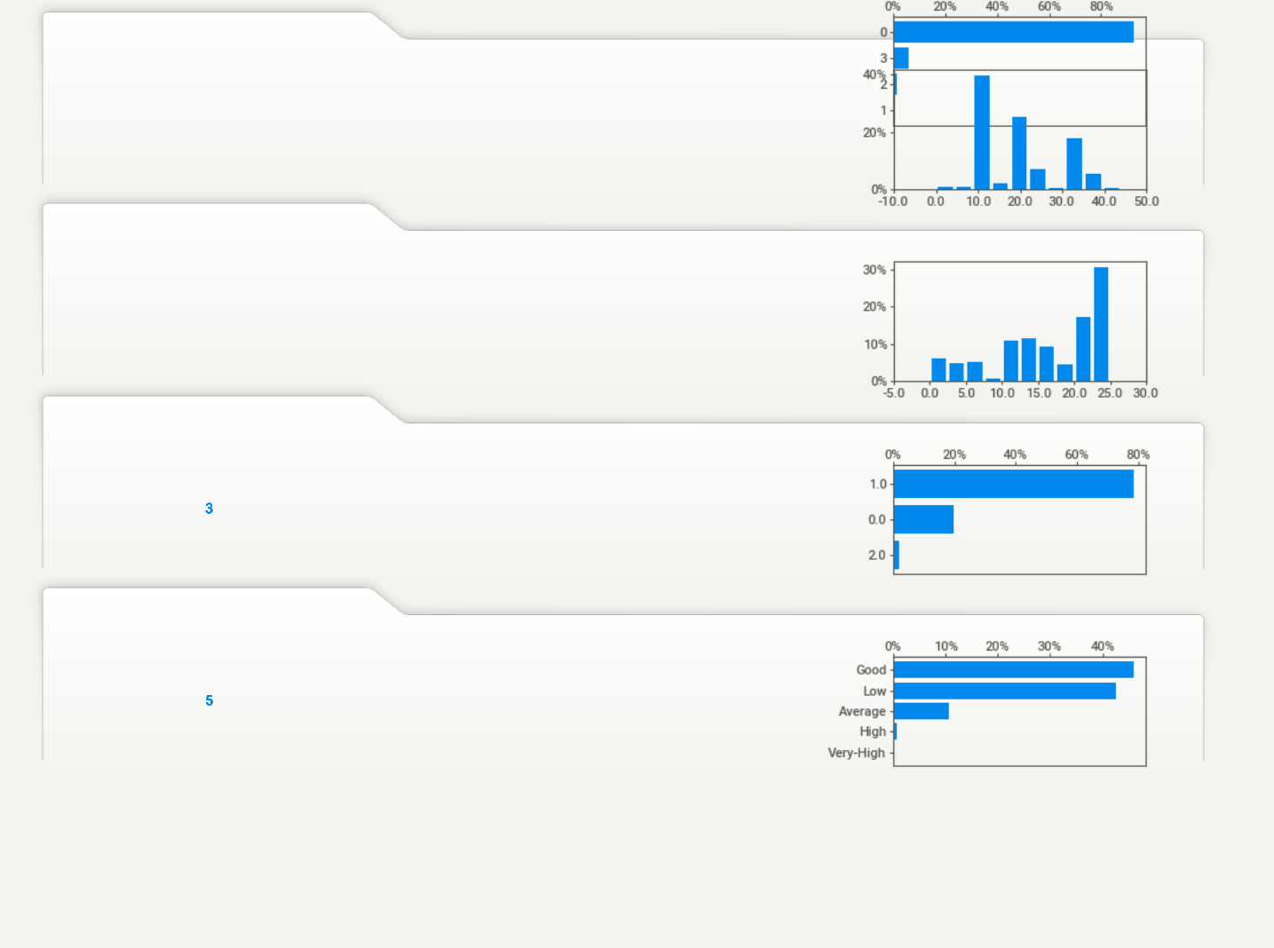

1. **Enc_Specialization**

|  |  |  |  |  |  |  |  |
| --- | --- | --- | --- | --- | --- | --- | --- |
| VALUES: | 3,958 | (100%) | MAX | 44.0 | RANGE | 44.0 |  |
| MISSING: | --- |  | 95% | 38.0 | IQR | 10.0 |  |
|  | 45 |  | Q3 | 23.0 | STD | 9.09 |  |
| DISTINCT: | (1%) | MEDIAN | 20.0 | VAR | 82.6 |  |
| ZEROES: | 3 | (<1%) | AVG | 19.6 | KURT. | -0.749 |  |
| Q1 | 13.0 |  |
|  |  |  | 5% | 9.0 | SKEW | 0.569 |  |
|  |  |  |  |  | SUM | 77,431 |  |
|  |  |  | MIN | 0.0 |  |

1. **Enc_CollegeState**

|  |  |  |  |  |  |  |  |
| --- | --- | --- | --- | --- | --- | --- | --- |
| VALUES: | 3,958 | (100%) | MAX | 25.0 | RANGE | 25.0 |  |
| MISSING: | --- |  | 95% | 24.0 | IQR | 12.0 |  |
|  | 26 |  | Q3 | 23.0 | STD | 7.13 |  |
| DISTINCT: | (<1%) | MEDIAN | 18.0 | VAR | 50.9 |  |
| ZEROES: | 223 | (6%) | AVG | 16.3 | KURT. | -0.390 |  |
| Q1 | 11.0 |  |
|  |  |  | 5% | 0.0 | SKEW | -0.794 |  |
|  |  |  |  |  | SUM | 64,590 |  |
|  |  |  | MIN | 0.0 |  |

1. **enc_City_Type**

|  |  |  |
| --- | --- | --- |
| VALUES: | 3,958 | (100%) |
| MISSING: | --- |  |
| DISTINCT: | 3 | (<1%) |

1. **Salary_Class**

|  |  |  |
| --- | --- | --- |
| VALUES: | 3,958 | (100%) |
| MISSING: | --- |  |
| DISTINCT: | 5 | (<1%) |

file:///C:/Users/sudee/Desktop/Capstone Project/SWEETVIZ_REPORT.html 4/4