Indian Sign Language Detection
and Translation System

Interim Review - 1
Design Document

Submitted by
[Department Name]
[University/College Name]
[Year]

Table of Contents
1. Problem Specification 3
2. Introduction 4
3. Literature Survey 5
4. Research Gap 7
5. Proposed Solution with Block Diagram 8
6. Results and Discussion 11
References 13

1. Problem Specification
Indian Sign Language (ISL) is the primary mode of communication for approximately 1.8 million deaf and hard-of-hearing individuals in India (Census 2011). Unlike American Sign Language (ASL), ISL is a two-handed sign language with distinct grammatical structures and vocabulary, yet it remains largely unsupported by existing technological solutions. The absence of real-time ISL translation tools creates a significant communication barrier between hearing-impaired individuals and the hearing majority. This project aims to develop a real-time ISL detection and translation system that recognizes hand gestures through a webcam, classifies them using deep learning models, and converts the detected signs into synthesized English speech output.

2. Introduction
Sign language serves as the fundamental communication medium for the deaf and hard-of-hearing community worldwide. In India, Indian Sign Language (ISL) is officially recognized and is structurally distinct from other sign languages such as American Sign Language (ASL) or British Sign Language (BSL). ISL employs two-handed signs, making it computationally more complex to recognize compared to predominantly one-handed systems like ASL. Despite the growing adoption of artificial intelligence in accessibility technologies, ISL remains significantly underrepresented in sign language recognition research.
Recent advances in computer vision and deep learning have made real-time hand gesture recognition feasible. Google's MediaPipe framework provides efficient, GPU-accelerated hand landmark detection capable of identifying 21 three-dimensional keypoints per hand at real-time frame rates. When combined with neural network architectures such as Dense Neural Networks for static gesture classification and Long Short-Term Memory (LSTM) networks for temporal sequence recognition, these landmark features can be transformed into accurate sign language predictions.
This project presents an end-to-end system for Indian Sign Language detection and translation. The system captures live video from a standard webcam, extracts hand landmarks using the MediaPipe HandLandmarker Tasks API, and classifies the detected gestures using trained deep learning models. The classification output is displayed on-screen as text and simultaneously converted to English speech using the Windows Speech API (SAPI 5). The system supports two recognition modes: a static mode that classifies individual hand poses from single frames using a Dense Neural Network, and a dynamic mode that recognizes motion-based gestures from 30-frame sequences using an LSTM network.
The current implementation supports a vocabulary of five ISL words — Hello, Namaste, Bye, Thank You, and Sorry — with a planned expansion to ten words including India, Language, Welcome, Please, and Practice. The system is designed for local execution on Windows and achieves 99.75% accuracy on static gesture recognition and 100% on dynamic gesture recognition. The architecture is modular and extensible, allowing additional signs to be incorporated by simply collecting new training data and retraining the models.

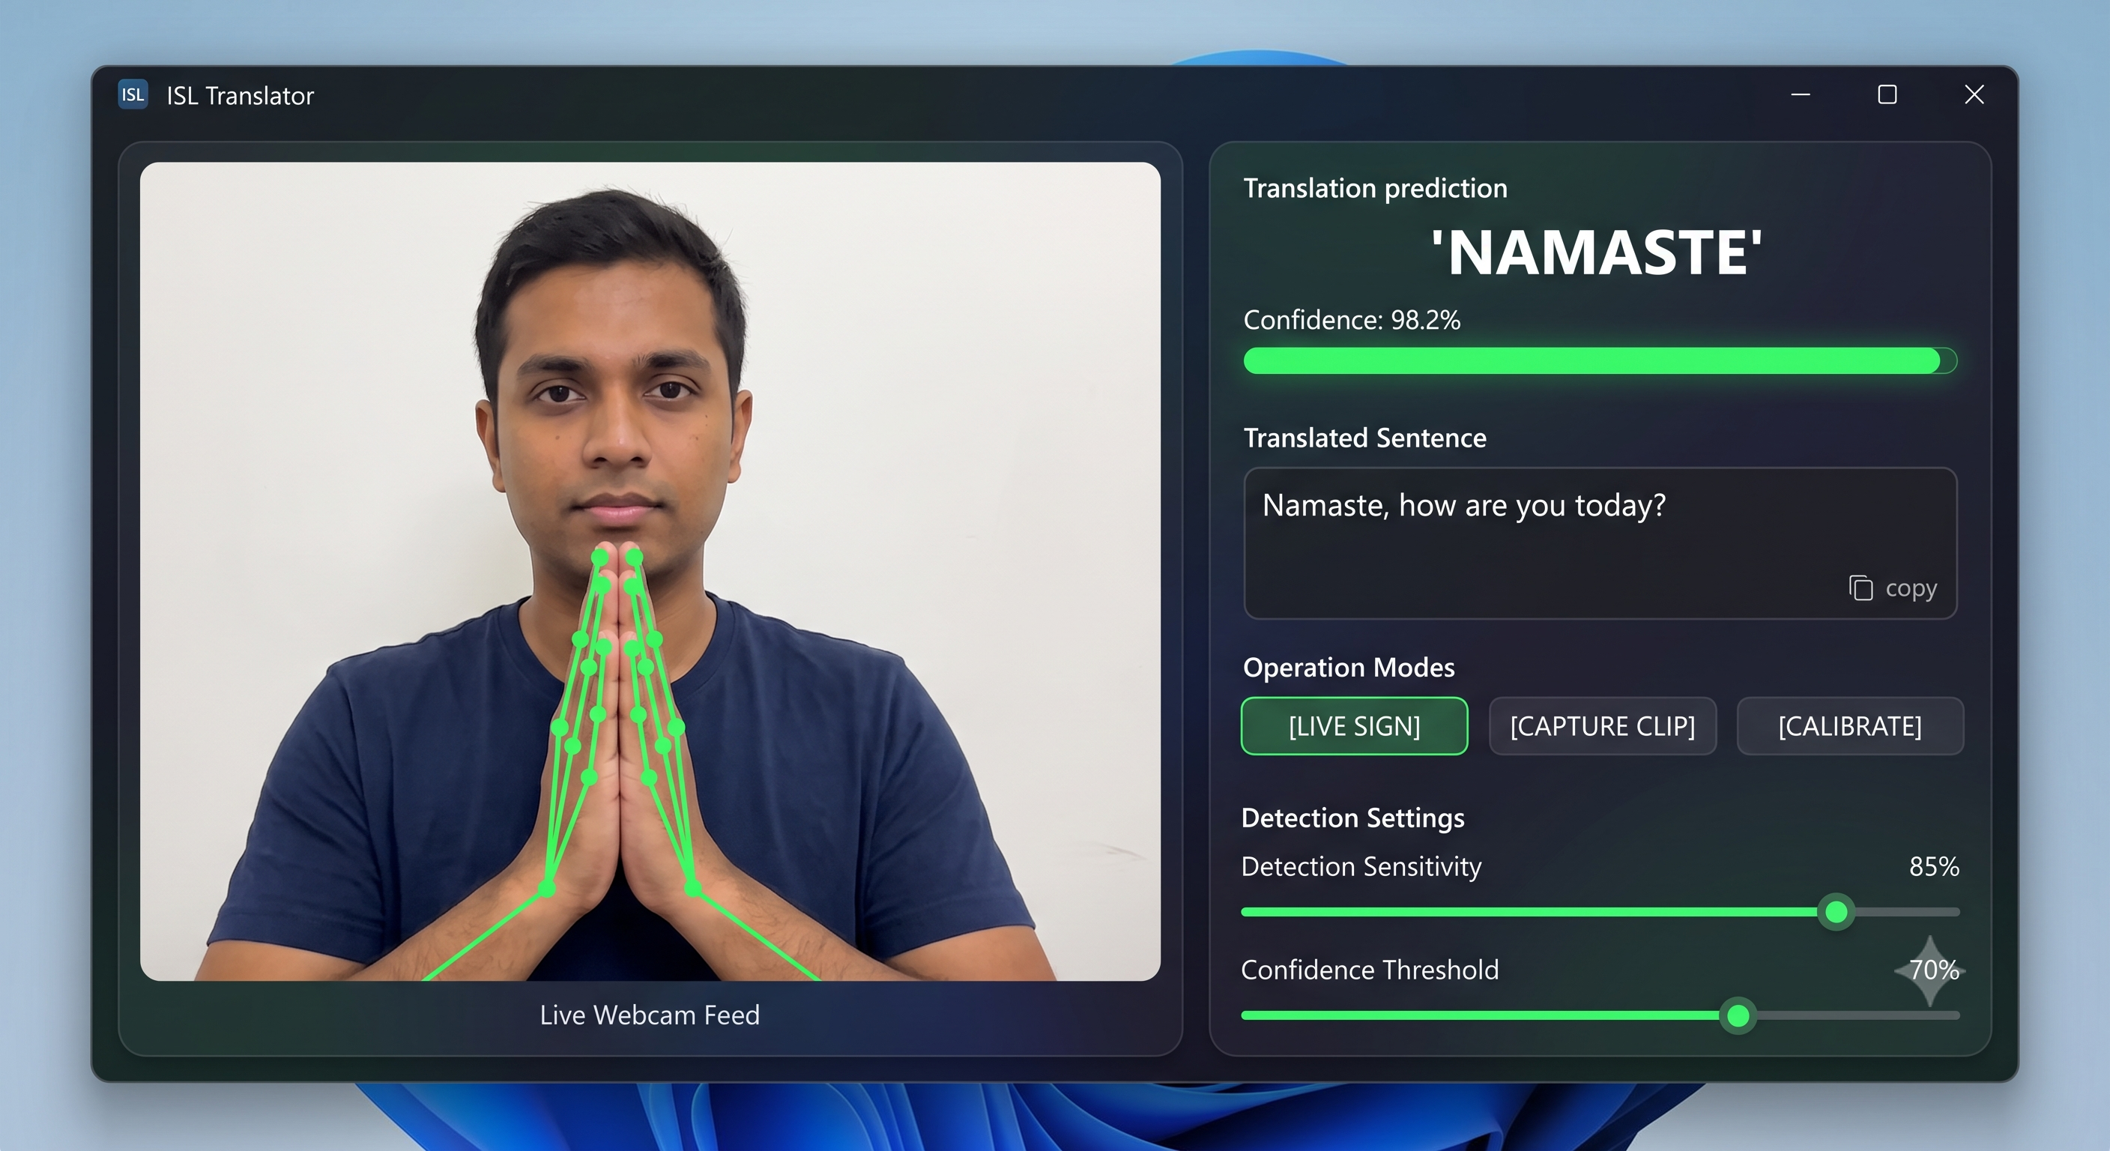
Fig. 2.1: ISL Recognition System in use

3. Literature Survey
Sign language recognition has been an active area of research in computer vision and machine learning. This section reviews key contributions that form the theoretical foundation for the proposed system.

3.1 MediaPipe-Based Approaches
Khartheesvar et al. (2024) proposed an automatic ISL recognition system using MediaPipe Holistic and LSTM networks [1]. Their work demonstrated that extracting spatiotemporal hand and body pose landmarks via MediaPipe, followed by LSTM-based sequential classification, achieves highly efficient translation of continuous dynamic ISL gestures. The MediaPipe framework was shown to outperform traditional feature extraction methods (HOG, SIFT) in both speed and accuracy for real-time applications. This work serves as the primary architectural reference for our proposed system, which similarly combines MediaPipe landmark extraction with LSTM-based temporal classification.

3.2 Hybrid CNN-LSTM Architectures
The LiST framework by the authors in Information journal (2023) proposed a lightweight framework for continuous ISL translation, combining Inception V3 for spatial feature extraction with a two-layered LSTM architecture [2]. This multimodal approach integrating hand gestures and facial expressions significantly improved continuous translation accuracy. Kumari and Anand (2024) further advanced this direction with a hybrid CNN-LSTM framework incorporating an attention mechanism [3], which selectively weights the most significant frames within a gesture sequence, thereby improving isolated gesture recognition robustness.

3.3 Deep Learning for Hand Landmark Detection
Kothadiya et al. (2022) presented DeepSign, a comprehensive system for sign language detection and recognition using deep learning [4]. Their work emphasized advanced spatial landmark detection techniques and conducted extensive comparative analyses of deep learning models for recognizing static ISL alphabets and numerical hand shapes. The study validated that landmark-based approaches significantly reduce computational overhead compared to raw image classification while maintaining competitive accuracy.

3.4 Real-Time Translation Systems
Recent work published in IEEE Access (2025) demonstrated a breakthrough real-time sign language-to-speech translation system integrating AI-powered wearable technology with TensorFlow-based vision models [5]. This system achieved sub-second latency for continuous ISL-to-speech conversion. Earlier, researchers in the Journal of Scientific and Industrial Research (2022) proposed a deep learning pipeline for real-time static and dynamic sign language recognition [6], employing Region of Interest (ROI) extraction to optimize continuous sign parsing without computational lag.

3.5 Comparative Studies
Evaluation studies at IEEE MysuruCon (2021) provided a comprehensive comparative analysis of traditional machine learning algorithms (k-Nearest Neighbors, Support Vector Machines, Random Forest) against deep neural network approaches [7]. The study concluded that while CNNs are optimal for static image classification, landmark-tracking paired with recurrent models (LSTM/GRU) dominates dynamic sign accuracy. A study in Array journal (Elsevier, 2023) compared SURF+SVM against end-to-end CNNs for ISL recognition [8], concluding that deep feature extraction is essential for handling lighting variation and signer-dependent differences in gesture execution.

3.6 Summary of Reviewed Literature
Ref. | Authors / Year | Method | Key Contribution
[1] | Khartheesvar et al., 2024 | MediaPipe + LSTM | Real-time ISL with landmark-based LSTM
[2] | Info. Journal, 2023 | Inception V3 + LSTM | Lightweight continuous ISL translation
[3] | Kumari & Anand, 2024 | CNN-LSTM + Attention | Attention-weighted frame selection
[4] | Kothadiya et al., 2022 | Deep Learning | Landmark-based static sign detection
[5] | IEEE Access, 2025 | TF + Wearable | Sub-second real-time ISL-to-speech
[6] | JSIR, 2022 | Deep Learning + ROI | Real-time static + dynamic recognition
[7] | IEEE MysuruCon, 2021 | ML Comparison | LSTM > CNN for dynamic signs
[8] | Array (Elsevier), 2023 | SURF+SVM vs CNN | Deep features for signer variance

Table 3.1: Summary of Literature Reviewed

4. Research Gap
Based on the comprehensive literature review conducted in Section 3, the following research gaps have been identified that the proposed system aims to address:
1. Limited ISL-Specific Solutions: The majority of existing sign language recognition systems are designed for American Sign Language (ASL), which is predominantly one-handed. ISL is a two-handed sign language with fundamentally different grammar and vocabulary, yet very few technological solutions specifically target ISL recognition. Most existing ISL research focuses on static alphabet recognition rather than word-level or phrase-level translation.
2. Absence of Integrated Speech Output: Most existing systems terminate at the classification stage, producing only text output. The integration of a real-time text-to-speech engine that converts detected signs into spoken English remains underexplored, particularly for ISL-to-English translation. Systems that do include speech output often introduce significant latency that disrupts natural conversation flow.
3. Static vs. Dynamic Recognition Gap: Existing approaches typically handle either static gestures (single-frame classification) or dynamic gestures (sequence-based recognition) independently. Few systems offer a unified framework that supports both recognition modes simultaneously, allowing the user to switch between modes depending on the nature of the sign being performed.
4. Dependency on Legacy APIs: Many existing MediaPipe-based implementations rely on the deprecated mp.solutions API, which has been removed in MediaPipe 0.10.x and later versions. Updated implementations using the modern MediaPipe Tasks API (mediapipe.tasks.python.vision) are scarce in literature, creating a practical gap for researchers building new systems.
5. Limited Vocabulary and Scalability: Most existing ISL recognition systems are trained on a fixed, small vocabulary and lack a modular architecture that allows easy vocabulary expansion. The proposed system addresses this through a data-collection-first approach where new signs can be added by simply recording additional training data and retraining the models without architectural changes.

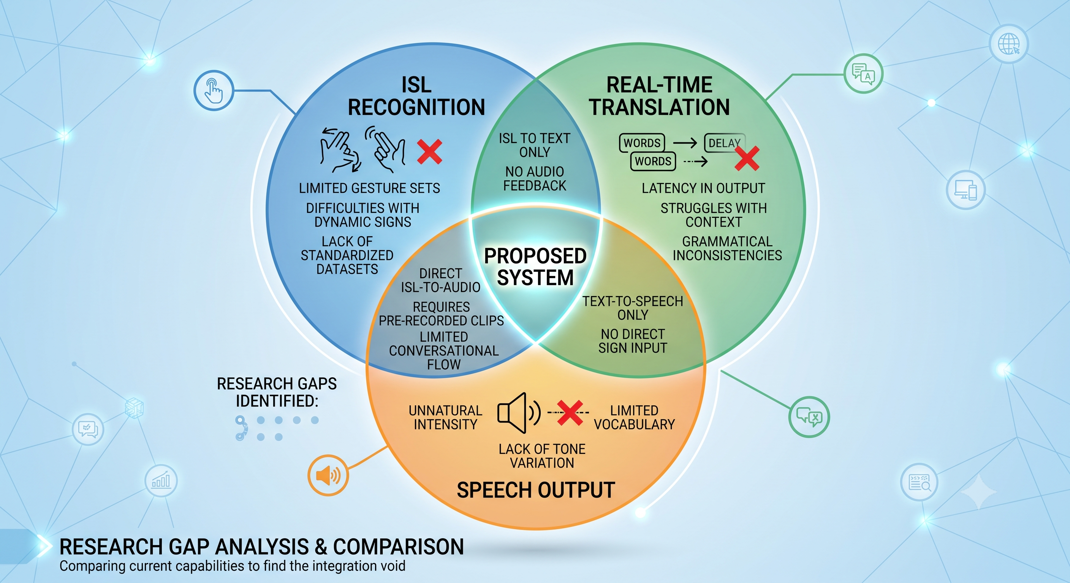

[IMAGE PLACEHOLDER]
Image Prompt: A comparison chart or infographic showing the research gap — a Venn diagram with three circles: 'ISL Recognition', 'Real-Time Translation', and 'Speech Output', with the intersection area labeled 'Proposed System' and the non-overlapping areas showing the gaps identified.

Fig. 4.1: Visual Representation of Research Gaps

5. Proposed Solution with Block Diagram

5.1 System Overview
The proposed system is an end-to-end real-time Indian Sign Language detection and translation pipeline that operates entirely on a local Windows machine using a standard webcam. The system architecture consists of five major stages: (1) Video Capture and Preprocessing, (2) Hand Landmark Extraction, (3) Feature Normalization, (4) Deep Learning Classification, and (5) Speech Synthesis Output.

5.2 System Block Diagram

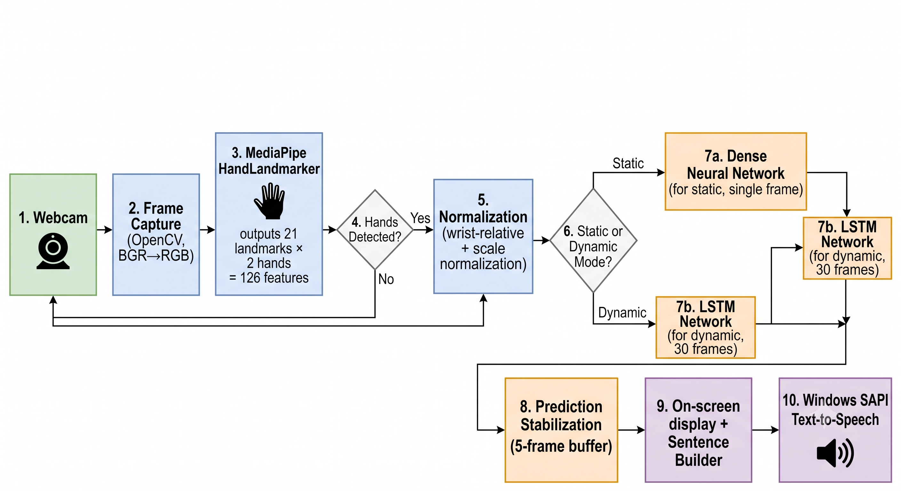
[IMAGE PLACEHOLDER]
Image Prompt: A professional system block diagram / flowchart showing the complete ISL pipeline. Blocks should be arranged left-to-right or top-to-bottom with arrows:
1. Webcam (camera icon) → 2. Frame Capture (OpenCV, BGR→RGB) → 3. MediaPipe HandLandmarker (hand icon, outputs 21 landmarks × 2 hands = 126 features) → 4. Decision diamond 'Hands Detected?' (Yes/No paths) → 5. Normalization (wrist-relative + scale normalization) → 6. Decision diamond 'Static or Dynamic Mode?' → 7a. Dense Neural Network (for static, single frame) / 7b. LSTM Network (for dynamic, 30 frames) → 8. Prediction Stabilization (5-frame buffer) → 9. On-screen display + Sentence Builder → 10. Windows SAPI Text-to-Speech (speaker icon).
Use clean rectangular boxes, diamond decision shapes, and directional arrows. Color-code the stages: green for input, blue for processing, orange for ML, purple for output.

Fig. 5.1: System Architecture Block Diagram

5.3 Hand Landmark Extraction
The MediaPipe HandLandmarker model (hand_landmarker.task, 7.8 MB) detects and tracks up to two hands simultaneously in real-time. For each detected hand, the model outputs 21 three-dimensional landmarks corresponding to anatomical keypoints of the hand skeleton — including the wrist, each finger's MCP, PIP, DIP, and TIP joints.

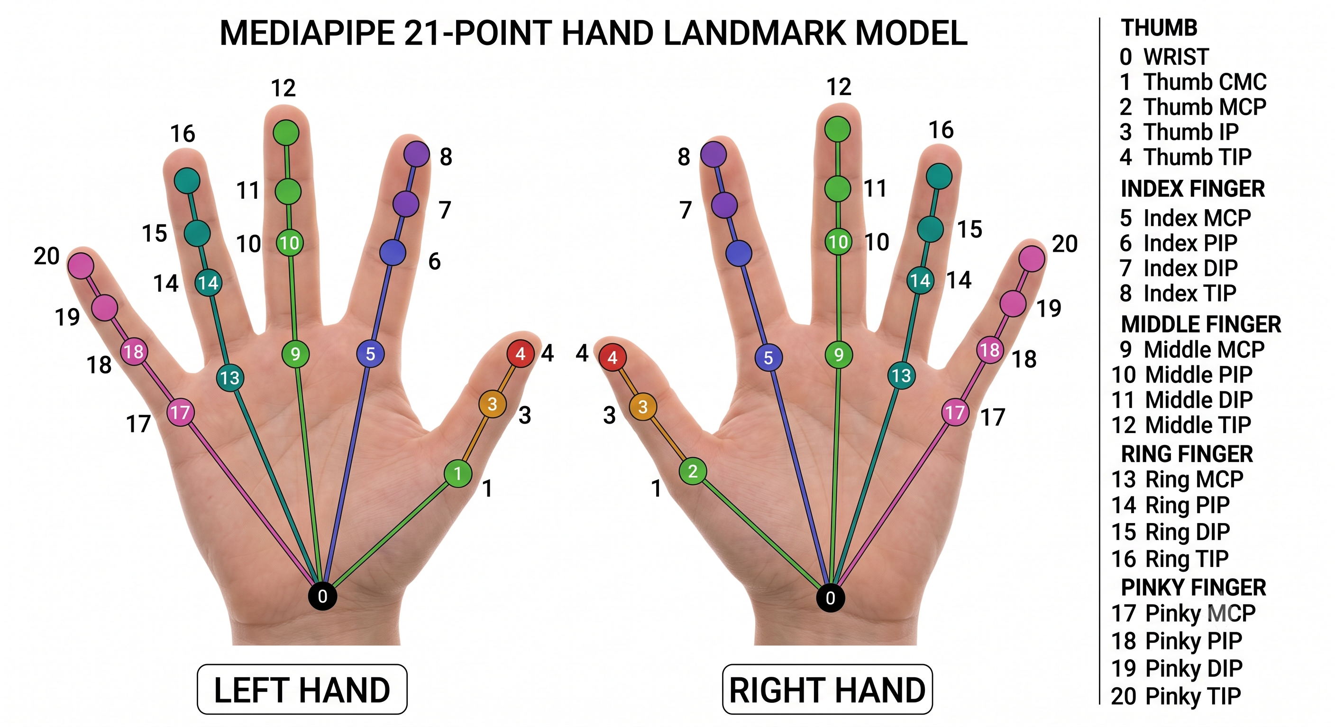

[IMAGE PLACEHOLDER]
Image Prompt: A diagram of the MediaPipe 21-point hand landmark model overlaid on a human hand. Each landmark should be numbered 0–20 with labels: 0=Wrist, 1–4=Thumb (CMC to TIP), 5–8=Index (MCP to TIP), 9–12=Middle, 13–16=Ring, 17–20=Pinky. Lines connect the landmarks following the hand skeleton connections. Show both left and right hands side by side.

Fig. 5.2: MediaPipe 21-Point Hand Landmark Model
Each hand produces 63 features (21 landmarks × 3 coordinates: x, y, z). With both hands combined, the feature vector has 126 dimensions. If only one hand is detected, the absent hand's features are zero-padded.

5.4 Feature Normalization
Raw landmark coordinates are screen-position-dependent and hand-size-dependent. To ensure the model generalizes across different users and hand positions, the following normalization is applied independently to each hand:
Step 1 — Position Invariance: Subtract the wrist position (landmark 0) from all 21 landmarks, making all coordinates relative to the wrist origin.
Step 2 — Scale Invariance: Divide all shifted coordinates by the maximum Euclidean distance from the wrist to any other landmark. This normalizes the hand to a unit scale regardless of physical hand size or camera distance.

5.5 Model Architectures

5.5.1 Static Model — Dense Neural Network
For static gestures (recognizable from a single frame), a fully-connected Dense Neural Network is used. The architecture consists of:
Layer | Output Shape | Parameters | Details
Input | (126,) | 0 | Normalized landmark features
Dense + ReLU | (256,) | 32,512 | Fully connected layer
BatchNormalization | (256,) | 1,024 | Normalizes activations
Dropout (0.3) | (256,) | 0 | Regularization
Dense + ReLU | (128,) | 32,896 | Fully connected layer
BatchNormalization | (128,) | 512 | Normalizes activations
Dropout (0.3) | (128,) | 0 | Regularization
Dense + ReLU | (64,) | 8,256 | Fully connected layer
BatchNormalization | (64,) | 256 | Normalizes activations
Dense + Softmax | (N,) | 325 | Output (N=5 classes)

Table 5.1: Static Model (Dense NN) Architecture — Total: 75,781 parameters

5.5.2 Dynamic Model — LSTM Network
For dynamic gestures involving hand movement over time, a Long Short-Term Memory (LSTM) network processes sequences of 30 consecutive frames (~1 second of video):
Layer | Output Shape | Details
Input | (30, 126) | 30 frames × 126 features per frame
LSTM (return_sequences=True) | (30, 128) | 128 hidden units, full sequence output
Dropout (0.3) | (30, 128) | Regularization
LSTM (return_sequences=False) | (64,) | 64 hidden units, final hidden state only
Dropout (0.3) | (64,) | Regularization
Dense + ReLU | (64,) | Fully connected layer
BatchNormalization | (64,) | Normalizes activations
Dense + ReLU | (32,) | Fully connected layer
Dense + Softmax | (N,) | Output (N=5 classes)

Table 5.2: Dynamic Model (LSTM) Architecture

5.6 Prediction Stabilization
To prevent flickering outputs caused by frame-to-frame prediction variance, a rolling buffer of 5 consecutive frames is maintained. A prediction is confirmed and spoken only when all 5 frames in the buffer agree on the same class with confidence exceeding the threshold (0.6). Additionally, a 1-second cooldown prevents rapid repetition of the same detected word.

5.7 Text-to-Speech Output
Confirmed predictions are converted to spoken English using the Windows Speech API (SAPI 5) via the win32com COM interface. The speech engine operates asynchronously, allowing the recognition pipeline to continue processing frames without blocking on speech synthesis. Detected words are also accumulated into a sentence buffer that the user can speak as a complete sentence on demand.

6. Results and Discussion

6.1 Dataset Summary
Training data was self-recorded using the system's data collection module. For each of the five gesture classes, 50 dynamic sequences of 30 frames each were captured, yielding approximately 1,500 usable frames per class.
Gesture | Type | Sequences | Frames/Sequence | Total Frames
Hello | Dynamic | 50 | 30 | ~1,500
Namaste | Dynamic | 50 | 30 | ~1,500
Bye | Dynamic | 50 | 30 | ~1,500
Thank You | Dynamic | 50 | 30 | ~1,500
Sorry | Dynamic | 50 | 30 | ~1,500
Total | — | 250 | — | ~7,500

Table 6.1: Dataset Summary

6.2 Static Model Results
The Dense Neural Network was trained on individual frames extracted from the dynamic sequences, augmented 3× with Gaussian noise, random scaling, and translation. The model achieved convergence at epoch 6 out of 50 (early stopping triggered at epoch 16) with the following per-class performance:
Class | Precision | Recall | F1-Score | Support
Bye | 0.99 | 1.00 | 0.99 | 899
Hello | 1.00 | 0.99 | 0.99 | 887
Namaste | 1.00 | 1.00 | 1.00 | 876
Sorry | 1.00 | 1.00 | 1.00 | 900
Thank You | 1.00 | 1.00 | 1.00 | 772
Overall Accuracy | — | — | 99.75% | 4,334

Table 6.2: Static Model Classification Report

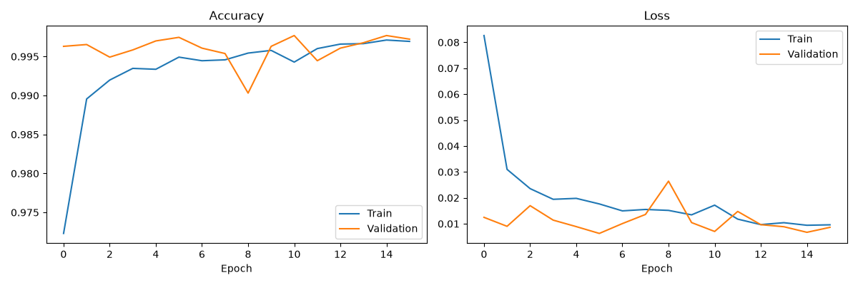
[IMAGE PLACEHOLDER]
Image Prompt: Insert the training history chart from models/training_history.png — two side-by-side line charts showing (1) Training Accuracy vs Validation Accuracy over epochs and (2) Training Loss vs Validation Loss over epochs. Both curves should converge and flatten, indicating good model convergence without overfitting.

Fig. 6.1: Static Model Training History (Accuracy and Loss Curves)

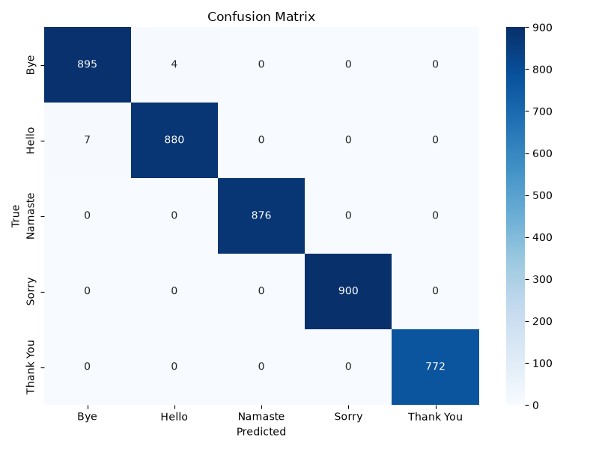

[IMAGE PLACEHOLDER]
Image Prompt: Insert the confusion matrix heatmap from models/confusion_matrix.png — a 5×5 heatmap with classes (Bye, Hello, Namaste, Sorry, Thank You) on both axes. The diagonal should be dark blue (high values) indicating correct predictions, with near-zero off-diagonal entries.

Fig. 6.2: Static Model Confusion Matrix

6.3 Dynamic Model Results (LSTM)
The LSTM network was trained on the original 30-frame sequences with normalized landmarks. The model trained for 100 epochs with the best weights restored from epoch 93. The dynamic model achieved perfect classification:
Class | Precision | Recall | F1-Score | Support
Bye | 1.00 | 1.00 | 1.00 | 10
Hello | 1.00 | 1.00 | 1.00 | 10
Namaste | 1.00 | 1.00 | 1.00 | 10
Sorry | 1.00 | 1.00 | 1.00 | 10
Thank You | 1.00 | 1.00 | 1.00 | 10
Overall Accuracy | — | — | 100.00% | 50

Table 6.3: Dynamic Model (LSTM) Classification Report

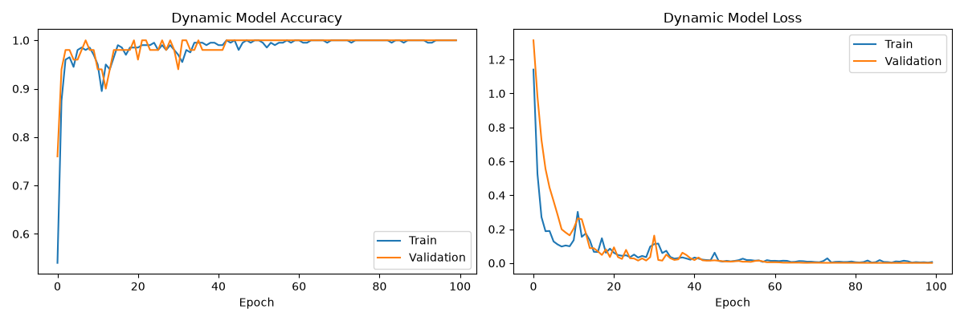

[IMAGE PLACEHOLDER]
Image Prompt: Insert the dynamic training history chart from models/dynamic_training_history.png — two side-by-side line charts showing Dynamic Model Accuracy and Dynamic Model Loss over ~100 epochs. Accuracy should quickly reach 1.0 and loss should decrease to near 0.
Fig. 6.3: Dynamic Model (LSTM) Training History

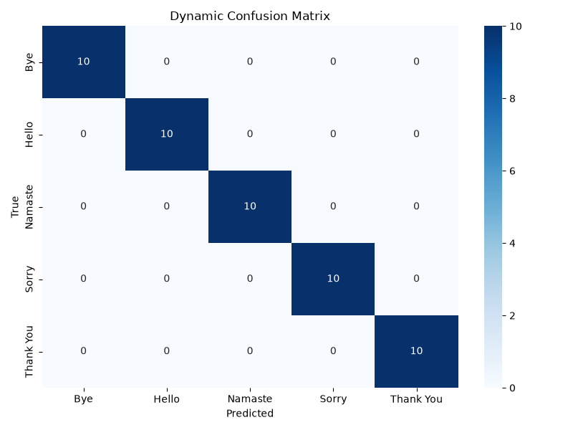
Fig. 6.4: Dynamic Model (LSTM) Confusion Matrix

6.4 Model Comparison
Property | Static Model (Dense NN) | Dynamic Model (LSTM)
Input | Single frame (126-D) | 30-frame sequence (30×126)
Architecture | Dense + BatchNorm + Dropout | LSTM + Dense + BatchNorm
Parameters | 75,781 (296 KB) | ~2.3 MB
Test Accuracy | 99.75% | 100.00%
Training Epochs | 16 (early stop) | 100 (best @ epoch 93)
Best For | Static hand poses | Motion-based gestures
Inference Speed | ~2 ms/frame | ~18 ms/sequence

Table 6.4: Comparison of Static vs Dynamic Model Performance

6.5 Discussion
Both models achieve near-perfect accuracy on the test dataset, which validates the effectiveness of the landmark-based feature extraction approach. The use of wrist-relative normalization successfully provides position and scale invariance, allowing the models to generalize across different hand placements within the camera frame.
The static model, while fast and lightweight (296 KB), is inherently limited to gestures that can be distinguished by hand shape alone. Gestures with similar hand shapes but different motions (e.g., Hello and Bye, which both involve an open palm) can cause confusion in static mode. The LSTM model resolves this by analyzing the temporal pattern of hand movement across 30 frames, providing superior discrimination for motion-based signs.
The high accuracy achieved with only 50 sequences per class (relatively small dataset) can be attributed to two factors: (1) the landmark-based representation significantly reduces input dimensionality compared to raw image pixels, and (2) the normalization step eliminates position and scale variability. However, the current dataset is signer-dependent (trained on a single user), and real-world deployment would require multi-signer data collection to improve generalization.
The text-to-speech integration using Windows SAPI 5 provides immediate audio feedback with minimal latency. The asynchronous speech synthesis ensures that the recognition pipeline is not blocked during speech output, maintaining real-time frame processing rates.

6.6 Limitations and Future Work
Current limitations include: (1) signer-dependent model requiring retraining for new users, (2) limited vocabulary of 5 words, (3) no support for continuous sentence-level sign language recognition, and (4) Windows-only deployment due to SAPI dependency. Future work will expand the vocabulary to the full planned 10-word set, introduce signer-independent training with multi-user datasets, integrate facial expressions and body pose for improved context, and explore cross-platform deployment using gTTS or similar platform-independent speech libraries.

References
[1] Khartheesvar, G., Kumar, M., Yadav, A. K., & Yadav, D. (2024). "Automatic Indian Sign Language Recognition using MediaPipe Holistic and LSTM Network." Multimedia Tools and Applications, Springer. DOI: 10.1007/s11042-023-17361-y
[2] "LiST: A Lightweight Framework for Continuous Indian Sign Language Translation." (2023). Information, MDPI, 14(2), 79. DOI: 10.3390/info14020079
[3] Kumari, D., & Anand, R. S. (2024). "Isolated Video-Based Sign Language Recognition Using a Hybrid CNN-LSTM Framework Based on Attention Mechanism." Electronics, MDPI, 13(7), 1229. DOI: 10.3390/electronics13071229
[4] Kothadiya, D., et al. (2022). "DeepSign: Sign Language Detection and Recognition Using Deep Learning." Electronics, MDPI, 11(11), 1780. DOI: 10.3390/electronics11111780
[5] "Real-Time Sign Language-to-Speech Translation System With AI-Powered Wearable Technology." (2025). IEEE Access. DOI: 10.1109/ACCESS.2025.3602794
[6] "Real-time Static and Dynamic Sign Language Recognition using Deep Learning." (2022). Journal of Scientific and Industrial Research, 81(11). DOI: 10.56042/jsir.v81i11.60865
[7] "Evaluation of Machine Learning Models for Real-Time Sign Recognition." (2021). IEEE Mysore Sub Section International Conference (MysuruCon). DOI: 10.1109/MysuruCon52639.2021.9641518
[8] "Indian Sign Language Recognition System Using SURF with SVM and CNN." (2023). Array, Elsevier. DOI: 10.1016/j.array.2023.100257

