EXPERIMENT NO. 1

Aim: Write a program to demonstrate Inter-process communication in Client Server Environment using gRPC/RMI .

Introduction
gRPC is defined by Google as a modern Remote Procedure Call (RPC) framework that can run in any environment. gRPC in principle enables client and server applications to communicate transparently, and makes it easier to build connected systems.gRPC clients and servers can run and talk to each other in a variety of environments - from servers inside Google to your own desktop - and can be written in any of gRPC’s supported languages. So, for example, you can easily create a gRPC server in Java with clients in Go, Python, or Ruby. In addition, the latest Google APIs will have gRPC versions of their interfaces, letting you easily build Google functionality into your applications

Q1. What is the need for client and server stub?
Ans: Client and server stubs act as intermediaries between the application and the RPC framework. They hide networking details like message formatting, serialization, and communication. This allows remote method calls to appear like local function calls.
Q2. How are call by value and call by reference implemented in RPC? (Design)
Ans: Call by value is implemented by serializing and sending a copy of the data to the server. Call by reference is simulated by passing an object identifier or remote reference, allowing the server to invoke methods on the original object remotely.
Q3. How is an object passed as reference in RMI? (Justify)
Ans: In RMI, objects are passed by reference if they implement the Remote interface. The JVM passes a stub (remote reference) instead of the actual object, enabling remote method invocation on the same object.
Q4. What is lightweight RPC? What is callback RPC? (Design)
Ans: Lightweight RPC minimizes overhead by using simpler protocols and reduced processing, suitable for high-performance systems. Callback RPC allows the server to invoke a method on the client, enabling asynchronous communication.
Q5. What are the call semantics of RPC?
Ans: RPC call semantics define how failures are handled, such as at-most-once, at-least-once, and exactly-once. These semantics ensure predictable behavior during retries and failures.

Q6. How is failure handled in RPC?
Ans: RPC handles failures using timeouts, retransmissions, and exception handling. The client is notified of communication or server failures through error codes or exceptions.

- documentation: https://grpc.io/docs/languages/python/quickstart/
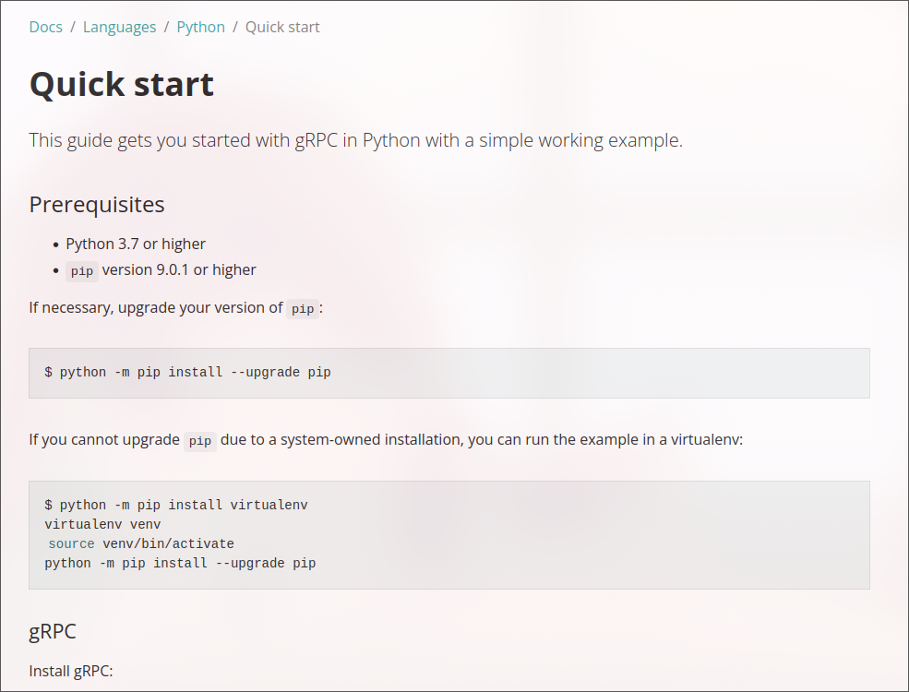

2. Python and pip version
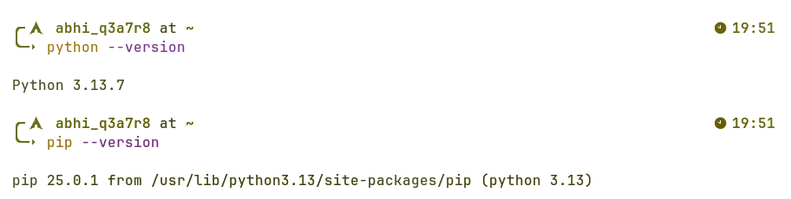3. Installing Libraries
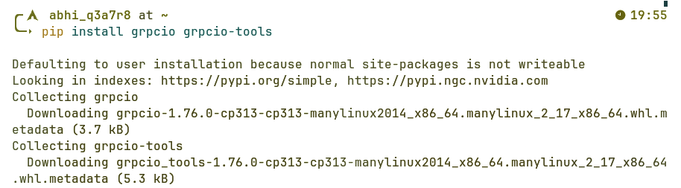

4. Cloning the git repository as given in the documentation.
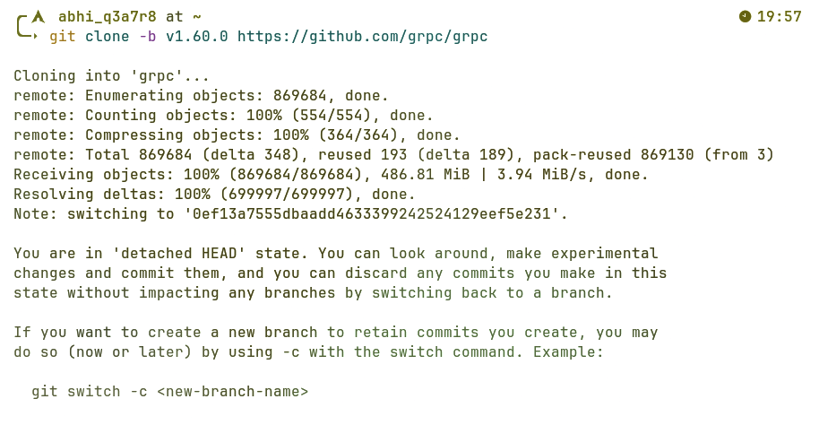

5. Making changes to the greeter_server.py and customize the output (return message in class Greeter).
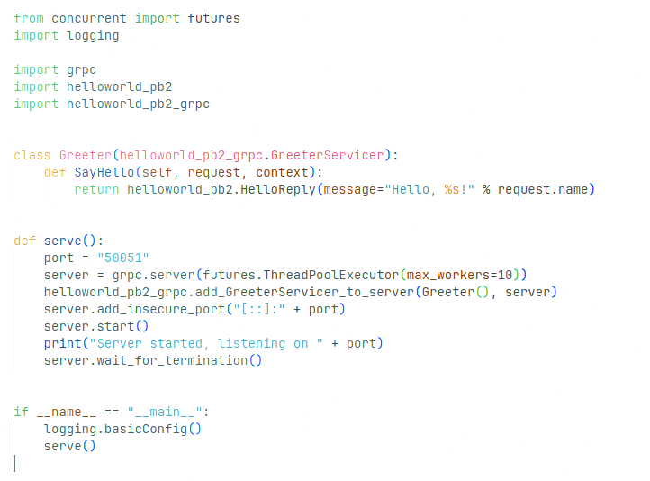

6. Saving changes and restarting server
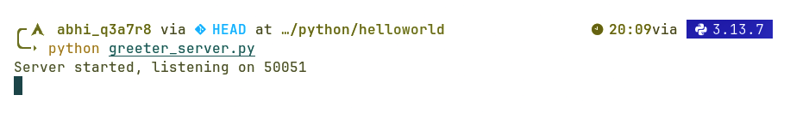
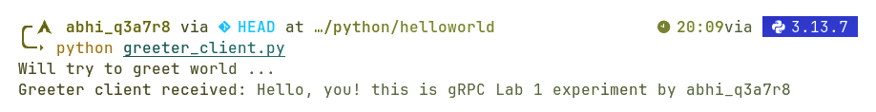

Conclusion:
Thus, the concept of Inter-Process Communication (IPC) using Remote Procedure Call (RPC) was successfully understood and implemented. A client–server application using Unary gRPC was developed, demonstrating seamless communication between distributed processes. The experiment helped in understanding service definition, request–response interaction

