3_visualization.r

abhia

2019-11-13

fifa = read.csv("1_cleaned_data.csv")  
library(ggplot2)  
theme_set(theme_classic())  
options(scipen = 999)  
  
# BOXPLOT OF AGE VS POSITION  
print(ggplot(fifa, aes(Position, Age)) + geom_boxplot(varwidth=T, fill="plum") + labs(title="Box plot",   
 subtitle="Age"))

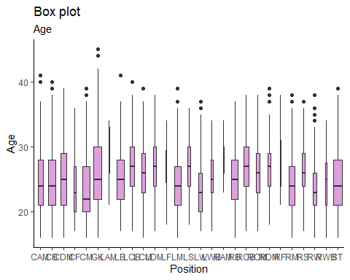

# BOXPLOT OF AGE VS PREFERRED FOOT  
print(ggplot(fifa, aes(Preferred.Foot, Age)) + geom_boxplot(varwidth=T, fill="plum") + labs(title="Box plot",subtitle="Age"))

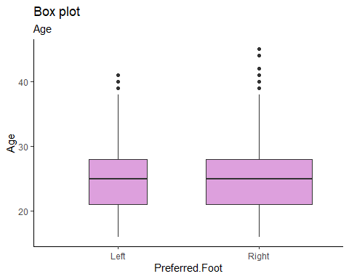

# FREQUENCY GRAPH FOR PREFFERED FOOT  
library("ggpubr")

## Loading required package: magrittr

print(ggplot(fifa, aes(Preferred.Foot)) +geom_bar(fill = "#0073C2FF") +theme_pubclean())

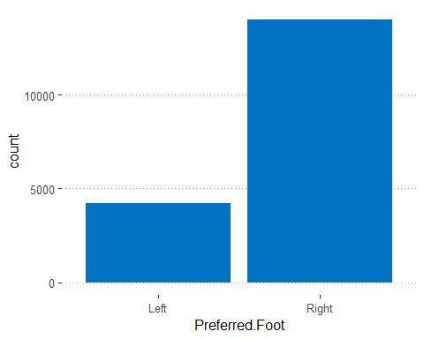

# FREQUENCY GRAPH FOR POSITION  
print(ggplot(fifa, aes(Position)) +geom_bar(fill = "#0073C2FF") +theme_pubclean())

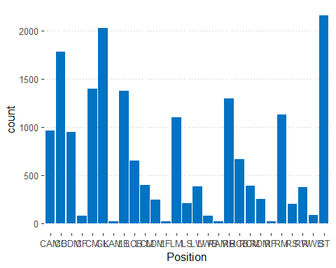

# HISTOGRAM ON JERSEY NUMBER  
ggplot(fifa, aes(x=Overall)) + geom_histogram(binwidth=1, color="black", fill="white")

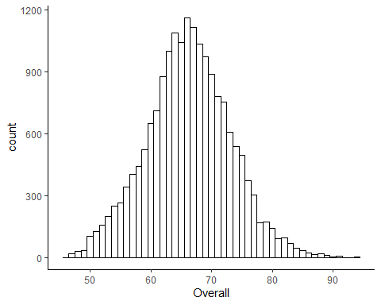

# DENSITY PLOT OF AGE  
print(ggplot(fifa, aes(x=Age)) + geom_density()+geom_vline(aes(xintercept = mean(Age)),color="blue", linetype="dashed", size=1))

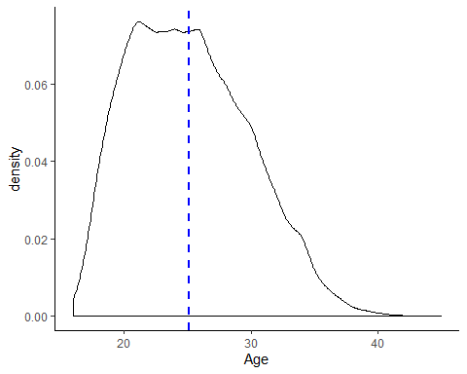

#SCATTER PLOT FOR HEIGHT VS WEIGHT  
print(ggplot(fifa, aes(x=Height, y =Weight)) + geom_point() + geom_smooth(method = lm))

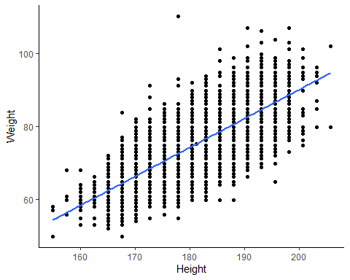

print(ggplot(fifa, aes(x=Height, y =Weight)) + geom_bin2d()+geom_smooth(method = lm))

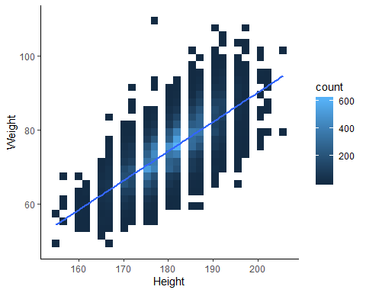

#SCATTER PLOT FOR OVERALL VS WAGE  
print(ggplot(fifa, aes(x=Overall, y =Wage)) + geom_jitter()+geom_smooth()) +theme_cleveland()

## `geom_smooth()` using method = 'gam' and formula 'y ~ s(x, bs = "cs")'

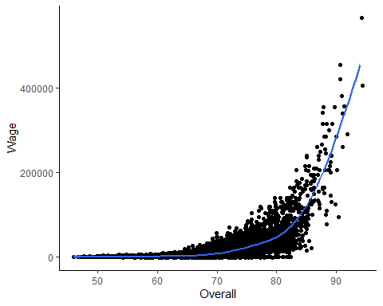

## `geom_smooth()` using method = 'gam' and formula 'y ~ s(x, bs = "cs")'

