4_correlation.r

abhia

2019-11-13

fifa = read.csv("1_cleaned_data.csv")  
options(scipen = 999)  
library("GGally")

## Loading required package: ggplot2

## Registered S3 method overwritten by 'GGally':  
## method from   
## +.gg ggplot2

#HEAT MAP  
print(ggcorr(fifa))

## Warning in ggcorr(fifa): data in column(s) 'Name', 'Nationality', 'Club',  
## 'Preferred.Foot', 'Body.Type', 'Position' are not numeric and were ignored

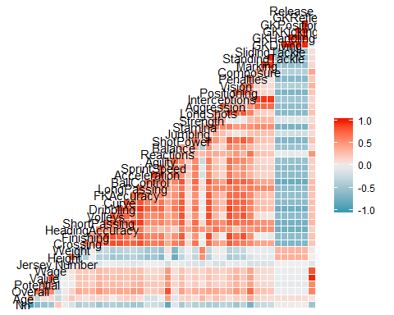

#SCATTER PLOT  
print(ggplot(fifa, aes(x=Release.Clause, y =Value)) + geom_jitter()+geom_smooth(method = lm))

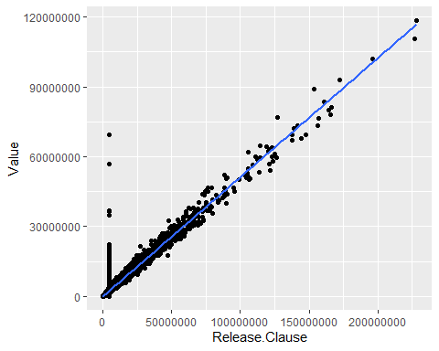

#PEARSON CORRELATION COEFFICIENT  
print(cor(fifa$Release.Clause,fifa$Value, method = "pearson", use = "complete.obs"))

## [1] 0.9720409

#PEARSON TEST FOR ASSOCIATION/CORRELATION BETWEEN SAMPLES  
print(cor.test(fifa$Release.Clause,fifa$Value, method="pearson"))

##   
## Pearson's product-moment correlation  
##   
## data: fifa$Release.Clause and fifa$Value  
## t = 558.53, df = 18204, p-value < 0.00000000000000022  
## alternative hypothesis: true correlation is not equal to 0  
## 95 percent confidence interval:  
## 0.9712286 0.9728307  
## sample estimates:  
## cor   
## 0.9720409

#KENDALL CORRELATION COEFFICIENT  
print(cor(fifa$Release.Clause,fifa$Value, method = "kendall", use = "complete.obs"))

## [1] 0.8243123

#KENDALL TEST FOR ASSOCIATION/CORRELATION BETWEEN SAMPLES  
print(cor.test(fifa$Release.Clause,fifa$Value, method="kendall"))

##   
## Kendall's rank correlation tau  
##   
## data: fifa$Release.Clause and fifa$Value  
## z = 165.09, p-value < 0.00000000000000022  
## alternative hypothesis: true tau is not equal to 0  
## sample estimates:  
## tau   
## 0.8243123

#SPREARMAN CORRELATION COEFFICIENT  
print(cor(fifa$Release.Clause,fifa$Value, method = "spearman", use = "complete.obs"))

## [1] 0.9002106

#SPEARMAN TEST FOR ASSOCIATION/CORRELATION BETWEEN SAMPLES  
print(cor.test(fifa$Release.Clause,fifa$Value, method="spearman"))

## Warning in cor.test.default(fifa$Release.Clause, fifa$Value, method =  
## "spearman"): Cannot compute exact p-value with ties

##   
## Spearman's rank correlation rho  
##   
## data: fifa$Release.Clause and fifa$Value  
## S = 100363716365, p-value < 0.00000000000000022  
## alternative hypothesis: true rho is not equal to 0  
## sample estimates:  
## rho   
## 0.9002106