PROJECT PLAN

## Project ID: I9

## Project Title: Online consultations and appointments(Practo)

## SRN And Names of team members:

PES1201800791: Surya Saveri Susarla

PES1201801776: Savita Gunaki

PES1201902400: Vaishnavi C

### **PROJECT LIFE CYCLE:**

* Waterfall Model
* For the development of any model we should have to follow the well scheduled path, which is known as Model
* Nowadays , many life cycle models are there , but according to our project and user convenience we are choosing the waterfall model. Here are some reasons to choose this model.
* At every phase there is provision of verification and validation , corrections of errors and inconsistencies , all the requirements are gathered once as done in this online consultation and appointment system.
* According to this model every stage is finished when the previous stage is finished, so we have prepared all stages as analysis ,designing , coding, and then finally development.
* This project consists of a linear set of distinct phases and every phase has its well defined entry and exit criteria .
* This model is cheap and easy to understand and it provides the proper feedback , to minimize the work again.This is achieved through the process of review and documentation
* This model is easy to explain to the other users too , stages and activities are well defined and the verification at each stages ensures early detection of errors or misunderstanding

### **TOOLS REQUIRED:**

|  |  |
| --- | --- |
| **Phases** | **Tool** |
| Planning tool | Google Sheet, Microsoft project and Redmine |
| Design tool | Figma is a free browser-based UI and UX design application ,with excellent design prototyping and code generation tool. |
| Version control | Git is the most used tool in view of features like forking, branching etc. |
| Development tool | Front End   * HTML * CSS * Java Script   Backend   * Server-Apache web server * Database - MySQL   IDE   * Visual Studio Code |
| Bug tracking | Bugzilla tool is used for tracking the bugs, it is a flexible tool with access control mechanisms.  Red mine, it is an open source tool used for bug tracking, it supports multiple databases while reporting. |
| Testing tool | Apache JMeter, which is used for testing and measuring the performance of HTTP web servers hosting the web applications.  Selenium, is an open source testing tool which facilitates automated web testing across web browsers. It is integrated with the python framework which is used for creation of test suites. |

### **WORK BREAKDOWN STRUCTURE:**

For our app, we plan to build a website where patients can consult doctors online book appointments and even order medicines online. The below flowchart will tell the deliverables needed to complete the project.

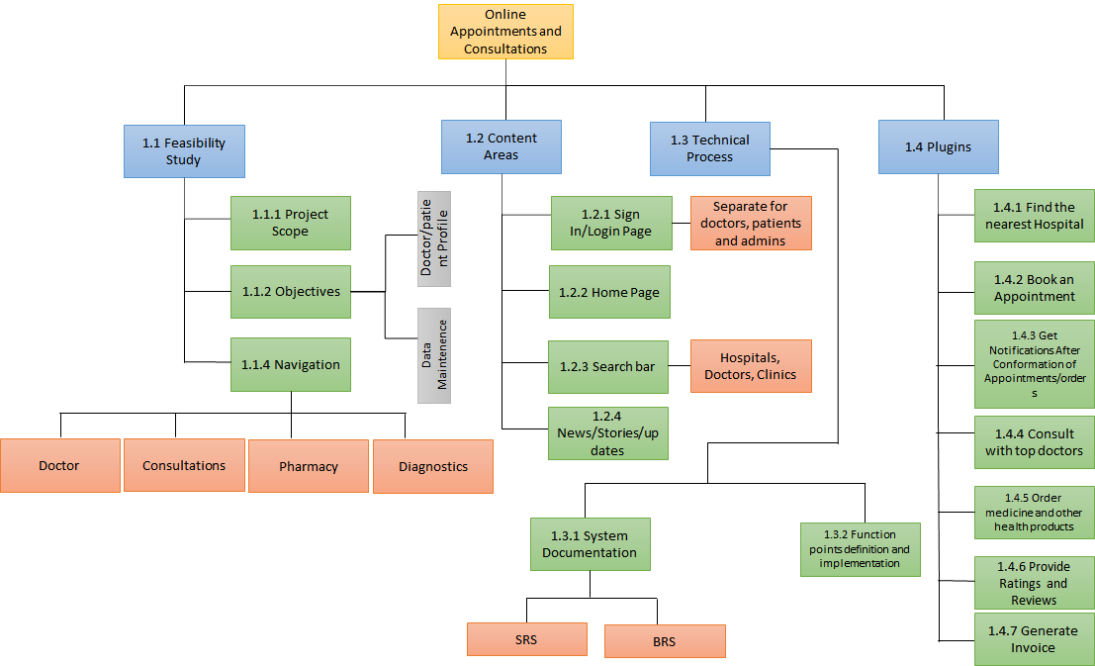

### **DELIVERABLES:**

|  |  |  |  |
| --- | --- | --- | --- |
| Sl No. | Deliverables | Reuse/Build | Justification |
| 1. | SRS (Software Requirement Specification) Document | Build | The SRS document gives a brief description of the software. Which is written, which will give the specifications and the requirements for our project. |
| 2. | Planning | Build | A specific planning has to be done in order to build the software. |
| 3. | Architecture of the software | Build | The software architecture has to be designed and built according to the requirements specified in the SRS document. |
| 4. | Wireframes | Build | The wireframes or the framework of our project website has to be built according to the SRS document requirements. |
| 5. | Database system | Build | The database is built for storing the patient details, doctor’s information and for other information is required. |
| 6. | Recommendation System | Reuse | For recommending the specialized doctors to the patients, we use existing systems or software. |
| 7. | User Interface | Build | The user interface for login, home page and other web pages have to be built from scratch. |

### **TASKS DONE BY EACH PERSON:**

Cocomo(Constructive Cost Model) It is a registration model based on Line Of Code. It is a procedural cost estimate model used for software projects and often used as a process of reliably predicting the various parameters related with making a project such as size, cost, effort, time and quality.

The project falls under the organic model, where the team size is small, the problem statement has been solved in the past and is well understood and also the team members have a nominal experience regarding the problem.

1. Feasibility study and requirements specifications

1.1 The estimation in feasibility study

Effort - 30%

Months - 1

Whereas the person months is 0.3 * 1 = 0.3

1.2 The estimation in requirements specifications

Effort - 30%

Months - 1

Whereas the person months is 0.3 * 1 = 0.3

1. Planning Phase

2.1 The estimation in Planning Phase is

Effort - 20%

Months - 1

Person months - 0.2

1. Design Phase

3.1 The estimation in design Phase is

Effort - 30%

Months - 1

Whereas the person months is 0.3 * 1 = 0.3

1. Implementation Phase

4.1 Developing User Interface

Effort - 20%

Months - 2

Person months - 0.4

4.2 Developing Database

Effort - 20%

Months - 0.5

Person months - 0.1

Formula:

For the project we will take Kilo Lines Of Code as 1.5

Effort(E) = a*(KLOC)^b

Time = c*(Effort)^d

After substituting the Kilo Lines Of Code = 1.5 in the formula for basic COCOMO model we get,

a= 2.4

b=1.05

c=2.5

d=0.38

Effort in terms of person months is 4.96

Time= 4.56 months

Person Required = Effort/ Time = 1

### **GANTT CHART FOR SCHEDULING THE DEFINED TASKS:**

|  |  |  |  |  |  |  |  |  |  |  |  |
| --- | --- | --- | --- | --- | --- | --- | --- | --- | --- | --- | --- |
| Tasks | W2 | W3 | W4 | W7 | W8 | W9 | W10 | W11 | W12 | W13 | W14 |
| SRS Format |  |  |  |  |  |  |  |  |  |  |  |
| Project Planning |  |  |  |  |  |  |  |  |  |  |  |
| Design and Coding |  |  |  |  |  |  |  |  |  |  |  |
| Implementation |  |  |  |  |  |  |  |  |  |  |  |
| Testing |  |  |  |  |  |  |  |  |  |  |  |