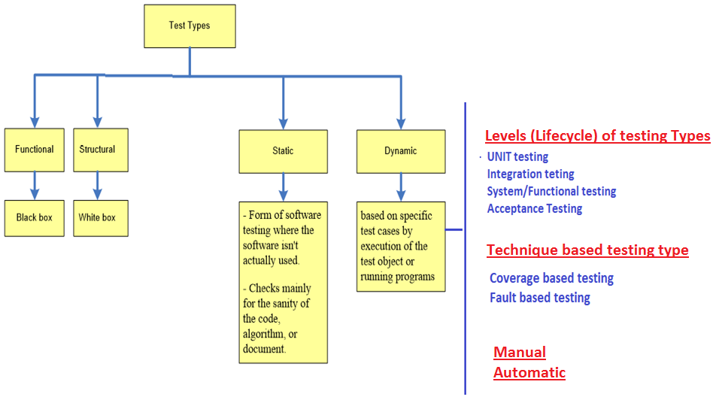

All testing are done manually with no automated testing engine

# Management of Appointment

# Recommend Doctors based on Symptoms specified

## If the user has logged in, then no catalog/menu must be shown

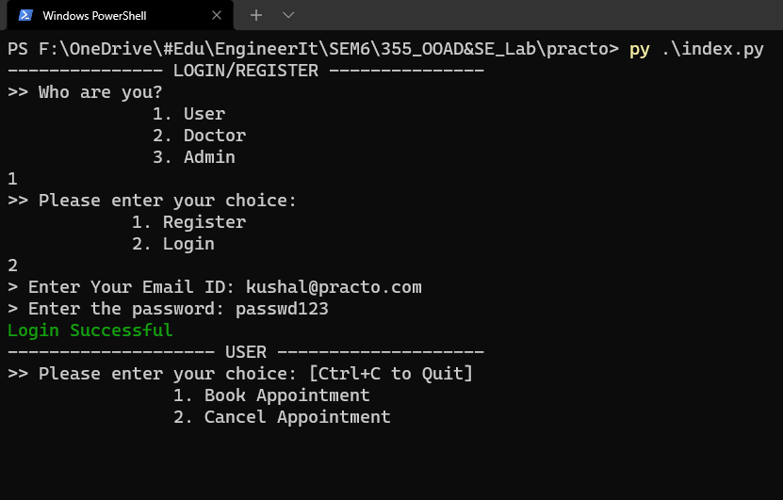

Figure - if login was successful

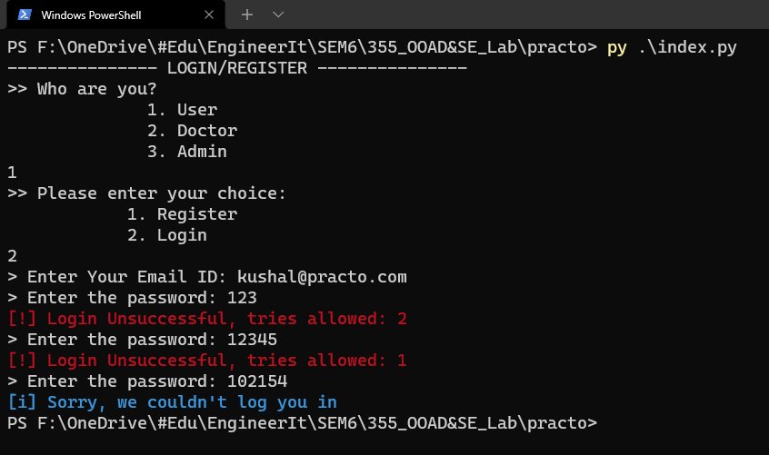

Figure - without login

## Problem cannot be empty

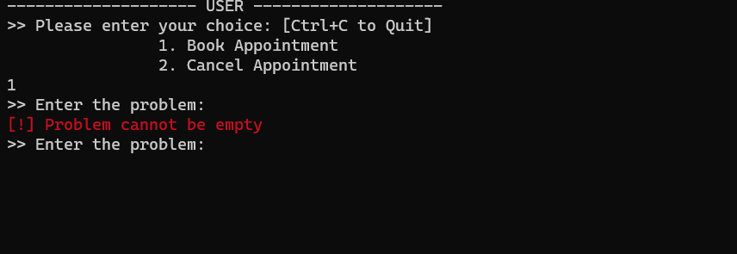

# Suppose Given problem which requires specific specialization has no doctor, then send him to general doctor

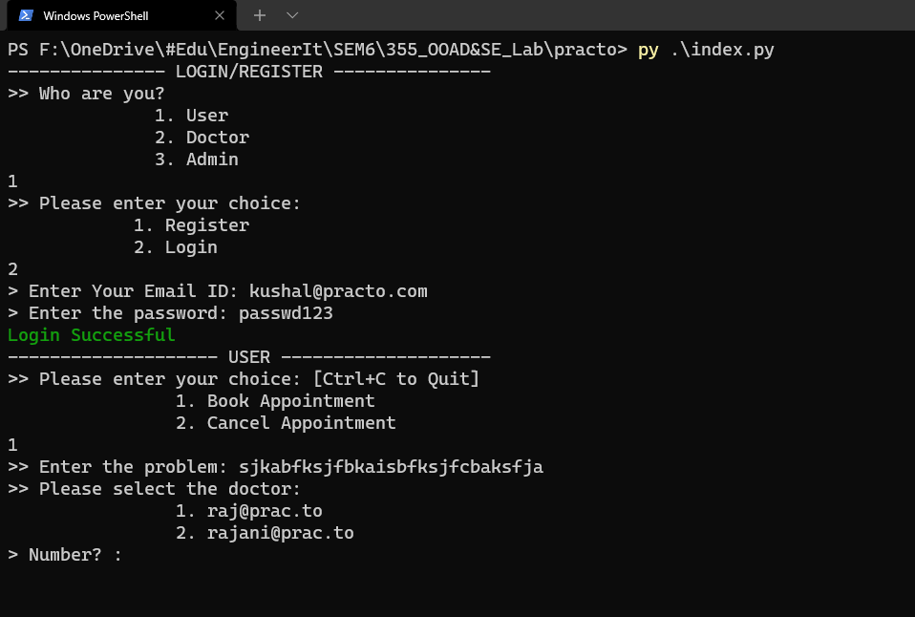

This requires NLP, but we just coded using regex.

# Ranfe

# Send Email Remainders