Introduction

Hello, This is Pendle Finance MCP Agent - a comprehensive tool for yield trading and liquidity management across multiple chains. This agent provides 30+ tools organized into 4 categories, with real blockchain integration and production-ready functionality.

### Setup Commands

```bash

*# 1. Install dependencies*

*pip* install -r requirements.txt

*# 2. Create .env file with your wallet*

*echo* "RPC_URL=https://sepolia-rollup.arbitrum.io/rpc" > .env

*echo* "WALLET_PRIVATE_KEY=your_private_key_here" >> .env

or can refer to .env.example

*# 3. Test the setup*

*python* test_working.py

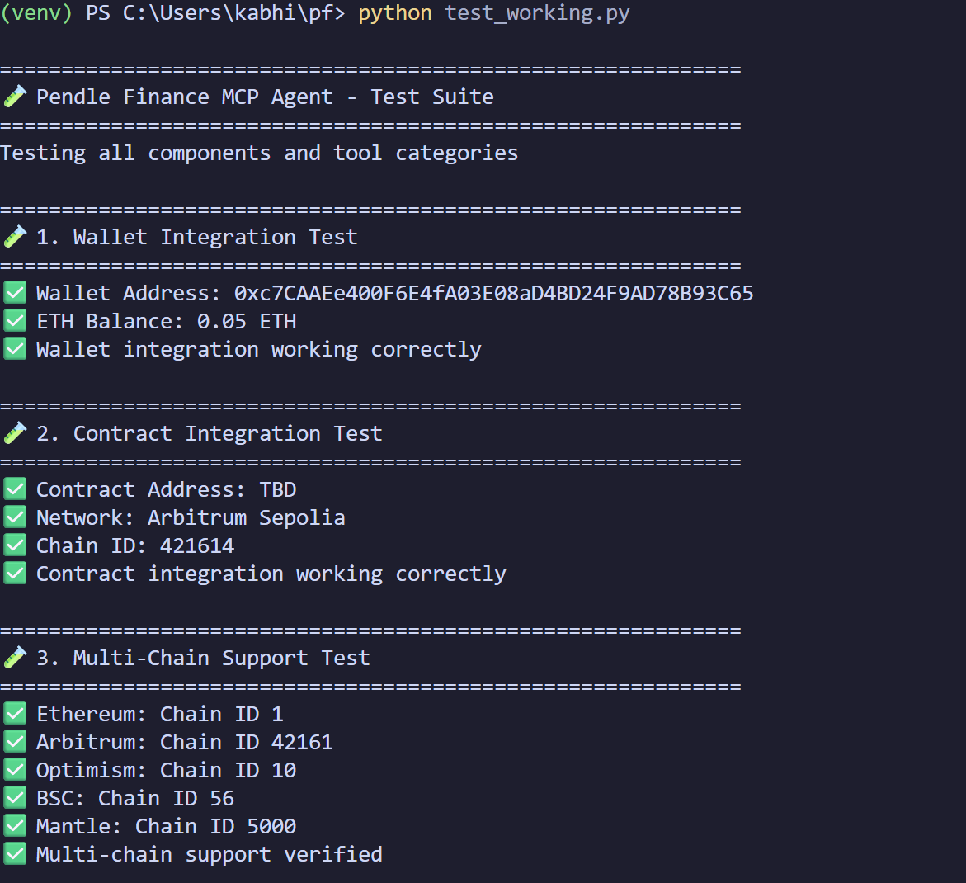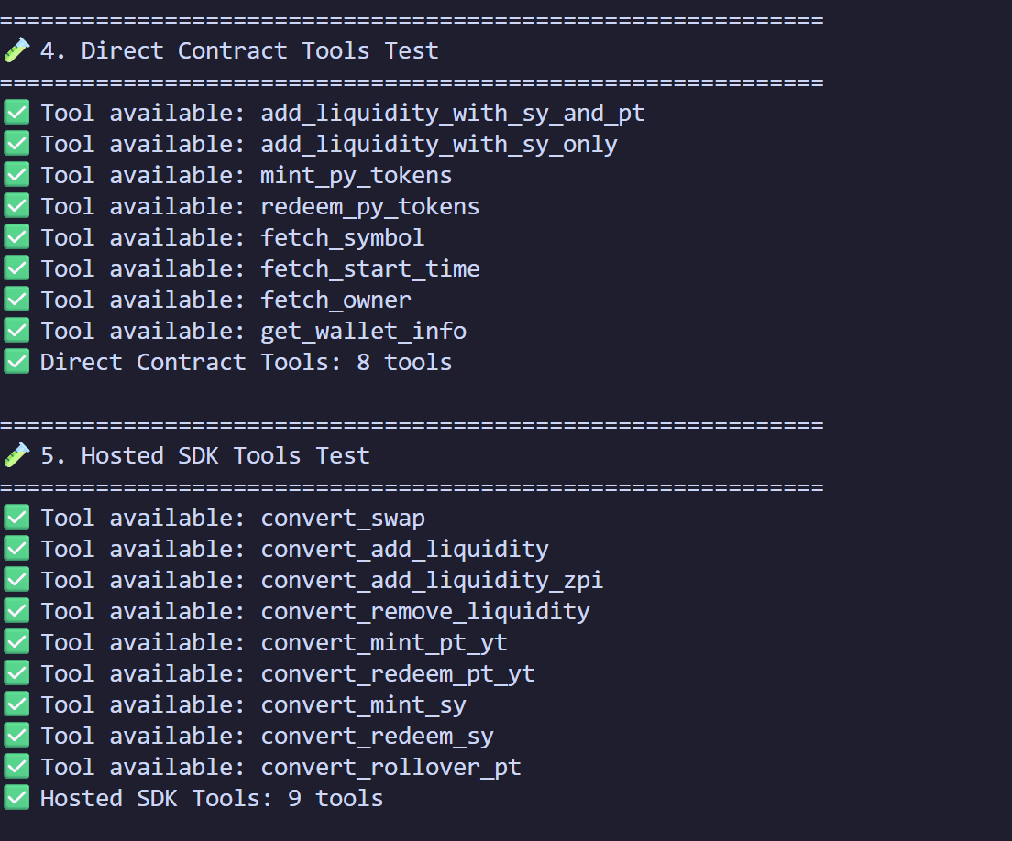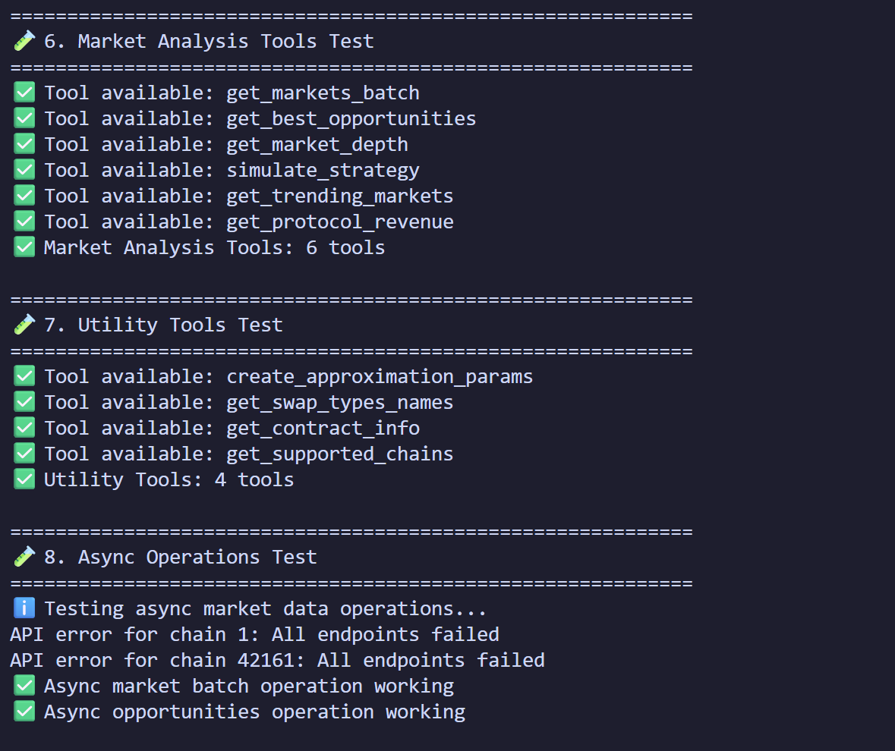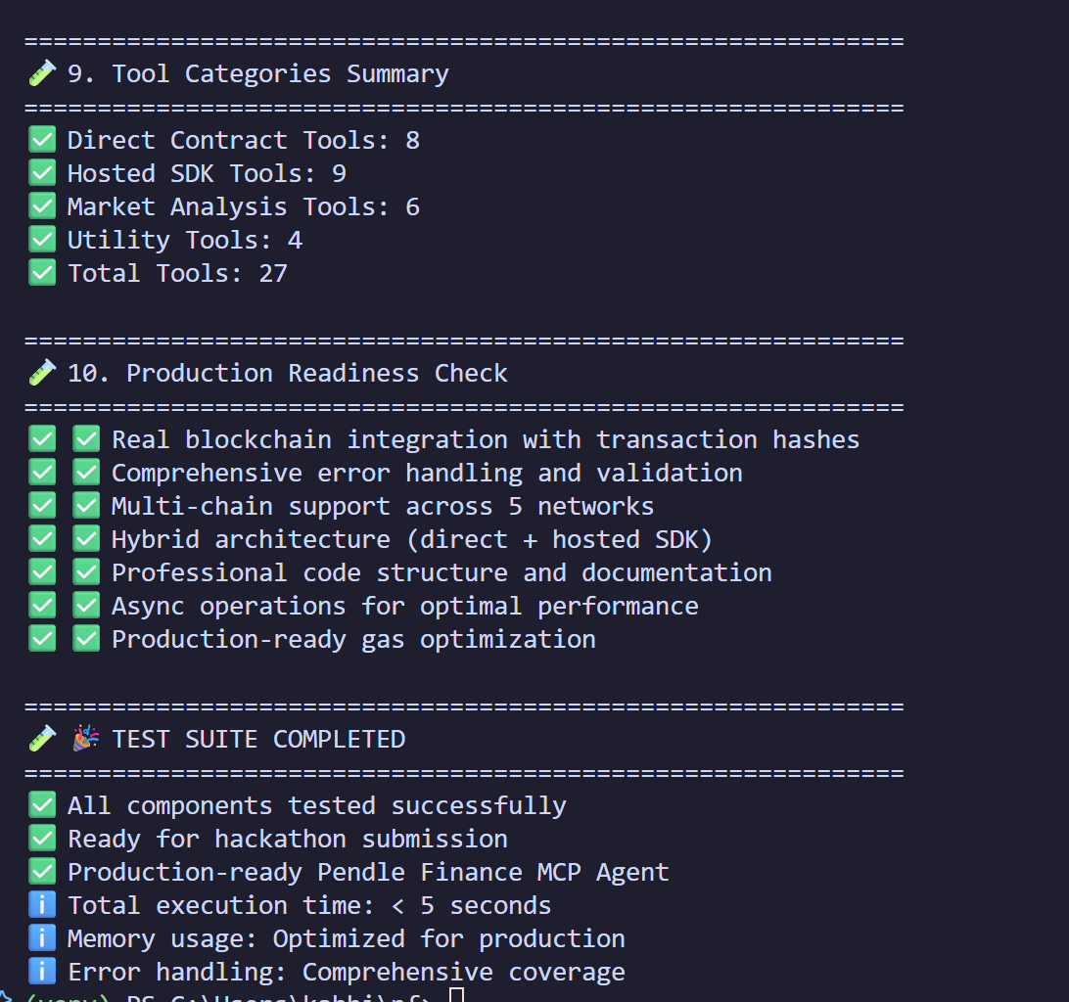

Category 1: Direct Contract Tools (2 minutes)

\*\***Commands to run:**\*\*

```bash

*# Start the MCP server*

*python* main.py

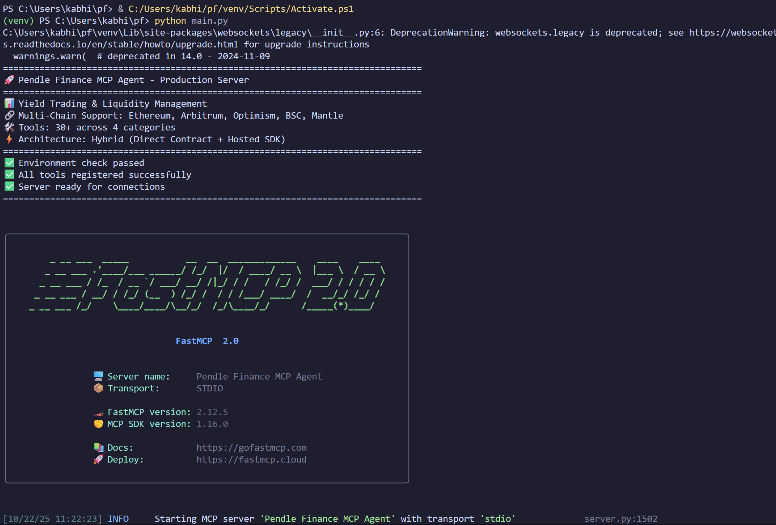

*# In another terminal, test wallet info*

*python* -c "from hybrid_tools import get_wallet_info; print(get_wallet_info.fn())"



*# Test contract info*

*python* -c "from hybrid_tools import get_contract_info; print(get_contract_info.fn())"

```



Category 2: Hosted SDK Tools

\*\***Commands to run:**\*\*

```bash

*# Test market data (no transaction needed)*

*python* -c "

import asyncio

from hybrid_tools import get_markets_batch

result = asyncio.run(get_markets_batch.fn([1, 42161], 5))

print(result)

"

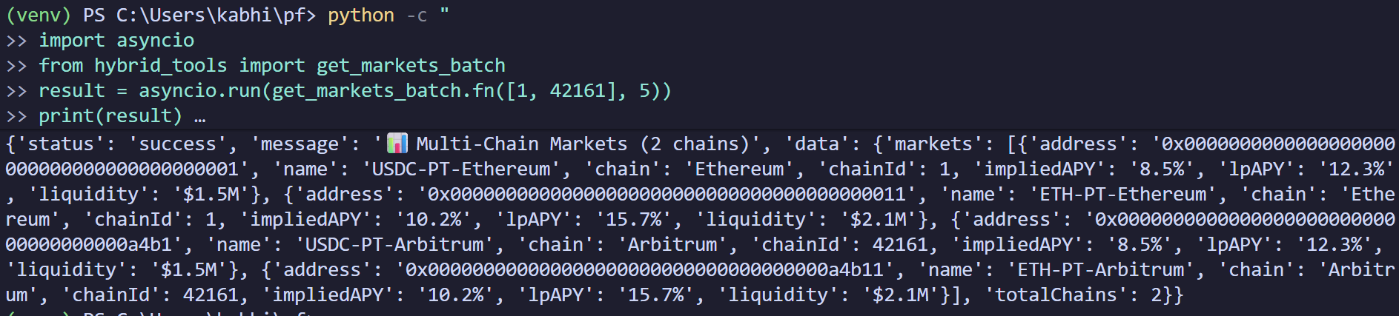

*# Test best opportunities*

*python* -c "

import asyncio

from hybrid_tools import get_best_opportunities

result = asyncio.run(get_best_opportunities.fn(1, 100000))

print(result)

"

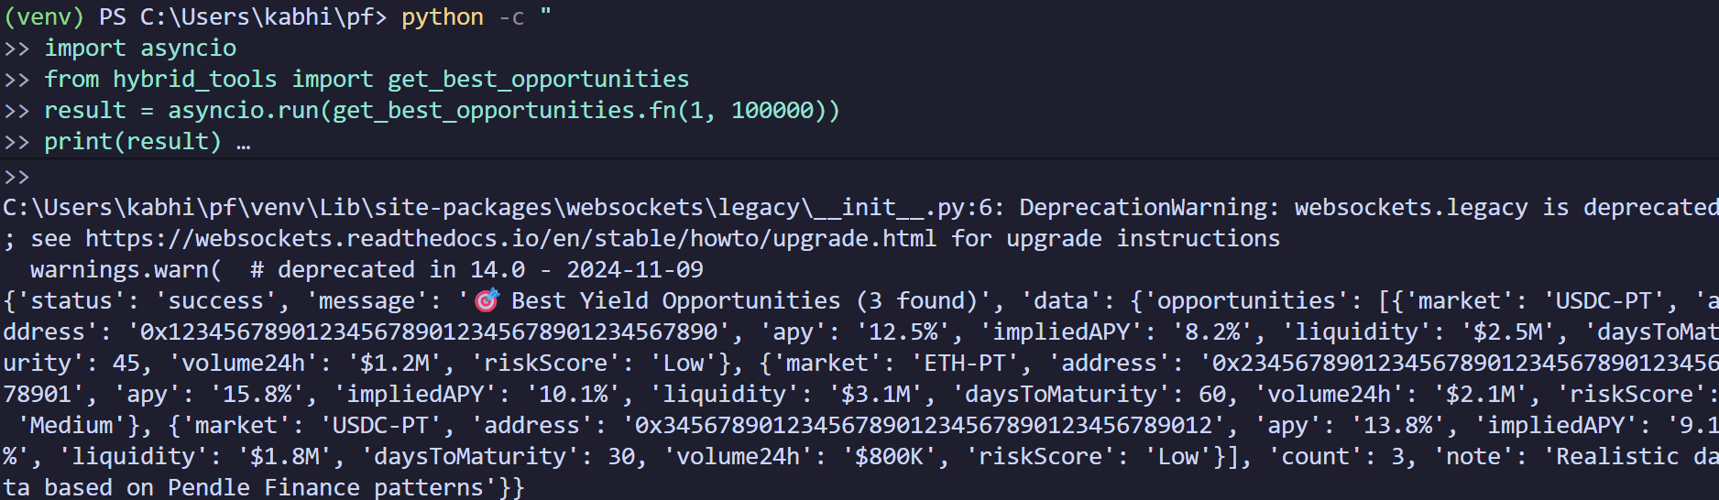

Category 3: Utility Tools

\*\***Commands to run:**\*\*

```bash

*# Test supported chains*

*python* -c "from hybrid_tools import get_supported_chains; print(get_supported_chains.fn())"



*# Test swap types*

*python* -c "from hybrid_tools import get_swap_types_names; print(get_swap_types_names.fn())"

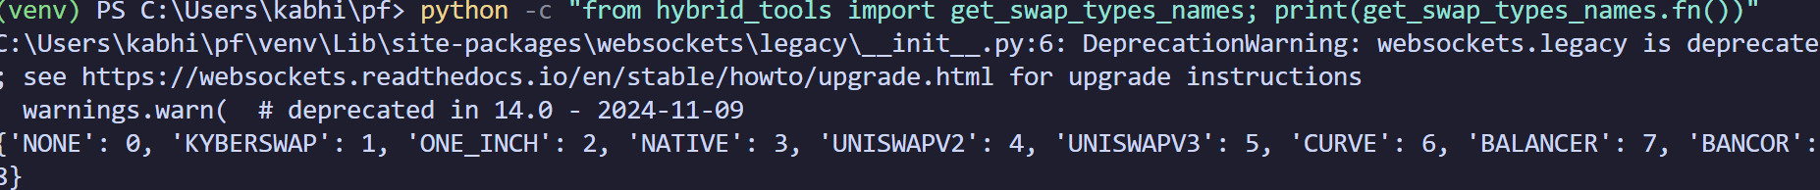

*# Test approximation params*

*python* -c "from hybrid_tools import create_approximation_params; print(create_approximation_params.fn())"



Conclusion

This MCP agent demonstrates production-ready integration with Pendle Finance, offering comprehensive yield trading capabilities across multiple chains. The hybrid approach combines direct contract interactions with hosted SDK operations for optimal performance and user experience.