Introduction to Tableau and Data Visualization – Assignment

Question 1: What is Tableau? Explain its importance in Business Intelligence and how it helps in data-driven decision-making.

Tableau is a powerful data visualization and business intelligence tool that helps users analyze, visualize, and understand data through interactive dashboards and reports. It enables organizations to transform raw data into meaningful insights, track KPIs, and support faster data-driven decisions.

Question 2 : Explain the role of the following Tableau components: a) Data Pane b) Worksheet c) Dashboard d) Story

Answer - Data Pane: Displays dimensions and measures from the data source.

Worksheet: Used to create individual visualizations.

Dashboard: Combines multiple worksheets into one interactive view.

Story: Presents insights in a narrative format.

Question 3: What is the difference between Dimensions and Measures in Tableau? Provide examples of each.

Answer - Dimensions are qualitative fields like Country and Product, while Measures are quantitative fields such as Sales and Profit that can be aggregated.

Question 4 : Define and explain the purpose of Filters, Parameters, and Sets in Tableau.

Answer - Filters limit data, Parameters allow dynamic user input, and Sets define subsets of data.

Question 5 : Create a bar chart showing Gross Sales by Country. ● 🔗 Dataset Link:Global_sales_dataset ● Sort the countries in descending order of sales ● Highlight or annotate the bar that represents the maximum and minimum Gross Sales. ● Add data labels and format the chart for presentation.
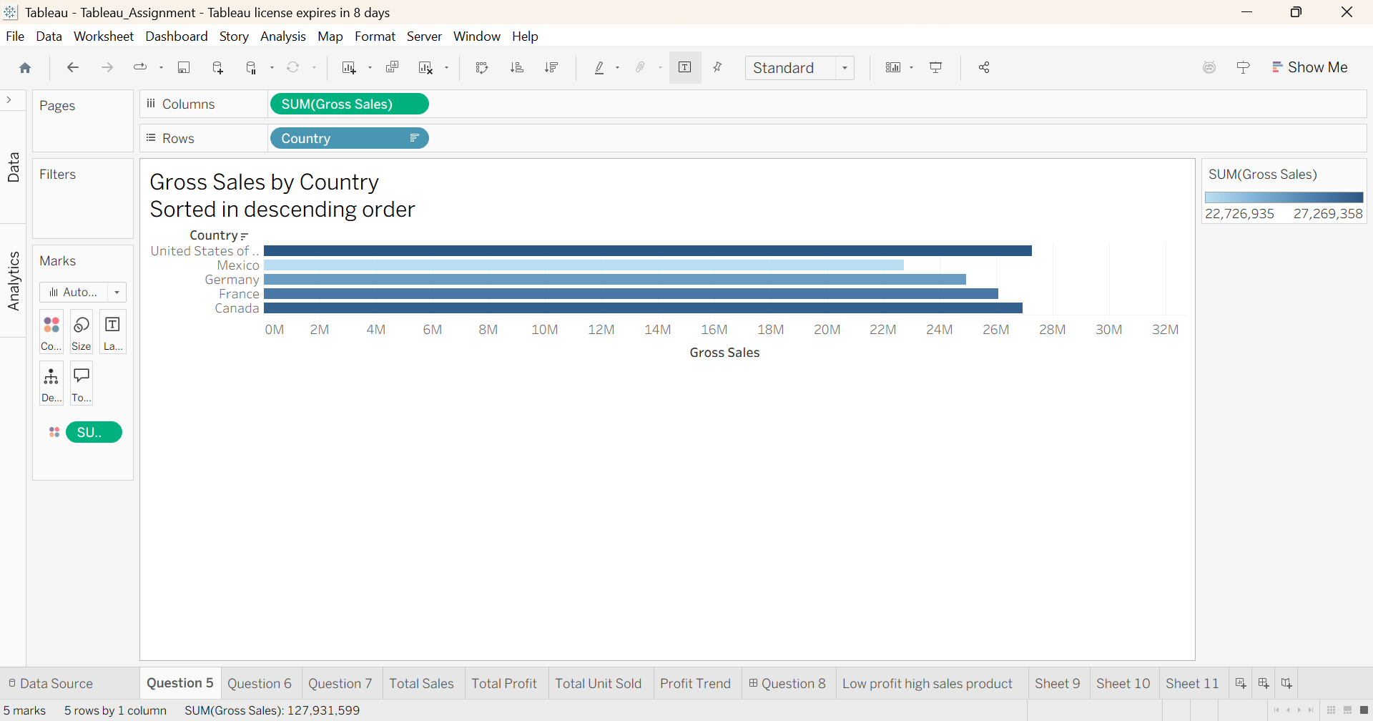
A bar chart was created to visualize Gross Sales by Country. The countries were sorted in descending order based on total Gross Sales to identify top and bottom performers. Data labels were added for clarity, and formatting was applied to enhance readability. The country with maximum and minimum Gross Sales was highlighted for easy comparison.

Question 6 Using Tableau, create a dual-axis chart that displays: ● 🔗 Dataset Link:Global_sales_dataset ● Monthly Sales as bars ● Monthly Profit as a line ● Filter the data to include only records from the year 2014 ● Ensure both axes are synchronized and properly labeled ● Add an appropriate chart title, and format the chart for clear visual presentation ● Paste a screenshot of the final chart in your submission

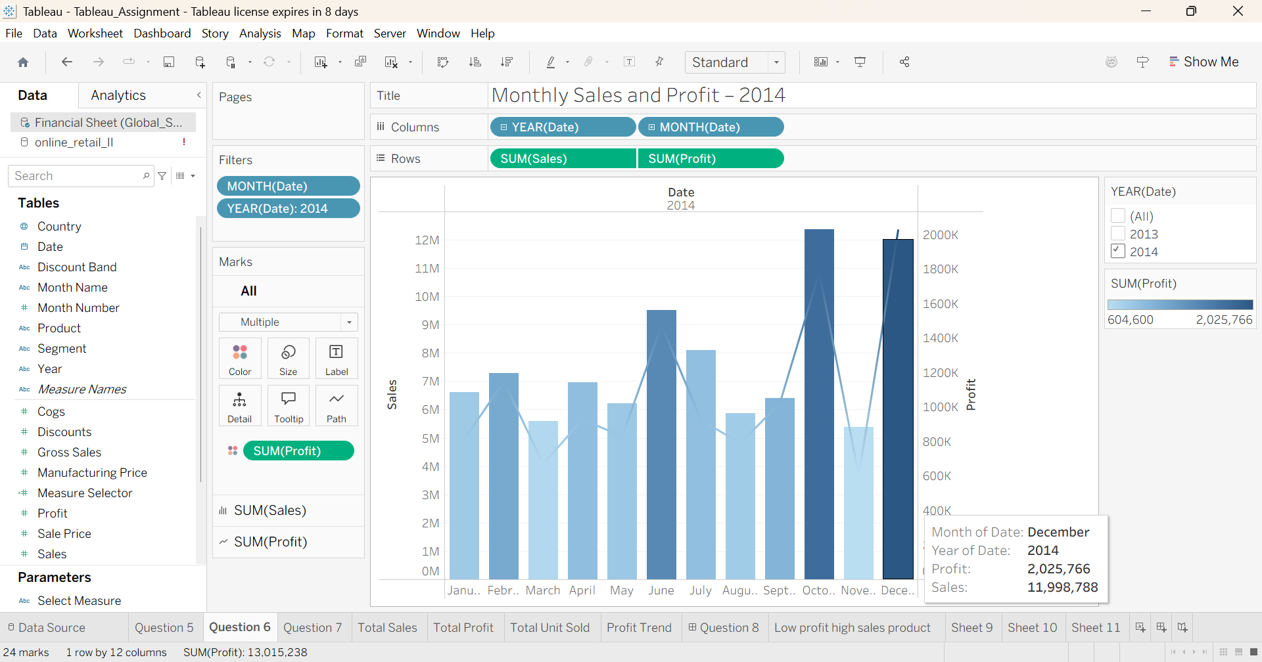

Question 7 : Create a filled map showing total Units Sold by Country. ● 🔗 Dataset Link:Global_sales_dataset ● Add a parameter to allow users to switch between Units Sold and Profit. ● Use the Discount Band as a filter in your visualization.
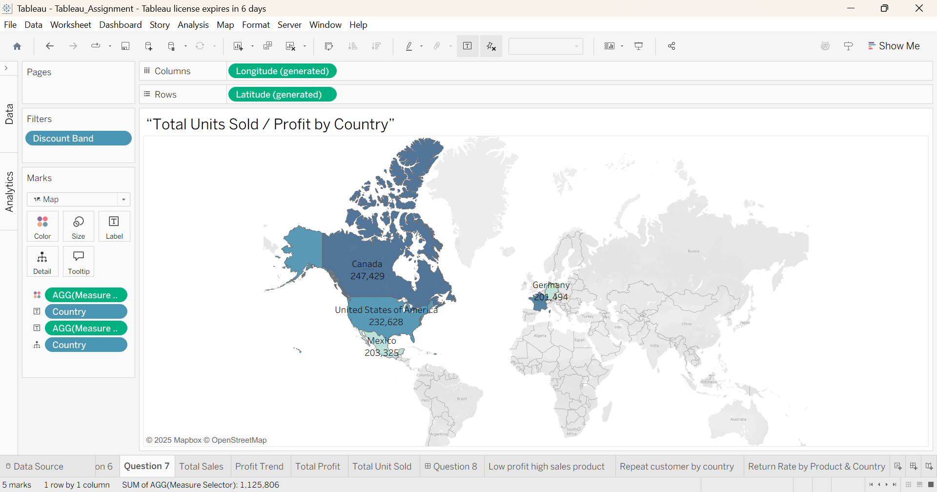
Question 8 : Create a dashboard that includes: ● 🔗 Dataset Link:Global_sales_dataset ● KPI tiles for Total Sales, Total Profit, and Total Units Sold ● A line chart for Profit trend over time ● Filters for Product and Country Ensure your dashboard is interactive and visually appealing

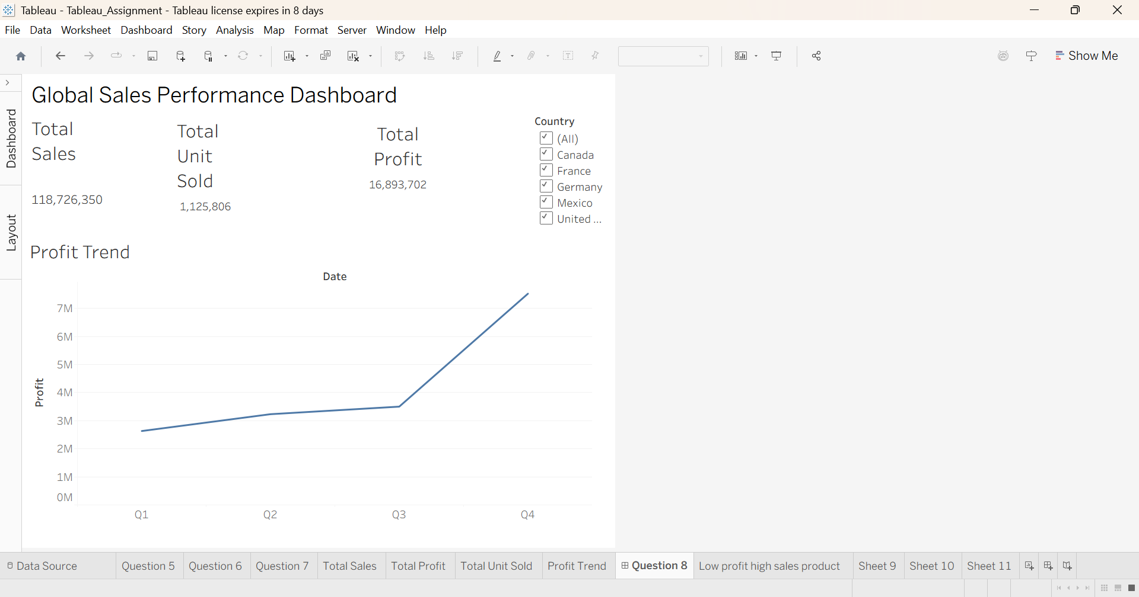

Question 9 : Your goal is to identify products that generate low profit despite high sales volume. ● 🔗 Dataset Link:Global_sales_dataset ● Use scatter plot or highlight table to identify such products. ● Add filters for Country and Segment. ● Write two business insights based on your chart.
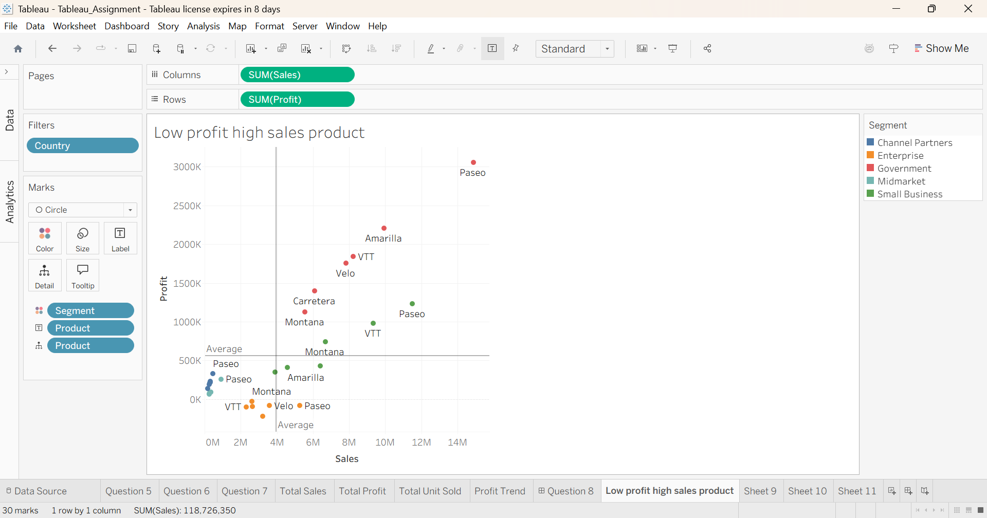
The scatter plot shows that some products generate high sales volume but relatively low profit, indicating possible high discounting, high production costs, or inefficient pricing strategies.
[Scenario-Based – Customer Behavior & Retention Strategy]
Dataset to Use: online_retail_II
Dataset Name: Online Retail II
Dataset Source: UCI Machine Learning Repository – Online Retail II Dataset
Business Scenario:
You are a Data Analyst at an e-commerce company that sells home decor and gifts
across multiple countries. The leadership team is concerned about customer churn
and revenue loss due to inconsistent customer behavior.
They’ve asked you to investigate patterns in customer orders, returns, and
geographic sales performance from the Online Retail II dataset.
Your Task in Tableau:
1. Use Tableau to answer these questions:
○ Which countries have the highest number of repeat customers?
○ What is the return rate by product and Find top 10 countries?
○ What time of year do customers tend to buy the most (Seasonality) ?
○ Are there certain customers with high order value but also high return rates?
2. Create visualizations:
○ A map showing Revenue by Country
○ A line chart of Monthly Sales Trend
○ A bar chart showing Top 10 customers by Total Revenue
○ A table/heatmap showing Top returned products by country
3. Build a dashboard for business insights:
Allow filters for Country, Product, and Customer ID
○ Use KPIs for:
■ Total Revenue
■ Total Returns
■ Repeat Customer Count
4. Write a short business insight (2–3 sentences):
Based on your Tableau dashboard, what recommendations would you make to help
reduce churn and increase customer loyalty?
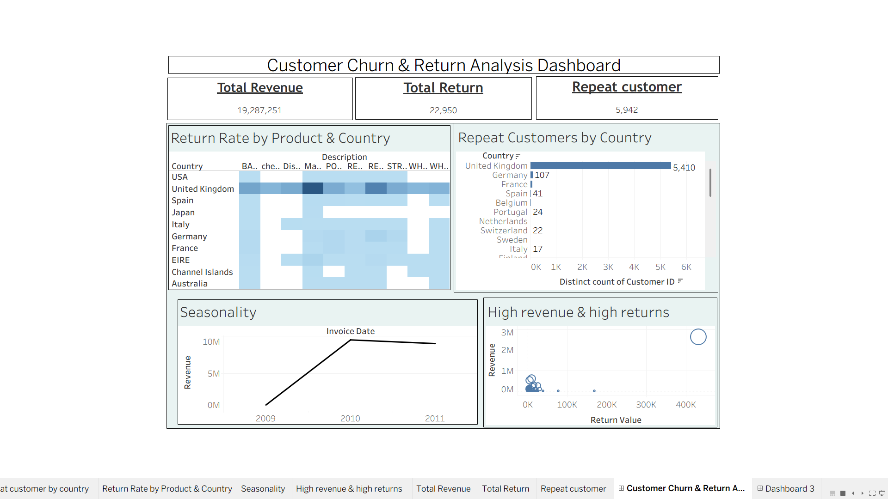
Key Insights from Dashboard
- United Kingdom dominates repeat customers, indicating strong customer loyalty and retention in this market.
- High returns are concentrated in a few products, suggesting potential quality or expectation mismatch issues.
- Revenue peaks around 2010, showing strong seasonal or demand-driven growth.
- Some products generate high revenue but also high returns, which may impact profitability and need operational review.
- Other countries show low repeat customer counts, indicating opportunity for targeted retention strategies.

