OFFLINE HANDWRITTEN SIGNATURE VERIFICATION
A project report submitted in partial fulfilment of the requirements for the award of the Degree of

BACHELOR OF ENGINEERING
IN
INFORMATION TECHNOLOGY

BY
ABHIRAJ SMIT (BE/10613/2013)
KRISHNA RATHI (BE/10596/2013)
ARCHIT SRIVASTAVA (BE/10617/2013)


DEPARTMENT OF COMPUTER SCIENCE AND ENGINEERING
BIRLA INSTITUTE OF TECHNOLOGY
MESRA, RANCHI
2017
DECLARATION CERTIFICATE

This is to certify that the work presented in the report entitled “OFFLINE HANDWRITTEN SIGNATURE VERIFICATION” in partial fulfilment of the requirement for the award of degree of “Bachelor of Engineering in Information Technology of Birla Institute of Technology Mesra, Ranchi” is an authentic work carried out under my supervision and guidance.
To the best of my knowledge, the content of this report does not form a basis for award of any previous Degree to anyone else.

Mrs. Akriti Nigam
(Project Mentor)

Dept.of Computer Science and Engineering, Birla Institute of Technology, Mesra, Ranchi.

CERTIFICATE OF APPROVAL

This is to certify that the project entitled “OFFLINE HANDWRITTEN SIGNATURE VERIFICATION” is hereby approved as a suitable design of an engineering subject, carried out and presented in satisfactory manner to warrant its acceptance as prerequisite to the degree for which it has been submitted.
It is understood that by this approval, the undersigned do not necessarily endorse any conclusion drawn or opinion expressed therein, but approve the project for which it is submitted.

External Examiner
Date:
Internal Examiner
Date:

Dr. Sandip Dutta
Head of Department
Department of Computer Science and Engineering
Birla Institute of Technology
Mesra, Ranchi

TABLE OF CONTENTS

ACKNOWLEDGEMENT
ABSTRACT
CHAPTER 1: INTRODUCTION
1.1 Handwritten Signature as a Biometric
1.2 Types of Biometrics
1.3 Advantages of Biometrics
1.4 Applications of Biometrics
1.5 What is Signature Verification
1.6 Types of Signature Verification
1.7 Types of Forgery
1.8 Application of Signature Verification
1.9 Motivation
1.10 Overview of Signature Verification System
CHAPTER 2: LITERATURE SURVEY
2.1 Offline Signature Verification
2.2 Online Signature Verification
2.3 Verification Techniques used
2.4 Conclusion
CHAPTER 3: PROPOSED METHODOLOGY
3.1 Image Acquisition and Pre-processing
3.2 Feature Extraction
3.3 Verification
3.4 Conclusion
CHAPTER 4: EXPERIMENTAL RESULTS AND ANALYSIS
4.1 Database Description and Experimental Setup
4.2 Performance Measures
4.3 Results
CHAPTER 5: CONCLUSION
CHAPTER 6: FUTURE SCOPE
CHAPTER 7: REFERENCES

ACKNOWLEDGEMENT

It gives me immense pleasure to express our deepest sense of gratitude to our highly respected and esteemed guide Mrs Akriti Nigam, Dept. of Computer Science and Engineering, Birla Institute of Technology Mesra, for her valuable guidance, encouragement and help for completing this work. Her useful suggestions for this whole work and co-operative behaviour are sincerely acknowledged.

We would also like to express our sincere thanks to our UG Project Coordinator, Dr. Subrajeet Mohapatra, Dept. of Computer Science and Engineering, Birla Institute of Technology Mesra, for giving us this opportunity to undertake this project. We also wish to express our gratitude to Dr. Sandip Dutta, HOD (Computer Science and Engineering) for his kind hearted support.

At the end we would like to express our sincere thanks to all our friends and others who helped us directly or indirectly during this project work.

Krishna Rathi Abhiraj Smit Archit Srivastava
(BE/10596/2013) (BE/10613/2013) (BE/10617/2013)

ABSTRACT

This project report work proposes an efficient technique to develop an offline signature identification and verification system that could help in crime prevention and biometric authentication systems. The technique proposed makes use of directional based methods to compute a set of features that are taken together as a combination. The features include the geometric details of the different strokes that compose a signature and contours of the signature. A grid based approach is applied to extract some of the features. A comprehensive study and analysis is done between two SVM and ANN classification models. Experiments are performed on a standard CEDAR database.

CHAPTER –I

INTRODUCTION

A large number of biometric techniques are being used since a very long time in history but none of them has the traits that can fully satisfy the needs of a biometric system. Thus the choice of the biometric technique is totally dependent on the application for which it is used. It takes into account not only the technique but also the social and cultural aspects, the setup and environment that is required to capture the data. Handwritten signatures occupy a very important place in the list of all the biometric traits. This is mainly due to the fact that handwritten signature is most commonly and very largely used from a very long time for personal verification.
Handwritten Signature has all the properties of handwriting. Earlier in history, information was passed from generation to generation verbally and in the form of pictorial representations. Gradually human beings developed the skill of handwriting and it became the most efficient way of passing information. The first recognizable event of handwriting was found in three different races of human beings, Sumerians in 3000 BC, Egyptians in 2800 BC and Chinese around 1800 BC.
When the population of world was not very large and it was feasible for the merchants and authorities to easily recognize and identify their people. But with the advancements in industries and more productive farming there was a rapid growth of cities in 19th century. This created a need for a formal system that could identify people. As handwriting was found to be unique for every person, it became a very popular and publicly accepted method for identification of people. People started writing their names in different styles on documents and various places wherever the proof of their identity was required. This practice evolved the concept of handwritten signature.
Throughout the history, there has always been a need to guarantee the authentication of any document. In the middle ages the empires used stamps to authenticate the official documents. Gradually with time people found signature to be a very easy and efficient way for the purpose. So people started signing the documents for authenticity. If a document is signed by a person then it means that the subscriber is in agreement with what is written in the document. The signature on the document is verified. If the signature is found to be fraud then the document is also considered invalid.
Handwritten signatures are now generally used by the financial and administrative institutions for verifying a person’s identity. People have also become very familiar with the use of signature in their daily life.

1.1 Handwritten Signature as a Biometric

The true emergence of biometrics took place with the emergence of computer systems. There was an explosion in the emergence of biometrics in 1990s and early 2000s. People started using biometric systems in everyday applications. Biometric systems today use features such as retinal scan, handwritten signature, voice etc.
We have started to see the use of advanced biometric systems by the introduction of National ID Card System by UK and Aadhar Cards by India. There has been a huge growth in investigating new technologies in this field and this growth will become exponential in the coming centuries. Automated biometric systems are available for use because of the significant advancements in computer processing.
The term ‘biometrics’ is made up of two Greek words “bio” meaning ‘life’ and “metrics” meaning ‘to measure’. Broadly defining biometrics is a field of science which deals with the identification and authentication of people by measuring relevant attributes, active properties or unique characteristics of the individuals.
The use of a biometric system is to differentiate individuals. It can be classified into two broad categories – Identification (“who the person is?”) where a person’s identity is confirmed by comparing the biometric traits of the individual to the previously collected database containing data of many people, i.e. it is a one-to-many search. The second category is – Verification (“is the person who he claims to be?”) here the person’s identity is checked only with one individual who he claims to be.
Any biometric system must have the following three properties:
Universal: The biometric characteristics should be present in every individual.
Unique: The biometric characteristics must be distinctive to each individual.
Permanent: The biometric characteristics should not change with time.
In order to determine identity, the biometric technologies measures person’s vital statistics. The biometric traits of every human being does not remain constant, it changes with time, surrounding conditions and depends upon lot of other things. But these changes are not very significant and the traits remain identical in the spatial and temporal context hence each individual is understood as having a coherent personality.

1.2 Types of Biometrics

Biometric technologies can be classified broadly into two categories:
1.2.1 Behavioural Biometrics:
In this category the technologies deal with the characteristics of human beings which are acquired naturally over time. These technologies are generally used for verification.
For example, Speaker Recognition, Handwritten Signature, Keystroke etc.

1.2.2 Physical Biometrics:
These methods measure the physical characteristics of a person which are inherent and unique. These methods are used for identification and verification.
For example, Fingerprint, Facial Recognition, Retinal Scan, DNA etc.

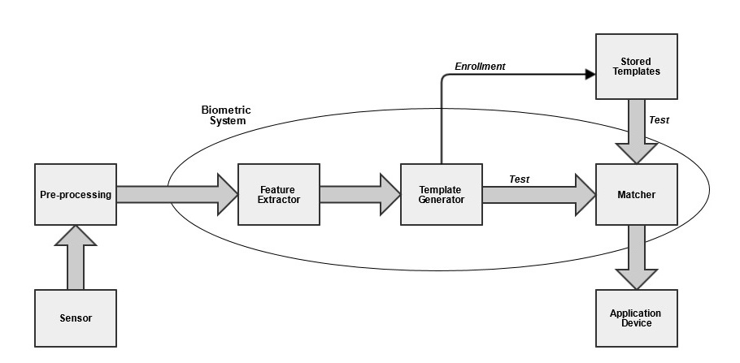
Figure 1.1: A General Biometric System

1.3 Advantages of Biometrics

- Increase security by giving access to a system only to authorized persons.
- Reducing fraud by developing systems which can detect forgery accurately. E.g. ID fraud
- By using physical biometric methods we can avoid the use of passwords which can be forgotten easily and can be shared among people.
- It can easily be found out WHO did WHAT and WHEN.
- It is a great area for research and reduces significant cost.

1.4 Applications of Biometrics

- Biometric time and attendance system is being used in various organizations to keep track of attendance of the employees.
- In banks, biometric safes and biometric locks provide a higher level of security.
- Nowadays biometric systems are used as administrator password in computer systems and as login passwords in various websites.
- DNA patterns and also other biometric techniques can be used to solve criminal cases.

1.5 What is Signature Verification

Signature verification is a process used to verify that whether a given query signature is of the same person of whom it is claimed to be or not. We know that handwriting of each individual is unique. Hence handwritten signature is a very efficient biometric trait. This method of identification captures the behavioral characteristics of a person rather than physical traits. Signature verification is a very complex process because it deals with the traits which depend on the psychophysical state of the signer and conditions under which the signature is being captured. The values of these characteristics vary with time. For example the signature of the same person will look different when he is happy than when he is sad or angry. It depends upon the emotions and mental state of the signer.
The main challenge of signature verification techniques is that the reference signatures are very less. There is very insufficient data available to train our system. Due to the unavailability of genuine and forged signatures in sufficient amount, training the system becomes a challenge. And if the training is not proper verifying the given signature becomes more difficult leading to wrong results.

Figure 1.2: Handwritten Signatures.

1.6 Types of Signature Verification

Signature verification is used as a biometric technique because it is highly unique and is a behavioural biometric. There are two types of features can be used in a signature verification system – static (Offline) and dynamic (Online) based upon the availability of the kind of data.

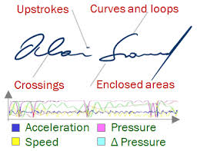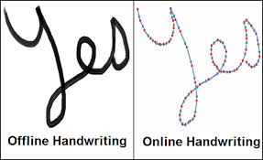
Figure 1.3: Types of Handwritten Signature Verification.

1.6.1 Static (Offline):
The data for input in this type of system is in the form of an image. These are particularly useful in bank cheques and document authentication. The image of the signature is captured using a camera and various features are then extracted using image processing techniques. The features that are used mainly depend upon the shape of the signature.
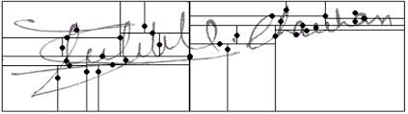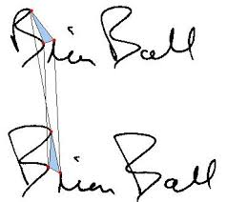
Figure 1.4: Offline Handwritten Signature Verification.

1.6.2 Dynamic (Online):
This method requires hardware to capture the input data. PDA’s, pressure sensitive tablets, webcam and signature pads are being used by many organizations nowadays. People are required to make their signature on the device which captures the dynamic properties of the signature in addition to its static properties. Some of the dynamic features are speed, pressure acceleration etc.

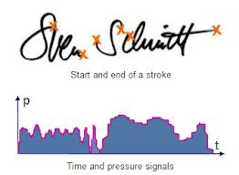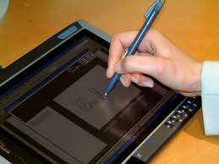
Figure 1.5: Online Handwritten Signature Verification.

Even if a skilled forger can accurately reproduce the shape of the genuine signature (static properties), he will never be able to match the speed of making the signature and pen pressure (dynamic properties).

1.7 Types of Forgery

The task of a signature verification system is to check the given signature for forgery. Forgery can be classified into the following three categories:
A Random or Zero-Effort forgery can be described as when the forger does not have any information about the original signature. He may even not know the name of the person whose signature is forged. The forger may just make the signature by writing any name in any style.
In a Simple forgery the forger only knows the name of the person whose signature is to be forged. He does not have any practice of the original signature. He might have seen the original signature once or twice. The forger spells the name correctly but makes it in his own style.
The forgery lies in the category of Skilled forgery when the forger has practiced the original thoroughly. He tries to copy the original signature in the same shape and makes it look exactly the same as original. Detecting skilled forgery is very difficult by static features but can still be found by dynamic features.
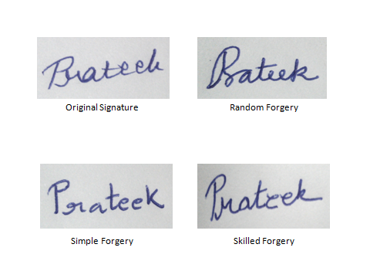
Figure 1.6: Types of Forgeries.

1.8 Application of Signature Verification

Signature verification is widely used in government as well as commercial level to forensic applications.
The main application area of signature verification is biometrics. Identification of people and authentication of documents are the areas where signature is widely used. Research is being done to develop multi-modal biometric systems which can be more accurate no matter what features are used. Unimodal systems are not considered adequate for large level security applications.
Other main application areas are banks, insurance companies, government organizations and other commercial use. Cheque authentication and any official document authentication are done by verifying the signature made on it.
Signature is also used in forensic applications and help police to solve many criminal cases.
Nowadays signatures are being used in online transactions in place of passwords and PINs. It can be used for authentication in ATMs, banks, e-commerce applications, health care services etc. it can also be used as ID of people for security.
Logging in to personal computers and any website can be done by verifying signature or a combination of signature and password. This will give a high level of security and confidentiality to the clients and protect their work.

1.9 Motivation

- While researching about signature verification it was found that around 300 cases related to identification of people are pending in Allahabad high court only. There are 635 courts (including Supreme Court, all high courts and all lower courts) in India. We can easily predict the number of cases pending in the whole country.

- In 2012 a controversy broke out over a letter that was sent to Mr. Barack Obama, the President of United States of America by about 64 members of parliament of India, persuading him to adhere to the current policy of refuting visa to Mr. Narendra Modi, Chief Minister of Gujarat. Many MPs claimed that they have not signed any such document. But a certified forensic document examiner of USA confirmed that that those signatures were original and authentic and not a work of cut-paste as purported.

This work is motivated by the pending cases of identification of people and many cases of verification of documents all over the world. An effort is made to explore and develop a signature verification technique which is more effective and accurate, dependable even if the person is under different emotional state, cost efficient (no additional hardware is required), robust against frauds and user friendly in terms of configuration.

1.10 Overview of Signature Verification System
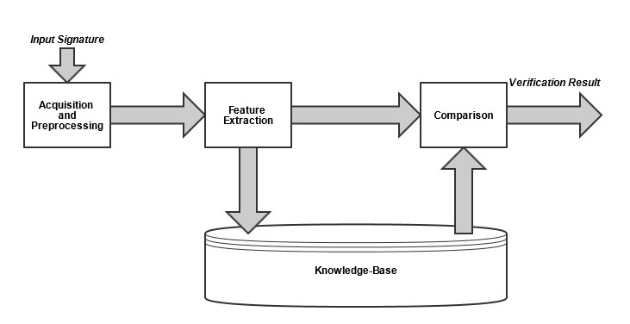
Figure 1.7: A General Handwritten Signature Verification System.

1.10.1 Data Acquisition and Pre-processing:
Different types of input data is required by static and dynamic systems. In offline systems input data is in the form of an image. To capture the image a camera or a scanner is required. In online systems input data is represented by electronic signals. Signature pads, PDAs, smart pens can be used to capture dynamic data.
The data acquired by the data acquisition devices is in raw form. This raw data has to be converted to useful information from which features can be extracted. Various pre-processing algorithms are applied for this. The input image is treated with binarization, dilation, erosion, skeletonization, pruning, size normalization and bounding box. Median filters are applied to remove noise and various morphological operators are also applied.
Some of the algorithms that are commonly used for dynamic signature verification involve smoothing, noise reduction and filtering.
1.10.2 Feature Extraction:
Features are some properties which are distinct in nature. With the help of features we can distinguish one thing from the other. In a signature verification system features are categorized as shown in figure. While calculating parameter features the signature is represented in the form of a vector. Every element of the vector represents a value of a feature. Evaluating function features is more time taking but it gives better results than parameter features.
Parameter features are further classified in global and local features.
Global features are extracted by considering the whole signature. Some of global features are orientation of signature globally, number of components, mathematical transforms, number of pen ups and downs, total time taken etc.
To calculate the local features only some specific parts of the signature is taken into consideration.
Depending upon the level of detail that is considered local features are further divided into two groups – component-oriented parameters and pixel-oriented parameters.
Component-oriented features are calculated at the level of each component. For example, stroke orientation, aspect ratio etc.
Pixel based features are extracted at grid based information, gray level intensity based etc.
However some features can be extracted at both global and local level. For example contours can be extracted at both global level (of the whole signature) and local level (of each connected component).

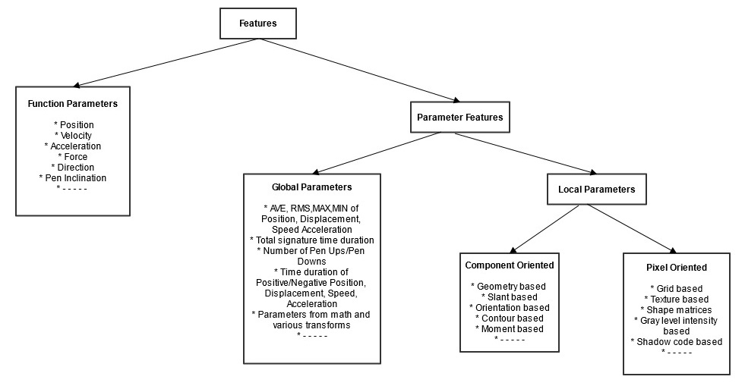
Figure 1.8: Classification of Features used for Handwritten Signature Verification.

1.10.3 Comparison:
After calculating the features, for classification various classifiers are used. During training features of all the classes are used to train the system, the classifier’s job is to draw a boundary between each class (in our case two – genuine and forged) which can accurately separate the instances of one class from the other. The authenticity of the test image is checked by comparing its features with the training data stored in the knowledge base. The classifier gives a binary result showing the test signature as genuine or forged.

CHAPTER –II

LITERATURE SURVEY

The main goal of Literature survey is to find out what work has been done previously by other people in the field. After reviewing the technologies used and methods applied so far, we decide our approach to solve the problem. We can compare our results with other people. In this chapter we will discuss some of the techniques and methods which have already been used previously.

2.1 Offline Signature Verification

In these methods, the static properties of handwritten signature are exploited. These properties are extracted from the images of the signature. Many techniques had been researched and experimented to determine static properties of the signature. Some of the researches done on these techniques are described below.

2.1.1 Curvature based Features
D. Bertolini et. al. [1] worked on two important aspects of signature verification, the feature set and ensemble of classifiers. They built two setups for experimentation. In the first case genuine signatures and random forgeries were used and in the other scenario simple forgeries were also included. They introduced a new feature set that considered the curvature of the signature. The features are grid-based. Four values that were calculated for each grid are distribution, density, slant and curvature. Slant was calculated both globally and locally. The dataset consisted signatures of 100 persons which was divided in 40 for training, 20 for validation and 40 for testing respectively. The results were promising.

2.1.2 Spatial Features
E. N. Zios et. al. [2] proposes a new approach of segmenting the signature image. As a preprocessing step a window was used. This formed the most informative window in which the features were extracted. A grid-based approach was applied in feature extraction. Spatial features were extracted from the partition by considering small portions of the strokes of image. A mask of 3*3 was traversed over the whole signature image. The curvature information of each pixel was stored. For classification a support vector machine was used. One model was created for every person. Genuine signatures and random forgeries were taken for training. Experiments were carried out by varying the number of training and testing samples. One of the databases taken for experimentation was a standard database and other was self-prepared. The average error rate showed encouraging results. The false acceptance rate was noted to be 0.5%.

2.1.3 Person Dependent and Person Independent approach
Harish Srinivasan et. al. [3] researched about the various learning methods that can be applied for signature verification. They classified the learning methods in two measures. First was the person-independent (general) approach where the training of the system is done by genuine and forged signatures of all the persons that are available. Second method was person-dependent (special) approach where training data comprised of signatures of only one person. The special approach outperforms the general approach by 5% if sufficient training data is available. The verification accuracy increases with the number of samples in the second approach. Experiments were performed on a CEDAR dataset containing 24 signatures each of 55 persons.

2.2 Online Signature Verification

A lot of work has also been done in the field of online signature verification. In this method dynamic properties of the signature are calculated. This technology has real time application. Some of the features used to determine dynamic properties of handwritten signature are pen pressure, speed of making the signature, acceleration, pen inclination, force, direction of pen movement etc. The classification techniques used are the same as in static features. The works done on dynamic properties are shown as reference in the table 2.1.

Functions | Category | References
Position | Online / Offline | J. Flerrez -Aguilar et. al . [4] , S. Krawczyk and A. K. Jam [5]
Velocity | Online | A. I. Al-Shoshan [7]
Pressure | Online | J. Fierrez-Aguilar et. al. [4], Y. Hongo et. al. [6]
Geometric-based | Offline | X. Ye et. al. [8]
Person dependent and person independent approach | Offline | Dominique Rivard et. al. [28]
Table 2.1: References for different features.

2.3 Verification Techniques used

Classification techniques like neural network and support vector machine were experimented for verification purpose. Papers on two of these verification techniques are described below and more work done in these techniques are shown in table 2.2.
The main focus of Napoles et. al. [4] was to experiment with the neural network for signature verification. They used artificial neural network which was further optimized by differential evolution algorithm. They calculated the features which were best to discriminate between the genuine and forged signatures. The features extracted were pen pressure, aspect ratio, distribution of pixels, centroid and skew of the signature. Some of the features were calculated globally and others locally by dividing the image into 3*4 grid. 5 – fold cross validation was used during training.

Verification Technique |  | Category | References
Support Vector Machine |  | Online / Offline | Srikanta Pal et. al. [9], Marianela Parodi et. al. [10]
NN | Multi-Layer Perceptrons | Online / Offline | A. I. Al-Shoshan [7]
Table 2.2: References for different Verification Techniques.

2.4 Conclusion

In this chapter various features and verification techniques used previously are discussed. This research helped in selecting the appropriate methods for this work. Papers discussed are given as reference in the form of tables.

CHAPTER –III

PROPOSED METHODOLOGY

The methodology embraced in this thesis work is described here. A detailed explanation of every step is given. This chapter starts with the explanation of pre-processing steps, followed by features used and verification techniques. An overview of the working on the system is shown in Figure 3.1 followed by detailed description of each step.

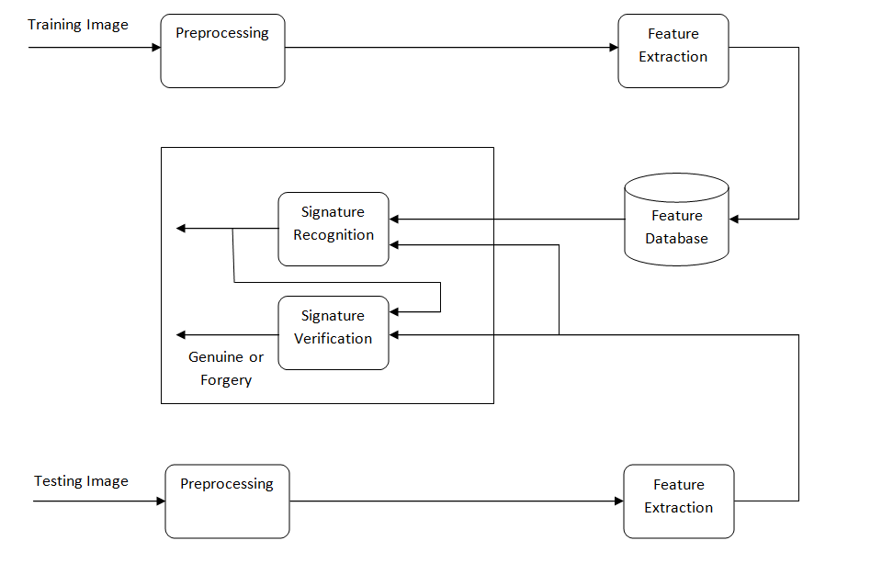
Figure 3.1: Block Diagram for Proposed Methodology.

3.1 Image Acquisition and Pre-processing

Images can also be acquired using a camera. The data acquired in the previous step was in raw form i.e. the images were not in proper form so that we can straight away extract the features from them. Therefore some pre-processing steps were carried out to remove the noises, normalize the images and convert them to a form which can be given as input to the functions to extract the features. The pre-processing steps are applied in the same sequence as explained below:
3.1.1 Binarization
The gray level values of the scanned images ranged from 0 – 255. By performing binarization we map these values to either 0 (foreground representing strokes of signature) or 1 (background). We define a threshold for this purpose which is established experimentally. All the pixel values above this threshold are converted to 1 and all the pixel values below this threshold are converted to 0.

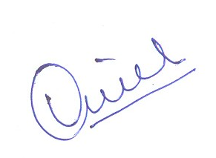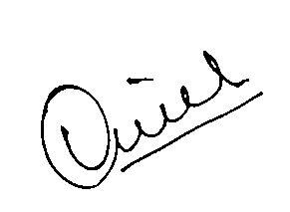
Figure 3.2: Result of Binarization.
Left: Original Scanned Signature; Right: Binarized Signature.

Morphological Operations
Morphological operators are often used for pre-processing of images for many applications. These operators take two inputs, the image and a structuring element (also known as kernel). Structuring element is of size 3*3 and is shifted over the image combining its values with the corresponding values of the image using a set operator (union, intersection, complement, inclusion etc.). The structuring element may contain values of 'foreground pixels', 'background pixels' and 'don't care's'. It is the structuring element that determines the effect of morphological operations on the input image.

3.1.2 Dilation
Dilation is a basic mathematical morphological operation. It is mostly applied in binary images. Dilation gradually enlarges the boundaries of the foreground region (signature stroke) and the holes in the foreground region become smaller. It takes two images as input. The first is the image to be dilated and second is the structuring element. It is used to smooth out the signature strokes.



Figure 3.4: Effect of Dilation using a 3*3 structuring element.
Top: Binarized Signature Image; Bottom: Dilated Signature Image.

3.1.3 Erosion
It is also a morphological operation applied mostly in binary images. It erodes the boundaries of the foreground stroke area in the image. Hence the foreground stroke area shrinks. The holes present in the stroke pixels get enlarged. It also takes two images as input. One is the signature image on which this operator is applied and the other one is the structuring element. Erosion is used after dilation.



Figure 3.6: Effect of Erosion using 3*3 structuring element.
Top: Dilated Signature Image; Bottom: Eroded Signature Image.

3.1.4 Thinning
Followed by Erosion, skeletonization of the input signature image is done. Skeletonization is also known as thinning. Thinning is a morphological operation which removes selected foreground pixels from the input image. By applying a set of structuring elements on the input image we reduce the size of each stroke of the signature to single pixel thickness so that directional features can be extracted from it. It preserves the directional and shape properties of the signature. The thinned image can be reverted to original image by reversing the process. A number of structuring elements are used in this algorithm.


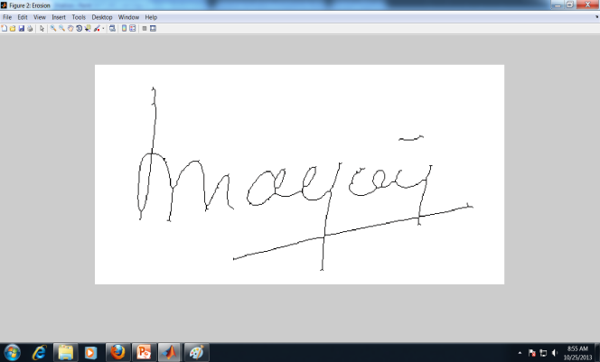
Figure 3.8: Effect of Thinning using 3*3 structuring elements.
Top: Eroded Signature Image; Bottom: Thinned Signature Image.

3.1.5 Pruning
There is a negative effect of thinning on the input image, spurs are obtained at the end points of the line. To remove these spurs pruning is done. These spurs are not the part of the original stroke and should be removed.

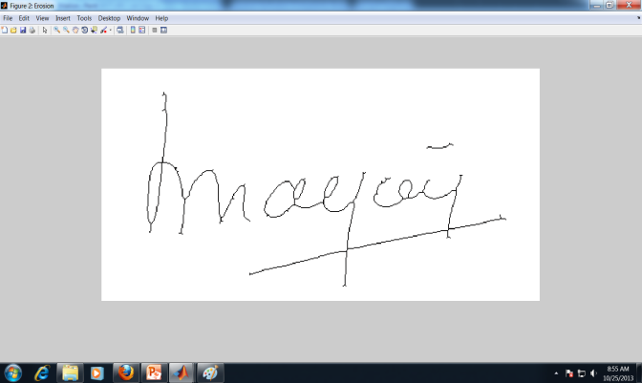

Figure 3.10: Effect of Pruning using 3*3 structuring elements.
Top: Thinned Signature Image; Bottom: Result after Pruning.

3.1.6 Bounding Box
There is a lot of space (only background pixels and no signature stroke part) from the edges of the images to the first foreground pixels from all the four sides. These spaces are removed from the images to reduce the processing time as during pre-processing and extraction of features the whole image is traversed several times pixel by pixel. The size of the image is reduced to the size of the bounding box containing the foreground pixels of the signature and the spare part of the image removed.

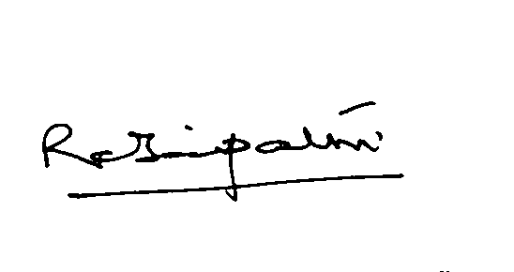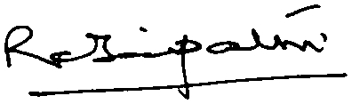
Figure 3.11: Bounding Box.

3.2 Feature Extraction

3.2.1 Aspect Ratio
Aspect Ratio is defined as the ratio if height and width of the image. The height and width of the signatures of an individual may change but the height–width ratio remains almost constant. To calculate the aspect ratio, the number of rows and number of columns in the image matrix is counted and their ratio is taken.

$$Aspect ratio= \frac{height of image}{width of image}……………………………….(3.8)$$

Total number of feature values generated: 1

3.2.2 Baseline
To calculate this feature polynomial curve fitting is done. The signature image is treated as a graph having coordinate axes. Every pixel has two coordinate values, x coordinate (column number) and y coordinate (row number). Considering the coordinate values of the foreground pixels we perform regression analysis. A linear curve is found which represents the foreground signature pixels most accurately. This curve represents the skew of the signature i.e. the overall slant of the signature. The coefficients of this linear curve are taken as features.
$y=ax+b$: Equation of the linear curve
Where:
$$a= \frac{\sum{x \sum{y - n\sum{xy} }}}{{(\sum{x})}^{2}- n\sum{x^{2}}}……………………………………………(3.9)$$

$$b= \frac{\sum{y\left(\sum{x^{2}}\right)- \sum{x} \sum{xy}}}{n\sum{x^{2}- {(\sum{x})}^{2}}}…………………………….……..(3.10)$$

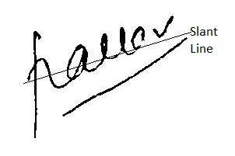
Figure 3.12: Slant of Signature.
Total number of feature values generated: 2

3.2.3 Centroid
To calculate the centroid again the signature image is treated as a graph having coordinate axes. Every pixel has two coordinate values, x coordinate (column number) and y coordinate (row number). The coordinate values of the centroid of the foreground pixels are calculated. The centroid is calculated spatially. Since the size of input image is normalized there is not much variation in the positions of the centroids of different signatures of the same individual. Whereas forged signatures have greater variation in position of centroid. Hence centroid location can be used to distinguish between genuine and forged signatures and is taken as a feature.

$$X_{centroid}= \frac{\sum{x}}{count}…………………………………………..(3.11) \\ Y_{centroid}= \frac{\sum{y}}{count}……………………………………………(3.12)$$
Where $X_{centroid}$, $Y_{centroid}$ are the coordinates of the centroid and ‘count’ is the count of number of foreground pixels.
Total number of feature values generated: 2

3.2.4 Count of Radical Points
We define three types of radical points:
Termination Points: These are the foreground pixels which are having only one neighbouring foreground pixel in the 8-neighborhood. Generally these are the starting point and end point of a stroke and where the direction of stroke reverses.
Trifurcate Points: These are the foreground pixels which are having only two neighbouring foreground pixels in the 8-neighborhood.
Intersection Points: These are the foreground pixels which are having more than two neighbouring foreground pixels in the 8-neighborhood. These points occur where one stroke crosses itself (thus forming a loop) or it crosses some other stroke of the signature.

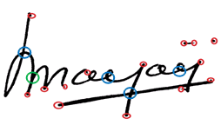
Figure 3.13: Radical Points.

The Red circles represent the Termination Points, the Blue circles represent the Intersection points and the Green circle represents the Trifurcate points.
We count the number of Termination, Trifurcate and Intersection points in the whole signature image globally and these counts are used as features.
Total number of feature values generated: 3

3.2.5 Adjacency Ratio
The length of adjacency columns are calculated from both top and bottom. These lengths are stored in 1D array. The ratio of sum of these lengths is taken as feature. For signatures of the same person the adjacency ratio will remain more or less the same.
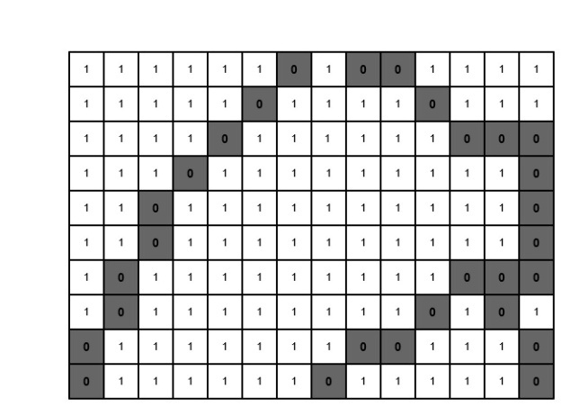
Figure 3.14: Adjacency ratio example image.

Figure 3.15: Calculation of length of adjacency columns from top and bottom

After calculating adjacency columns, Adjacency Ratio can be calculated by the following formula:

$$Adjacency Ratio= \frac{Sum(L_{T})}{Sum(L_{B})}………………………………………(3.13)$$
Total number of feature values generated: 1

3.3 Verification
For distinguishing genuine signatures from forged ones, various machine learning techniques are used as discussed in literature survey. In this work we have used both Artificial Neural Networks (ANN) and Support Vector Machine (SVM) for classification.
3.3.1 Support Vector Machine (SVM)
A binary SVM is implemented as we have only two classes of signature data, genuine and forged. For training purpose both genuine and forged signatures are taken as input. The SVM produces a single binary output; either ‘1’ or ‘0’ which implies the class to which the input test signature belongs.
SVM is a supervised machine learning technique which is used for classification. During training input data is marked with label of the class to which it belongs. SVM trains itself according to the label and builds a model of the input training data. This model is then utilized to classify the test data into different classes. A SVM constructs a hyperplane or set of hyperplanes which separates the classes. Separation of the classes is good when the distance between the nearest data point to the hyperplane and the hyperplane is maximized. This distance is called the margin and such data points which lie on the margin are called support vectors. Every data point has number of dimensions equal to the number of features values. A linear SVM constructs a (n-1) dimensional hyperplane to separate a data of dimension ‘n’.
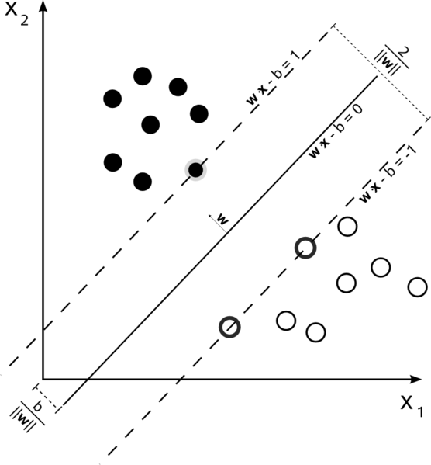
Figure 3.16: A hyperplane with maximum margin (solid line). The margins of the two classes (dotted lines). Support Vectors (vectors lying on the margins) [76].

The training feature set is represented in the form:
$$Feature set=\left\{\left(x_{i},y_{i}\right)\right|x_{i} ∈ R^{n} , y_{i} ∈\left\{1,-1\right\} :where i=1 to number of data points$$
$x_{i}$ is the feature data values and $y_{i}$is the class to which a data point belongs. The two classes are represented by ‘-1’ and ‘1’. The hyperplane which separates the class ‘1’ from class ‘-1’ is represented by the following equation:
$$w.x-b=0$$
Where ‘w’ represents the vector normal to the hyperplane. A dot product of this vector and the feature vector is taken. The offset of the hyperplane from the origin along the vector ‘w’ is given by the parameter $\frac{b}{|\left|w\right||}.$
The two class hyperplanes which separates the data if it is linearly separable can be described by the following equations:
$w .x-b=1$ And $w .x-b=-1$
During training SVM tries to maximize the distance between these hyperplanes. The distance found by geometry between the two hyperplanes is $\frac{b}{|\left|w\right||}$. Hence $|\left|w\right||$ is minimized.

3.3.2 Artificial Neural Networks (ANN)
Artificial Neural Networks are relatively crude electronic models based on the neural structure of the brain. The idea of ANNs is based on the belief that working of human brain by making the right connections, can be imitated using silicon and wires as living neurons and dendrites.
ANNs are composed of multiple nodes, which imitate biological neurons of human brain. The neurons are connected by links and they interact with each other. The nodes can take input data and perform simple operations on the data. The result of these operations is passed to other neurons. The output at each node is called its activation or node value. Each link is associated with weight. ANNs are capable of learning, which takes place by altering weight values. The following illustration shows a simple ANN −
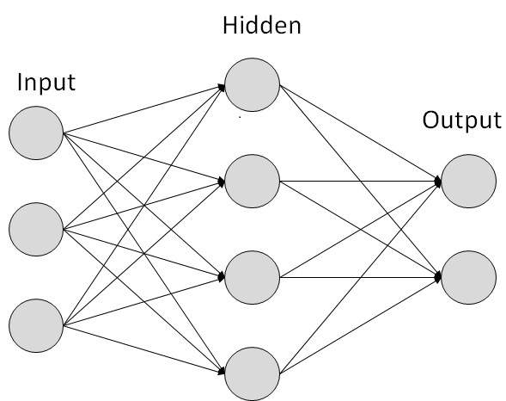
Figure 3.17 Artificial Neural Network
ANNs are capable of learning and they need to be trained. We have used the Supervised Learning technique to train the model. It involves a teacher that feeds some example data about which the teacher already knows the answers. For example, pattern recognizing. The ANN comes up with guesses while recognizing. Then the teacher provides the ANN with the answers. The network then compares it guesses with the teacher’s “correct” answers and makes adjustments according to errors.

3.4 Conclusion
In this chapter the features and verification technique used in this work are explained in detail. The overall working of the system is given, explaining each step in sequence. These techniques were selected for this work on the basis of literature survey done in Chapter 2.

CHAPTER-IV

EXPERIMENTAL RESULTS AND ANALYSIS

In this chapter description of the databases used for experimentation is given. The system is evaluated by dividing the databases into subsets and features are taken in different combinations. The results of all this experimentation are shown in a comprehensive manner.

4.1 Database Description and Experimental Setup
Experiments are carried out on a standard dataset CEDAR.
CEDAR dataset consists of signatures of 55 persons having 24 genuine and 24 forged signatures of each person. For experimentation various setups are made from the CEDAR dataset. First setup contains 8 genuine and 8 forged signatures for training and the rest of the signatures for testing. The second setup contains 16 genuine and 16 forged signatures for training and rest of the signatures for testing.
Performance of the system is measured for these two setups and all the features and the results are shown in the tables below.

4.2 Performance Measures
The performance of the system is calculated and an effort has been made to reduce the error as much as possible. For binary classification tests, Sensitivity and Specificity are a very common statistical performance measures. To calculate these measures, True positive, False positive, True negative, False negative are determined. These measures are computed on the entire databases. They are defined below:
True Positive (TP): forged signatures declared forged (correctly identified).
False Positive (FP): genuine signatures declared forged (incorrectly identified).
True Negative (TN): genuine signatures declared genuine (correctly rejected).
False Negative (FN): forged signatures declared genuine (incorrectly rejected).
False Acceptance Rate (FAR) is same as False Negative (FN).
False Rejection Rate (FRR) is same as False Positive (FP).
Thereafter calculating above quantities, results can be given in terms of Sensitivity (SN), Speciﬁcity (SP) and Accuracy (AC).

4.2.1 Sensitivity
It is related to the ability of the system to identify correctly. It shows the proportion of forged signatures which are also detected as forged signatures. It can be computed as follows:

$$Sensitivity= \frac{number of true positives}{number of true positives +number of false negatives }……………(4.1)$$
$$Sensitivity= \frac{number of true positives}{total number of forged signatures in the database}………………….(4.2)$$

4.2.2 Specificity
It is related to the ability of the system to exclude a condition correctly. It shows the proportion of genuine signatures which are also detected as genuine signatures. It can be computed as:

$$Specificity= \frac{number of true negatives}{number of true negatives+number of false positives}……………(4.3)$$

$$Specificity=\frac{number of true negatives}{total number of genuine signatures in the database}……………(4.4)$$

4.2.3 Accuracy
It can be defined as the degree of closeness of the output to the desired result, i.e. if a genuine signature is given as input, the output should also verify it as genuine and vice versa. It can be computed as:

$$Accuracy= \frac{TN+TP}{TN+TP+FN+FP}……………………………………(4.5)$$

4.3 Results

All results are given in percentage (%) values. The following results are computed through ANN analysis. Screenshots are also given below for further reference.
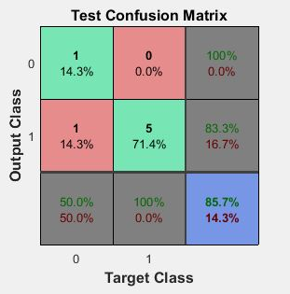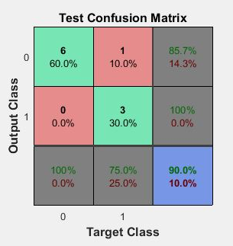
Person 1 Person 2
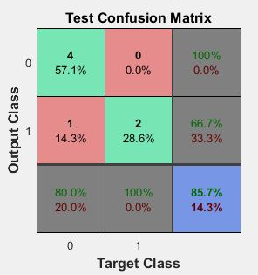
Person 3

Figure 4.1: Confusion Matrix Screenshots for three persons

Taking all Features at a time | CEDAR  (Person 1) | CEDAR  (Person 2) | CEDAR  (Person 3)
True Positive(TP) | 14.30 | 60.0 | 57.10
False Positive(FP) | 14.30 | 0.0 | 14.30
True Negative(TN) | 71.40 | 30.0 | 28.60
False Negative(FN) | 0.0 | 10.0 | 0.0
Sensitivity(SN) | 100.0 | 85.71 | 100.0
Specificity(SP) | 83.33 | 100.0 | 66.70
Accuracy | 85.71 | 90.00 | 85.71

Table 4.1: Comprehensive ANN Analysis

Taking all Features at a time | CEDAR  (Person 1) | CEDAR  (Person 2) | CEDAR  (Person 3)
True Positive(TP) | 58.34 | 45.00 | 46.67
False Positive(FP) | 0.0 | 5.0 | 8.34
True Negative(TN) | 33.34 | 43.34 | 40.0
False Negative(FN) | 8.34 | 6.67 | 5.0
Sensitivity(SN) | 87.50 | 87.09 | 90.32
Specificity(SP) | 100.0 | 89.65 | 82.75
Accuracy | 91.67 | 88.34 | 86.67

Table 4.2: Comprehensive SVM Analysis

Figure 4.2: SVM vs ANN Analysis

CHAPTER V

CONCLUSION

An Offline handwritten signature verification system is proposed in this project work. The research is focused on the directional features of a signature encapsulating the shape and curvature information. The signature images are subjected to number of pre-processing steps to convert it into a desired form which can be given as input to the system. The pre-processing steps include mainly morphological operations of digital image processing techniques.
To evaluate the performance of our system a publicly available CEDAR database is used. For classification a binary support vector machine as well as an artificial neural network is used. SVM was found to be most efficient technique for differentiating genuine from forgeries. Experiments are performed by taking various features. The system shows potential results with high accuracy.

CHAPTER-VI

FUTURE SCOPE

Handwritten signature has become a publicly adopted method of identification of people. Hence research is growing at a very fast rate in this field.
- The work done in this report can be extended by investigating about other features which can be used for signature verification.

- The above system can be extended to an online mode of signature verification. Signature verification technique can be implemented by using dynamic features. For this method a hardware is required. It can be more costly but is surely much more efficient than the static features.

- Further, the system can be evaluated by other publically available databases and also the self-prepared dataset can be used.

- A detailed analysis could be performed by taking a single feature at a time, two at a time, three at a time and so on.

- A proper GUI system can be designed according to the external users and their respective needs so as to exploit its commercial value.

CHAPTER-VII

REFERENCES

[1] D. Bertolini et al., “Reducing forgeries in writer-independent off-line signature verification through ensemble of classifiers”. 2010

[2] E. N. Zois, A. Nassiopoulos et. al., “Off-Line Signature Verification Using Two Step Transitional Features”. 2011

[3] Harish Srinivasan et. al., “Machine Learning for Signature Verification”, in Machine Learning in Document Analysis and Recognition, 2008

[4] J. Fierrez-Aguilar et. al., “Fusion of local and regional approaches for on-line signature verification”, 2005

[5] S. Krawczyk and A. K. Jain, “Securing electronic medical records using biometric authentication” 2005

[6] Y. Hongo et. al., “Boost-based on-line signature verifier” 2005

[7] A. I. Al-Shoshan et. al., “Handwritten signature verification using image invariant and dynamic features” 2006

[8] X. Ye, W. Hou, and W. Feng, “Offline handwritten signature verification with inflections features” 2005

[9] Srikanta Pal et. al., “Off-line Signature Identification Using Background and Foreground Information” 2011

[10] Marianela Parodi et. al., “A Circular Grid-Based Rotation Invariant Feature Extraction Approach for Off-line Signature Verification” 2011

[11] Aisha Hassan Abdalla et. Al., “An Evaluation on Offline Signature Verification using Artificial Neural Network Approach” 2014

[12] Fang, C. H. Leung et.al., “Off line signature verification with generated training samples” 2002
[13] R. Kumar, L. Kundu, B. Chanda, and J. D. Sharma, “A writer independent off-line signature verification system based on signature morphology” 2010

