Portfolio for CSC71001 ( programming I)

Abhiraj Basnet (23531855)

Southern Cross University

s

**Activity 1.8**

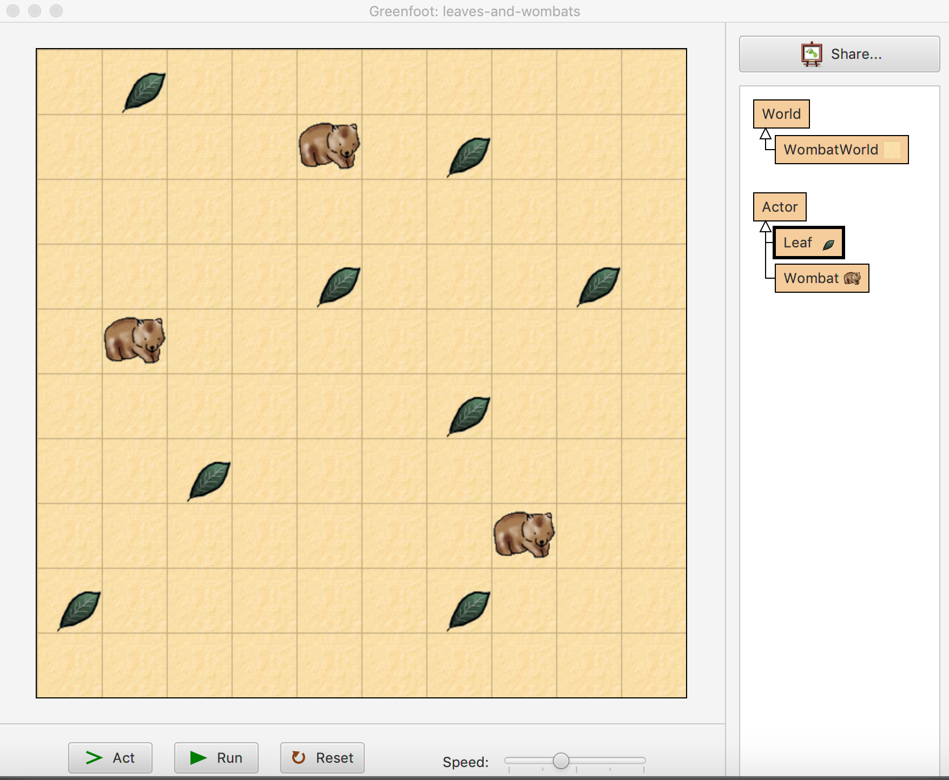

**Activity 2-8**