OS Lab 6
Abhiraj Tiwari (180905422)

Question 6.1

Reciever
#include <stdlib.h>
#include <stdio.h>
#include <sys/types.h>
#include <sys/msg.h>
#include <sys/ipc.h>
#include <errno.h>

#define SIZE 128

typedef struct message {
long mtype;
char c[SIZE];
}MESSAGE;

int isPalindrome(int n)
{
int r = 0, num = n;
while (n > 0)
{
r = r * 10 + n % 10;
n = n / 10;
}
if (r == num)
return 1;
else
return 0;
}

int main()
{
int qt;
MESSAGE msg;
if ((qt = msgget(1272, IPC_CREAT | IPC_EXCL | 0600)) < 0)
{
perror("Error in msgget()");
exit(EXIT_FAILURE);
}
printf("Message queue created.\n");
if (msgrcv(qt, &msg, sizeof(MESSAGE), 0, 0) < 0)
{
perror("Error in msgrcv()");
exit(EXIT_FAILURE);
}
printf("Successfully received number: %s\n", msg.c);

int num = atoi(msg.c);
if (isPalindrome(num))
printf("The number is a palindrome\n");
else
printf("The number is not a palindrome\n");

if(msgctl(qt, IPC_RMID, NULL)==-1)
{
fprintf(stderr, "IPC_RMID failed\n");
exit(EXIT_FAILURE);
}
exit(EXIT_SUCCESS);
}

Sender
#include <stdlib.h>
#include <stdio.h>
#include <sys/types.h>
#include <sys/msg.h>
#include <sys/ipc.h>
#include <errno.h>

#define SIZE 128

typedef struct message {
long mtype;
char c[SIZE];
}MESSAGE;

int main()
{
int qt;
MESSAGE msg;
if((qt = msgget(1272, 0)) < 0)
{
perror("Error in msgget()");
exit(EXIT_FAILURE);
}
printf("Enter the number: ");
fgets(msg.c, SIZE, stdin);
msg.mtype = 1;
if(msgsnd(qt, &msg, sizeof(MESSAGE), 0) < 0)
{
perror("Error in msgsnd()");
exit(1);
}
printf("Successfully sent.\n");
return 0;
}
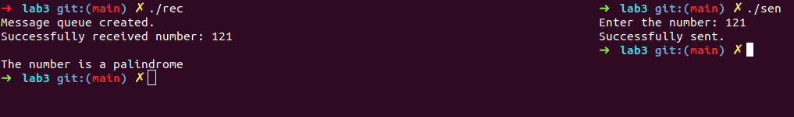

Question 6.2
#include <stdlib.h>
#include <stdio.h>
#include <unistd.h>
#include <sys/stat.h>
#include <sys/shm.h>
#include <sys/wait.h>

#define SIZE 2

char getNextAlphabet (char a)
{
return a=='z'?'a':a+1;
}

int main (int argc, const char * argv [])
{
int shmid = shmget(IPC_PRIVATE, SIZE, S_IRUSR | S_IWUSR);
if(shmid==-1)
{
fprintf(stderr, "shmget failed\n");
exit(EXIT_FAILURE);
}

char *shared_memory = (char *)shmat(shmid, NULL, 0);
if(shared_memory==(void*)-1)
{
fprintf(stderr, "shmat failed\n");
exit(EXIT_FAILURE);
}
*shared_memory = '\0';

printf("Enter an alphabet: ");
scanf("%c", shared_memory);

pid_t pid = fork();
if (pid == 0) //child process
{
while (*shared_memory == '\0');
*shared_memory = getNextAlphabet(*shared_memory);
exit(0);
}
else //parent process
{
printf("%s -> ", shared_memory);
wait(NULL);
printf("%s\n", shared_memory);
}

if(shmdt(shared_memory)==-1)
{
fprintf(stderr, "shmdt failed\n");
exit(EXIT_FAILURE);
}
if(shmctl(shmid, IPC_RMID, NULL)==-1)
{
fprintf(stderr, "IPC_RMID failed\n");
exit(EXIT_FAILURE);
}
exit(EXIT_SUCCESS);
}
