OS Lab 3
Abhiraj Tiwari (180905422)

Question 5.1

Producer
#include <stdlib.h>
#include <stdio.h>
#include <string.h>
#include <unistd.h>
#include <sys/types.h>
#include <sys/stat.h>
#include <fcntl.h>
#include <limits.h>

#define FIFO_NAME "/tmp/my_fifo"
#define BUFFER_SIZE PIPE_BUF
#define TEN_MEG (1024*1024*10)

int main(int argc, char *argv[])
{
int pipe_fd;
int res;
int open_mode = O_WRONLY;
int bytes_sent = 0;
char buffer[BUFFER_SIZE + 1];
if (access(FIFO_NAME, F_OK) == -1) {
res = mkfifo(FIFO_NAME, 0777);
if (res!=0) {
fprintf(stderr, "Could not create fifo%s\n", FIFO_NAME);
exit(EXIT_FAILURE);
}
}
printf("Process %d opening FIFO WRONLY\n", getpid());
pipe_fd = open(FIFO_NAME, open_mode);
printf("Process %d opening FIFO O_WRONLY\n", getpid());
pipe_fd = open(FIFO_NAME, open_mode);
printf("Process %d result %d\n", getpid(), pipe_fd);
if (pipe_fd != -1) {
while (bytes_sent < TEN_MEG) {
res = write(pipe_fd, buffer, BUFFER_SIZE);
if (res == -1) {
fprintf(stderr, "Write error on pipe\n");
exit(EXIT_FAILURE);
}
bytes_sent += res;
}
(void)close(pipe_fd);
}
else {
exit(EXIT_FAILURE);
}
printf("Process %d finished\n",getpid());
exit(EXIT_SUCCESS);
}

Consumer
#include <stdlib.h>
#include <stdio.h>
#include <string.h>
#include <unistd.h>
#include <sys/types.h>
#include <sys/stat.h>
#include <fcntl.h>
#include <limits.h>

#define FIFO_NAME "/tmp/my_fifo"
#define BUFFER_SIZE PIPE_BUF

int main()
{
int pipe_fd;
int res;
int open_mode = O_RDONLY;
char buffer[BUFFER_SIZE + 1];
int bytes_read = 0;
memset(buffer,'\0',sizeof(buffer));
printf("Process %d opening read-only FIFO\n", getpid());
pipe_fd = open(FIFO_NAME, open_mode);
printf("Process %d result %d\n", getpid(), pipe_fd);
if(pipe_fd!=-1)
{
do {
res = read(pipe_fd, buffer, BUFFER_SIZE);
bytes_read += res;
} while (res > 0);
(void)close(pipe_fd);
}
else
{
perror("pipe");
exit(EXIT_FAILURE);
}
printf("Process %d finished\nBytes read = %d\n", getpid(), bytes_read);
exit(EXIT_SUCCESS);
return 0;
}
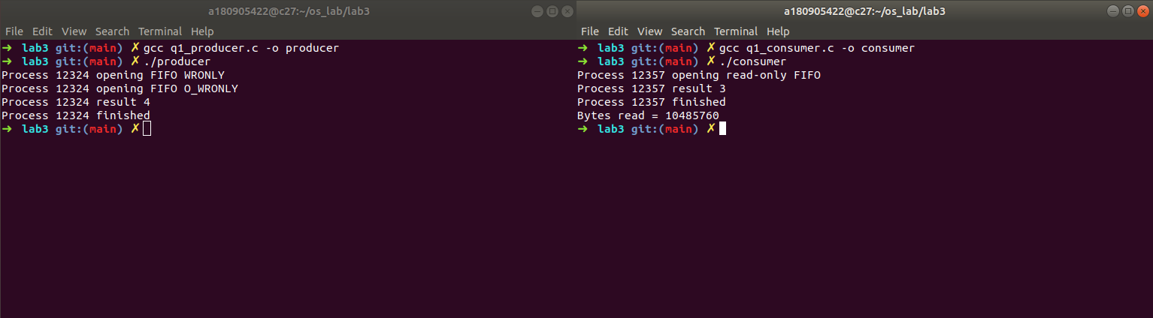

Question 5.2
#include <stdlib.h>
#include <stdio.h>
#include <string.h>
#include <unistd.h>
#include <sys/types.h>
#include <sys/stat.h>
#include <fcntl.h>
#include <wait.h>

int main(int argc, char *argv[])
{
int fd[2];
pid_t pid;
char buf;
if(argc!=2)
{
printf("Invalid no. of arguments\n");
exit(EXIT_FAILURE);
}
if(pipe(fd)==-1)
{
perror("pipe");
exit(EXIT_FAILURE);
}
pid = fork();
if(pid==-1)
{
perror("fork");
exit(EXIT_FAILURE);
}
else if(pid==0) //child process
{
printf("Reading in child...\n");
close(fd[1]); //close unused write end
while(read(fd[0], &buf, 1)>0)
write(STDOUT_FILENO, &buf, 1);
write(STDOUT_FILENO, "\n", 1);
close(fd[0]);
printf("Child ended\n");
exit(EXIT_SUCCESS);
}
else //parent process
{
printf("Writing in parent...\n");
close(fd[0]); //close unused read end
write(fd[1], argv[1], strlen(argv[1]));
close(fd[1]); //reader will see EOF
wait(NULL); //wait for child to terminate
printf("Parent ended\n");
exit(EXIT_SUCCESS);
}
return 0;
}
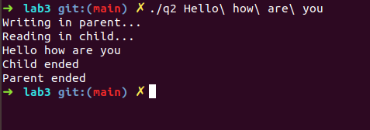

Question 5.3

Read end
#include <stdio.h>
#include <string.h>
#include <fcntl.h>
#include <sys/stat.h>
#include <sys/types.h>
#include <unistd.h>

int main()
{
int fd1;

char * myfifo = "/tmp/myfifo";
mkfifo(myfifo, 0777);

char str1[80], str2[80];
while (1)
{
fd1 = open(myfifo,O_RDONLY);
read(fd1, str1, 80);

printf("User1: %s\n", str1);
close(fd1);

fd1 = open(myfifo,O_WRONLY);
printf(">> ");
fgets(str2, 80, stdin);
write(fd1, str2, strlen(str2)+1);
close(fd1);
}
return 0;
}

Write end
#include <stdio.h>
#include <string.h>
#include <fcntl.h>
#include <sys/stat.h>
#include <sys/types.h>
#include <unistd.h>

int main()
{
int fd;
char * myfifo = "/tmp/myfifo";

mkfifo(myfifo, 0777);

char arr1[80], arr2[80];
while (1)
{
fd = open(myfifo, O_WRONLY);
printf(">> ");
fgets(arr2, 80, stdin);
write(fd, arr2, strlen(arr2)+1);
close(fd);

fd = open(myfifo, O_RDONLY);
read(fd, arr1, sizeof(arr1));

printf("User2: %s\n", arr1);
close(fd);
}
return 0;
}
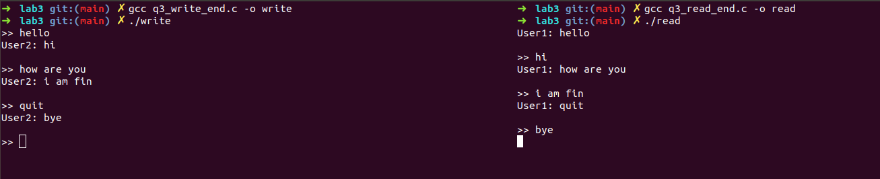

Question 5.4
#include <stdlib.h>
#include <stdio.h>
#include <string.h>
#include <fcntl.h>

int main(int argc, char** argv) {
if (argc < 3) {
printf("Less Arguments.\n");
printf("Usage: %s <bin_file_name> <string_to_write_there>\n", argv[0]);
exit(-1);
}
FILE* f = fopen(argv[1], "wb");
fwrite(argv[2], strlen(argv[2]),1,f);
close(f);
printf("Written the file.\n\n");

f = fopen(argv[1], "rb");
char buff[strlen(argv[2])];
fread(buff, strlen(argv[2]),1,f);
for(int i = 0; i < strlen(argv[2]); ++i) printf("%x ", buff[i]);
close(f);
return 0;
}
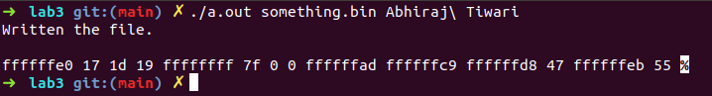

Question 6.1

Reciever
#include <stdlib.h>
#include <stdio.h>
#include <sys/types.h>
#include <sys/msg.h>
#include <sys/ipc.h>
#include <errno.h>

#define SIZE 128

typedef struct message {
long mtype;
char c[SIZE];
}MESSAGE;

int isPalindrome(int n)
{
int r = 0, num = n;
while (n > 0)
{
r = r * 10 + n % 10;
n = n / 10;
}
if (r == num)
return 1;
else
return 0;
}

int main()
{
int qt;
MESSAGE msg;
if ((qt = msgget(1272, IPC_CREAT | IPC_EXCL | 0600)) < 0)
{
perror("Error in msgget()");
exit(EXIT_FAILURE);
}
printf("Message queue created.\n");
if (msgrcv(qt, &msg, sizeof(MESSAGE), 0, 0) < 0)
{
perror("Error in msgrcv()");
exit(EXIT_FAILURE);
}
printf("Successfully received number: %s\n", msg.c);

int num = atoi(msg.c);
if (isPalindrome(num))
printf("The number is a palindrome\n");
else
printf("The number is not a palindrome\n");

if(msgctl(qt, IPC_RMID, NULL)==-1)
{
fprintf(stderr, "IPC_RMID failed\n");
exit(EXIT_FAILURE);
}
exit(EXIT_SUCCESS);
}

Sender
#include <stdlib.h>
#include <stdio.h>
#include <sys/types.h>
#include <sys/msg.h>
#include <sys/ipc.h>
#include <errno.h>

#define SIZE 128

typedef struct message {
long mtype;
char c[SIZE];
}MESSAGE;

int main()
{
int qt;
MESSAGE msg;
if((qt = msgget(1272, 0)) < 0)
{
perror("Error in msgget()");
exit(EXIT_FAILURE);
}
printf("Enter the number: ");
fgets(msg.c, SIZE, stdin);
msg.mtype = 1;
if(msgsnd(qt, &msg, sizeof(MESSAGE), 0) < 0)
{
perror("Error in msgsnd()");
exit(1);
}
printf("Successfully sent.\n");
return 0;
}
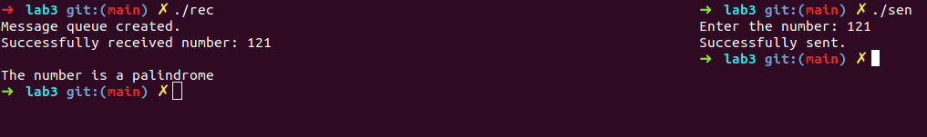

Question 6.2
#include <stdlib.h>
#include <stdio.h>
#include <unistd.h>
#include <sys/stat.h>
#include <sys/shm.h>
#include <sys/wait.h>

#define SIZE 2

char getNextAlphabet (char a)
{
return a=='z'?'a':a+1;
}

int main (int argc, const char * argv [])
{
int shmid = shmget(IPC_PRIVATE, SIZE, S_IRUSR | S_IWUSR);
if(shmid==-1)
{
fprintf(stderr, "shmget failed\n");
exit(EXIT_FAILURE);
}

char *shared_memory = (char *)shmat(shmid, NULL, 0);
if(shared_memory==(void*)-1)
{
fprintf(stderr, "shmat failed\n");
exit(EXIT_FAILURE);
}
*shared_memory = '\0';

printf("Enter an alphabet: ");
scanf("%c", shared_memory);

pid_t pid = fork();
if (pid == 0) //child process
{
while (*shared_memory == '\0');
*shared_memory = getNextAlphabet(*shared_memory);
exit(0);
}
else //parent process
{
printf("%s -> ", shared_memory);
wait(NULL);
printf("%s\n", shared_memory);
}

if(shmdt(shared_memory)==-1)
{
fprintf(stderr, "shmdt failed\n");
exit(EXIT_FAILURE);
}
if(shmctl(shmid, IPC_RMID, NULL)==-1)
{
fprintf(stderr, "IPC_RMID failed\n");
exit(EXIT_FAILURE);
}
exit(EXIT_SUCCESS);
}
