OS Lab 2
Abhiraj Tiwari (180905422)

Question 1

Code
#include <unistd.h>
#include <stdio.h>
#include <sys/stat.h>
#include <sys/types.h>
#include<dirent.h>
int main()
{
DIR * dp;
struct dirent * entry;
struct stat statbuf;
if ((dp = opendir(".")) == NULL) {
printf("Cannot open directory \n");
return 0;
}
while ((entry = readdir(dp)) != NULL)
{
lstat(entry->d_name, &statbuf);
if (!S_ISDIR(statbuf.st_mode)) {
printf( (S_ISDIR(statbuf.st_mode)) ? "d" : "-");
printf( (statbuf.st_mode & S_IRUSR) ? "r" : "-");
printf( (statbuf.st_mode & S_IWUSR) ? "w" : "-");
printf( (statbuf.st_mode & S_IXUSR) ? "x" : "-");
printf( (statbuf.st_mode & S_IRGRP) ? "r" : "-");
printf( (statbuf.st_mode & S_IWGRP) ? "w" : "-");
printf( (statbuf.st_mode & S_IXGRP) ? "x" : "-");
printf( (statbuf.st_mode & S_IROTH) ? "r" : "-");
printf( (statbuf.st_mode & S_IWOTH) ? "w" : "-");
printf( (statbuf.st_mode & S_IXOTH) ? "x" : "-");
printf("\t%s", entry->d_name);
printf("\n");
}
}
}

Input/Output
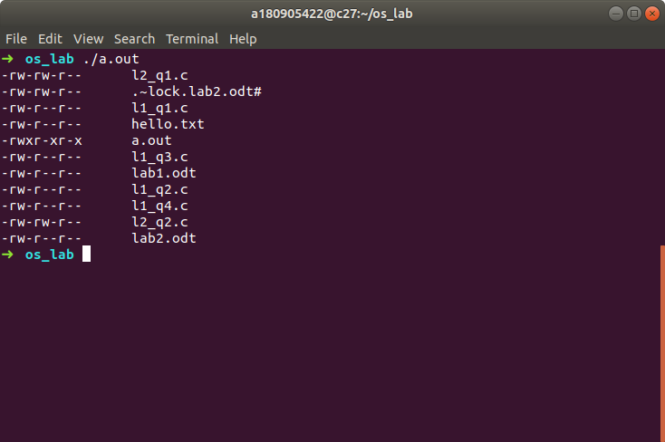

Question 2

Code
#include <unistd.h>
#include <stdio.h>
#include <sys/stat.h>
#include <sys/types.h>
#include <dirent.h>

void printDir(char *dir, int depth)
{
DIR * dp;
struct dirent * entry;
struct stat statbuf;
if ((dp = opendir(dir)) == NULL) {
printf("Cannot open directory \n");
return;
}
chdir(dir);
while ((entry = readdir(dp)) != NULL) {
lstat(entry->d_name, &statbuf);
if (S_ISDIR(statbuf.st_mode)) {
if (strcmp(".", entry->d_name) == 0 || strcmp(".." , entry->d_name ) == 0 )
continue;
printf("%*s%s/\n", depth, "", entry->d_name );
printDir(entry->d_name, depth + 4);
}
else {
printf("%*s%s\n", depth, "", entry->d_name);
}
}
chdir("..");
closedir(dp);
}

int main(int argc, char** argv) {
int depth = 0;
printDir(".", depth);
return 0;
}

Input/Output
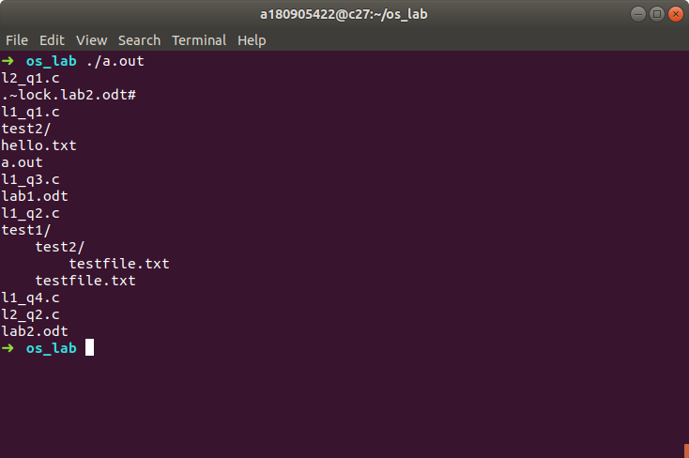

Question 3

Code
#include <unistd.h>
#include <stdio.h>
#include <dirent.h>
#include <string.h>
#include <sys/stat.h>
#include <stdlib.h>

void printDir(char *dir,int depth)
{
DIR * dp;
struct dirent * entry;
struct stat statbuf;
if((dp = opendir(dir)) == NULL) {
printf("Cannot open directory \n");
return;
}
chdir(dir);
while((entry = readdir(dp)) != NULL) {
lstat(entry->d_name,&statbuf);
if(S_ISDIR(statbuf.st_mode)){
if(strcmp(".",entry->d_name) == 0 || strcmp(".." , entry->d_name ) == 0 )
continue;
printf("%*s%s/\n",depth,"",entry->d_name );
printDir(entry->d_name,depth+4);
}
else{
printf("%*s%s/\n",depth,"",entry->d_name);
}
}
chdir(".");
closedir(dp);
}
int main() {
printDir("/usr/bin",0);
}

Input/Output
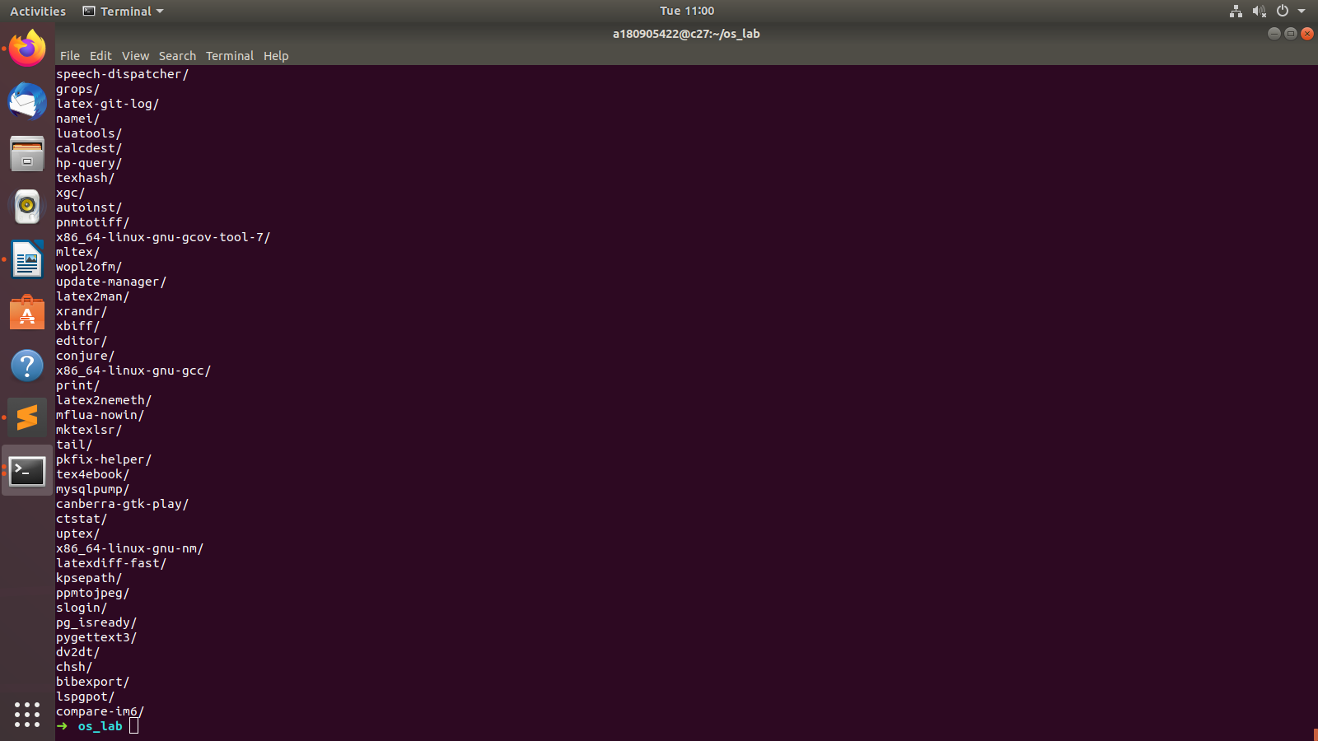

Question 4

Code
#include <unistd.h>
#include <stdio.h>
#include <dirent.h>
#include <string.h>
#include <sys/stat.h>
#include <stdlib.h>

void printDir(char *dir,int depth)
{
DIR * dp;
struct dirent * entry;
struct stat statbuf;
if((dp = opendir(dir)) == NULL) {
printf("Cannot open directory \n");
return;
}
chdir(dir);
while((entry = readdir(dp)) != NULL) {
lstat(entry->d_name,&statbuf);
if(S_ISDIR(statbuf.st_mode)){
if(strcmp(".",entry->d_name) == 0 || strcmp(".." , entry->d_name ) == 0 )
continue;
printf("%*s%s/\n",depth,"",entry->d_name );
printDir(entry->d_name,depth+4);
}
else{
printf("%*s%s/\n",depth,"",entry->d_name);
}
}
chdir(".");
closedir(dp);
}

int main() {
printDir("/var/lib/dpkg/info",0);
}

Input/Output
