OS Lab 1
Abhiraj Tiwari (180905422)

Question 1

Code
#include <unistd.h>
#include <sys/stat.h>
#include <fcntl.h>
#include <stdlib.h>
#include <stdio.h>
#include <string.h>
void printWordLine(char* word, int buff_size, char buff[]) {
char c[80];
int j = 0;
int line_number = 1;
for(int i = 0 ; i <= buff_size; i++) {
if(buff[i] == '\n') {
c[j++] = '\0';
char* p = strstr(c, word);
if(p) {
printf("line %d : %s \n", line_number, c);
}
j = 0;
line_number++;
} else {
c[j++] = buff[i];
}
}
}

int main(int argc, char** argv) {
char buff[100];
char* word = argv[1];
char* filename = argv[2];
int fd = open(filename, O_RDONLY);
int buff_size = read(fd, buff, sizeof(buff));
if(buff_size == -1) {
printf("ERROR");
exit(1);
}
printWordLine(word, buff_size, buff);
return 0;
}

Input/Output
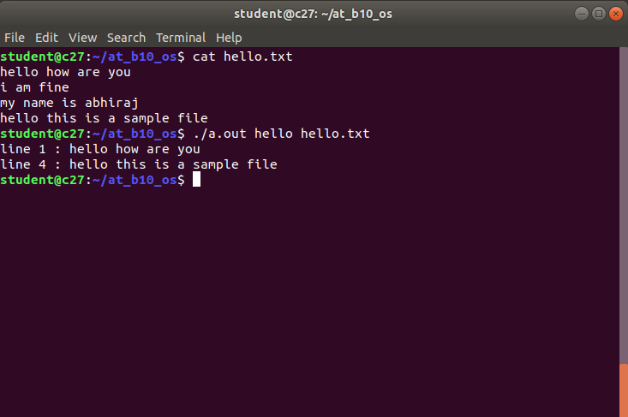

Question 2

Code
#include <unistd.h>
#include <sys/stat.h>
#include <fcntl.h>
#include <stdlib.h>
#include <stdio.h>
#include <string.h>

int printFile(int buff_size, char buff[]) {
int lines = 0;
for (int i = 0; i < buff_size; ++i) {
printf("%c", buff[i]);
if (buff[i]=='\n') lines++;
if (lines == 20) {getchar(); lines=0;}
}
}

int main(int argc, char ** argv) {
char buff[1000];
char* file_name = argv[1];
int fd = open(file_name, O_RDONLY);
int buff_size = read(fd, buff, sizeof(buff));
if (buff_size == -1) {
printf("ERROR\n");
exit(-1);
}
printFile(buff_size, buff);
return 0;
}

Input/Output
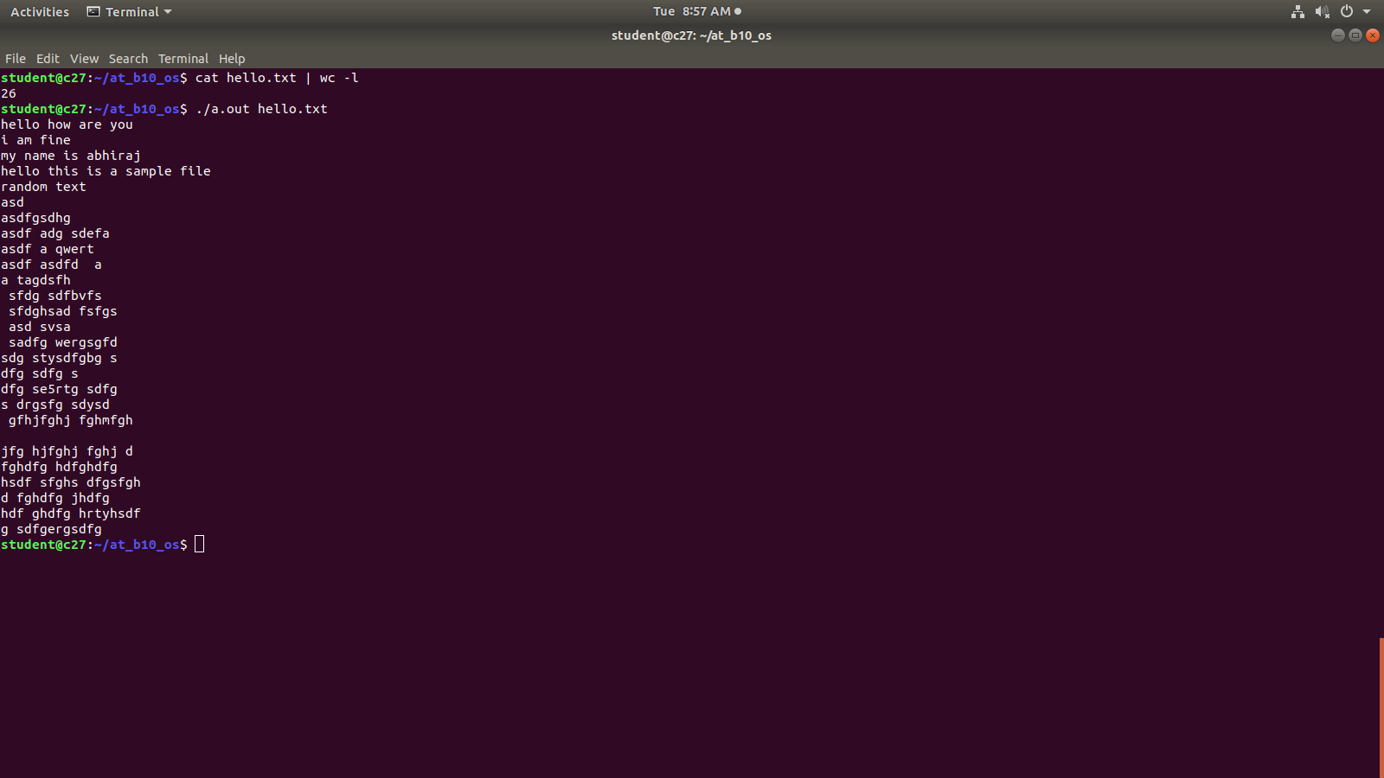

Question 3

Code
#include <stdio.h>

int main(){
int number;
float floating;
char character;
scanf("%d%f",&number,&floating);
while(getchar()!='\n');
character = getchar();
printf("\nInteger= %d,\nfloat=%f \nchar=%c\n",number, floating,character);
return 0;
}

Input/Output
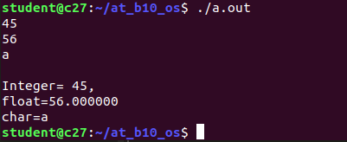

Question 4

Code
#include <unistd.h>
#include <sys/stat.h>
#include <fcntl.h>
#include <stdlib.h>
#include <stdio.h>
#include <string.h>

int main(int argc, char** argv) {
char* filename1 = argv[1];
char* filename2 = argv[2];
char cp;
int f1 = open(filename1, O_RDONLY);
int f2 = open(filename2, O_WRONLY|O_CREAT, S_IRUSR|S_IWUSR);
while (read(f1, &cp, 1)==1 && cp != EOF) write(f2, &cp, 1);
}

Input/Output
