CD Lab 1
Abhiraj Tiwari (180905422)

Question 2.1

Code
#include <stdio.h>
#include <stdlib.h>

int main(int argc, char** argv)
{
char* file = argv[1];
char* out_file = argv[2];
FILE *fp = fopen(file, "r");
if (fp == NULL) {
printf("Cannot open file.\n");
exit(0);
}
FILE *out = fopen(out_file, "w");
char c;
while ((c = getc(fp)) != EOF) {
if (c == ' ' || c == '\t') {
putc(c, out);
while((c=getc(fp))!=EOF && (c==' '||c=='\t'));
putc(c, out);
}
else putc(c, out);
}
return 0;
}

Question 2.2

Code
#include <stdlib.h>
#include <stdio.h>
#include <string.h>

const char *directives[] = {"#include","#define","#if"};

int is_directive(char *str)
{
for(int i = 0; i < sizeof(directives)/sizeof(char *); i++)
{
int len = strlen(directives[i]);
if(strncmp(str, directives[i], len) == 0)
return 1;
}
return 0;
}

int main(int argc, char** argv)
{
FILE *fa,*fb;
char* input = argv[1];
char* output = argv[2];

fa = fopen(input, "r");
fb = fopen(output, "w");

if(fa == NULL || fb == NULL)
{
perror("Invalid files\n");
return 1;
}
char line[256];
while(fgets(line, 256, fa))
{
if(!is_directive(line))
{
fputs(line, fb);
}
}
fclose(fa);
fclose(fb);
}

Question 2.3

Code
#include <stdio.h>
#include <string.h>
#include <stdlib.h>

const char *keywords[33] = {"auto", "double", "int", "struct", "break", "else", "long", "switch", "case", "enum", "register", "typedef",
"char", "extern", "return", "union", "continue", "for", "signed", "void", "do", "if", "static", "while", "default", "goto", "sizeof",
"volatile", "const", "float", "short", "unsigned", "printf"};

int isKeyword (char *word)
{
for (int i=0; i<33; i++) {
if (strcmp(word, keywords[i]) == 0)
{
return 1;
}
}
return 0;
}

int main(int argc, char** argv) {
char* in = argv[1];

FILE* in_fd = fopen(in, "r");

if (in_fd == NULL) {
perror("ERROR");
exit(0);
}

char* buffer;
buffer = (char *)malloc(1024*sizeof(char));
int k;
const char delimiters[] = " .,;:*&!?-_(){}[]\n\t";

while (fgets(buffer, 1024, in_fd)!=NULL) {
char *token = (char *)malloc(256 * sizeof(char));
while((token = strsep(&buffer, delimiters)))
{
if(isKeyword(token))
{
for (int i=0; i<strlen(token); i++)
printf("%c", toupper(token[i]));
printf("\n");
}
}
free(buffer);
buffer = (char *)malloc(1024*sizeof(char));
}

fclose(in_fd);
return 0;
}

Screenshot for Q1,2,3
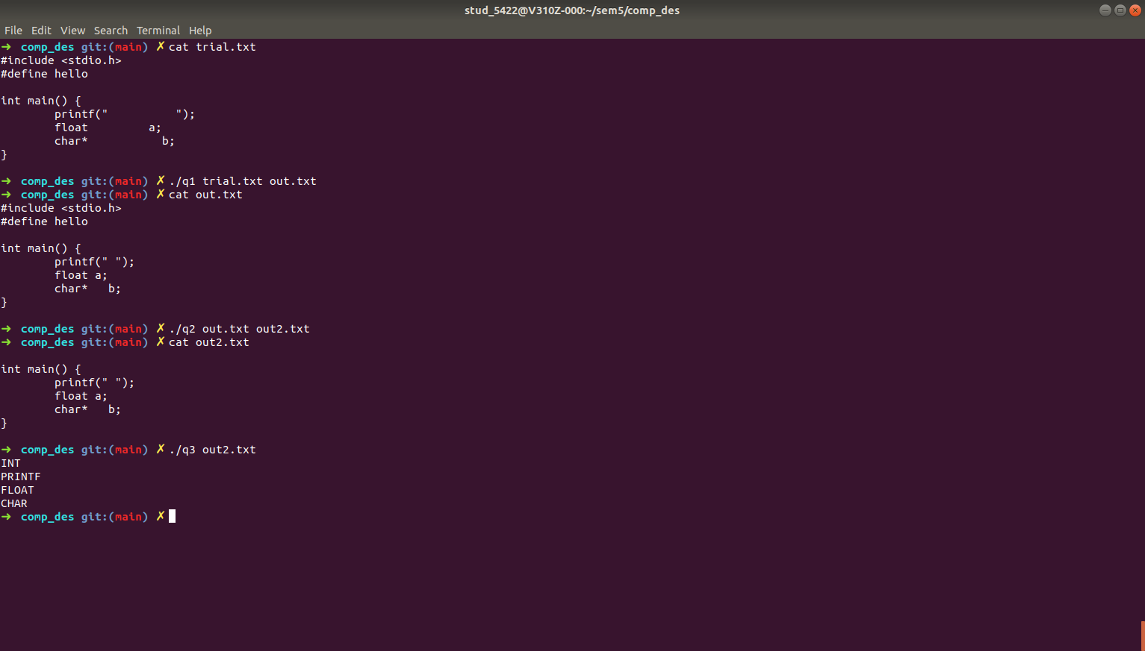

Question 3.1
#include <stdlib.h>
#include <stdio.h>
#include <string.h>
#include <ctype.h>

struct token
{
char lexeme[64];
unsigned int row,col;
char type[20];
};

static int row=1,col=1;
char buf[2048];

char specialsymbols[] = {'?',';',':',',','.'};

const char *keywords[] = {"const", "bool", "char", "int","float", "double","unsigned", "return", "for", "while", "do", "switch","if", "else","case", "break", "continue"};

char arithmeticsymbols[] = {'*','%'};

int isKeyword(char *word)
{
for(int i=0;i<sizeof(keywords)/sizeof(char*);i++)
{
if(strcmp(word,keywords[i])==0)
return 1;
}
return 0;
}

int charBelongsTo(int c, char *arr)
{
int len=0;
if(arr==specialsymbols)
len=sizeof(specialsymbols)/sizeof(char);
else if(arr==arithmeticsymbols)
len=sizeof(arithmeticsymbols)/sizeof(char);

for(int i=0;i<len;i++)
{
if(c==arr[i])
return 1;
}
return 0;
}

void fillToken(struct token *t, char c, int row, int col, char *type)
{
t->lexeme[0]=c; t->lexeme[1]='\0';
t->row=row; t->col=col;
strcpy(t->type,type);
}

void newLine()
{
row++; col=1;
}

struct token getNextToken(FILE *f)
{
int c;
struct token tkn=
{
.row=-1
};

int gotToken=0;
while(!gotToken && (c = fgetc(f))!=EOF)
{
if(charBelongsTo(c,specialsymbols))
{
fillToken(&tkn,c,row,col,"SS");
gotToken=1;
++col;
}
else if(charBelongsTo(c,arithmeticsymbols))
{
fillToken(&tkn,c,row,col,"ARITHMETIC OPERATOR");
gotToken=1;
++col;
}
else if(c=='(')
{
fillToken(&tkn,c,row,col,"LB");
gotToken=1;
++col;
}
else if(c==')')
{
fillToken(&tkn,c,row,col,"RB");
gotToken=1;
++col;
}
else if(c=='{')
{
fillToken(&tkn,c,row,col,"LC");
gotToken=1;
++col;
}
else if(c=='}')
{
fillToken(&tkn,c,row,col,"RC");
gotToken=1;
++col;
}
else if(c=='[')
{
fillToken(&tkn,c,row,col,"LS");
gotToken=1;
++col;
}
else if(c==']')
{
fillToken(&tkn,c,row,col,"RS");
gotToken=1;
++col;
}
else if(c=='+')
{
int d=fgetc(f);
if(d!='+')
{
fillToken(&tkn,c,row,col,"ARITHMETIC OPERATOR");
gotToken=1;
++col;
fseek(f,-1,SEEK_CUR); //go back 1 step *
}
else
{
fillToken(&tkn,c,row,col,"UNARY OPERATOR");
strcpy(tkn.lexeme,"++");
gotToken=1;
col+=2; //skip next as it is already included
}
}
else if(c=='-')
{
int d=fgetc(f);
if(d!='-')
{
fillToken(&tkn,c,row,col,"ARITHMETIC OPERATOR");
gotToken=1;
++col;
fseek(f,-1,SEEK_CUR); //go back 1 step *
}
else
{
fillToken(&tkn,c,row,col,"UNARY OPERATOR");
strcpy(tkn.lexeme,"--");
gotToken=1;
col+=2; //skip next as it is already included
}
}
else if(c=='=')
{
int d=fgetc(f);
if(d!='=')
{
fillToken(&tkn,c,row,col,"ASSIGNMENT OPERATOR");
gotToken=1;
++col;
fseek(f,-1,SEEK_CUR); //go back 1 step *
}
else
{
fillToken(&tkn,c,row,col,"RELATIONAL OPERATOR");
strcpy(tkn.lexeme,"==");
gotToken=1;
col+=2; //skip next as it is already included
}
}
else if(isdigit(c))
{
tkn.row=row;
tkn.col=col++;
tkn.lexeme[0]=c;
int k=1;
while((c=fgetc(f))!=EOF && isdigit(c))
{
tkn.lexeme[k++]=c;
col++;
}
tkn.lexeme[k]='\0';
strcpy(tkn.type,"NUMBER");
gotToken=1;
fseek(f,-1,SEEK_CUR); //go back 1 step *
}
else if(c == '#')
{
while((c = fgetc(f)) != EOF && c != '\n');
newLine();
}
else if(c=='\n')
{
newLine();
c = fgetc(f);
if(c == '#')
{
while((c = fgetc(f)) != EOF && c != '\n');
newLine();
}
else if(c != EOF)
fseek(f, -1, SEEK_CUR);
}
else if(isspace(c))
++col;
else if(isalpha(c)||c=='_')
{
tkn.row=row;
tkn.col=col++;
tkn.lexeme[0]=c;
int k=1;
while((c=fgetc(f))!= EOF && isalnum(c))
{
tkn.lexeme[k++]=c;
++col;
}
tkn.lexeme[k]='\0';
if(isKeyword(tkn.lexeme))
strcpy(tkn.type,"KEYWORD");
else
strcpy(tkn.type,"IDENTIFIER");
gotToken=1;
fseek(f,-1,SEEK_CUR);
}
else if(c=='/')
{
int d=fgetc(f);
++col;
if(d=='/')
{
while((c=fgetc(f))!= EOF && c!='\n')
++col;
if(c=='\n')
newLine();
}
else if(d=='*')
{
do
{
if(d=='\n')
newLine();
while((c==fgetc(f))!= EOF && c!='*')
{
++col;
if(c=='\n')
newLine();
}
++col;
}while((d==fgetc(f))!= EOF && d!='/' && (++col));
++col;
}
else
{
fillToken(&tkn,c,row,--col,"ARITHMETIC OPERATOR");
gotToken=1;
fseek(f,-1,SEEK_CUR);
}
}
else if(c == '"')
{
tkn.row = row;
tkn.col = col;
strcpy(tkn.type, "STRING LITERAL");
int k = 1;
tkn.lexeme[0] = '"';
while((c = fgetc(f)) != EOF && c != '"')
{
tkn.lexeme[k++] = c;
++col;
}
tkn.lexeme[k] = '"';
gotToken = 1;
}
else if(c == '<' || c == '>' || c == '!')
{
fillToken(&tkn, c, row, col, "RELATIONAL OPERATOR");
++col;
int d = fgetc(f);
if(d == '=')
{
++col;
strcat(tkn.lexeme, "=");
}
else
{
if(c == '!')
strcpy(tkn.type, "LOGICAL OPERATOR");
fseek(f, -1, SEEK_CUR);
}
gotToken = 1;
}
else if(c == '&' || c == '|')
{
int d = fgetc(f);
if(c == d)
{
tkn.lexeme[0] = tkn.lexeme[1] = c; tkn.lexeme[2] = '\0';
tkn.row = row;
tkn.col = col;
++col;
gotToken = 1;
strcpy(tkn.type, "LOGICAL OPERATOR");
}
else
{
tkn.lexeme[0] = c; tkn.lexeme[1] = '\0';
tkn.row = row;
tkn.col = col;
++col;
gotToken = 1;
strcpy(tkn.type, "BITWISE OPERATOR");
fseek(f, -1, SEEK_CUR);
}
++col;
}
else
++col;
}
return tkn;
}
const char *directives[] = {"#include","#define","#if"};

int is_directive(char *str)
{
for(int i = 0; i < sizeof(directives)/sizeof(char *); i++)
{
int len = strlen(directives[i]);
if(strncmp(str, directives[i], len) == 0)
return 1;
}
return 0;
}

void cleanFile(FILE* in) {
FILE* clean = fopen("temp.clean", "w");
char line[256];
while(fgets(line, 256, in))
{
if(!is_directive(line))
{
fputs(line, clean);
}
}
fclose(clean);
clean = fopen("temp.clean", "r");
FILE* clean2 = fopen("temp2.clean", "w");
char c;
while ((c = getc(clean))!=EOF) {
if (c=='/') {
c = getc(clean);
if (c == '/') {
while((c=getc(clean))!='\n');
}
else if (c == '*') {
do {
while (c!='*')c=getc(clean);
c = getc(clean);
} while(c!='/');
}
else putc(c, clean2);
}
else {
putc(c, clean2);
}
}
}

int main(int argc, char** argv)
{

char* input = argv[1];
FILE *f = fopen(input, "r");
if (f == NULL)
{
printf("Cannot open file\n");
exit(0);
}

struct token t;
cleanFile(f);
fclose(f);
f = fopen(f, "r");
while((t = getNextToken(f)).row != -1)
printf("<%s, %d, %d, %s>\n",t.lexeme,t.row,t.col,t.type);

fclose(f);
return 0;
}
